Prices of agricultural products in February 2023
Procurement prices of basic agricultural products decreased in February 2023 in comparison with the previous month (by 1.4%) while they increased (by 31.2%) compared to the corresponding month of the previous year.
31.2%
an increase in procurement prices of basic agricultural products in comparison with February 2022

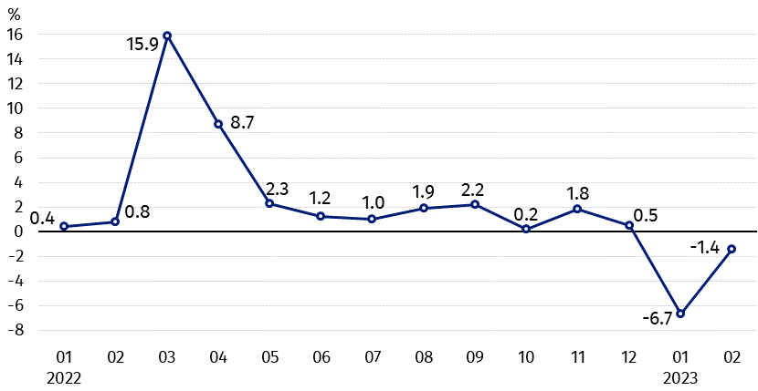
Chart 1. Changes in procurement prices of basic agricultural products in relation to the previous month
In February 2023, compared to January 2023 the procurement prices of wheat, rye and cows’ milk decreased

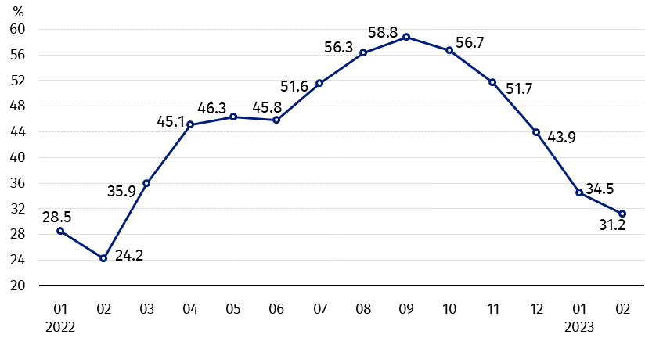
Chart 2. Changes in procurement prices of basic agricultural products in relation to the corresponding month of the previous year
The prices of pigs for slaughter, poultry and cows’ milk increased the most on an annual basis

Procurement prices and marketplace prices received by farmers
In February 2023 compared to the previous month, both in procurement and on marketplaces, prices of most agricultural products decreased. The prices of animals for slaughter in procurement and potatoes on both markets were higher.
In comparison with the corresponding month of the previous year, in February 2023, growth in procurement and marketplaces prices of all agricultural products was recorded with exception of rye in procurement. The prices of pigs for slaughter in procurement and cattle for slaughter on marketplaces increased the most.

Table 1. Prices of agricultural products (excluding VAT) in February 2023
Specification | Procurement prices |  |  | Marketplaces prices
Specification | 02 2023
Specification | in zloty | 01 2023=100 | 02 2022=100 | in zloty | 01 2023=100 | 02 2022=100
Cereal grain – per 1 dt
Wheat | 128.95 | 95.8 | 102.0 | 158.91 | 95.8 | 115.9
Rye | 101.25 | 94.1 | 91.7 | 129.24 | 97.2 | 123.3
Barley | 115.44 | 91.8 | 103.4 | 149.79 | 96.0 | 120.1
Triticale | 116.00 | 95.4 | 102.8 | 142.60 | 96.9 | 119.4
Oat | 120.70 | 95.7 | 125.2 | 136.28 | 97.5 | 134.4
Maize | 123.70 | 93.7 | 112.2 | 164.21 | 97.6 | 120.6
Potatoes– per 1 dt | 105.01 | 103.9 | 129.9 | 175.47 | 100.8 | 120.7
Animals for slaughter – per kg  Cattle (excl. calves) | 10.94 | 100.3 | 112.0 | 10.71 | 95.3 | 139.5
of which young cattle | 11.09 | 100.4 | 112.4 | 11.19 | 94.8 | 141.5
Pigs ª | 8.37 | 110.3 | 190.2 | . | . | .
Poultry | 6.31 | 101.3 | 127.9 | . | . | .
Cows’ milk – per 1 hl | 227.40 | 92.6 | 123.4 | . | . | .
a – No data.
Data on procurement prices were calculated on the basis of information on value and quantity of procurement by legal persons and independent organizational entities without legal personality (without natural persons).
Indices of procurement prices and prices received by farmers on marketplaces were calculated on the basis of absolute data expressed with more precision than In the tables.

Prices of major agricultural products in February 2023
In February 2023 procurement price of wheat (128.95 PLN per dt) decreased compared to the previous month (by 4.2%), but was higher on an annual basis (by 2.0%). On marketplaces, wheat was sold for 158.91 PLN per dt, i.e. by 4.2% cheaper than in January this year, while by 15.9% more expensive than in the corresponding period 2022.
The price of rye in procurement amounted to 101.25 PLN per dt and was lower compared to January this year (by 5.9%) as well as to February 2022 (by 8.3%). The transaction price of rye on marketplace (129.24 PLN per dt) decreased on a monthly basis (by 2.8%), while increased on an annual basis (by 23.3%).
In February 2023 105.01 PLN was paid per dt of potatoes in procurement, i.e. by 3.9% more than in the previous month and by 29.9% more than in the corresponding period 2022. The price of potatoes on marketplaces (175.47 PLN per dt) was higher as related to January this year (by 0.8%) as well as compared to February 2022 (by 20.7%).
The procurement price of cattle for slaughter (10.94 PLN per kg) increased on a monthly basis (by 0.3%) as well as on an annual basis (by 12.0%). The price of cattle for slaughter on marketplaces (10.71 PLN per kg) dropped in comparison with January this year (by 4.7%), but it was higher than in the corresponding period of the last year (by 39.5%).
In February 2023 8.37 PLN was paid per kg of pigs for slaughter, i.e. by 10.3% more than in the previous month and by 90.2% more than a year ago.
The procurement price of poultry for slaughter (6.31 PLN per kg) increased in comparison with January this year (by 1.3%) as well as compared to the same period 2022 (by 27.9%).
227.40 PLN was paid in procurement per hl of cows’ milk, i.e. by 7.4% less than in the previous year, but by 23.4% more than in February 2022.

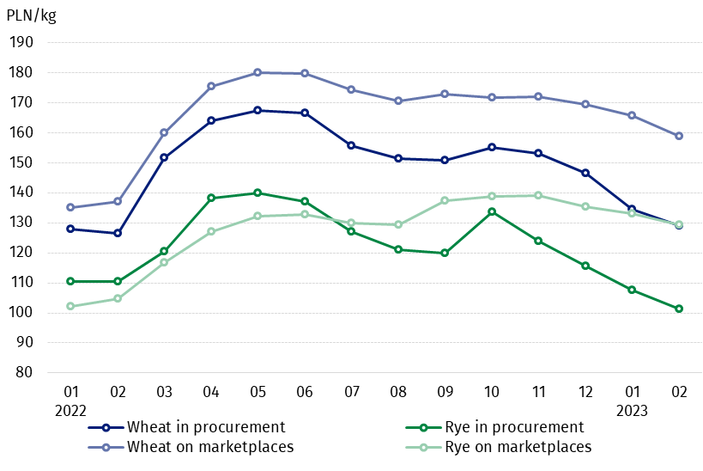
Chart 3. Procurement and marketplaces prices of wheat and rye

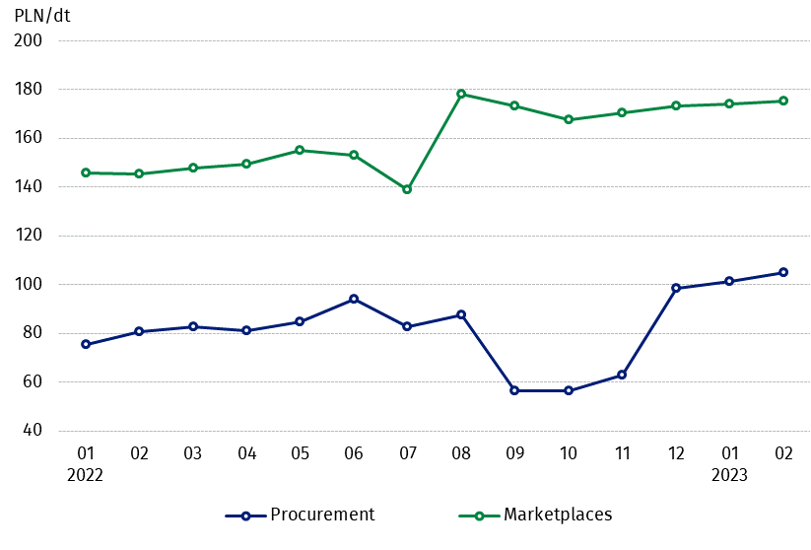
Chart 4. Procurement and marketplaces prices of potatoes

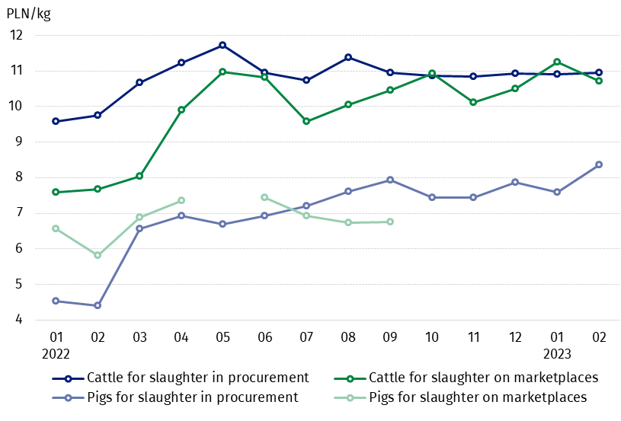
Chart 5. Procurement and marketplaces prices of cattle for slaughter and pigs for slaughter

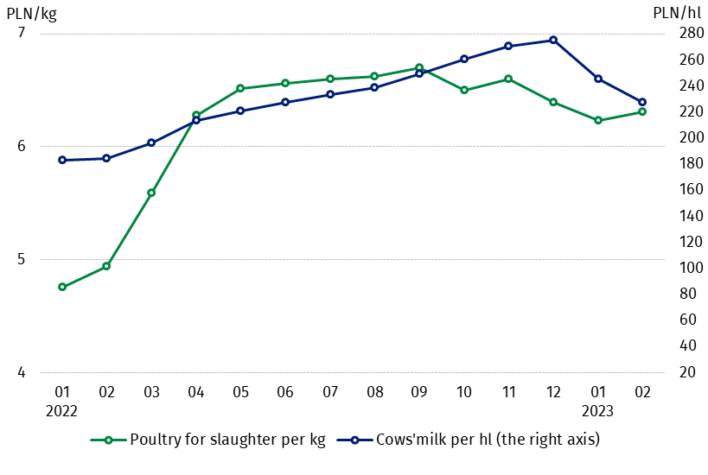
Chart 6. Procurement prices of poultry for slaughter and cows’ milk

The differentiation of the level of prices of basic agricultural products in particular voivodships is presented in Table 2 for procurement prices and in Table 3 for prices obtained by farmers on marketplaces (Excel sheet).
In case of quoting Statistics Poland data, please provide information: “Source of data: Statistics Poland”, and in case of publishing calculations made on data published by Statistics Poland, please include the following disclaimer: “Own study based on figures from Statistics Poland”.

Prepared by:  Trade and Services Department  Director Ewa Adach-Stankiewicz  Phone: (+48 22) 608 31 24 | Issued by:  The Spokesperson for the President  of Statistics Poland  Karolina Banaszek  Phone: (+48) 695 255 011
Press Office  Phone: (+48 22) 608 38 04  e-mail: obslugaprasowa@stat.gov.pl |   www.stat.gov.pl/en/

@StatPoland

@GlownyUrzadStatystyczny

gus_stat

glownyurzadstatystycznygus

glownyurzadstatystyczny
Related information
Socio-economic situation of the country in 2023
Procurement and prices of agricultural products in 2021
Prices in the national economy in 2021

Data available in databases
BDL - Prices in agriculture (monthly and annual data)
DBW - Prices in agriculture (monthly and annual data)

Terms used in official statistics
Procurement of agricultural products
Procurement prices
Marketplace
Marketplace prices

Wheat, rye, cattle for slaughter, pigs for slaughter, poultry, cows’ milk
Procurement prices – excluding sowing seed.
Procurement prices – total (of which: edible early kinds, seeds, edible late, industrial, of which starch). Marketplaces prices – edible excluding early kinds.
Marketplaces prices – average weighted price of cattle for slaughter calculated with the adoption of the structure of procurement quantity of young cattle and cows for slaughter.

