Prices of agricultural products in December 2022
Procurement prices of basic agricultural products increased in December 2022 in comparison with the previous month (by 0.5%) as well as while compared to the corresponding month of the previous year (by 43.9%).
43.9%
an increase in procurement prices of basic agricultural products in comparison with December 2021

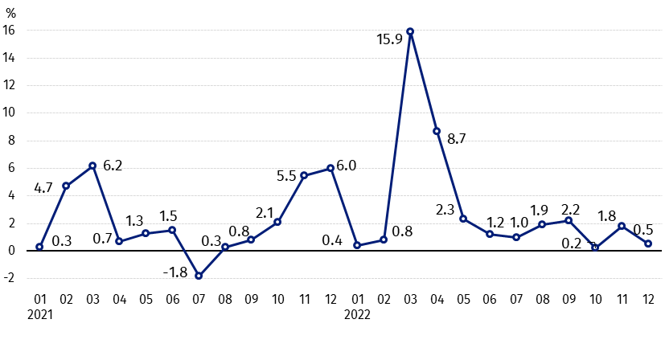
Chart 1. Changes in procurement prices of basic agricultural products in relation to the previous month
In December 2022 in comparison with November 2022 the procurement prices of cattle for slaughter, pigs for slaughter and cows’ milk increased

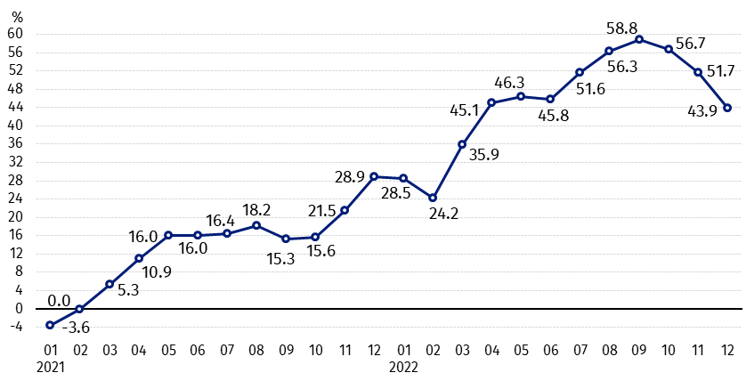
Chart 2. Changes in procurement prices of basic agricultural products in relation to the corresponding month of the previous year
Procurement prices of all basic agricultural products in December 2022 were much higher than a year ago

Procurement prices and marketplace prices received by farmers
In December 2022 compared to the previous month, both in procurement and on marketplaces, prices of most agricultural products decreased. The prices of maize, pigs for slaughter and cows’ milk were higher in procurement and the prices of potatoes and cattle for slaughter on both markets.
In comparison with the corresponding month of the previous year, in December 2022, much higher growth in procurement and marketplaces prices of all agricultural products was recorded. The prices of potatoes and pigs for slaughter in procurement and oats on marketplaces increased the most.

Table 1. Prices of agricultural products (excluding VAT) in December 2022
Specification | Procurement prices |  |  | Marketplaces prices
Specification | 12 2022
Specification | in zloty | 11 2022=100 | 12 2021=100 | in zloty | 11 2022=100 | 12 2021=100
Cereal grain – per 1 dt
Wheat | 146.55 | 95.7 | 111.6 | 169.56 | 98.5 | 133.6
Rye | 115.48 | 93.2 | 104.6 | 135.49 | 97.4 | 140.1
Barley | 135.77 | 98.7 | 131.4 | 156.80 | 98.9 | 140.4
Triticale | 132.68 | 94.1 | 115.8 | 150.48 | 98.5 | 138.6
Oat | 133.08 | 96.6 | 145.4 | 138.84 | 99.5 | 152.0
Maize | 128.30 | 118.8 | 124.5 | 171.74 | 97.7 | 131.5
Potatoes– per 1 dt | 98.40 | 156.3 | 279.8 | 173.29 | 101.7 | 122.2
Animals for slaughter – per kg
Cattle (excl. calves) | 10.92 | 100.6 | 116.4 | 10.50 | 103.8 | 136.2
of which young cattle | 11.12 | 101.6 | 116.3 | 11.11 | 103.7 | 139.7
Pigs ª | 7.87 | 106.0 | 170.8 | . | . | .
Poultry | 6.39 | 96.7 | 139.7 | . | . | .
Cows’ milk – per 1 hl | 275.47 | 101.9 | 149.6 | . | . | .
a – No data.
Data on procurement prices were calculated on the basis of information on value and quantity of procurement by legal persons and independent organizational entities without legal personality (without natural persons).
Indices of procurement prices and prices received by farmers on marketplaces were calculated on the basis of absolute data expressed with more precision than In the tables.

Prices of major agricultural products in December 2022
In December 2022 procurement price of wheat (146.55 PLN per dt) decreased as related to the previous month (by 4.3%), but it was higher on an annual basis (by 11.6%). On marketplaces, wheat was sold for 169.56 PLN per dt, i.e. by 1.5% cheaper than in November 2022, while by 33.6% more expensive then in the corresponding period 2021.
The price of rye in procurement amounted to 115.48 PLN per dt and was lower compared to November 2022 (by 6.8%), but it was higher in comparison with December 2021 (by 4.6%). In marketplace transaction the price of rye (135.49 PLN per dt) decreased on a monthly basis (by 2.6%), while increased on an annual basis (by 40.1%).
In December 2022 98.40 PLN was paid per dt of potatoes in procurement, i.e. by 56.3% more than in the previous month and by 179.8% more than in the corresponding period 2021. Such a large increase in prices was caused by purchase of more expensive late potatoes, whose share in purchase amounted to 65%. On marketplaces price of potatoes (173.29 PLN per dt) was higher as related to November 2022 (by 1.7%) as well as compared to December 2021 (by 22.2%).
The procurement price of cattle for slaughter (10.92 PLN per kg) increased on a monthly basis (by 0.6%) and on an annual basis (by 16.4%) and also on marketplaces (10.50 PLN per dt) – in comparison with November 2022 (by 3.8%) as well as with corresponding period 2021 (by 36.2%).
In December 2022 the procurement price of pigs for slaughter amounted 7.87 PLN per kg and it was by 6.0% higher than in November 2022 and by 70.8% – than in December 2021.
The procurement price of poultry for slaughter (6.39 PLN per kg) decreased in comparison with the previous year (by 3.3%), but increased by corresponding period 2021 (by 39.7%).
275.47 PLN was paid in procurement per hl of cows’ milk, i.e. by 1.9% more than in November 2022 and by 49.6% - than in December 2021.

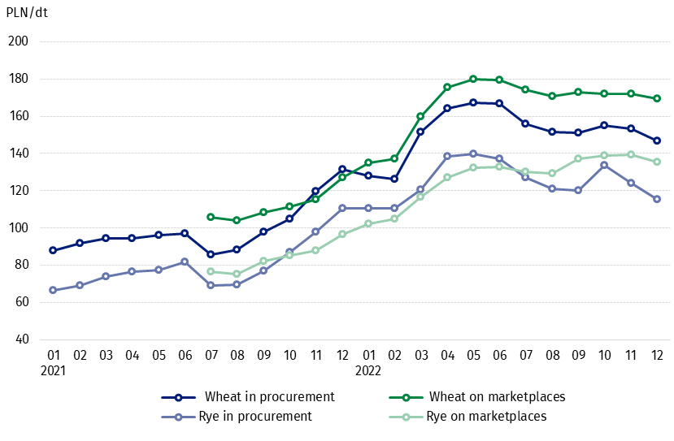
Chart 3. Procurement and marketplaces prices of wheat and rye

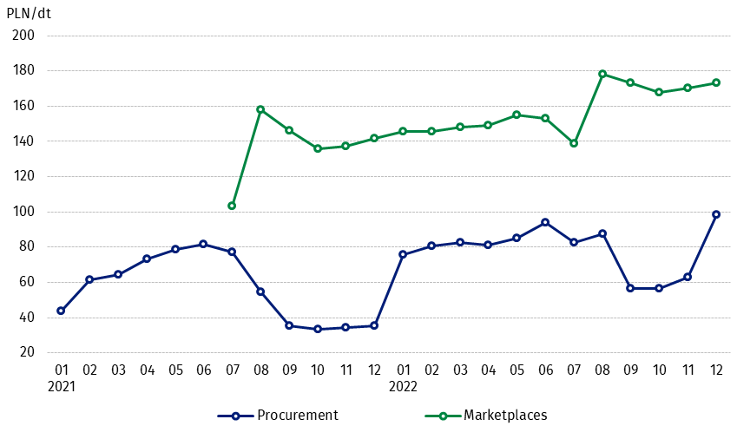
Chart 4. Procurement and marketplaces prices of potatoes

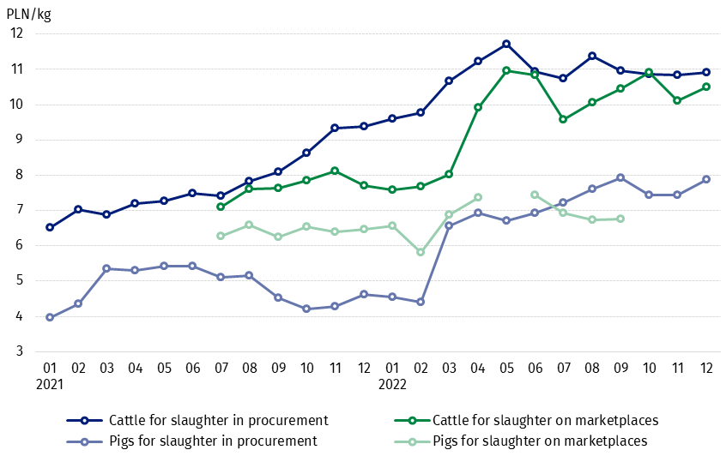
Chart 5. Procurement and marketplaces prices of cattle for slaughter and pigs for slaughter

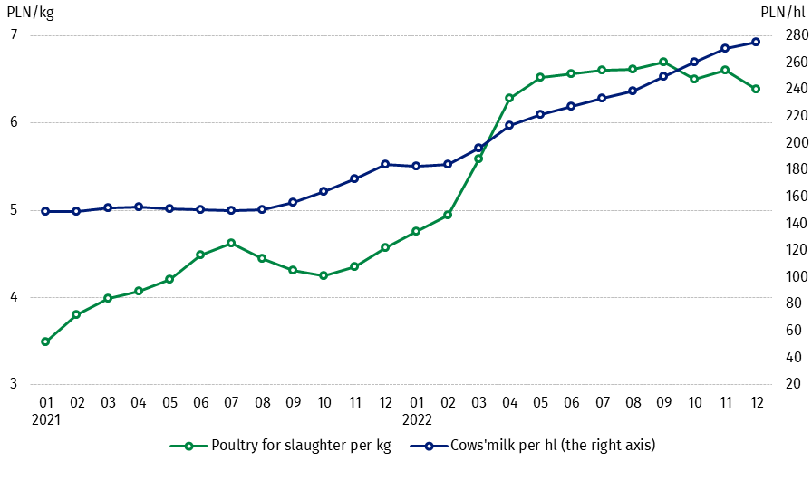
Chart 6. Procurement prices of poultry for slaughter and cows’ milk

The differentiation of the level of prices of basic agricultural products in particular voivodships is presented in Table 2 for procurement prices and in Table 3 for prices obtained by farmers on marketplaces (Excel sheet).
In case of quoting Statistics Poland data, please provide information: “Source of data: Statistics Poland”, and in case of publishing calculations made on data published by Statistics Poland, please include the following disclaimer: “Own study based on figures from Statistics Poland”.

Prepared by:  Trade and Services Department  Director Ewa Adach-Stankiewicz  Phone: (+48 22) 608 31 24 | Issued by:  The Spokesperson for the President  of Statistics Poland  Karolina Banaszek  Phone: (+48) 695 255 011
Press Office  Phone: (+48 22) 608 38 04  e-mail: obslugaprasowa@stat.gov.pl |   www.stat.gov.pl/en/

@StatPoland

@GlownyUrzadStatystyczny

gus_stat

glownyurzadstatystycznygus

glownyurzadstatystyczny
Related information
Socio-economic situation of the country in 2022
Procurement and prices of agricultural products in 2021
Prices in the national economy in 2021

Data available in databases
BDL - Prices in agriculture (monthly and annual data)
DBW - Prices in agriculture (monthly and annual data)

Terms used in official statistics
Procurement of agricultural products
Procurement prices
Marketplace
Marketplace prices

Wheat, rye, cattle for slaughter, pigs for slaughter, poultry, cows’ milk
Procurement prices – excluding sowing seed.
Procurement prices – total (of which: edible early kinds, seeds, edible late, industrial, of which starch). Marketplaces prices – edible excluding early kinds.
Marketplaces prices – average weighted price of cattle for slaughter calculated with the adoption of the structure of procurement quantity of young cattle and cows for slaughter.

