Residential construction in the period of January-December 2022

In 2022, there were more dwellings completed than the year before. Whereas the number of dwellings for which permits have been granted or which have been registered with a construction project as well as dwellings in which construction has begun decreased.
101.7
Index number of dwellings
completed y/y

Dwellings completed
Developers and private investors completed respectively: 60.3% and 38.1% of the total number of dwellings
According to the preliminary data, 238.6 thousand dwellings were completed in the period of January-December 2022, i.e. 1.7% more than in the corresponding period of 2021. Developers completed 143.8 thousand dwellings – by 1.3% more than a year ago, whereas private investors completed 91.0 thousand dwellings, i.e. by 3.2% more. Within these forms of construction, 98.4% of the total number of newly completed dwellings was built. Within other forms of construction, i.e. cooperative, municipal, public building society and company construction 3.8 thousand dwellings were completed (4.6 thousand in the previous year).
The total useful floor area of dwellings completed amounted to 22.1 million m², i.e. by 1.2% more than a year ago and the average useful floor area of 1 dwelling was 92.5 m².

Table 1. Dwellings completed
SPECIFICATION | 12 2022 |  |  | 01-12 2022
SPECIFICATION | Number  of dwellings | 12 2021=100 | 11 2022=100 | Number  of dwellings | 01-12  2021=100
TOTAL | 24 350 | 101.4 | 96.9 | 238 584 | 101.7
Private | 9 558 | 102.0 | 112.8 | 90 988 | 103.2
For sale or rent | 14 251 | 99.7 | 88.7 | 143 809 | 101.3
of which for rent | 103 | 66.0 | 39.9 | 2 028 | 101.8
Cooperative | 64 | 75.3 | 15.5 | 1 514 | 75.0
Municipal | 152 | 434.3 | 760.0 | 629 | 49.9
Public building society | 324 | 171.4 | 203.8 | 1 607 | 132.3
Company | 1 | 40-fold less | . | 37 | 32.2

Dwellings for which permits have been granted or which have been registered with
a construction project
The number of dwellings for which permits have been granted or which have been registered with a construction project decreased in 2022 by 12.8% y/y
In 2022, permits and registrations have been granted for construction of 297.4 thousand dwellings, i.e. by 12.8% less than in 2021. Permits for construction of the biggest number of dwellings were given to developers (203.0 thousand, a decrease of 4.9% y/y) and to private investors (89.5 thousand, a decrease of 27.2%). Within these forms of construction, permits have been granted and registrations with a construction project were made for 98.4% of dwellings in total. In other forms of construction 4.9 thousand dwellings for which permits have been granted or which have been registered with a construction project were noted (4.5 thousand dwellings in the previous year).

Table 2. Dwellings for which permits have been granted or which have been registered with a construction project
SPECIFICATION | 12 2022 |  |  | 01-12 2022
SPECIFICATION | Number  of dwellings | 12 2021=100 | 11 2022=100 | Number  of dwellings | 01-12  2021=100
TOTAL | 19 982 | 60.5 | 103.2 | 297 416 | 87.2
Private | 5 215 | 63.1 | 92.3 | 89 530 | 72.8
For sale or rent | 14 176 | 59.6 | 107.8 | 203 025 | 95.1
Cooperative | 4 | 27-fold less | 15.4 | 643 | 76.0
Municipal | 312 | 35.9 | 124.3 | 2 251 | 127.2
Public building society | 269 | . | 96.1 | 1 912 | 114.5
Company | 6 | 150.0 | 100.0 | 55 | 29.1

Dwellings in which construction has begun
In 2022, the number of dwellings in which construction has begun was 200.3 thousand, i.e. by 27.8% less than a year ago. Developers have started construction of 115.3 thousand dwellings (by 30.7% less), and private investors of 82.2 thousand (by 22.5% less). Altogether the share of these forms of construction was 98.6% of the total number of dwellings. In other forms of construction the number of dwellings in which construction has begun was 2.9 thousand (5.1 thousand in the previous year).

Table 3. Dwellings in which construction has begun
SPECIFICATION | 12 2022 |  |  | 01-12 2022
SPECIFICATION | Number  of dwellings | 12 2021=100 | 11 2022=100 | Number  of dwellings | 01-12  2021=100
TOTAL | 9 844 | 56.7 | 81.2 | 200 288 | 72.2
Private | 2 827 | 60.3 | 62.4 | 82 150 | 77.5
For sale or rent | 6 949 | 55.2 | 94.3 | 115 285 | 69.3
of which for rent | 151 | over 15-  fold more | 539.3 | 563 | 38.2
Cooperative | - | . | . | 687 | 35.9
Municipal | 22 | 36.7 | 366.7 | 839 | 79.5
Public building society | 46 | 255.6 | 35.4 | 1 243 | 64.9
Company | - | . | . | 84 | 44.4
It is estimated that at the end of December 2022, there were 833.0 thousand dwellings under construction, i.e. by 4.4% less than in the corresponding period of 2021.

Chart 1. Construction activity in the scope of residential construction in Poland
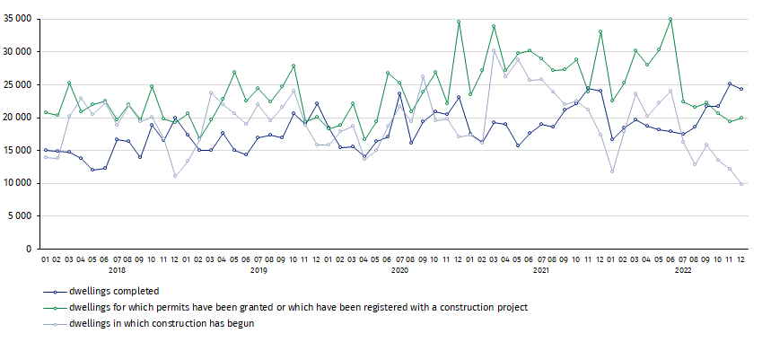
In December, compared to November 2022, the number of dwellings for which permits have been granted or which have been registered with a construction project increased (by 3.2%), whereas the number of dwellings completed and the number of dwellings in which construction has begun decreased (respectively by 3.1% and 18.8%)

In 2022, the highest values of dwellings completed, as well as dwellings in which construction has begun and dwellings for which permits have been granted or which have been registered with a construction project, were recorded in Mazowieckie voivodship (respectively: 43.1 thou-sand, 36.6 thousand and 53.8 thousand dwellings). High values were also noted in Wielkopol-skie (25.8 thousand, 19.7 thousand and 27.8 thousand) and Małopolskie (23.8 thousand, 18.2 thousand and 27.0 thousand).

Chart 2. Construction activity in the scope of residential construction by voivodships
(January- December 2022)
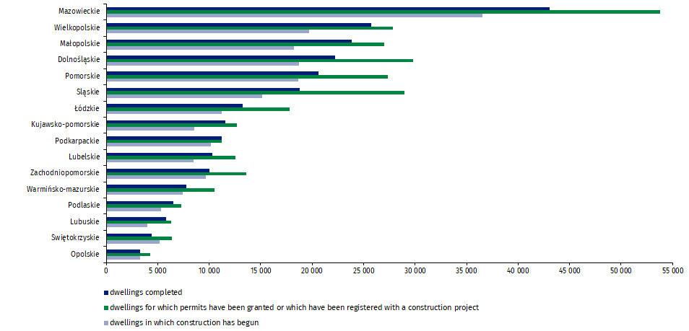

In case of quoting Statistics Poland data, please provide information: “Source of data: Statistics Poland” and in case of publishing calculations made on data published by Statistics Poland, please include the following disclaimer: “Own study based on figures from Statistics Poland”.
Prepared by:  Statistical Office in Lublin  Director Krzysztof Markowski  Phone: (+48) 695 255 301 | Issued by:  The Spokesperson for the President  of Statistics Poland  Karolina Banaszek  Phone: (+48) 695 255 011
Press Office  Phone: (+48 22) 608 38 04  e-mail: obslugaprasowa@stat.gov.pl |   www.stat.gov.pl/en/

@StatPoland

@GlownyUrzadStatystyczny

gus_stat

glownyurzadstatystycznygus

glownyurzadstatystyczny
Related information
Statistical Bulletin
Socio-economic situation of the country
Construction results
Data available in databases
Knowledge Databases Construction
Local Data Bank
Terms used in official statistics
Dwellings for which permits have been granted or which have been registered with a construction project
Dwellings in which construction has begun
Dwellings completed

Reported data – subject to change upon developing quarterly reports.

