Employed, unemployed and economically inactive persons (preliminary results of the Polish Labour Force Survey)
In the third quarter of 2022, economically active persons accounted for 57.8% of the population aged 15–89 years. The rate decreased as compared with both: the second quarter of 2022 – by 0.1 pp., and the same period of the last year – by 0.4 pp.
57.8%
Activity rate of persons aged 15-89 years

Economic activity of the population aged 15-89 years by the LFS
Compared with the previous quarter, economic activity rate for persons aged
15–89 years decreased among women, while among men it stayed at the same level. Compared with the same period of the last year, the indicator decreased among both men and women
In the third quarter of 2022, the number of economically active persons aged 15–89 years comprised 17192 thousand, of which: 16690 thousand constituted employed persons, while 502 thousand – the unemployed. The population of economically inactive persons in this age group comprised 12532 thousand.
Compared with the second quarter of 2022, the number of economically active persons slightly decreased - by 32 thousand, i.e. by 0.2%, while compared with the same period of the last year, a significant drop in the number of this group was observed - by 150 thousand, i.e. by 0.9%.
In the third quarter of 2022, the share of economically active persons in the total number of persons aged 15 - 89 years was higher among men and accounted for 65.7%, while in the population of women this percentage was at the level of 50.6% (the respective figures for persons at the working age comprised 83.3% and 76.4%). The corresponding indicators for urban and rural areas respectively accounted for 57.6% and 58.2% (at the working age: 81.8% and 77.7%).
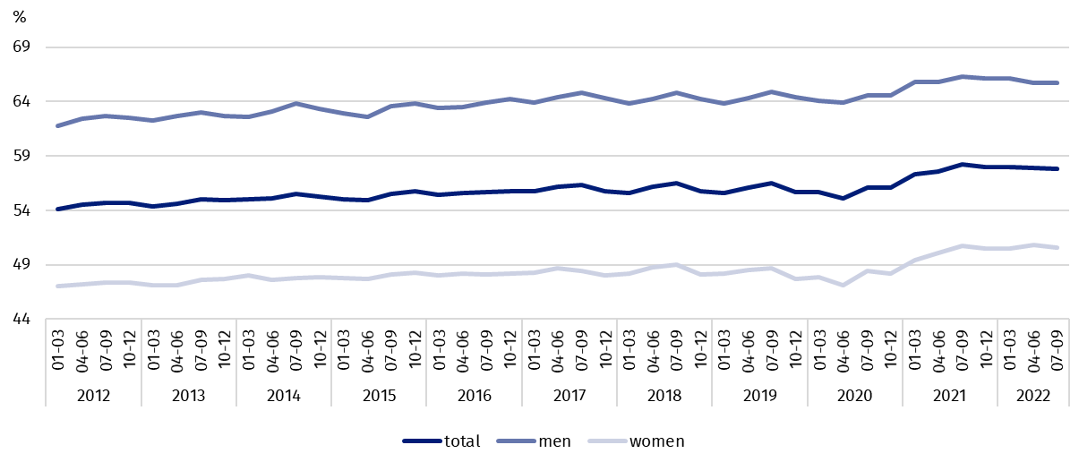
Chart 1. Activity rate of persons aged 15-89 years
Among persons aged 15-89 years, the ratio of the number of not working persons (the unemployed and the economically inactive) to the number of employed persons increased compared with both: the previous quarter and the same period of 2021. In the third quarter of 2022, there were 781 jobless persons aged 15-89 years per 1000 employed persons (in the second quarter of 2022 and in the third quarter of 2021 there were 773 persons).
The index describing the relations of jobless persons to the number of employed persons increased compared with both: the previous quarter, as well as over the year
In the third quarter of 2022, employed persons accounted for 56.1% of the population aged
15–89 years. Compared with both: the previous quarter of 2022 and the same period of 2021, the employment rate decreased by respectively 0.3 pp. in each. It was higher in the male population (63.7%) than among women (49.2%).
56.1%
Employment rate
of persons aged 15-89 years

Employed persons aged 15-89 years by the LFS
The number of employed persons decreased compared with both: the previous quarter, as well as compared with the same period of 2021
In the third quarter of 2022, population of employed persons aged 15–89 years comprised 16690 thousand persons and its number decreased compared with both: the previous quarter (by 80 thousand, i.e. by 0.5%), as well as the third quarter of 2021 (by 124 thousand, i.e. 0.7%).
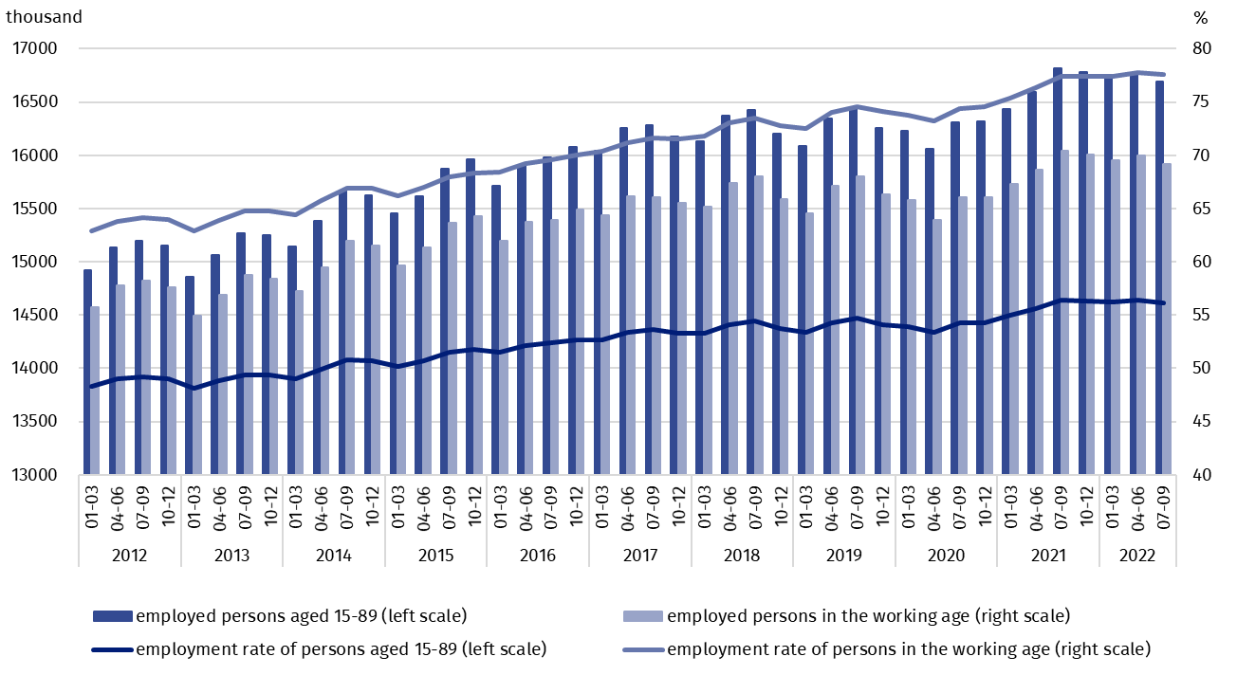
Chart 2. Employed persons and employment rate of persons aged 15-89 years and in the working age
As regards the division by sex, the number of employed persons decreased over the quarter among both: men (a drop by 59 thousand, i.e. by 0.6%) and women (by 21 thousand, i.e. by 0.3%). Taking into account the place of residence, a drop in the number of employed persons was observed mainly among urban residents (by 67 thousand persons, i.e. by 0.7%).
Over the year, a drop in the number of employed persons was observed in almost all analysed groups with exception of rural residents, where a slight growth in this population was observed (by 19 thousand, i.e. by 0.3%). As regards sex, the number of the employed decreased mainly among men (by 110 thousand, i.e. by 1.2%), while regarding the place of residence, among urban residents (by 143 thousand, i.e. by 1.4%).
The dominant among the employed were still men, who constituted 54.4% (i.e. 9074 thousand) of this population, while regarding the place of residence, the share of urban residents accounted for 59.4% (i.e. 9915 thousand persons).
In the third quarter of 2022, the employment rate total accounted for 56.1% and was higher among men (63.7%) than among women (49.2%). A similar level of the indicator was recorded in urban areas (56.0%) and in rural areas (56.3%).
Over the quarter, a drop in the employment rate was observed in all analysed groups: among men by 0.4 pp., in female population by 0.1 pp., in urban areas by 0.4 pp., in rural a-reas by 0.2 pp.
As regards sex and place of residence, employment rate decreased over the year in male population (by 0.6 pp.) and among urban residents (by 0.5 pp.). Among women and rural re-sidents a slight growth in the indicator was recorded (respectively by 0.1 pp. in each group).
The LFS results indicate that in the third quarter of 2022:
The number of persons employed full-time slightly increased compared with the previous quarter, while it decreased compared with the same period of the last year
- 15648 thousand persons performed full-time work, while 1042 thousand were employed part-time,
- the average number of hours worked in the reference week in the main job comprised 40.1 hours,
- the share of employees employed in public companies/institutions or by a private employer in the total number of employed persons accounted for 80.1% (13372 thousand persons), self-employed persons constituted 18.7%, while the share of contributing family workers accounted for 1.2%,
- a decided majority of employees employed in public companies/institutions or by a private employer performed their work on the basis on the contract for unlimited duration (84.2%, i.e. 11265 thousand),
- the largest number of persons were employed in manufacturing – 19.0% of all employed persons (3173 thousand), 14.0% (2331 thousand) were employed in wholesale and retail trade; repair of motor vehicles and motorcycles. The next place belonged to persons employed in section agriculture, forestry and fishing – 8.3% of the employed (1385 thousand persons), while 7.9% (1324 thousand persons) were employed in construction.
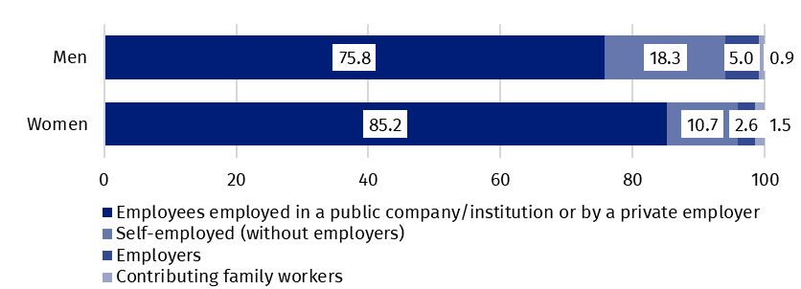
Chart 3. Structure of employed men and women aged 15–89 years by employment status in the main job in the third quarter of 2022 (in %)
In the third quarter of 2022, the highest drop in the number of employed persons compared with the previous quarter was recorded in manufacturing (by 78 thousand), agriculture, fo-restry and fishing (by 45 thousand), transportation and storage (by 31 thousand) and construction (by 30 thousand). The highest growth concerned wholesale and retail trade; repair of motor vehicles and motorcycles (by 78 thousand).
Compared with the third quarter of 2021, the highest drop in the number of the employed was observed in transportation and storage (by 74 thousand) and manufacturing (by 61 thousand), while the highest increase was observed in administrative and support service activities (by 50 thousand) and activities related to accommodation and food service activities (by 31 thousand).
In the third quarter of 2022, 1430 thousand persons had a job, but were not performing work in the reference week, which accounted for 8.6% of the total number of the employed (the corresponding population in the previous quarter comprised 713 thousand, i.e. 4.3%, while a year ago it was 1429 thousand, i.e. 8.5%). Among these persons, 1418 thousand (i.e. 99.2%) indicated that it was not directly related to the COVID-19 pandemic.
The impact of the COVID-19 pandemic was observed in the data regarding the place of performing work to a similar extent as in the previous quarter. In the third quarter of 2022, the number of persons performing their work usually or sometimes at home comprised 1887 thousand, which accounted for 11.3% of the total number of the employed. Among this population, 203 thousand persons (i.e. 10.8%) worked at home because of the situation connected to the COVID-19 pandemic. In the third quarter of 2022, there were 943 thousand persons (which accounted for 5.7% of the total number of the employed) who performed their work-related responsibilities usually or sometimes in a form of remote work (the place of performing work is not considered here), among them 20.8% performed work in this form due to the COVID-19 pandemic.
5.7% of the employed worked in a form of remote work – for 1/5 of them it was directly connected with the pandemic

2.9%
Unemployment rate of persons aged 15-89 years
In the third quarter of 2022, unemployed persons accounted for 2.9% of economically active population aged 15–89 years. Compared with the previous quarter, unemployment rate increased by 0.3 pp. Over the year, a drop was observed – by 0.1 pp. Unemployment intensity was lower in po-pulation of women than among men (respectively 2.9% vs. 3.0%).

Unemployed persons by the LFS
In the third quarter of 2022, population of unemployed persons aged 15–74 years comprised 502 thousand and it increased compared with the second quarter of 2022 (by 48 thousand, i.e. by 10.6%), while regarding the same period of the last year it decreased (by 26 thousand, i.e. by 4.9%).
A majority of unemployed population in the third quarter of 2022 constituted men – 55.0%, i.e. 276 thousand, while regarding the place of residence, urban residents (55.0% of this group, i.e. 276 thousand).
A growth in the number of unemployed persons compared with the previous quarter was caused by an increase in the number of the unemployed among men (by 61 thousand, i.e. by 28.4%), while the number of unemployed women decreased only slightly (by 13 thousand, i.e. by 5.4%). Taking into account the place of residence, a slightly higher growth in the number of this group was observed among rural residents (by 30 thousand, i.e. o 15.3%) than among urban residents (by 18 thousand, i.e. by 7.0%).
Compared with the third quarter of the last year, the number of unemployed persons declined among women (by 23 thousand, i.e. 9.2%), while among men it stayed at a similar level. When analysing this group by the place of residence, a decline in the number of the unemployed concerned urban residents (a drop by 38 thousand, i.e. 12.1%), while among rural residents no significant change in the number of unemployed persons was recorded.
In the third quarter of 2022, unemployment rate accounted for 2.9% and it was slightly lower among women than men (respectively 2.9% and 3.0%).
Compared with the previous quarter, unemployment intensity increased by 0.3 pp., whereas as regards division by sex, a growth took place in population of men (by 0.7 pp.), while in population of women it decreased slightly (by 0.1 pp). As regards the place of residence, a slightly higher increase was observed among rural residents (by 0.4 pp.) than in urban areas (by 0.2 pp.).
Over the year, a slight drop in unemployment rate was observed (by 0.1 pp.), while regarding division by sex, changes with opposite directions took place, among women a drop by 0.3 pp. was observed, while among men a slight increase – by 0.1 pp. A similar situation was observed in respect to the place of residence, where among urban residents a decline in unemployment rate was observed (by 0.3 pp.), while among rural residents it increased slightly (by 0.1 pp.).
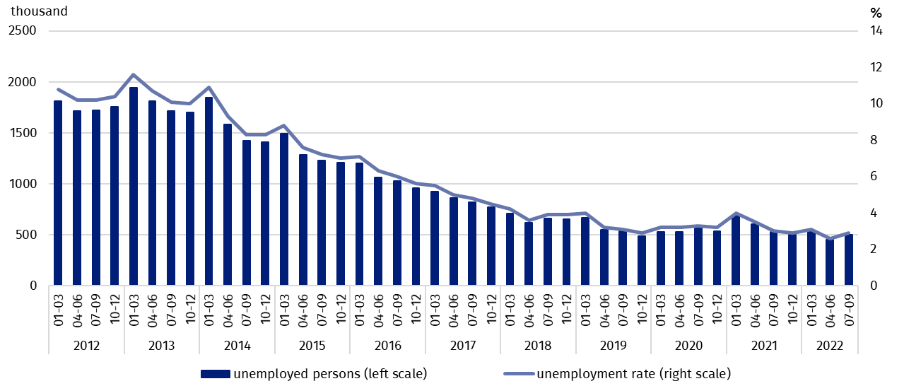
Chart 4. Unemployed persons aged 15-74 years and unemployment rate in population of persons aged 15-89 years
Unemployment rate increased over the quarter in most of the analysed age groups, with the exception of persons aged 35-44 years where a drop in unemployment was observed (by 0.2 pp.). The highest growth took place among persons aged 15-24 years (by 3.1 pp.), which is also related with inflow of school leavers to the group of unemployed persons. Over the year, unemployment decreased in the group of persons aged 35-44 years (a drop by 0.4 pp.) and among persons aged 25-34 years (by 0.2 pp.), while it increased among persons aged
15-24 years (by 0.6 pp.). The lowest changes in unemployment intensity were recorded in the oldest analysed age group, i.e. persons aged 45-89 years (when comparing a year to year, as well as a quarter to quarter, a slight growth was observed by 0.1 pp.). Still the highest unemployment was observed among the youngest persons (aged 15-24 years) for whom unemployment rate comprised 12.0%. Among persons aged 25–34 years, unemployment intensity was at the level of 3.5%, 35-44 years - 1.8%, 45-89 years – 2.1%. Among persons at the working age (18–59/64 years) unemployment rate comprised 3.0%.
Compared with the previous quarter, a growth in unemployment rate was observed in all groups determined by level of education, while the highest increase in this indicator concerned persons with lower secondary, primary, incomplete primary and without school education (a growth from 6.8% to 7.8%). Over the year, unemployment rate decreased among persons with general secondary education (from 5.3% to 4.7%) and with tertiary education (from 1.7% to 1.4%), in other groups determined by the level of education, unemployment intensity slightly increased (from 0.1 pp. to 0.3 pp.).
To the greatest extent, unemployment affected persons with the lowest level of education

The largest population of the unemployed constituted persons who lost a job (42.9%, i.e. 215 thousand). The share of persons re-entering work after a break accounted for 24.3% (122 thousand), the share of persons taking up their first job accounted for 22.2% (111 thousand), while the smallest group constituted persons who resigned from work – 10.6% (53 thousand).
Every fourteenth person previously employed indicated the loss or termination of work due to the pandemic

In the third quarter of 2022, among 350 thousand unemployed persons previously employed, 25 thousand persons (7.1%) declared the situation caused by the COVID-19 pandemic as the reason for termination of the last performed work (in the previous quarter it was 19 thousand persons, i.e. 5.5%, while a year ago – 62 thousand persons, i.e. 16.9%). Among this group, 18 thousand persons (i.e. 72.0%) indicated liquidation of an establishment or a work position as a direct reason for termination of work.
In the analysed period, the average duration of a job search comprised 8.7 months (the same duration as in the previous quarter, while a year ago it was 8.3 months). Persons who were seeking a job for the longest duration were the ones aged 30–34 years and 45–54 years (10.9 months in each group), and persons aged 25–29 years (9.8 months), while the shortest job search duration was observed for the youngest persons, in the age group 15–19 years (2.2 months).
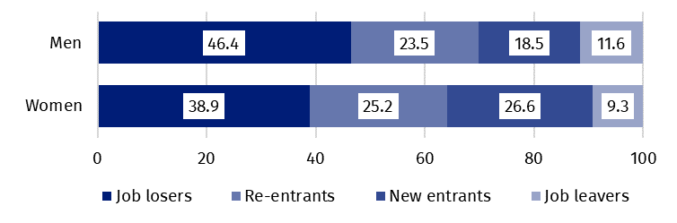
Chart 5. Structure of unemployed men and women by the source of unemployment in the third quarter of 2022 (in %)

In the third quarter of 2022, economically inactive persons accounted for 42.2% of the total number of population aged 15–89 lat. The percentage reached a higher level compared with the
previous quarter (a growth by 0.1 pp.), as well as compared with the same period of the last year (a growth by 0.4 pp.).
42.2%
The share of economically ina-ctive persons in the total number of the population aged 15–89 years

Economically inactive persons aged 15–89 by the LFS
In the third quarter of 2022, population of economically inactive persons aged 15-89 years comprised 12532 thousand and it reached a slightly higher level compared with both: the second quarter of 2022 (a growth by 24 thousand, i.e. by 0.2%) and the third quarter of 2021 (a growth by 57 thousand, i.e. by 0.5%).
Women still constitute a majority of economically inactive population
Over a half of economically inactive persons constituted women – 61.0%, i.e. 7648 thousand. Taking into account the place of residence, urban residents constituted 59.8% of this population (i.e. 7499 thousand).
As regards sex, the number of economically inactive women increased over the quarter (by 30 thousand, i.e. by 0.4%), while among men no significant change was recorded. In the case of the place of residence, a growth in the number of economically inactive persons was observed among urban residents (by 30 thousand, i.e. by 0.4%), while among rural residents there was no significant change in this population.
An increase in this group observed over the year was mainly caused by a growth in the number of economically inactive men (by 67 thousand, i.e. by 1.4%), while among women, the number of this group did not change significantly. Regarding the place of residence, an increase in the number of economically inactive persons was observed among urban residents (by 83 thousand, i.e. by 1.1%), while a decline was recorded among rural residents (by 26 thousand, i.e. by 0.5%).
The economically inactive population is a specific one in respect to the labour market resources, as its scope includes persons who have not entered the labour market yet (inclu-ding the majority of the youth still participating in education), persons who have definitely left the labour market or will never enter the labour market (some retirees, pensioners, persons maintaining themselves from other sources than work), but also persons who entered the labour market, then partially deactivated and who will want to re-enter the labour market after a break.
In the third quarter of 2022, over a half of the economically inactive persons aged
15-74 years comprising 10261 thousand (the reason for inactivity was determined for this age group) constituted retirees (51.0%), while the second largest group were students (20.8%).
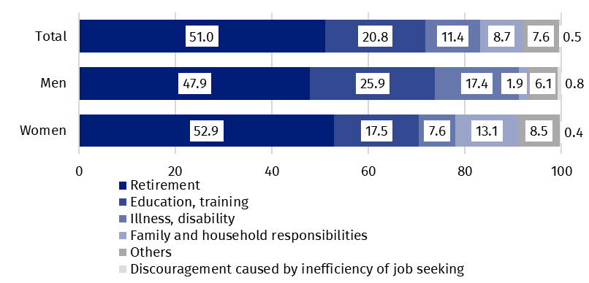
Chart 6. Structure of economically inactive persons aged 15-74 years by sex and reasons for inactivity in the third quarter of 2022 (in %)
In the case of economically inactive persons at the working age (4087 thousand), the most often reasons for inactivity were: education and training (27.3%), illness and disability (25.3%), family responsibilities (20.7%), retirement (8.9%), and discouragement with unsuccessful job search (1.2%).

Methodological notes

The presented news release was prepared on the basis of the generalised results of the sample survey Badanie Aktywności Ekonomicznej Ludności/BAEL (the Polish equivalent of the European survey on the labour force - Labour Force Survey/LFS) in the third quarter of 2022.
Badanie Aktywności Ekonomicznej Ludności has been carried out in Poland quarterly since May 1992 and it has been improved in accordance with the Eurostat recommendations.
From the first quarter of 2021 onwards, the base of the EU-LFS methodology are definitions of the employed, the unemployed and economically inactive persons in accordance with the Resolution concerning statistics of work, employment and labour underutilization adopted in 2013 on the 19th International Conference of Labour Statisticians in Geneva (ICLS) and re-commended by the International Labour Organization (ILO) for the use in all countries. The survey object is the situation within the scope of economic activity of the population, i.e. the fact of performing work, being unemployed or economically inactive persons in the refe-rence week. In the European Union, the implementation of the provisions of the above mentioned Resolution was carried out through introduction of new legal acts. From 2021 onwards, EU-LFS has been one of the key surveys embraced by the framework regulation for social statistics (the so-called IESS FR). Accompanying IESS FR implementing regulations in the domain of the labour force specify the range of the core survey and module surveys, determine survey organisation and define in detail particular populations specified according to the status of persons in the labour market.
Due to the implementation of the methodological changes, from the first quarter of 2021, the BAEL data cannot be compared with the previous periods (with the exception of the recalculated data). For the purposes of carrying out comparative analyses for longer time series, Statistics Poland prepared historical data from the BAEL for the years 2010–2020 compiled in accordance with definitions of the main population categories specified according to their labour market status, i.e. the employed, the unemployed and economically inactive persons, obligatory from 2021 onwards. The data are available on the Statistics Poland website: recalculated LFS data for the years 2010-2020
Detailed results of the survey as well as the up-dated methodology – obligatory from the first quarter of 2021, are included in the quarterly publication “Labour Force Survey in Poland” available on the Statistics Poland website:
https://stat.gov.pl/en/topics/labour-market/working-unemployed-economically-inactive-by-lfs/labour-force-survey-in-poland-quarter-22022.2.46.html

Prepared by:  Labour Market Department  Director Agnieszka Zgierska  Phone: (+48 22) 608 30 15 | Issued by:  The Spokesperson for the President  of Statistics Poland  Karolina Banaszek  Phone: (+48) 695 255 011
Press Office  Phone: (+48 22) 608 38 04  e-mail: obslugaprasowa@stat.gov.pl |   www.stat.gov.pl/en/

@StatPoland

@GlownyUrzadStatystyczny

gus_stat

glownyurzadstatystycznygus

glownyurzadstatystyczny
Related information
Methodological report. Labour Force Survey (the methodology valid until the end of 2020)
Labour Force Survey in Poland
Other publications containing the results of LFS and its module surveys
stat.gov.pl → Topics → Labour Market
Data available in databases
Strateg → Topics → Labour Market
Local Data Bank → labour Market
Terms used in official statistics
Economic activity by LFS
Economically active population by LFS
Employed persons by LFS
Unemployed persons by LFS
Economically inactive population according to the LFS

Activity rate by LFS
Employment rate by LFS
Unemployment rate by LFS

The LFS results refer to the population staying or intending to stay in the country’s territory for at least 12 months, living in private households.
Men aged 18-64 years and women aged 18-59 years.
The data from the first quarter of 2012 to the fourth quarter of 2020 were recalculated in accordance with the definitions obligatory in the LFS from 2021 onwards.
The data from the first quarter of 2012 to the fourth quarter of 2020 were recalculated in accordance with the definitions obligatory in the LFS from 2021 onwards.
The data from the first quarter of 2012 to the fourth quarter of 2020 were recalculated in accordance with the definitions obligatory in the LFS from 2021 onwards.

