Employed, unemployed and economically inactive persons (preliminary LFS results)
Since the first quarter of 2021, the base of the LFS methodology have been definitions re-garding employed, unemployed and economically inactive persons included in the Resolu-tion concerning statistics of work, employment and labour underutilization. The Resolution was worked out at the Nineteenth International Conference of Labour Statisticians in Geneva (ICLS) in 2013 and recommended by the International Labour Organization (ILO) for the use in all countries of the world (until 2020 inclusive, the LFS base had constituted provisions of the Thirteenth ICLS of 1982).
In the European Union, the implementation of the provisions of the above-mentioned Resolution was achieved through passing new legal acts. Since 2021 onwards, the EU-LFS has been one of the key surveys included in the framework regulation for social statistics (i.e. IESS FR). Accompanying the IESS FR implementing regulations regarding the domain of labour force specify the range of the core survey and module surveys, describe the survey organisation and define in a detailed way particular populations specified according to the status of persons on the labour market.
Following the implementation of the above-mentioned changes into the survey, the LFS data for the first, second, third and fourth quarters of 2021 cannot be currently compared with the previous periods, with the exception of the recalculated historical data for the years 2010-2020, compiled with the use of the revised from 2021 onwards definitions regarding specification of the main categories of persons on the labour market, i.e. the employed, the unemployed and economically inactive persons (the valid definitions are included in the publication Labour Force Survey in Poland). The information concerning recalculated LFS results with the data was published in January 2022 on the Statistics Poland website.
In the fourth quarter of 2021, economically active persons accounted for 58.0% of the population aged 15–89 years. The rate decreased compared with the third quarter of 2021 by 0.2 percentage point.
0.2 pp
Decrease Q/Q of employment rate of persons aged 15-89 years

Economic activity of the population aged 15-89 years by the LFS
Economic activity rate for persons aged 15-89 years decreased among both men and women compared to the previous quarter
In the fourth quarter of 2021, the number of the economically active persons aged 15–89 years comprised 17278 thousand, of which: 16780 thousand constituted employed persons, while 497 thousand – the unemployed. The population of economically inactive persons at the same age group amounted to 12529 thousand.
Compared to the third quarter of 2021, the number of economically active persons decreased by 64 thousand, i.e. by 0.4%, while the number of economically inactive persons increased by 54 thousand, i.e. by 0.4%.
The share of economically active persons in the total number of persons aged 15-89 years was higher among men and accounted for 66.1% in the fourth quarter of 2021, while in the population of women this percentage was at the level of 50.5% (the respective figures for persons at working age comprised 83.3% and 75.9%). The corresponding indicators for urban and rural areas respectively accounted for 58.2% and 57.7% (at working age: 82.2% and 76.6%).
The index describing the relations of the number of jobless persons to the number of employed persons increased compared to the previous quarter
The indicator defining the ratio of the number of not working persons (the unemployed aged 15-74 years and the economically inactive aged 15-89 years) to the number of employed persons (aged 15-89 years) increased compared with the previous period. In the fourth quarter of 2021, there were 776 jobless persons aged 15-89 years per 1000 employed persons (in the third quarter of 2021 there were 773 persons).
In the fourth quarter of 2021, employed persons accounted for 56.3% of the population aged
15–89 years. Compared with the third quarter of 2021, employment rate slightly decreased (by 0.1 percentage point). It was higher in the male population (64.2%,) than among women (49.0%) – for persons at working age it was respectively 80.9% and 73.5%.
0.1 pp
Decrease Q/Q of employment rate of persons aged 15-89

Employed persons aged 15-89 years by the LFS
The population of employed persons slightly decreased compared to the previous quarter
In the analysed period, the population of employed persons aged 15-89 years comprised 16780 thousand persons and it decreased compared to the previous period by 34 thousand, i.e. by 0.2%. As regards the division by sex, the number of employed persons decreased over the quarter among both: women (a drop by 22 thousand, i.e. by 0.3%) and men (a drop by 12 thousand, i.e. by 0.1%). As regards the place of residence, a drop in the number of the employed occurred mainly among rural residents – over a quarter it comprised 0.4% (by 30 thousand persons).
The dominant among the employed were men, who constituted 54.7% (i.e. 9172 thousand) of this population. While, as regards the place of residence, the share of urban residents accounted for 59.9% (i.e. 10055 thousand persons).
The number of persons employed full-time dropped compared to the previous quarter

In the fourth quarter of 2021, 15795 thousand persons performed full-time work, while 985 thousand worked part-time. Compared with the third quarter of 2021, the number of per-sons employed full-time decreased by 39 thousand, i.e. by 0.2%, while the number of per-sons employed part-time stayed at a similar level.
The average number of hours worked during the reference week in the main job comprised 38.9 hours and was lower than the one recorded in the third quarter of 2021 (by 1.7 hour).
Over the quarter, the share of employees employed in a public company/institution or by a private employer in the total number of the employed increased – by 0.2 percentage point to the level of 80.4% (13491 thousand). While the share of self-employed persons decreased– by 0.2 percentage point to 18.5% (3112 thousand). The share of contributing family workers stayed at the same level as in the previous quarter and accounted for 1.1% of the total number of the employed.
A decided majority of employees employed in a public company/institution or by a private employer performed their work on the basis of a contract for unlimited duration (85.4%, i.e. 11516 thousand). The share decreased over the quarter by 0.5 percentage point.
As regards the kind of activity of the main job, in the fourth quarter of 2021, the number of the employed increased compared to the previous quarter mainly in transportation and storage (by 42 thousand), education (by 33 thousand), construction (by 27 thousand) and professional, scientific and technical activities (by 26 thousand). Whereas the highest drop concerned the number of the employed in wholesale and retail trade; repair of motor vehicles including motorcycles (by 88 thousand), human health and social work activities (by 46 thousand) and agriculture, forestry and fishing (by 36 thousand).
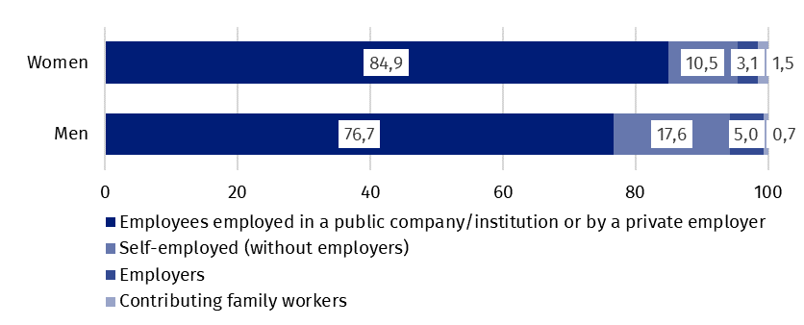
Chart 1. Structure of employed women and men aged 15-89 years by employment status in the main job in the fourth quarter of 2021 (in %)
In the fourth quarter of 2021, 872 thousand persons had a job, but were not performing work in the reference week, which accounted for 5.2% of the total number of the employed (the corresponding population in the previous quarter comprised 1429 thousand, i.e. 8.5%). Among these persons, 77 thousand (i.e. 8,8%) indicated that it was directly related to the COVID-19 pandemic (in the previous quarter it was 15 thousand persons, which accounted for 1.0%).
The impact of the COVID-19 pandemic was observed in the data regarding the place of per-forming work to a similar extent as in the previous quarter. In the fourth quarter of 2021, the number of persons performing their work usually or sometimes at home comprised 2206 thousand, which accounted for 13.1% of the total number of the employed (in the third quarter of 2021, the respective figure was 2111 thousand, i.e. 12.6%). Among this population, 755 thousand persons (i.e. 34.2%) worked at home because of the situation connected to the COVID-19 pandemic (in the third quarter of 2021, it was 631 thousand, i.e. 29.9%). In the fourth quarter of 2021, there were 1139 thousand persons (which accounted for 6.8% of the total number of the employed) who performed their work-related responsibilities in a form of remote work (the place of performing work is not considered here), among them 69.2% performed work in this form due to the COVID-19 pandemic (in the third quarter of 2021, it was 937 thousand, i.e. 5.6% of the total number of the employed, among whom 65.2% - due to the pandemic).
Around 7% of the employed worked in a form of remote work – for over 2/3 of them it was directly connected with the pandemic

In the fourth quarter of 2021, unemployed persons accounted for 2.9% of the economically active population aged 15–89 years (compared with the third quarter of 2021, a drop by 0.1 percentage point). Unemployment rate of men was at a lower level than unemployment rate of women (respe-ctively 2.8% vs. 3.0%). Its intensity was higher among rural residents (3.2%) than in urban areas (2.7%).
0.1 pp
Decrease Q/Q of unemployment rate
Unemployment rate by the LFS in the male population was lower than in the po-pulation of women

Unemployed persons by the LFS
In the fourth quarter of 2021, the population of unemployed persons aged 15-74 years comprised 497 thousand and it decreased compared with the third quarter of 2021 by 31 thousand, i.e. by 5.9%. Compared with the previous quarter, the number of unemployed persons decreased to a greater extent among women (by 17 thousand, i.e. 6.8%) than among men (a drop by 14 thousand, i.e. by 5.0%). When analysing this group in respect to the place of residence, a drop in the number of unemployed persons compared with the third quarter of 2021, concerned urban areas (a drop by 36 thousand, i.e. 11.5%), whereas among rural residents, a slight increase in the number of unemployed persons was recorded (by 6 thousand, i.e. 2.8%).
The majority of this population constituted men – 53.3%, i.e. 265 thousand. As regards the place of residence, urban residents constituted 55.9% of this group, i.e. 278 thousand.
Unemployment rate decreased over the quarter only among the youngest persons (aged 15-24 years), albeit still the highest figure was observed among this group, i.e. 9.1% versus 11.4% in the previous quarter. Among persons aged 25–34 years, 35-44 years and 45-89 years, unemployment intensity stayed at the level of the last quarter and respectively accounted for: 3.7%, 2.2% and 2.0%. Among persons at the working age (18–59/64 years), unemployment rate comprised 3.0%.
The highest intensity of unemployment is still observed among persons aged 15–24 years
Slight drops in unemployment rate were observed for most of groups specified according to the level of education: among persons with general secondary education (by 0.9 percentage point to 4.4%), lower secondary, primary, incomplete primary and without school education (by 0.6 percentage point to 6.9%), tertiary (by 0.2 percentage point to 1.4%), and postsecondary and vocational secondary (by 0.2 percentage point to 2.8%). Only among persons with basic vocational/sectoral education, unemployment rate increased (by 0.4 percentage point) and comprised 3.7%.
To the greatest extent, unemployment affected persons with the lowest level of education
The largest population of the unemployed constituted persons who lost a job (47.9%, i.e. 238 thousand). The share of persons re-entering work after a break accounted for 29.2% (145 thousand), the share of persons taking up their first job accounted for 13.7% (68 thousand), while the number of persons who resigned from work was the lowest – 9.5% (47 thousand).
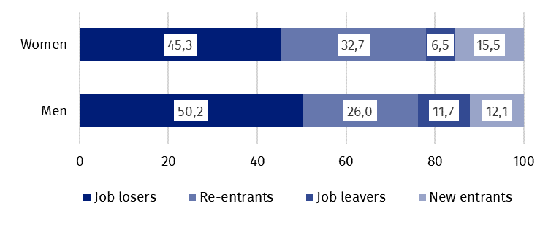
Chart 2. Structure of unemployed persons by the source of inflow to unemployment and sex in the fourth quarter of 2021 (in %)
Almost every sixth per-son previously employed indicated the loss or termination of work due to the pandemic
In the fourth quarter of 2021, among 376 thousand unemployed persons previously employ-ed, 68 thousand persons (18.1%) declared the situation caused by the COVID-19 pandemic as the reason for termination of the last performed work (in the previous quarter it was 62 thousand persons, i.e. 16.9%). Among this group, 37 thousand persons (i.e. 54.4%) indicated as a direct reason liquidation of an establishment or a work position, 17 thousand (i.e. 25.0%) termination of work for limited duration/casual/seasonal one, while 7 thousand (i.e. 10.3%) termination for other reasons.
In the analysed period, the average duration of a job search comprised 8.3 months (the same as in the previous quarter). Persons who were seeking a job for the longest period were the ones aged 35-44 years (10.0 months), aged 55-74 years (9.7 months), and aged 45-54 years (9.4 months); the shortest job search duration was observed for the youngest persons, in the age group 15-19 years (5.4 months) and 25-29 years (6.1 months).

In the fourth quarter of 2021, economically inactive persons accounted for 42.0% of the total number of the population aged 15-89 years (by 0.2 percentage point more than in the third quarter of 2021). The percentage was lower in the population of men (33.9%) than among women (49.5%). Whereas, it stayed at a similar level in both: urban areas (41.8%) and in rural areas (42.3%).
The share of economically inactive persons increased among both men and women by 0.2 percentage point compared to the previous quarter
0,2 pp
Increase Q/Q of the share of economically inactive persons in the total number of population aged 15–89 years

Economically inactive persons aged 15-89 years by the LFS
In the fourth quarter of 2021, the population of economically inactive persons aged 15-89 years comprised 12529 thousand and it reached a higher level compared with the third quarter of 2021 (a growth by 54 thousand, i.e. by 0.4%). Compared with the third quarter of 2021, a growth in the number was observed in the population of women (by 33 thousand, i.e. by 0.4%), as well as among men (by 22 thousand, i.e. by 0.5%). As regards the place of residence, an increase in the economically inactive population occurred among rural residents (by 36 thousand, i.e. by 0.7%), as well as among urban residents (by 18 thousand, i.e. by 0.2%).
Women still constitute the majority of the economi-cally inactive population
More than a half of the economically inactive were women – 61.4%, i.e. 7690 thousand). As regards the place of residence, urban residents constituted 59.3% of this population (i.e. 7434 thousand).
The economically inactive population is a specific one in respect to the labour market resources, as its scope includes persons who have not entered the labour market yet (including the majority of the youth still participating in education), persons who have definitely left the labour market or will never enter the labour market (some retirees, pensioners, persons maintaining themselves from other sources than work), but also persons who entered the labour market, then partially deactivated and who will want to re-enter the labour market after a break.
In the fourth quarter of 2021, more than a half of the economically inactive persons aged 15-74 years comprising 10326 thousand (the reason for inactivity was determined for this age group) constituted retirees (51.2%), while the second largest group were students (21.5%). Whereas, in the case of economically inactive persons at the working age (4173 thousand), the most often reasons for inactivity were: education and training (29.5%), illness and disability (25.1%), family responsibilities (19.7%) and retirement (9.3%).
Chart 3. Structure of economically inactive persons aged 15-74 years by sex and reasons for inactivity in the fourth quarter of 2021 (in %)
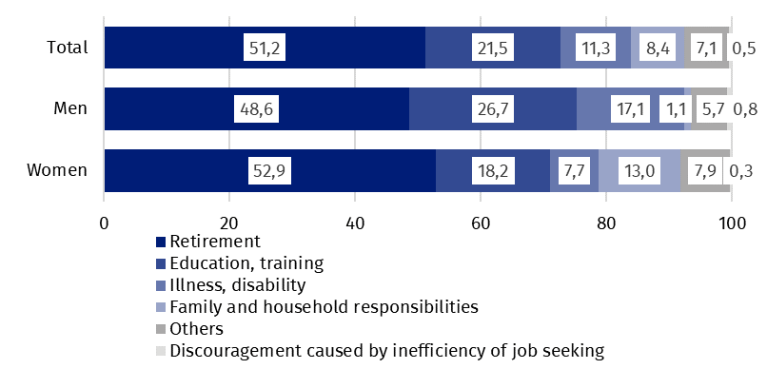

Prepared by:  Labour Market Department  Director Agnieszka Zgierska  Phone: (+48 22) 608 30 15 | Issued by:  The Spokesperson for the President  of Statistics Poland  Karolina Banaszek  Phone: (+48) 695 255 011
Press Office  Phone: (+48 22) 608 38 04  e-mail: obslugaprasowa@stat.gov.pl |   www.stat.gov.pl/en/

@StatPoland

@GlownyUrzadStatystyczny

gus_stat

glownyurzadstatystycznygus

glownyurzadstatystyczny
Related information
Methodological report. Labour Force Survey (the methodology valid until the end of 2020)
Labour Force Survey in Poland
Other publications containing the results of LFS and its module surveys
stat.gov.pl → Topics → Labour Market
Data available in databases
Strateg → Topics → Labour Market
Local Data Bank → labour Market
Terms used in official statistics
Economic activity by LFS
Economically active population by LFS
Employed persons by LFS
Unemployed persons by LFS
Economically inactive population according to the LFS

Activity rate by LFS
Employment rate by LFS
Unemployment rate by LFS

Information of Statistics Poland concerning the results of the Badanie Aktywności Ekonomicznej Ludności (Polish LFS) recalculated for the years 2010-2020
It regards the population living in private households. The main information concerning the population covered by the survey and applied definitions is available in the quarterly publication Labour Force Survey in Poland

