Culture satellite account for 2017
The share of culture in the national economy amounted to almost 3%, which was mainly due to the activity of entities in the domain of Advertising, followed by Audio-visual arts and multimedia, and Books and press. These areas dominated most of the transactions that made up the culture satellite account in 2017.
2.9%
Share of the area of culture in generation of gross added value and gross output in 2017

Share of the area of culture in the national economy
The culture satellite account makes it possible to estimate the contribution of the area of culture, understood as the activity of local government and state cultural institutions, non-governmental organisations operating in the field of culture, and entities belonging to the cultural and creative industries, to the national economy. The share of the area of culture in the national economy is best assessed by the gross added value of the area of culture in relation to the gross value added of the entire economy and the value of gross output of the area of culture to the gross output of the entire national economy – in 2017, both of these values amounted to 2.9%.

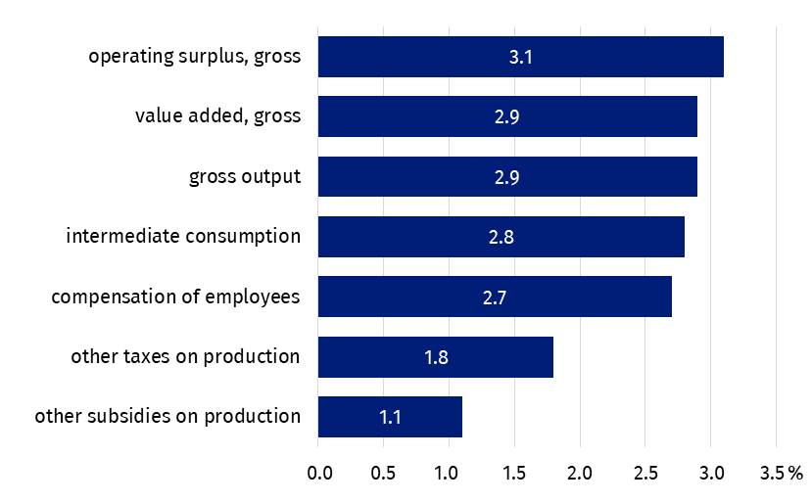
Chart 1. Share of the area of culture in selected transactions of the production account and the income generation account of the national economy in 2017
The entities belonging to the Advertising domain had the largest share (22.6% of the added value of the cultural area) in creating the added value of culture, whereas Culture management and administration (0.6%) had the least share.

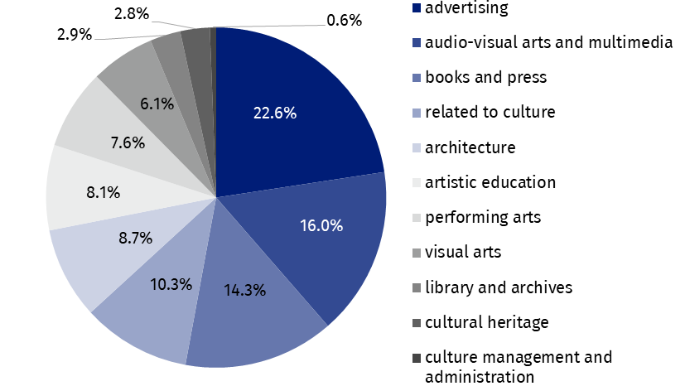
Chart 2. Structure of gross value added in the area of culture by cultural domains in 2017
The entities included in Advertising domain had the largest share in generating gross value added in the area of culture.
The comparison of the area of culture with other sectors of the national economy, taking into account the Polish Classification of Activities (PKD) classification, shows the real role of the area of culture in the national economy, and therefore the contribution of the area of culture to the creation of Poland's Gross Domestic Product (GDP). Gross value added generated by entities operating within the PKD classes included in the area of culture was in 2017 only slightly lower (by 0.2 percentage points) than the value added generated by entities included in section A grouping entities from sector agriculture, forestry, hunting and fishery, and was 1.0 pp higher than the gross value added generated by entities classified in section B - mining and quarrying.

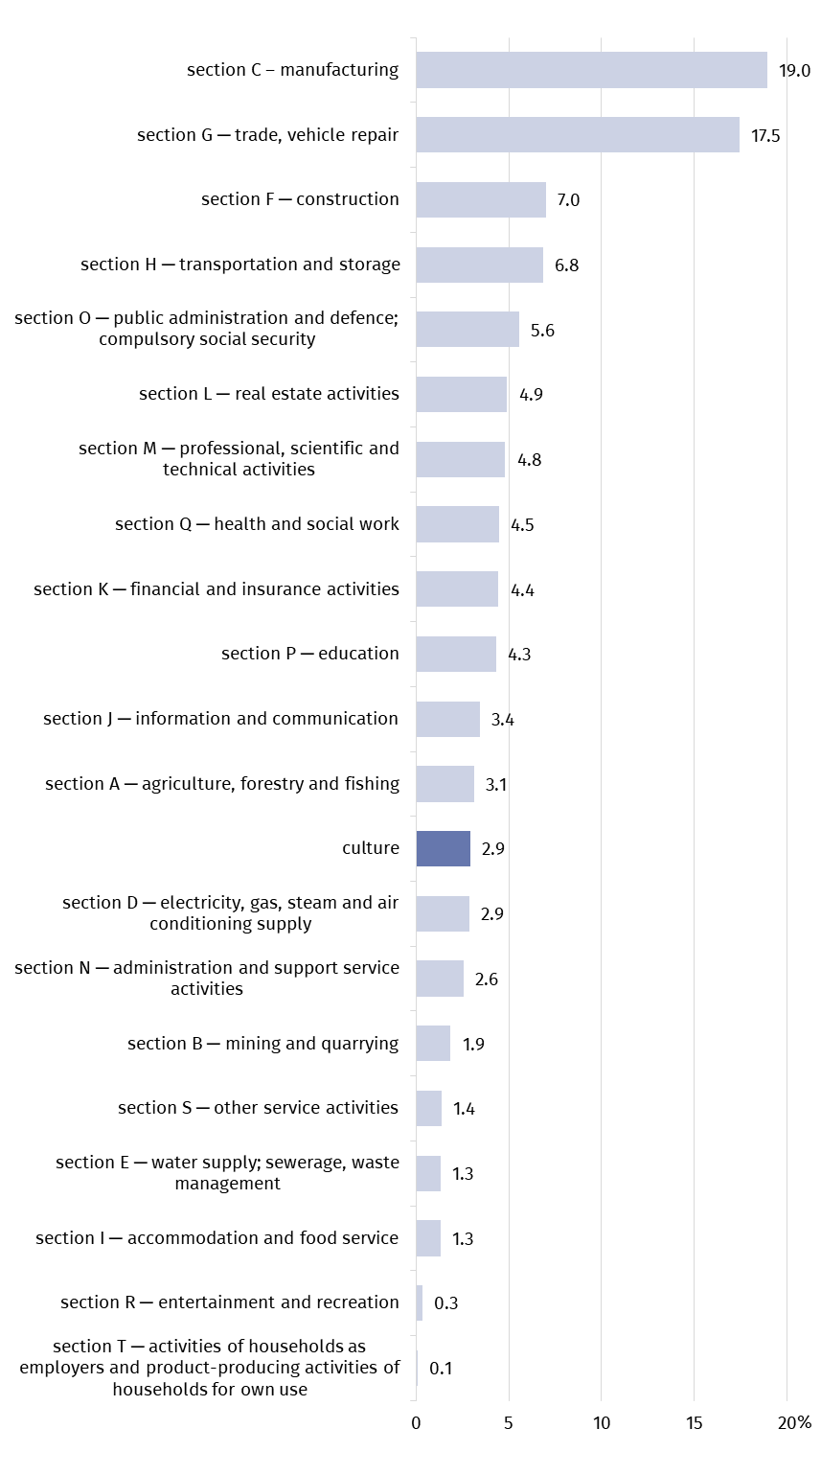
Chart 3. Share of the culture area in generating gross value added as compared to sections of national economy in 2017 (according to PKD 2007)
The contribution of the cultural area to the national economy, counted by the gross value added, was 2.9%.

Transactions in the culture satellite account
In 2017, the value of gross output of the cultural area amounted to PLN 114,969.6 million, with the highest value of gross output recorded in the Advertising domain. The following areas also had a significant share: Audio-visual arts and multimedia (16.0%) and Books and press (14.3%).
59% of the total global output in culture was generated by three domains: Advertising, Audio-visual arts and multimedia, and Books and press.
The total value of gross output generated by these three domains amounted to 59.0% of the total gross output in the field of culture. The smallest contribution to the gross output of the cultural area was made by entities belonging to Culture management and administration domain (0.6%).
The value of intermediate consumption was PLN 63,847.2 million, while the total gross value added for the entire area of culture was PLN 51,122.4 million. The Advertising domain (PLN 11,520.6 million) made the largest contribution to gross value added. The following areas also had a significant share: Audio-visual arts and multimedia (PLN 8,187.9 million) and Books and press (PLN 7,286.0 million). Domains such as Libraries and archives and Cultural education deserve attention, as in their case the gross value added was twice as high as the value of intermediate consumption. For comparison, in the case of Advertising, Audio-visual arts and multimedia, intermediate consumption was approximately 2/3 higher than the generated gross value added.
In 2017, compensation of employees amounted to PLN 20,639.8 million. In addition to domains: Advertising, Audio-visual arts and multimedia and Books and press, the following areas were also clearly visible in these costs: Performing arts, Artistic education and Related to culture (all above PLN 2,500 million).
Gross operating surplus, constituting the difference between gross value added and compensation of employees and other taxes related to production diminished by other subsidies related to production, amounted to PLN 30,128.5 million. The highest result was achieved by entities in the Advertising domain (PLN 8,415.8 million). The highest subsidies related to production were received by entities from the domain Related to culture (36.0% of all subsidies related to production. But the highest production-related taxes were observed in Audio-visual arts and multimedia domain (42.4% of all production-related taxes).
In the analysed year, gross capital formation in the area of culture, measuring the increase in property, reached the value of PLN 2,989.0 million. The highest value was related to the field of Architecture (PLN 1,394.5 million), and only smaller – to Performing arts (PLN 1,385.2 million).
In 2017, final consumption expenditure amounted to PLN 48,193.7 million, of which 72.3% related to households. In their case, the highest value of consumption was recorded in Audio-visual arts and multimedia domain (PLN 16,644.9 million). In the final consumption expenditure of general government sector (25.7% of total final consumption expenditure), the highest value of consumption was observed in Performing arts domain (PLN 7 140.9 million), and the smallest – in Visual arts (PLN 80.5 million). On the other hand, the final consumption expenditure by non-profit institutions related to the area of culture amounted to PLN 972 million, most of which concerned Performing arts domain (PLN 298.3 million) and the least Audio-visual arts and multimedia (PLN 2.0 million).
More than 70% of final consumption expenditure was attributable to households, where the highest values were recorded in Audio-visual arts and multimedia domain.

Table 1. Main transactions in culture satellite account according to cultural domains in 2017
Specification | Gross output | Intermediate consumption | Value added, gross | Compensation of employees | Other taxes on production | Other subsidies on production | Operating surplus, gross
Specification | in PLN million
Total | 114,969.6 | 63,847.2 | 51,122.4 | 20,639.8 | 626.1 | 272.0 | 30,128.5
Cultural heritage | 2,792.0 | 1,370.2 | 1,421.8 | 1,041.3 | 36.9 | 0.6 | 344.2
Library and archives | 2,205.0 | 710.7 | 1,494.4 | 1,291.6 | 18.5 | 0.1 | 184.5
Books and press | 14,326.4 | 7,040.4 | 7,286.0 | 2,806.7 | 52.4 | 24.8 | 4,451.6
Visual arts | 5,417.2 | 2,282.7 | 3,134.6 | 531.2 | 9.9 | 7.7 | 2,601.2
Performing arts | 7,620.1 | 3,742.0 | 3,878.1 | 2,713.1 | 104.2 | 26.8 | 1,087.6
Audio-visual arts and multimedia | 22,667.0 | 14,479.1 | 8,187.9 | 2,799.8 | 265.6 | 34.7 | 5,157.3
Architecture | 7,798.5 | 3,335.8 | 4,462.7 | 919.9 | 16.3 | 1.5 | 3,528.0
Advertising | 30,864.5 | 19,343.9 | 11,520.6 | 3,055.1 | 58.2 | 8.5 | 8,415.8
Artistic education | 6,261.3 | 2,100.2 | 4,161.1 | 2,544.7 | 39.5 | 54.3 | 1,631.2
Related to culture | 14,311.7 | 9,039.0 | 5,272.7 | 2,631.8 | 24.2 | 97.9 | 2,714.7
Culture management and administration | 705.8 | 403.4 | 302.5 | 304.6 | 0.6 | 15.1 | 12.4

Table 1. Main transactions in culture satellite account according to cultural domains in 2017 (cont.)
Specification | Final consumption expenditure |  |  | Gross capital formation | Imports of goods and services | Exports of goods and services
Specification | by households | by non-profit institutions | by general government | Gross capital formation | Imports of goods and services | Exports of goods and services
Specification | in PLN million
Total | 34,821.6 | 971.6 | 12,400.5 | 2,989.0 | 18,370.9 | 24,430.2
Cultural heritage | 749.8 | 194.2 | 170.0 | 0.5 | 207.7 | 373.2
Library and archives | – | 32.5 | 891.4 | 0.2 | – | –
Books and press | 8,318.2 | 19.0 | 956.8 | 113.0 | 2,392.1 | 5,918.7
Visual arts | 3,126.0 | 40.0 | 80.5 | 2.8 | 37.8 | 68.3
Performing arts | 4,238.7 | 298.3 | 7,140.9 | 1,385.2 | 720.3 | 234.4
Audio-visual arts and multimedia | 16,644.9 | 2.0 | 349.0 | 69.1 | 10,287.1 | 8,951.5
Architecture | – | – | 189.4 | 1,394.5 | 81.0 | 152.8
Advertising | – | – | – | 16.3 | 4,623.2 | 8,589.9
Artistic education | 879.8 | 191.9 | 2,402.0 | -1.9 | – | –
Related to culture | 864.2 | 2.5 | – | 0.6 | 21.7 | 141.5
Culture management and administration | – | 191.0 | 220.6 | 8.7 | – | –
In 2017, there was a positive balance in foreign trade in cultural and creative goods and services in the amount of PLN 6,059.2 million, which was mainly due to the commercial activity of entities from Advertising domain (balance: PLN 3,966.6 million). Audio-visual arts and multimedia as well as Performing arts recorded a negative balance (PLN -1,335.6 million and PLN 485.9 million, respectively). The level of exports was mainly related to Audio-visual arts and multimedia domain (36.6%), Advertising (35.2%) and Books and press (24.2%). In the case of import, these areas also dominated, responsible for 56.0%, 25.2% and 13.0% of the total import in the area of culture, respectively.
In the case of quoting data from the Statistics Poland, please provide information: "Statistics Poland data source", and in the case of publishing calculations made on data published by the Statistics Poland, please provide information: "Own study based on Statistics Poland data".

Prepared by:  Statistical Office in Kraków  Director Agnieszka Szlubowska  Phone: (+48 12) 420 40 50 | Issued by:  The Spokesperson for the President  of Statistics Poland  Karolina Banaszek  Phone: (+48) 695 255 011
Press Office  Phone: (+48 22) 608 38 04  e-mail: obslugaprasowa@stat.gov.pl |   stat.gov.pl/en/

@StatPoland

@GlownyUrzadStatystyczny

gus_stat

glownyurzadstatystycznygus

glownyurzadstatystyczny
Related information
Report on methodological work. Culture Satellite Account (PL version only)
Cultural and creative industries in 2014–2016
Cultural and creative industries in 2020
Culture in 2020
Terms used in official statistics
Gross capital formation
Exports of goods and services
Imports of goods and services
Compensation of employees
Operating surplus, gross
Gross output
Gross Domestic Product (GDP)
Final consumption expenditure
Value added, gross
Intermediate consumption

In order to present the data according to PKD sections, it was necessary to exclude from some sections of the national economy individual classes that were included in the calculations for the area of culture. The area of culture includes the following classes: 18.11; 18.12; 18.20; 32.20; 47.61; 47.62; 47.63; 58.11; 58.13; 58.14; 58.21; 59.11; 59.12; 59.13; 59.14; 59.20; 60.10; 60.20; 63.91; 71.11; 73.11; 74.10; 74.20; 74.30; 77.22; 90.01; 90.02; 90.03; 90.04; 91.01; 91.02; 91.03 and for data concerning the general government sector also some part of classes: 84.11; 84.12; 84.25, 94.12 and in the field of artistic education some part of classes: 85.10; 85.20; 85.31; 85.32; 85.41; 85.42; 85.52; 85.59; 85.60.
Data on final consumption expenditure, gross accumulation and foreign trade in Culture satellite account are calculated on the basis of data by balance groups presented in the supply and use tables.

