Value chains of national enterprises in 2020
At the end of 2020, most (66.8%) of surveyed enterprises with 10 or more persons employed performed business functions exclusively internally and did not sourced them outside. The phenomenon of external sourcing occured in 33.2% of surveyed enterprises, most of which (88.0%) contracted out functions only to other domestic enterprises. Abroad, business functions were contructad out mainly to the European Union countries.
33.2%
of surveyed enterprises sourced business functions externally at the end of 2020

Location of performing business functions
At the end of 2020, business functions were sourced externally more often by large enterprises, i.e. with 250 and more persons employed – 44.7% of entities within this size class compared to 33.2% in total
At the end of 2020, two-thirds (28,564) of the surveyed enterprises with 10 or more persons employed performed business functions exclusively internally, and one-third (14,198) sourced functions externally to other entities to perform fully or partially. More often, functions were sourced externally by large enterprises (with 250 or more persons employed) – 44.7% of entities belonging to this size class, and less often by small enterprises (with 10–49 persons employed) – 30.4%

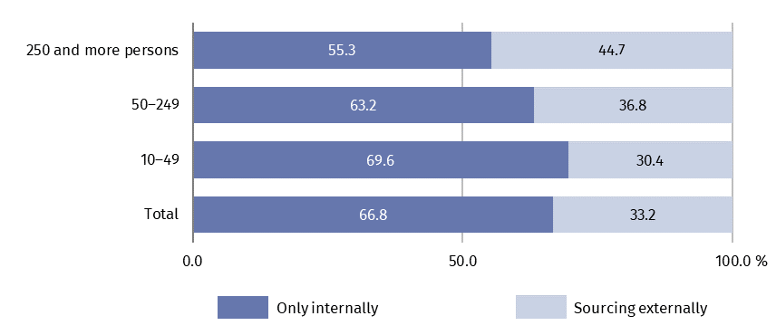
Chart 1. Structure of surveyed enterprises by size class and location of performing business functions in 2020
Industrial enterprises were characterized by a slightly higher share of entities sourcing activities externally to other enterprises than entities conducting other kinds of activities. The highest share of such entities was observed among enterprises operating in electricity, gas, steam and air conditioning supply (42.9% of entities within this section) and manufacturing (37.8%). Among enterprises other than industrial, the performance of functions was most often sourced to external entities by units in the following sections: financial and insurance activities (35.7%), information and communication (35.4%) and construction (35.0%). Entities operating in the field of education had the highest share of entities performing functions only internally compared to other kinds of activities (81.3% of entities within this section).
In terms of the location of the surveyed enterprises, the implementation of functions was sourced externally more frequently by enterprises located in voivodships: Dolnośląskie (36.2%), Warmińsko-Mazurskie (36.0%) and Mazowieckie (35.0%) than in other locations. Enterprises from Lubelskie voivodship more often than entities from other voivodships performed all functions exclusively on their own (72.5%).

Activities performed by enterprises on their own
At the end of 2020, the most frequently performed business function internally by enterprises was marketing, sales and after-sales services – it was conducted by 60.6% of surveyed entities
At the end of 2020, surveyed enterprises with 10 and more persons employed the most frequently performed on their own functions related to marketing, sales and after-sales services (in 60.6% of the surveyed enterprises), management and administration (50.5%) and production (46.1%). In total, nearly two-thirds (3067.9 thousand persons) of the total number of persons employed in the surveyed enterprises were involved in the implementation of these functions. The functions least frequently performed by the surveyed entities were engineering and related technical services (in 12.5% of the surveyed enterprises) and research and development (5.9%). They also involved the lowest number of persons employed.

Table 1. Enterprises and persons employed by business functions (as of 31 December 2020)
Business functions | Number of enterprisesª | Number of persons employed
Business functions | Number of enterprisesª | in absolute number | in %
Total | 42 762 | 4 868 379 | 100.0
Production | 19 710 | 1 645 694 | 33.8
Management and administration | 21 587 | 486 250 | 10.0
Engineering and related technical services | 5 349 | 119 007 | 2.4
Research and development | 2 535 | 55 159 | 1.1
Information technology | 7 431 | 161 553 | 3.3
Marketing, sales and after-sales services | 25 934 | 935 932 | 19.2
Transportation, logistics and storage | 13 568 | 495 391 | 10.2
Other business functions^{b} | 17 302 | 969 393 | 19.9
a Due to the possibility of performing multiple functions within an enterprise, the functions do not add up to a "total" value. b Involve facility management, maintenance and repair services and other services.
Large enterprises (with 250 or more persons employed) were characterized by the most diverse structure of tasks performed – the percentage of large enterprises performing particular business functions was higher compared to percentage of enterprises from other size classes in the case of each analysed function.

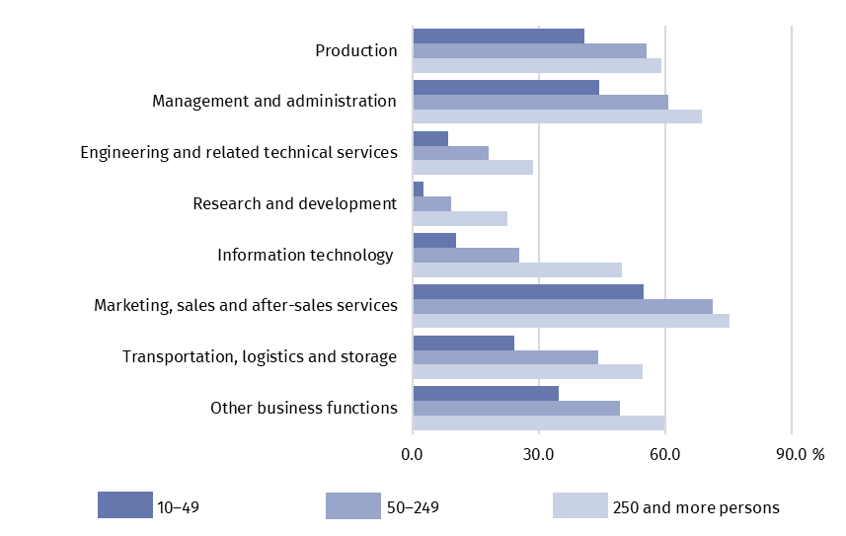
Chart 2. Percentage of surveyed enterprises in each size class by type of business function performed internally in 2020
For particular size classes, the structure of the number of persons employed by business function was slightly varied. Only in the case of small enterprises (with 10–49 persons employed), a higher percentage of employees working in the marketing, sales and after-sales services functions (25.3% compared to about 18% for other size classes), and a lower percentage in production-related activities (28.1% compared to about 35% for other size classes) was observed compared to enterprises in other size classes.

Directions for commissioning selected activities
Among enterprises having sourced business functions externally at the end of 2020, the vast majority (88.0%) performed them only in other domestic enterprises
Of the 14,198 surveyed enterprises with 10 and more persons employed, which externally sourced functions completely or partially at the end of 2020, the vast majority (88.0%) indicated only other domestic enterprises as the place of performing the functions, 10.1% simultaneously domestic and foreign enterprises, and 1.9% only other foreign enterprises. Large enterprises (with 250 or more persons employed) more often than enterprises in other size classes sourced functions externally to foreign entities, i.e. to both domestic and foreign or only foreign enterprises (a total of 26.1% of entities within this class).

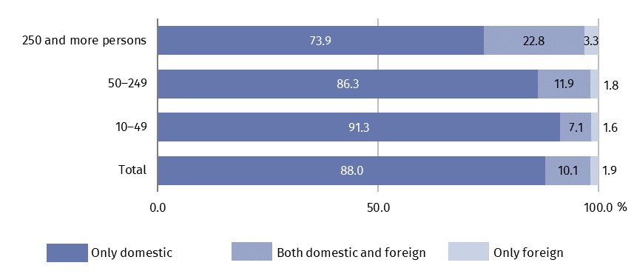
Chart 3. Structure of enterprises sourcing functions externally by size class and place of sourcing in 2020

The implementation of activities abroad was most frequently reported by enterprises from sections: transport and storage (19.2% of entities within this section sourced functions externally), financial and insurance activities (18.4%) and information and communication (17.3%).
The place of performing business functions outside Poland was most frequently chosen by enterprises based in voivodeships: Mazowieckie (total 17.0% of entities from this voivodeship sourced functions externally), Lubuskie (15.7%) and Zachodniopomorskie (14.1%).
In 2020, most frequently contracted out to other domestic enterprises were tasks related to management and administration as well as information technology. Functions sourced externally within country were mainly performed by unrelated companies, i.e. outside the same enterprise group.
Sourced externally outside Poland were mainly information technology functions related tasks and (to a lesser extent) marketing, sales and after-sales services as well as management and administration functions. Activities sourced externally abroad were mostly performed by other related companies, i.e. belonging to the same enterprise group.

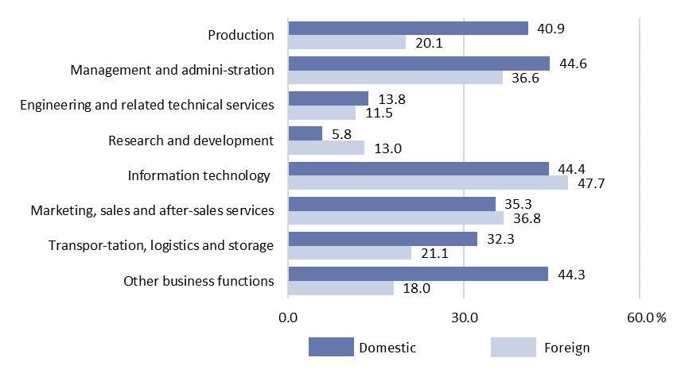
Chart 4. Percentage of enterprises sourcing business functions externally by type of function and place of sourcing in 2020
Among the total 1698 enterprises sourcing business functions externally abroad at the end of 2020, the highest percentage (94.9%) indicated another European enterprise as the place where the function was performed, of which 86.9% other unit from the European Union.
The vast majority (86.9%) of enterprises having sourced business functions externally abroad in 2020 indicated European Union countries as a place of functions performance
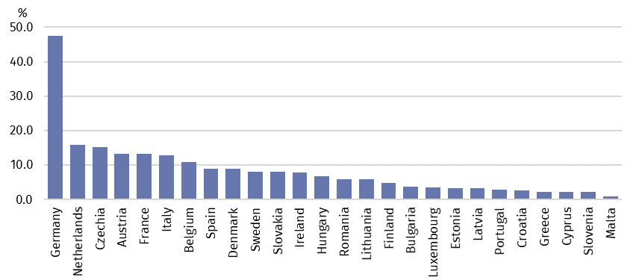
Chart 5. Percentage of enterprises sourcing business functions externally in the European Union countries in 2020
In the Visegrd Group countries, functions were performed by 20.4% of the total number of enterprises carrying out activities abroad (in the Czechia 15.3%, in Slovakia 8.0%, in Hungary 6.7%), and in the United Kingdom 17.3%. In countries outside Europe, functions were most frequently performed in the United States and Canada (13.7%).

Table 2. Percentage of enterprises sourcing business functions externally abroad by selected areas in 2020
Business functions | Total | Europe | United States and Canada | China | India
 | in %
Production | 100.0 | 93.6 | 5.0 | 7.3 | 2.6
Management and administration | 100.0 | 94.8 | 11.8 | 1.6 | 4.3
Engineering and related technical services | 100.0 | 98.5 | 7.1 | 2.6 | 2.0
Research and development | 100.0 | 86.9 | 14.5 | 3.2 | 0.9
Information technology | 100.0 | 93.0 | 13.0 | 0.5 | 3.6
Marketing, sales and after-sales services | 100.0 | 95.0 | 10.6 | 2.2 | 1.3
Transportation, logistics and storage | 100.0 | 97.2 | 6.7 | 3.4 | 1.7
Other business functions | 100.0 | 97.1 | 12.1 | 4.2 | 2.0

The data presented in this study concern 42 762 legal units with the number of persons employed 10 and more, organised in the form of civil law partnerships, partnerships, commercial companies, capital companies, branches of foreign enterprises, state-owned enterprises, whose main kind of economic activity is classified to the following sections of the Polish Classification of Activity PKD 2007 (NACE ver. 2.0): B, C, D, E, F, G, H, I, J (excluding cultural institutions with legal personality), K (without banks, cooperative savings and credit unions, insurance companies, brokerage houses, investment funds and pension funds), L, M, N, P (without higher education), Q (without independent health care facilities), R (excluding cultural institutions with legal personality), S (without division 94).
Survey of global value chains has been conducted in Statistics Poland since 2020. The current first results of the study have allowed for preliminary analysis of the value chains of national enterprises, carried out using business function. There were distinguished 8 business functions:
- Production (manufacturing and assembly, production of energy and extraction of raw materials, construction);
- Management and administration;
- Engineering and related technical services;
- Research and development;
- Information technology (information technology services, software programming, IT system installation, maintenance, help desk services, telecommunication);
- Marketing, sales and after-sales services;
- Transportation, logistics and storage;
- Other business functions (facility management, maintenance and repair services and other services).
In case of quoting Statistics Poland data, please provide information: “Source of data: Statistics Poland”, and in case of publishing calculations made on data published by Statistics Poland, please include the following disclaimer: “Own study based on figures from Statistics Poland”.

Prepared by:  Enterprises Department  Director Katarzyna Walkowska  Phone: (+48 22) 608 35 66 | Issued by:  The Spokesperson for the President  of Statistics Poland  Karolina Banaszek  Phone: (+48) 695 255 011
Press Office  Phone: (+48 22) 608 38 04  e-mail: obslugaprasowa@stat.gov.pl |   www.stat.gov.pl/en/

@StatPoland

@GlownyUrzadStatystyczny

gus_stat

glownyurzadstatystycznygus

glownyurzadstatystyczny
Terms used inn official statistics
Business function
Enterprise group

Business function is a set of tasks that an enterprise must carry out on a regular basis in order to bring goods or services to market. These tasks may be performed internally by an enterprise or sourced externally.
The term „Industry” includes sections: B (Mining and quarrying), C (Manufacturing), D (Electricity, gas steam and air conditioning supply), E (Water supply; sewerage, waste management and remediation activities).

