Biotechnology and nanotechnology in Poland
in 2021

In 2021, 173 firms conducted biotechnology activities, which constitutes a decrease by 2.3%
in comparison to the previous year. Biotechnology intramural expenditures incurred by firms amounted to PLN 1380.9 million and increased
by 13.2% on an annual basis. In 2021, 3953 persons were employed in biotechnology in firms. Biotechnology research and experimental development was conducted by 217 entities, that is, by 4.4% less in comparison with the previous year. Biotechnology R&D intramural expenditures amounted to PLN 1184.7 million and increased by 8.7% annually. 8202 persons were involved in biotechnology research and experimental development.
13.2%
An increase in biotechnology
intramural expenditures in firms
Nanotechnology activities were conducted by 74 enterprises, i.e. by 4.2% more than in the previous year. Intramural expenditures on nanotechnology incurred by firms amounted to PLN 427.5 million and were higher by 54.9% in comparison with the previous year. 3487 persons were employed in the field of nanotechnology, of which 1248 persons were employed in firms. Research and experiemntal development in the field of nanotechnology just like last year were carried out by 130 entities. Nanotechnology R&D intramural expenditures amounted to PLN 373.4 million and were by 25.9% higher than in the previous year. 2626 persons were involved in nanotechnology research and experimental development.
25.9%
An Increase in nanotechnology R&D intramural expenditures

BIOTECHNOLOGY

Biotechnology in firms
In 2021, biotechnology activities were conducted by 173 firms called biotechnology firms (BF). Among them dedicated biotechnology firms (DBF) constituted 42.2%. Biotechnology research and experimental development (R&D) firms (BRDF) constituted 60.7% of all biotechnology firms, of which 58.1% conducted only R&D in biotechnology. The remaining firms (BRDF) combined R&D with biotechnology manufacturing.
Over a half of firms conducting biotechnology activities constituted small firms, that is, with the number of persons
employed below 50
Taking into account size classes, small firms (with the number of persons employed below 50) prevailed constituting 52.6% of the total number of biotechnology firms; the share of medium firms (employing 50-249 persons) and large firms (250 and more persons) amounted
to 30.1% and 17.3%, respectively.

Chart 1. Biotechnology firms conducting biotechnology activities
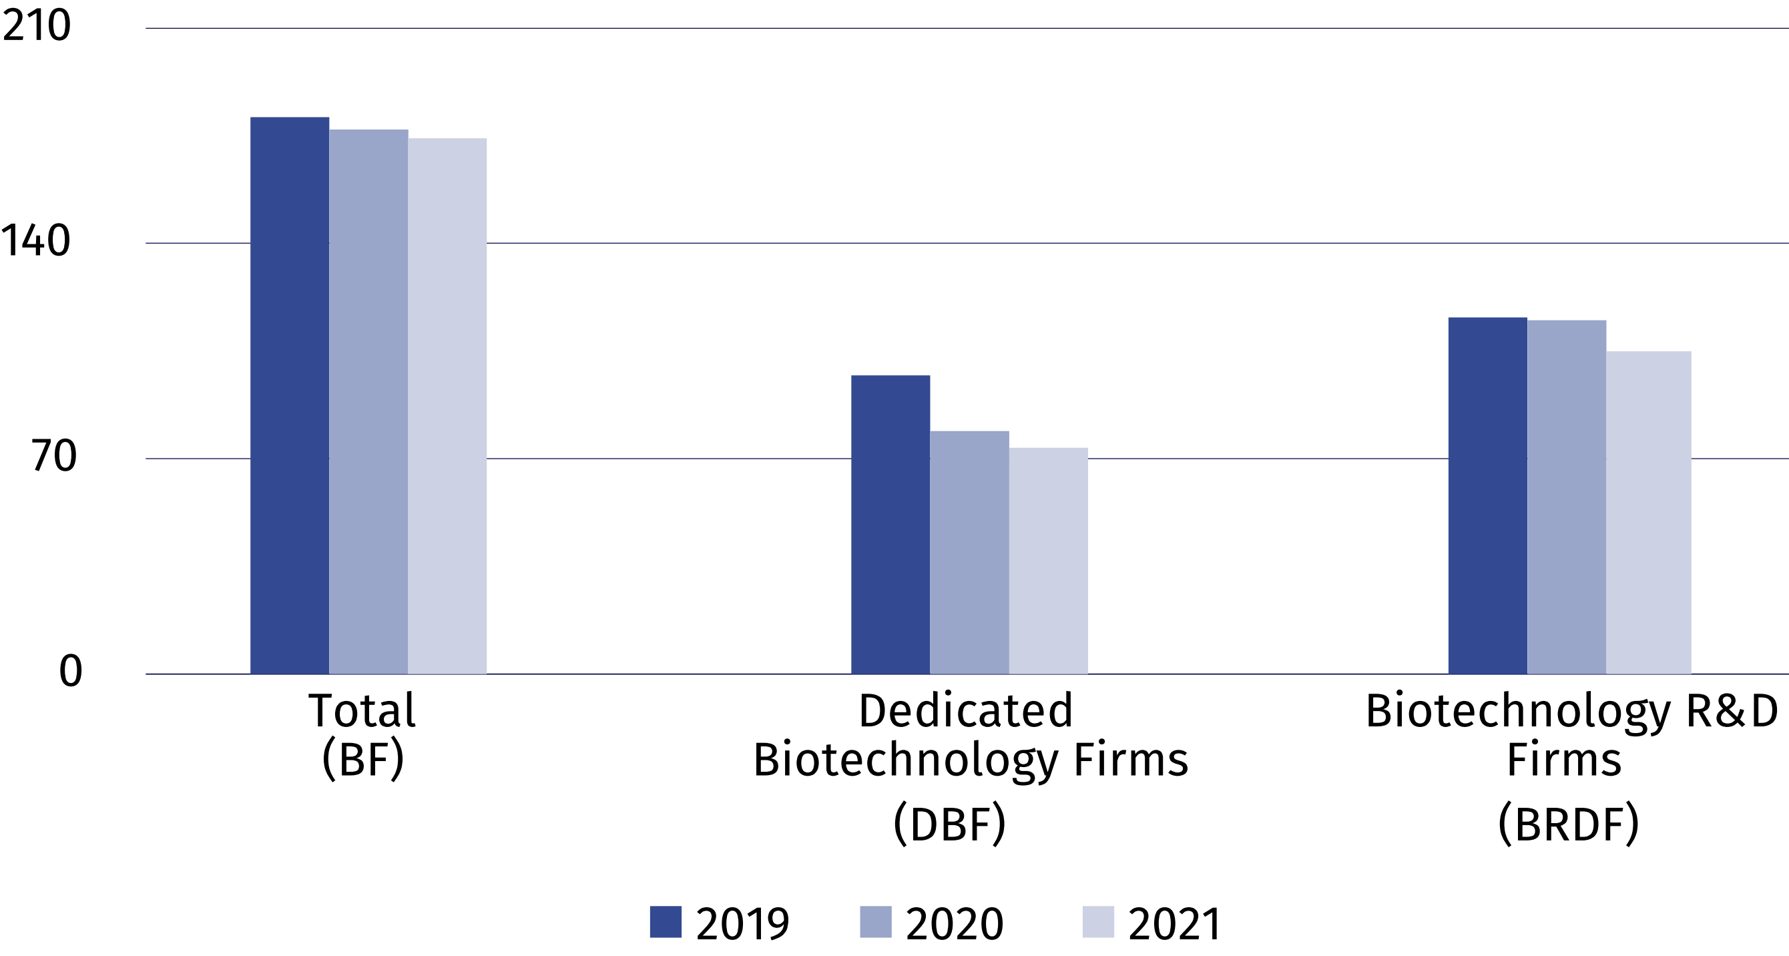

Biotechnology intramural expenditures of biotechnology firms
In 2021, intramural expenditures of firms incurred on biotechnology amounted to PLN 1380.9 million, of which internal funds of firms constituted 83.0%
Nearly half (47.3%) of the total expenditure on biotechnology were incurred by medium-sized enterprises.
Analysing size classes of firms, it can be noted that the highest expenditures on biotechnology, like in the previous year, were incurred by entities classified as medium (PLN 653.1 million). Compared to the previous year, however notice decreased by 4.0%.
Chart 2. Biotechnology intramural expenditures of biotechnology firms
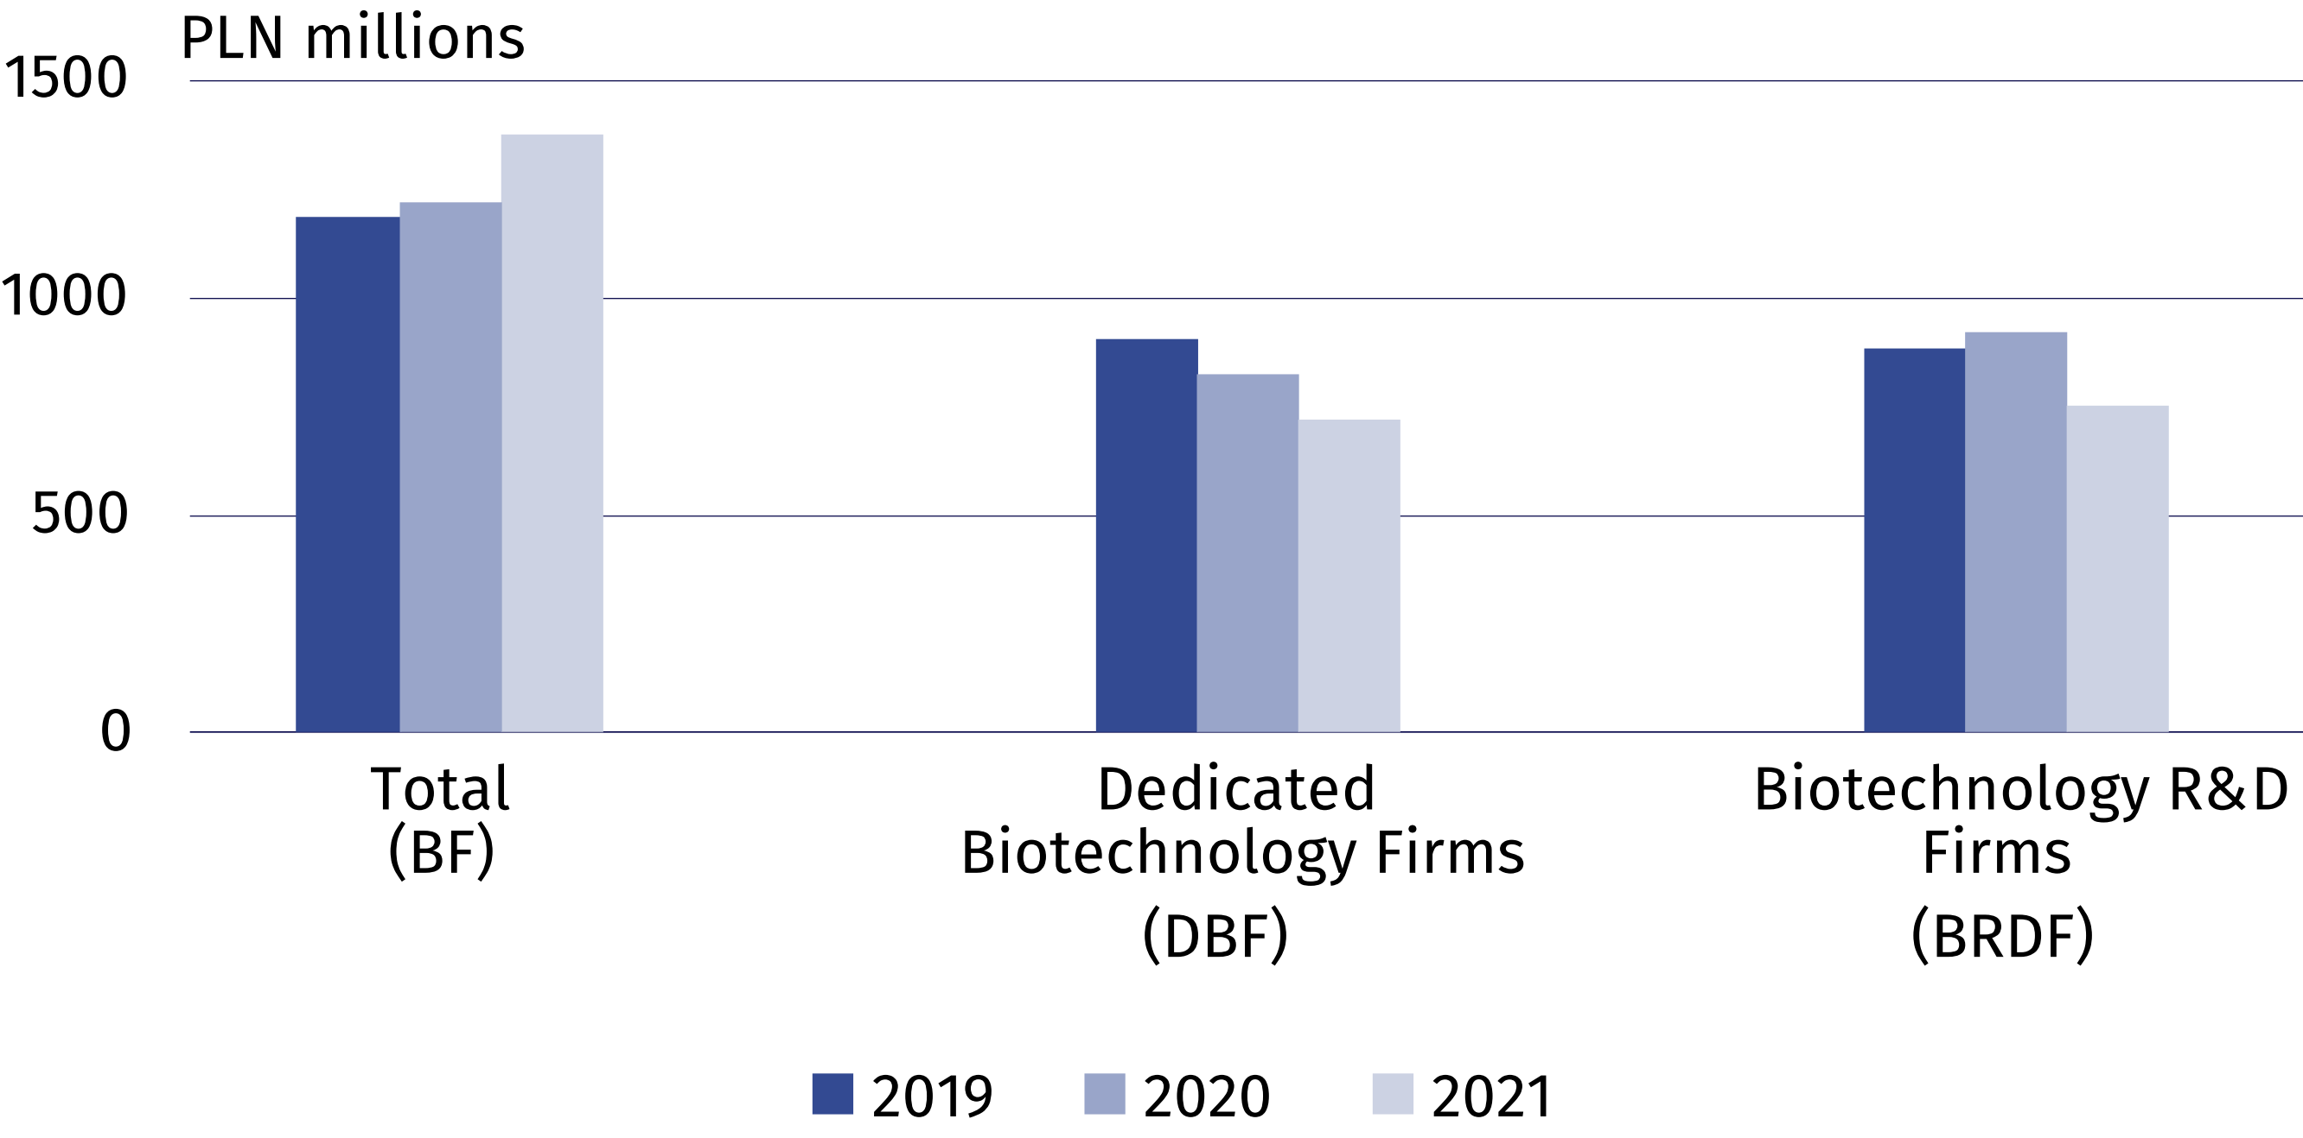

Biotechnology personnel
In 2021, the number of persons employed in dedicated
biotechnology firms (DBF)
increased by 4.2%.
In 2021, 10064 persons were involved in biotechnology (by 3.7% more than in the previous year), of which almost a half worked in firms. Biotechnology research and experimental development in firms was performed by 2091 persons.

Chart 3. Biotechnology personnel in firms
As of 31 December
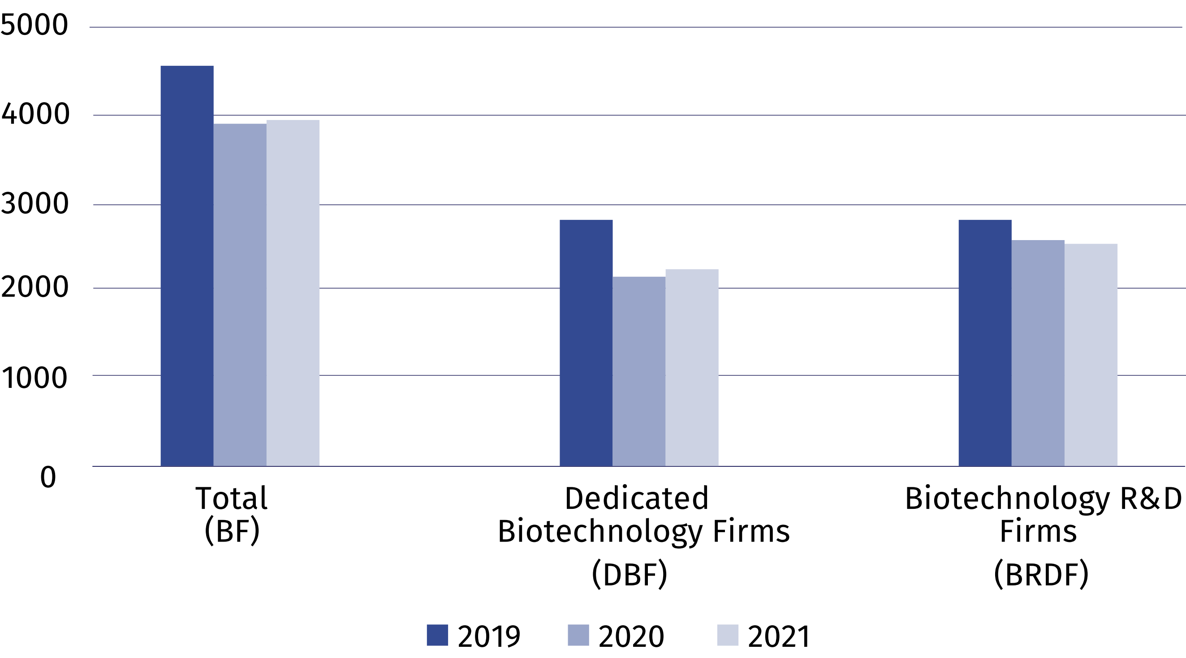

Biotechnology research and experimental development
In 2021, biotechnology research and experimental development was conducted in Poland
by 217 entities, of which over a half belonged to the business enterprise sector. The most
numerous group with regard to biotechnology applications was entities dealing with human health – 61.8% of the total number of entities conducting biotechnology R&D.
In 2021, biotechnology R&D intramural expenditures increased by 8.7% on an annual basis amounting to PLN 1184.7 million. Intramural expenditures of entities which belong to the higher education sector constituted 52.8% of this amount, the business enterprise sector
– 45.3%, the government and private non-profit sector – 1.9%.
8202 persons were engaged in biotechnology R&D in 2021. The number of persons employed increased by 5.4% in comparison with the previous year. Researchers constituted almost three-fourths of personnel involved in biotechnology R&D.
Table 1. Biotechnology R&D intramural expenditures by sectors of performance
Sectors of performance | 2019 | 2020 | 2021
Sectors of performance | in PLN thousand
Total | 976 761.0 | 1 090 126.1 | 1 184 735.1
Business enterprise sector | 466 988.5 | 530 043.0 | 536 196.0
of which enterprises | 424 736.6 | 462 327.9 | 459 609.0
Government and private  non-profit sector | 4 774.6 | 20 044.0 | 23 055.5
Higher education sector | 504 997.9 | 540 039.1 | 625 483.6

NANOTECHNOLOGY

Nanotechnology in firms
In 2021, the number of enterprises which indicated conducting nanotechnology activities
in the survey, i.e. used nanotechnology for the production of intermediate and final goods and / or conducted research and experimental development in the field of nanotechnology, amounted to 74, which means an increase of 4.2% compared to the previous year.
Chart 4. Nanotechnology firms conducting nanotechnology activities
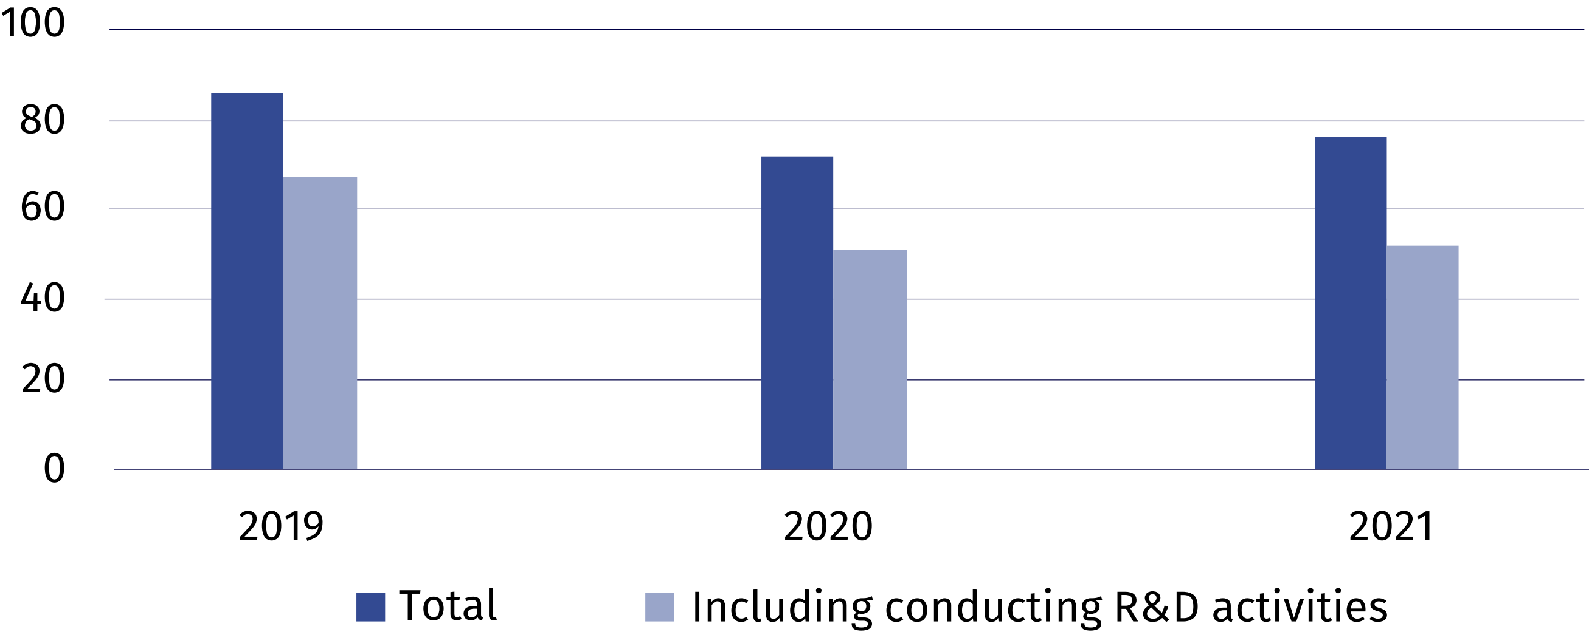
Nanotechnology activities in firms are related to production in which nanotechnology is used to produce intermediate and final goods. Applying nanotechnology in production also includes indirect involvement of firms, as a user or an integrator. Nanotechnology is also used
in research and development, i.e. in scientific research and experimental development.
In 2021, nanomaterials constituted the dominant area
of nanotechnology application for 78.4% of surveyed firms
In the nanotechnology survey firms defined the areas of nanotechnology application in production as well as in research and experimental development as well as indicated the dominant area. In 2021, as in the previous years, nanomaterials constituted the dominant area
of nanotechnology application for the majority of firm; the number of such entities increased annually by 3.6%.
Table 2. Firms according to the dominant area of nanotechnology application
Application areas | 2019 | 2020 | 2021
Total | 86 | 71 | 74
Nanomaterials | 62 | 56 | 58
Nanoelectronics | 2 | 1 | –
Nanooptics | 2 | – | –
Nanobiotechnology | 2 | 2 | 2
Nanomedicine | 4 | 2 | 2
Filtration and membranes | 1 | – | –
Nanoscale tools | 1 | – | –
Nanophotonics | 1 | – | 1
Modelling and simulation software | 2 | 1 | 1
Other | 9 | 9 | 10

Nanotechnology intramural expenditures of nanotechnology firms
Nanotechnology intramural expenditures are expenditure incurred for this purpose by firms in the reporting year, regardless of the source of the funds spent.
In 2021, PLN 427.5 million was allocated to nanotechnology activities, of which 89.4% constituted own funds of enterprises. Compared to the previous year, expenditures on nanotechnology increased by 54.9%.
Chart 5. Intramural expenditures in nanotechnology firms conducting nanotechnology
activities
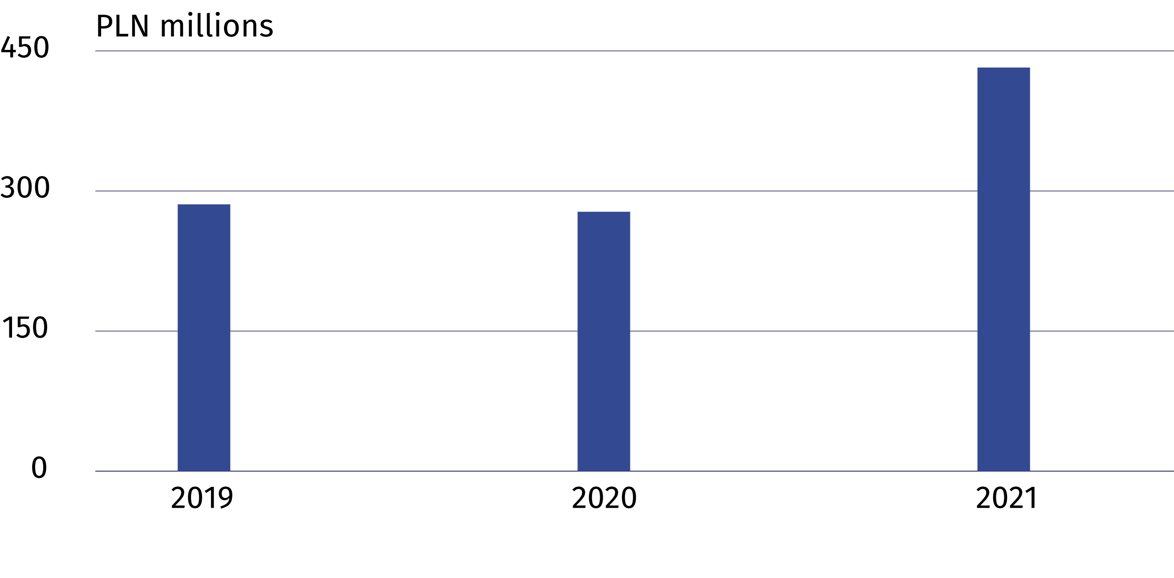

Nanotechnology personnel
In 2021, the number of persons employed in nanotechnology firms increased annually
by 25.2%
In 2021, 3487 persons were involved in nanotechnology activities (both in scientific units and firms). Firms employed 1248 persons, i.e. by 25.2% more than in the previous year. Research and experimental development in firms was carried out by 387 persons (including 153 women), which constituted 31.0% of the total number of persons employed in the field of nanotechnology.
Chart 6. Nanotechnology personnel in firms
As of 31 December
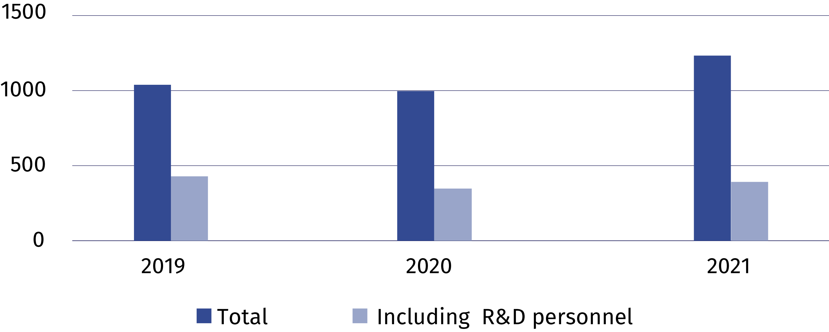

Nanotechnology research and experimental development
In 2021, the number of firms conducting research and
experimental development
in nanotechnology was
by 2.0% higher than last year
The basic classification of research and experimental development is the division of entities into sectors of performance. In 2021, nanotechnology research and experimental development was carried out by 130 entities, of which the enterprise sector accounted for the largest share (47.7%).
In 2021, the amount of nanotechnology R&D intramural expenditures amounted to PLN 373.4 million, i.e. by 25.9% more than in the previous year. The higher education sector had the highest share in nanotechnology R&D intramural expenditures (53.4%).

Table 3. Nanotechnology R&D intramural expenditures by sectors of performance
Sectors of performance | 2019 | 2020 | 2021
Sectors of performance | in PLN thousand
Total | 261 412.7 | 296 736.6 | 373 386.9
Business enterprise sector | 85 902.3 | 72 099.5 | 166 965.3
of which enterprises | 61 540.3 | 60 608.7 | .
Government and private non-profit sector | 4 814.3 | 6 712.5 | 6 943.1
Higher education sector | 170 696.1 | 217 924.6 | 199 478.3

In 2021, 2626 persons, including 1114 women, were involved in research and experimental development in the field of nanotechnology. Compared to 2020, there was an increase in the number of R&D personnel in the field of nanotechnology by 7.1%, including women - by 12.0%.

When citing data from the Central Statistical Office, please include the following information: "Source of CSO data", and in the case of publishing calculations made on the data published by the Central Statistical Office, please include the following information: "Own study based on GUS data"
.
Prepared by:  Statistical Office in Szczecin  Director Magdalena Wegner  Phone: (+48 91) 459 77 00 | Issued by:  The Spokesperson for the President  of Statistics Poland  Karolina Banaszek  Phone: (+48) 695 255 011
Press Office  Phone: (+48 22) 608 38 04  e-mail: obslugaprasowa@stat.gov.pl |   stat.gov.pl/en/

@StatPoland

@GlownyUrzadStatystyczny

gus_stat

glownyurzadstatystycznygus

glownyurzadstatystyczny
Related information
Biotechnology and nanotechnology in Poland in 2020
Science and technology in 2020
Terms used inn official statistics

Biotechnology

The areas of activity in the field of biotechnology

Enterprise by type of biotechnology activity

Nanotechnology

