Research and experimental development in Poland in 2021
In 2021, gross domestic expenditure on R&D (GERD) amounted to 37.7 billion PLN and increased by 16.3% in comaparison to the previous year. R&D intensity indicator, which constitutes a share of intramural R&D expenditure in GDP, amounted to 1.44% (in 2020 – 1.39%). Gross domestic expenditure on R&D per capita amounted to 992 PLN and was higher by 16.9% than in the previous year. The number of R&D entities increased by 15.5%.
16.3%
An increase in gross domestic expenditure on R&D

Table 1. Selected data on R&D
Specification | 2015 | 2016 | 2017 | 2018 | 2019 | 2020 | 2021
Number of entities in R&D | 4 427 | 4 871 | 5 102 | 5 779 | 5 863 | 6 381 | 7 370
Gross domestic expenditure on R&D (GERD) in million PLN | 18 061 | 17 943 | 20 578 | 25 648 | 30 285 | 32 402 | 37 676
Relation of GERD to GDP in % | 1.00 | 0.96 | 1.03 | 1.21 | 1.32 | 1.39 | 1.44

INTRAMURAL EXPENDITURE ON RESEARCH AND DEVELOPMENT
R&D intensity (GERD/GDP) amounted to 1.44%
In the year 2021, like in the previous years, current expenditure prevailed in the structure of intramural expenditure on R&D by type of costs. Their share in all incurred expenditure on scientific research and experimental development amounted to 84.4%.
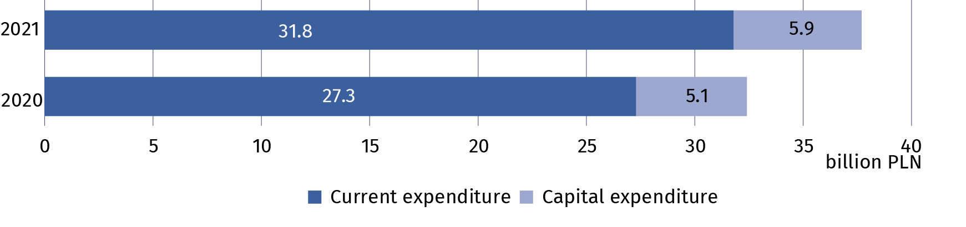
Chart 1. Intramural expenditure on R&D by type of costs
The business enterprise
expenditure on R&D (BERD) accounted for 63.1% of gross domestic expenditure on R&D (GERD)

The highest intramural expenditure on research and experimental development among the sectors of performance were incurred by the business enterprise sector which allocated on conducting research and experimental development 23.8 billion PLN (by 16.7% more than in 2020). Expenditure of this sector accounted for 63.1% of gross domestic expenditure on R&D in 2021 (compared to 62.8% in 2020). The share of other sectors of performance in these expenditure amounted to: higher education – 34.7%, government – 2.0% and private non-profit – 0.2% (compared to 34.9%, 2.0% and 0.2% in 2020).

Table 2. Intramural expenditure on R&D by sectors of performance
Sectors of performance | 2020 | 2021
Sectors of performance | in million PLN
Total (GERD) | 32 402.1 | 37 675.8
Business enterprise (BERD) | 20 359.1 | 23 769.1
Government (GOVERD) | 639.1 | 770.3
Higher education (HERD) | 11 324.4 | 13 059.0
Private non-profit (PNPERD) | 79.5 | 77.5

In the year 2021, like in the previous years, main funding sectors for research and experimental development were the business enterprise sector and the government sector whose funds accounted for 50.9% and 37.4% of all intramural expenditure on R&D, respectively (compared to 50.6% and 39.0% in 2020).
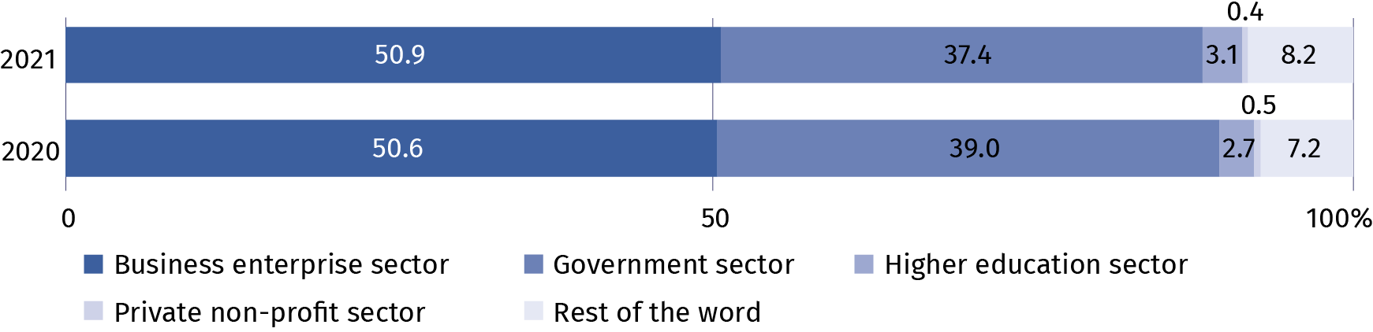
Chart 2. Intramural expenditure on R&D by funding sectors

PERSONNEL IN RESEARCH AND DEVELOPMENT
Internal personnel accounted for 83.7% of R&D personnel
in FTE
The number of personnel involved in research and experimental development in 2021 amounted to 305.6 thousand persons, that is, by 7.8% more than in the previous year. Actual involvement of R&D personnel in research and experimental development in full-time equivalents amounted to 185.3 thousand FTE and increased by 6.9% on an annual basis. R&D was mainly performed by internal personnel which accounted for 81.5% of personnel in headcount and 83.7% - in FTE in 2021 (in 2020 these shares amounted to 79.8% and 82.8%, respectively).
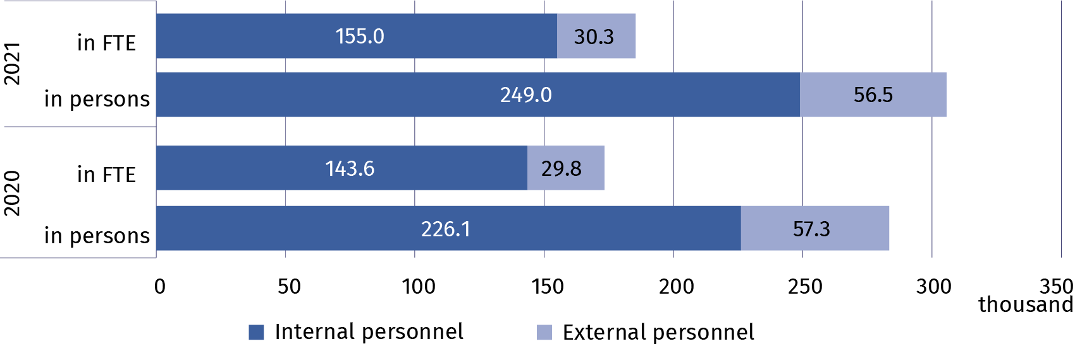
Chart 3. R&D personnel by main groups

In 2021, researchers prevailed in the structure of persons engaged in research and experimental development by R&D functions. They accounted for 70.0% of internal personnel and 73.1% of external personnel in headcount (compared to 70.0% and 66.7% in 2020). In FTE, researchers as the share of persons employed in R&D accounted for 72.7% and as the share of external contributors 75.8% (compared to 72.6% and 68.3% in 2020).
Table 3. Selected indicators on internal R&D personnelª
Specification | 2015 | 2016 | 2017 | 2018 | 2019 | 2020 | 2021
per 1000 active population^{b}
Internal R&D personnel | 6.4 | 6.6 | 7.1 | 7.8 | 8.1 | 8.6 | 9.0
of which researchers | 4.9 | 5.2 | 5.7 | 5.8 | 5.9 | 6.2 | 6.5
per 1000 persons employed^{c}
Internal R&D personnel | 6.9 | 7.0 | 7.5 | 8.1 | 8.4 | 8.8 | 9.3
of which researchers | 5.3 | 5.5 | 6.0 | 6.1 | 6.1 | 6.4 | 6.8
a In full-time equivalents (FTE). In 2015 – employees. b Active population aged 15-89 years according to the LFS – average annual data. c Persons employed aged 15-89 years according to the LFS – average annual data

In 2021, the business enterprise sector and higher education sector had the highest share in the structure of internal R&D personnel by sectors of performance. The percentage of internal personnel in these sectors accounted for 55.3% and 41.7% of total number of internal personnel engaged in conducting research and experimental development. On an annual basis, the number of person included in internal personnel increased by 17.1% in the business enterprise sector and by 2.0% in the higher education sector. The highest value of full-time equivalent was noted in the business enterprise sector (93.3 thousand FTE) which increased by 11.4% in comparison to 2020.
Chart 4. Internal R&D personnel by sectors of performance
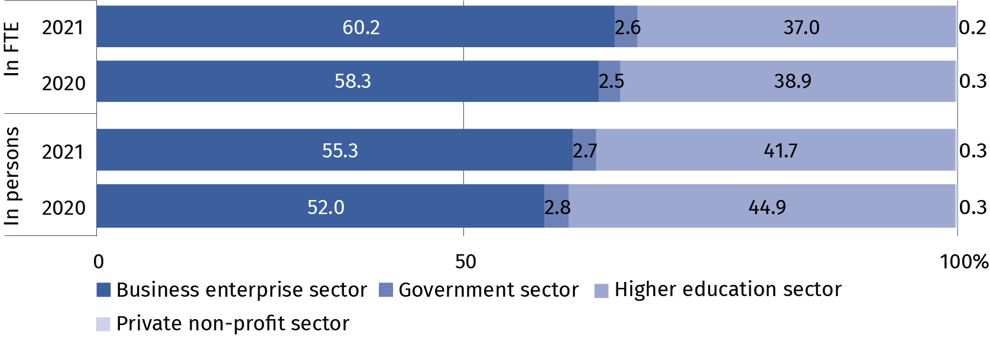
Persons with other tertiary education prevailed among both internal personnel and external personnel – they accounted for 55.9% and 64.6% of a given R&D personnel group, respectively. Among internal R&D personnel 32.7% of persons held at least the scientific degree of doctor (PhD) and among external personnel this share amounted to 19.2%.

Table 4. R&D personnel by educational level and main groups
Specification  a – 2020  b – 2021 |  | Total | With tertiary education |  |  |  |  |  |  |  |  | Persons with other educational level
 |  | Total | with professor title |  | with scientific degree of |  |  |  |  | other |  | Persons with other educational level
 |  | Total |  |  | habilitated doctor |  |  | doctor (PhD) |  |  |  | Persons with other educational level
 |  | in headcount
Total | a | 283 431 |  | 14 196 |  | 26 053 | 49 797 |  | 159 145 |  | 34 240
Total | b | 305 563 |  | 14 645 |  | 25 619 | 51 980 |  | 175 659 |  | 37 660
Internal  personnel | a | 226 131 |  | 11 076 |  | 23 268 | 45 434 |  | 121 301 |  | 25 052
Internal  personnel | b | 249 014 |  | 113 33 |  | 22 761 | 47 307 |  | 139 139 |  | 28 474
External  personnel | a | 57 300 |  | 3 120 |  | 2 785 | 4 363 |  | 37 844 |  | 9 188
External  personnel | b | 56 549 |  | 3 312 |  | 2 858 | 4 673 |  | 36 520 |  | 9 186

Prepared by:  Statistical Office in Szczecin  Director Magdalena Wegner  Phone: (+48 91) 459 77 00 | Issued by:  The Spokesperson for the President  of Statistics Poland  Karolina Banaszek  Phone: (+48) 695 255 011
Press Office  Phone: (+48 22) 608 38 04  e-mail: obslugaprasowa@stat.gov.pl |   stat.gov.pl/en/

@StatPoland

@GlownyUrzadStatystyczny

gus_stat

glownyurzadstatystycznygus

glownyurzadstatystyczny
Related information
Research and experimental development in Poland 2020
Science and technology in 2020
Methodological report. Research and experimental development
Data available in databases
Macroeconomic Data Bank (BDM)
Local Data Bank (BDL)
Knowledge Databases (DBW)
Strateg
Terms used inn official statistics
Research and experimental development (R&D)
Gross domestic expenditures on research and development (GERD)
Intramural expenditures on R&D
Basic research
Applied research
Experimental development
R&D personnel
Internal R&D personnel
External R&D personnel

