Information society in Poland 2022

INFORMATION AND COMMUNICATION TECHNOLOGIES USAGE IN HOUSEHOLDS
AND BY INDIVIDUALS
In 2022, the percentage of individuals aged 16-74 ordering goods or services online for private use in the last
12 months amounted to 64.6%, that is, 3.4 p.p. more than in the previous year.
3.4 p.p.
An increase in the percentage of individuals ordering goods or services online for private purpose compared to 2021

Over 93% of households
had access to the Internet
In 2022, 93.3 percent of households had access to the Internet, 0.9 p.p. more than in the previous year. On an annual basis, the percentage of households with fixed-line broadband access to the Internet increased by 0.7 p.p. Access via mobile broadband indicated 1.4 p.p. fewer households than last year. Internet access and the type of Internet connection owned was varied by household type, domicile classes and degree of urbanisation. Households with children were more likely to have Internet access than without them. Taking into account domicile classes, the percentage of households with Internet was greater in large cities than in smaller towns and in rural areas, and taking into account the degree of urbanisation - it was highest in densely populated areas.
Chart 1. Access to the Internet in households (in % of total households)
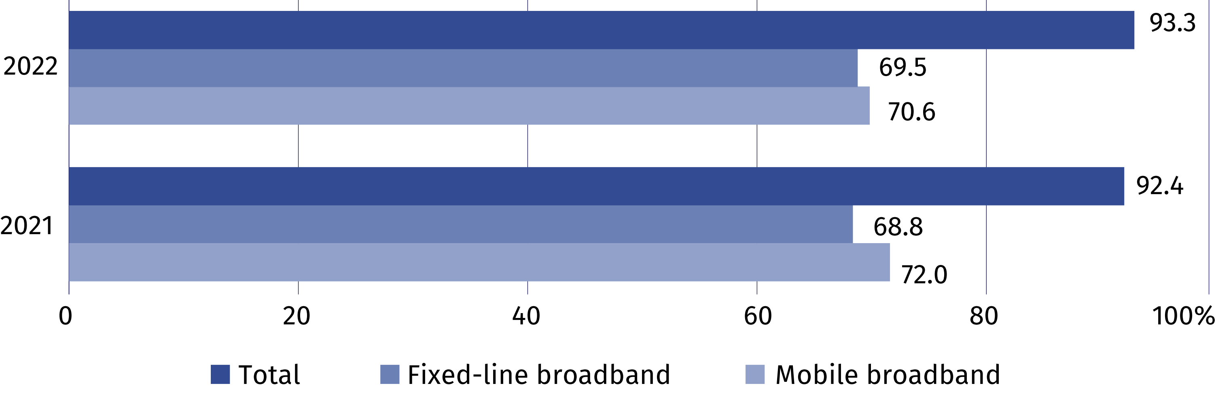
Chart 2. Households with Internet access at home (in % of total households)
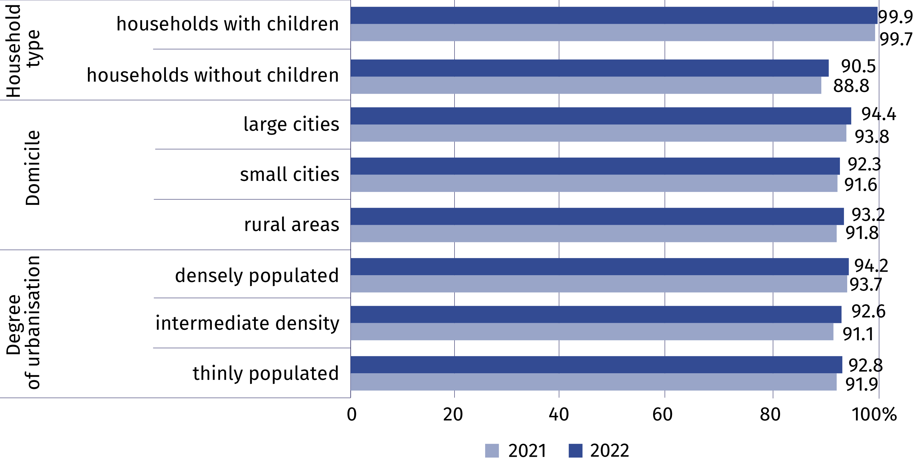
In 2022, individuals using public administration services online in the last 12 months accounted for more than 55% of the population aged 16-74. Use of e-government was indicated by 12.2 p.p. more residents of urban areas than rural areas. The most popular activities performed via the websites or applications of public administration included searching for information, downloading or printing official forms, and sending completed tax declarations.
55.4% of individuals aged
16-74 contacted the public administration through
a website

Table 1. Individuals using e-government services in the last 12 months
Specification | Total | Urban areas | Rural areas
Specification | in % of total individuals
Individuals using e-government services  in the last 12 months | 55.4 | 60.3 | 48.1

in order to:
access personal information stored  by public authorities or public services | 25.4 | 30.2 | 18.4
access information from public databases or registers | 8.1 | 10.5 | 4.5
obtain information | 29.3 | 32.8 | 24.1
make an appointment or reservation | 13.2 | 16.8 | 8.0
receive any official communication/document by public authorities via account  on a website or app | 23.2 | 27.2 | 17.3
print or download official forms | 29.1 | 32.8 | 23.5
submit tax declaration | 28.9 | 34.3 | 20.9
request official documents or certificates | 6.1 | 7.8 | 3.7
request benefits or entitlements | 15.9 | 16.3 | 15.3

In 2022, 64.6% of individuals aged 16-74 ordered or purchased goods or services over the
Internet (compared to 61.2% in 2021). On an annual basis, the disparity between urban and rural areas decreased (from 8.3 p.p. to 5.4 p.p.), the largest remained in Macroregion
Mazowieckie Voivodship (18.7 p.p.), and the smallest in Macroregion East (0.1 p.p.).

Chart 3. Individuals ordering or purchasing goods or services over the Internet for private
use in the last 12 months by macroregions
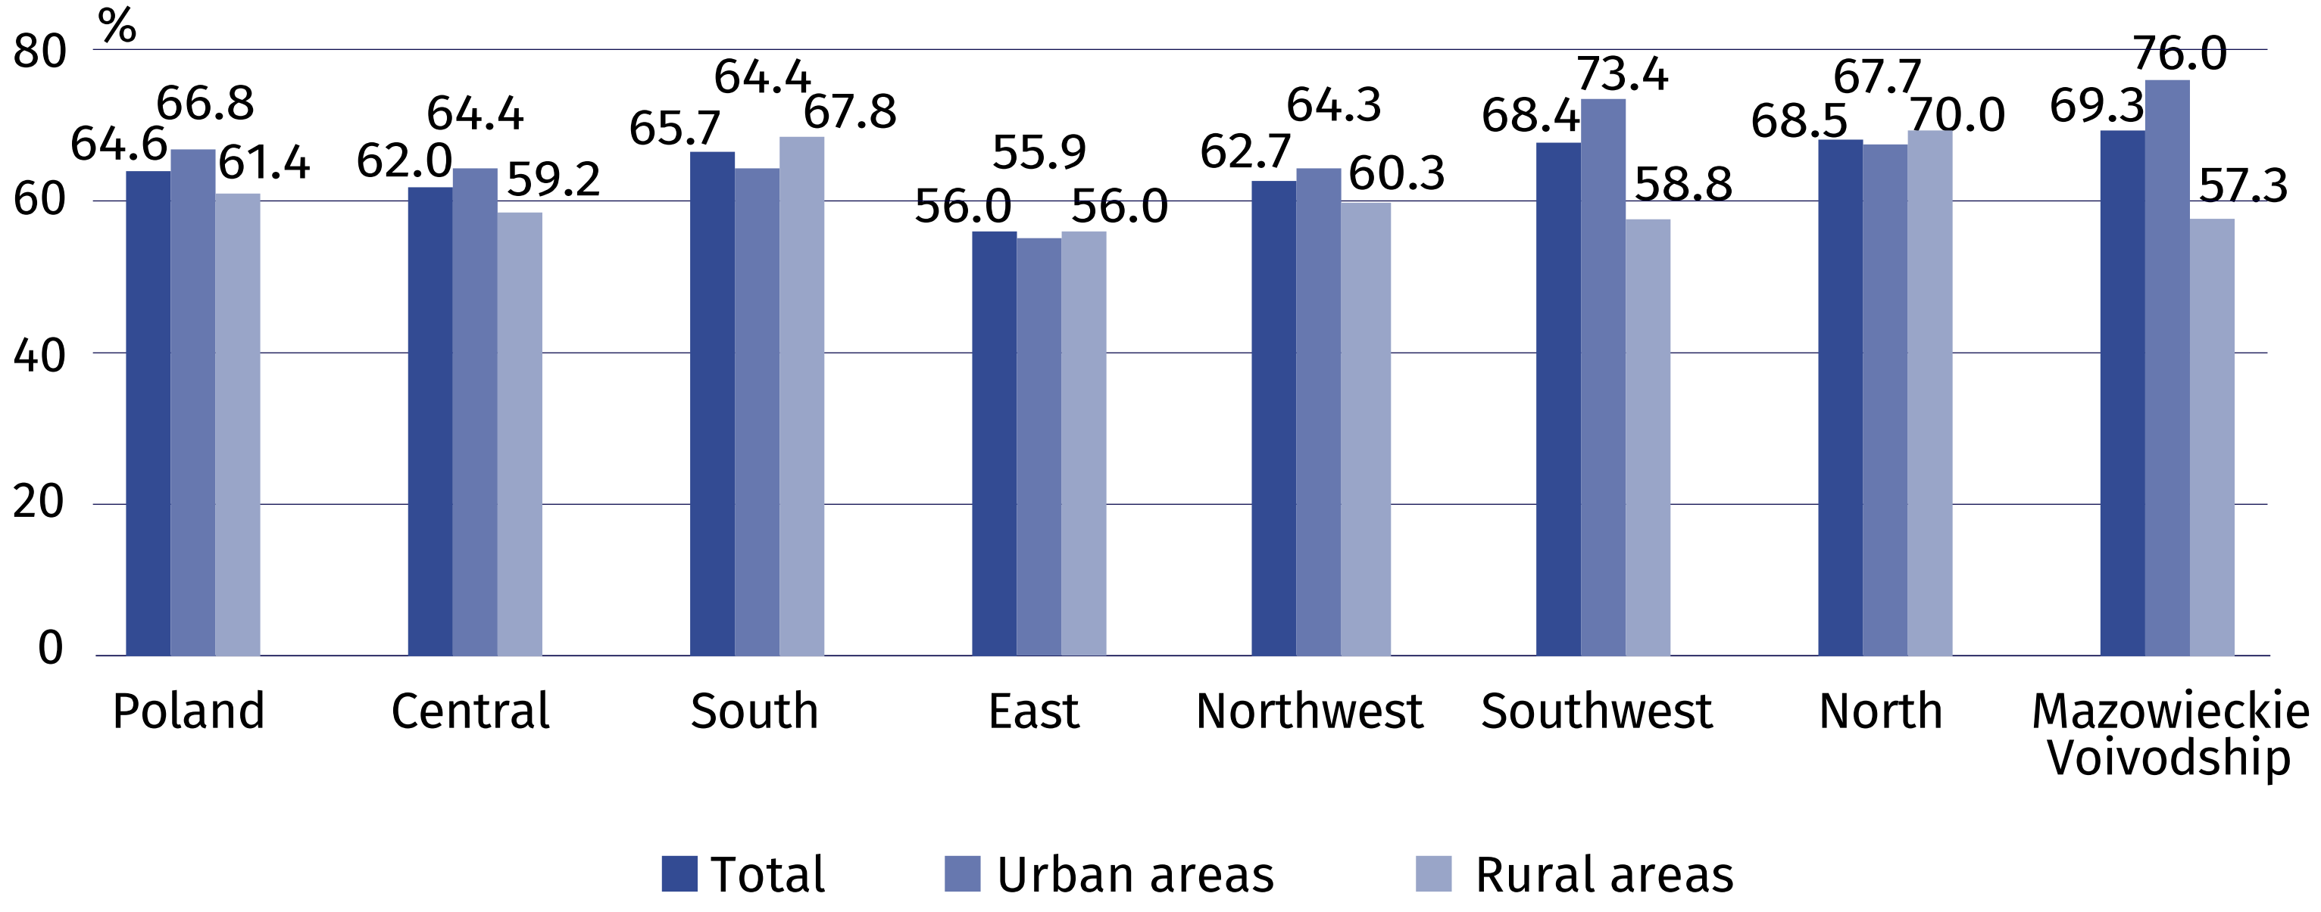
Taking into account the place of residence of individuals ordering or buying online, it can
be noted that both urban and rural areas had the lowest percentage of such individuals
in Macroregion East.
Analysing data on decisions about what was done with devices after they were replaced or no longer used, it can be seen that the most frequently answer for all devices was "It is still kept in my household." One in five individuals sold or gave away their mobile or smartphone after they stopped using it, and one in eight gave their old desktop computer to an e-waste collection point.

Chart 4. Decisions on what to do with a device after it is no longer in use
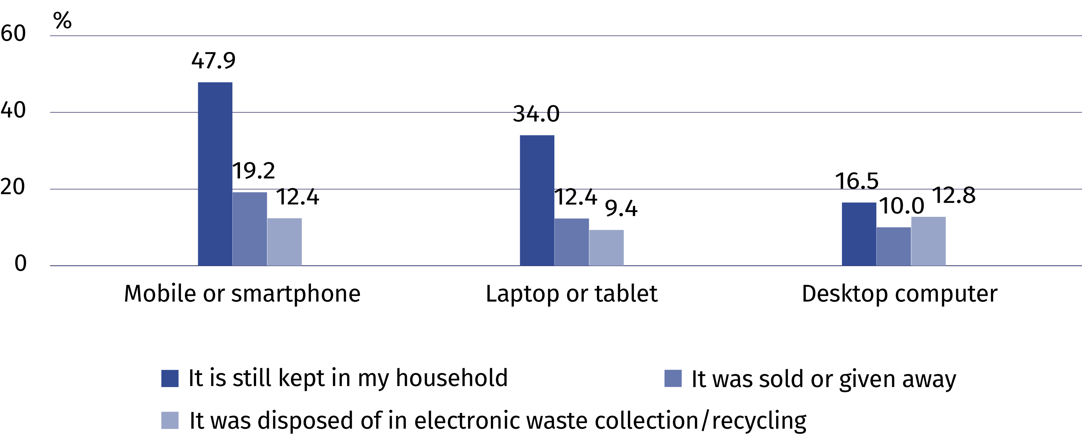

INFORMATION AND COMMUNICATION TECHNOLOGIES USAGE IN ENTERPRISES
In 2022, almost a half of enetrprises provided persons employed with remote access to documents of the enterprise. 55% of enterprises applied measures aimed at reducing the amount of used paper and 43% reduced energy consumption.
5.7 p.p.
An increase in the percentage of enterprises hiring ICT specialists in comparison with
the year 2020
z 2020 r.

In 2022, more than two-thirds of enterprises (67.1%) provided persons employed with remote access to their resources, of which 65.4% to buisness e-mail, 48.3% to documents of the enterprise, and 50.1% to business applications or software. Remote access was provided most often by large entities (97.1%), and least often by the small ones (62.6%).
In 2022, over a third of enterprises (36.8%) organised business meetings via the Internet. More than a quarter (27.3%) applied tightened security measures when organising such meetings.

Chart 5. Enterprises applying selected pro-ecological measures in 2022
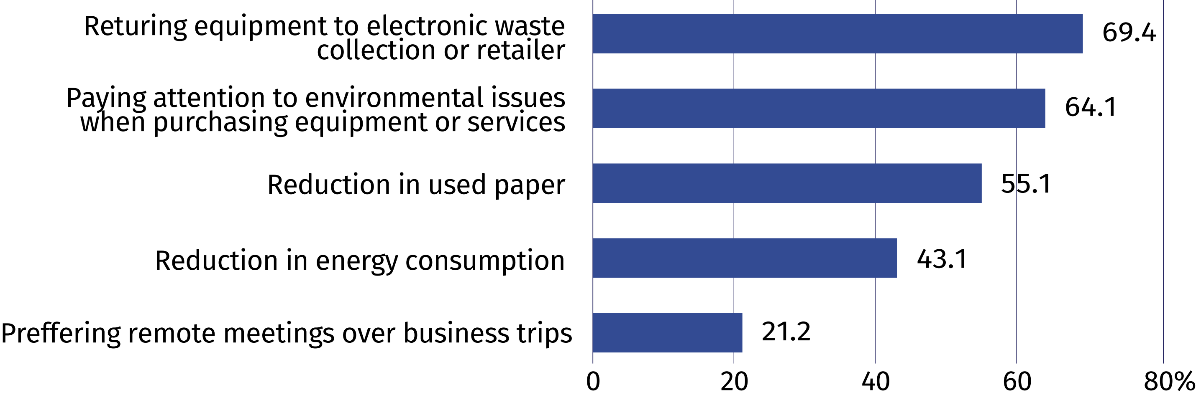
In 2022, over two-thirds of enterprises (70.2%) hiring over 249 persons applied measures
aimed at reducing paper use and paid attention to environmental issues when selecting equipment or services (70.9%). A half of them (52.1%) applied measures aimed at reducing energy consumption.

Chart 6. Enterprises using selected ICT security measures
(in % of total enterprises)
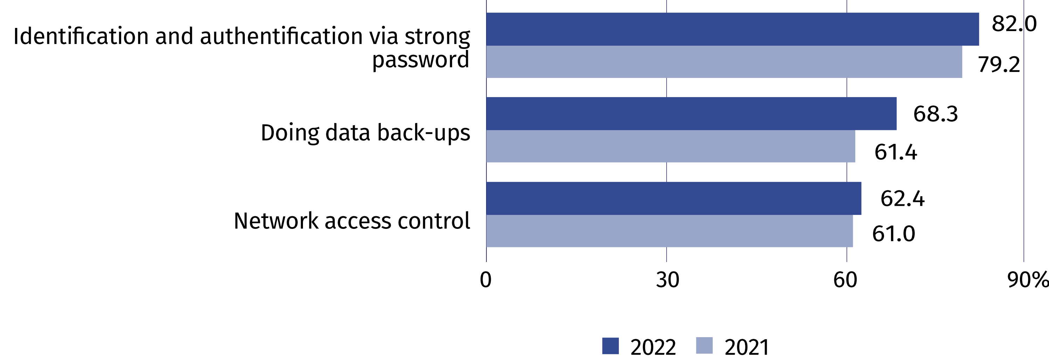
In 2022, almost three-fourths of enterprises declared that ICT security related activities were carried out by external suppliers. Almost 90% of enterprises hiring over 249 persons also
indicated participation of own employees in carrying out these activities.
In 2022, 14.4% of enterprises had an insurance against ICT security incidents
Chart 7. Enterprises providing training to develop ICT-related skills for persons employed
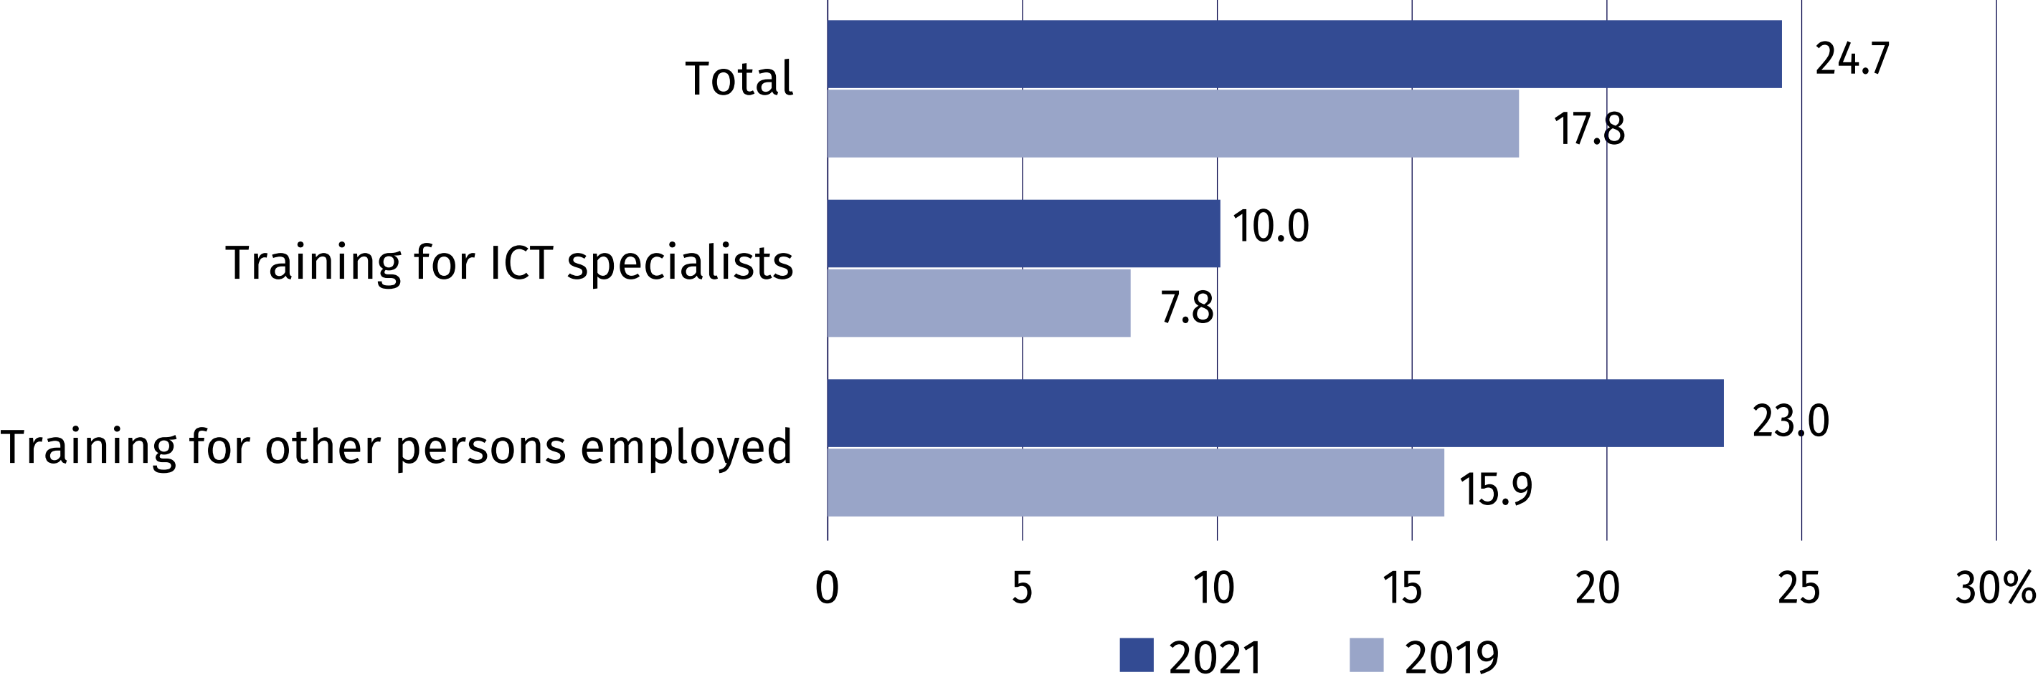
In 2021, 5.1% of enterprises conducted recruitment of ICT specialists
In 2022, slightly over a half of enterprises (51.2%) applied practices to make persons employed more aware of ICT security related issues. The most common way of informing persons
employed was by signing clauses or obligations, e.g. during signing an employment contract (41.3%).

Chart 8. Enterprises having Internet connection with speed at least 500 Mbit/s
(in % of total enterprises)
In 2021, 17.0% of enterprises had web sales. 15.1% of enterprises performed sales via an own website or app, and 9.1% – via e-commerce marketplace websites.
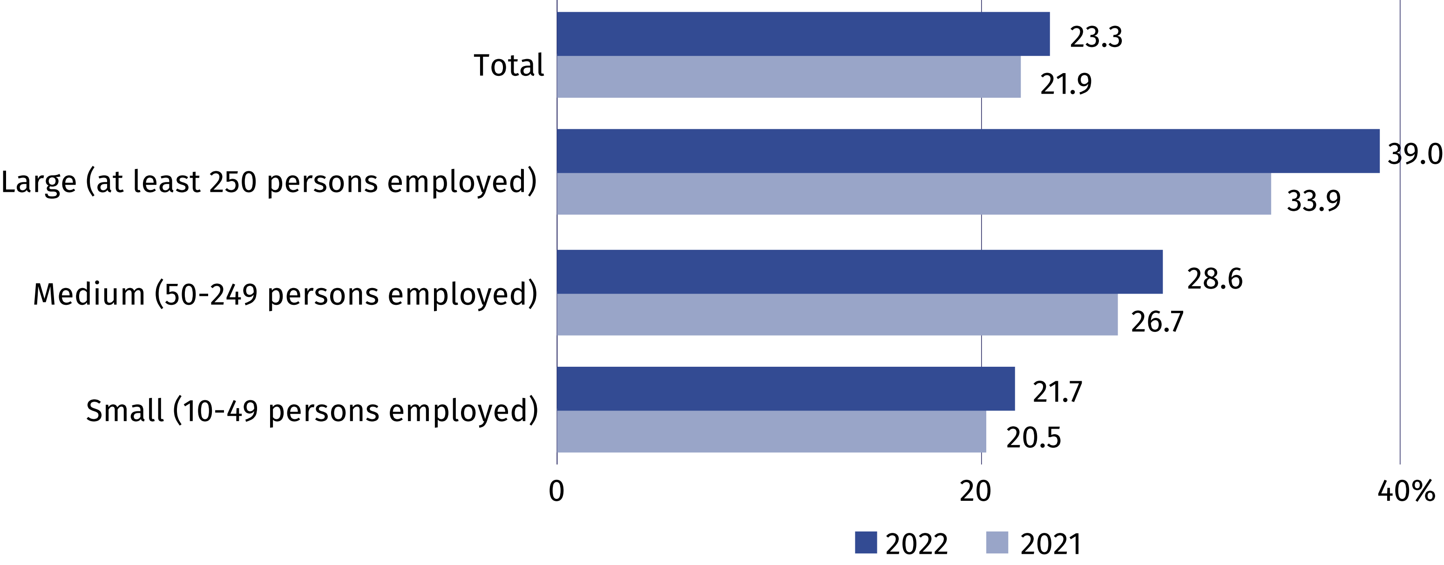
In 2021, almost every fifth enterprise used open data (19.0%, that is, by 1.7 p.p. more than
in the year 2020). Most often they included data related to economy and finance (16.6%).

Prepared by:  Statistical Office in Szczecin  Director Magdalena Wegner  Phone: (+48 91) 459 77 00 | Issued by:  The Spokesperson for the President  of Statistics Poland  Karolina Banaszek  Phone: (+48) 695 255 011
Press Office  Phone: (+48 22) 608 38 04  e-mail: obslugaprasowa@stat.gov.pl |   stat.gov.pl/en/

@StatPoland

@GlownyUrzadStatystyczny

gus_stat

glownyurzadstatystycznygus

glownyurzadstatystyczny
Related information
Information society in Poland in 2021
Methodological report. Information society indicators. Surveys on the use of information and communication technologies
Data available in databases
Local Data Bank – Science and technology – Information society in Poland
Terms used inn official statistics
ICT Security
E-government
E-commerce
Internet
Broadband connection
Mobile connection to the Internet
Open data
Specialist ICT
Information society

