Physical education in 2021
30.1%
Increase in the number of competitors holding Polish sports association licences compared to 2020
In 2021, there were 66 sports associations in Poland. Compared to 2020, the number of competitors and coaches holding licences from the Polish sports associations increased, whereas the number of Polish representatives, judges and instructors decreased. Physical education organisations associated 6.7 thousand units. In relation to the previous year, the number of units increased slightly whereas the number of members and persons practising sports in these organizations decreased.
Polish sports associations
In 2021, Polish sports associations (PZS) selected 10142 members of the national team
In 2021, a total of 66 Polish sports associations (in 2020 – 67, the Polish Karate Association has lost its status as a Polish sports association) and 562 regional sports associations were active. The Polish sports associations selected 10.1 thousand members of the national team, 41.4% of whom were women. There were 48.8% of Polish representatives in junior categories.
Table 1. Basic information on Polish sports associations in 2021
SPECIFICATION | Total | Of which women
Polish representatives | 10142 | 4202
of which:
juniors | 4951 | 2279
Competitorsª | 995359 | 245434
of which:
junior competitors^{b} | 534378 | 139010
Coaching staff^{c}
coaches | 33923 | 2706
instructors | 11404 | 3199
Judges^{c} | 40076 | 8441
of which:
with international class | 1570 | 357
a Including foreign competitors performing in Poland. The competitors can be shown several times if they are licensed in several sports supervised by one sports association. b Total juniors, younger junior "cadets", sub-juniors and children. c Members of the coaching staff and judges can be shown several times if they are licensed in several sports supervised by one sports association.
Compared to 2020, there was a 5.2% decrease in the number of Polish representatives. However, the number of women increased – by 6.0%. The number of representatives who are members of foreign clubs decreased slightly (from 300 in 2020 to 287 in 2021).
In 2021, the largest number of members of the national team was in the Polish Volleyball Federation (1527 representatives), followed by the Polish Basketball Association (552) and the Polish Football Association (488). In 2020, the most numerous was the Polish Karate Federation (2110 representatives).
Chart 1. Polish representatives in 2021
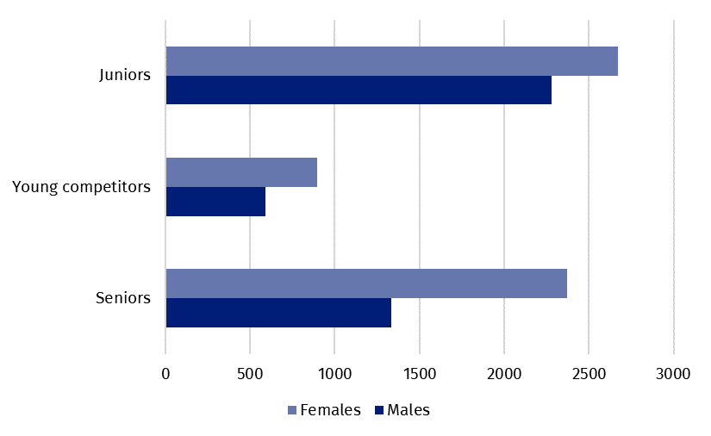
In 2021, 995.0 thousand competitors held licenses of the Polish sports associations (in 2020 – 764.6 thousand), of which 24.7% were women (in 2020 – 19.3%). There were 41.4% competitors in the senior category (in 2020 – 30.9%).
Map 1. Competitors registered in Polish sports associations in 2021
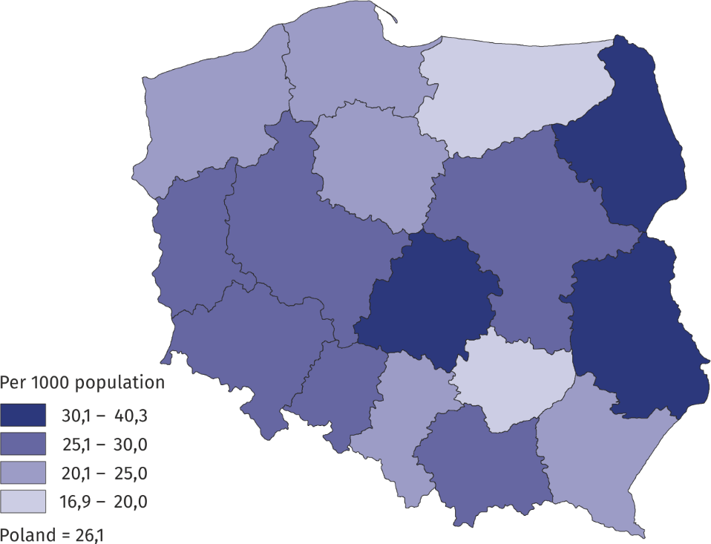
Most persons were practising in Mazowieckie Voivodship (14.1%) followed by Śląskie Voi-vodship (11.0%) and Wielkopolskie Voivodship (9.1%). As in 2020, the highest percentage were competitors holding Polish Football Association licences – 38.3% (in 2020 – 47.4%), followed by the Polish Tug of War Federation – 22.4% and the Polish Sport Shooting Fed-eration – 4.6%.
The number of competitors with disabilities holding licenses of the Polish sports associa-tions was 3,036 persons in 2021 (an increase of 19.9% compared to 2020), of which over 75% were men. The percentage of competitors with disabilities in relation to the total number of competitors was 0.3% - the highest in Zachodniopomorskie Voivodship (0.7%).
Foreign competitors holding licenses of the Polish sports association constituted 0.4% of all competitors in 2021 (0.6% in 2020). Of these, football licensed competitors predominat-ed (64.4%, 52.7% in 2020). The highest percentage of foreign competitors was recorded in Lubuskie and Opolskie Voivodships (0.7% each).
In 2021, the number of coaches holding licences of the Polish sports association increased by over 3% in relation to 2020, whereas the number of instructors decreased by over 4%
In 2021, the coaching staff employed in the Polish sports associations amounted to 663 persons. This number slightly increased in relation to 2020 (by 23 persons), with a decrease record-ed in the employment of medical staff (231 persons in 2021 and 272 persons in 2020). In 2021, 33.9 thousand coaches and 11.4 thousand instructors held current licenses of the Polish sports associations. Compared to the previous year, the number of coaches in-creased by 1.0 thousand, whereas the number of instructors decreased by 0.5 thousand.
Chart 2. Coaching staff in Polish sports associations in 2021
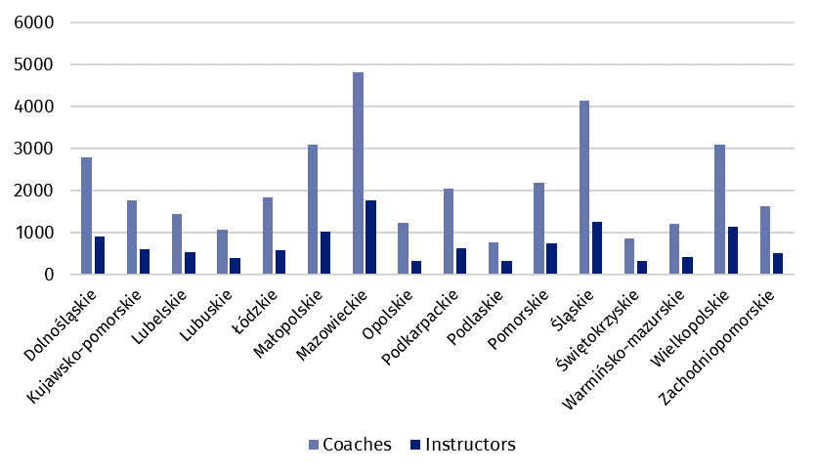
In 2021, 40.1 thousand sports judges were registered in the Polish sports associations (a decrease of 0.8% compared to 2020). Of these, 21.1% were women. The percentage of judges with international class was 3.9%. The highest number of judges held licences in sports shooting (22.7%). A significant group were football referees (20.5%) and athletics judges (6.8%). Women as judges prevailed mainly in artistic gymnastics – 100% each and synchro-nous swimming – 97.2%. A significant part of them also judged wheelchair rugby (75.9%) and horse riding (67.8%).
Achievements of Polish competitors in the international area
In 2021, the Polish representatives won 14 Olympic medals and 695 medals of the World and European Championships

The Olympic Games Tokyo 2020, which were postponed from 2020 due to the COVID-19 pandemic, were held in Tokyo in July and August 2021. 210 Polish representatives took part in the competition, winning 14 medals: 4 gold (4 in athletics), 5 silver (2 in athletics, 1 in canoeing, 1 in rowing and 1 in sailing) and 5 bronze (3 in athletics, 1 in canoeing and 1 in wrestling).
In 2021, Polish representatives at the World Championships occupied the podium 232 times (in 2020 – 44 times). They won 69 gold, 71 silver and 92 bronze medals. The most medal places in 2021 were won by competitors in aerial sports (45 medals), followed by bodybuilding, fitness and powerlifting (44 medals) and kick-boxing (23 medals).
At sports events of the European Championships rank, the Poles won a total of 463 medals in 2021 (122 in 2020), of which: 114 gold, 153 silver and 196 bronze. The most medals were won in sumo (68), followed by bodybuilding, fitness and powerlifting (52) and ITF taekwondo and kick-boxing (51 each).
In 2021, the Polish competitors with disabilities won 25 Paralympic medals and 144 medals at the World Championships and European Championships
Due to the COVID-19 pandemic, the Tokyo 2020 Paralympic Games were also postponed from 2020, eventually taking place in August and September 2021. There were 89 Polish representatives at the Games, who won 25 medals (7 gold, 6 silver and 12 bronze). As many as 11 medals were won by Polish competitors in athletics.
In 2021, competitors with disabilities won 59 medals at the World Championships (16 gold, 19 silver, 24 bronze) and 85 medals at the European Championships (20 gold, 38 silver and 27 bronze). In 2020, competitors with disabilities won 20 medals at the World Championships and 3 medals at the European championships).
Table 2. Medals won by Polish competitors in the international arena in 2021
SPECIFICATION | Medals
SPECIFICATION | total | gold | silver | bronze
Olympic Games Tokyo 2020 | 14 | 4 | 5 | 5
World Championships | 232 | 69 | 71 | 92
of which young competitors and juniors | 133 | 39 | 43 | 51
European Championships | 463 | 114 | 153 | 196
of which young competitors and juniors | 292 | 79 | 95 | 118
Tokyo 2020 Paralympic Games | 25 | 7 | 6 | 12
World Championships for persons with disabilities | 59 | 16 | 19 | 24
European Championships for persons with disabilities | 85 | 20 | 38 | 27

Physical education organisations
In 2021, physical education organisations such as: Academic Sports Association, „Rural Sports Teams” Association, The Polish Sports Association for the Disabled ’’Start’’ and the Society for the Promotion of Physical Education showed a total of 6.7 thousand organisational units (an increase of 41 compared to 2020), 317.2 thousand members (in 2020 – 310.3 thousand) and 276.6 thousand persons practising sports (in 2020 – 282.6 thousand). In terms of the number of members and persons actively practising sports, the „Rural Sports Teams” Association was the most numerous one (201.5 thousand members, 175.9 thousand persons practising sports). The Society for Promotion of Physical Education also had a large membership base (65.3 thousand members, 77.1 thousand persons practising sports). The Academic Sports Association reported 47.4 thousand members and 20.9 thousand persons practising sports and the Polish Sports Association for the Disabled "Start" – 3.0 thousand members and 2.6 thousand persons practising sports.
The highest number of members of physical education organisations was recorded in Zachodniopomorskie Voivodship (14.2%). The highest number of persons actively practising sports was registered in Wielkopolskie Voivodship (14.0%).
When quoting Statistics Poland data, please provide information: “Source of data: Statistics Poland”, and when publishing calculations made on data published by Statistics Poland, please provide information: “Own study based on Statistics Poland data”.
Prepared by:  Statistical Office in Rzeszów  Director Marek Cierpiał-Wolan  Phone: (+48 17) 853 52 10 | Issued by:  The Spokesperson for the President  of Statistics Poland  Karolina Banaszek  Phone: (+48) 695 255 011
Press Office  Phone: (+48 22) 608 38 04  e-mail: obslugaprasowa@stat.gov.pl |   stat.gov.pl /en/

@StatPoland

@GlownyUrzadStatystyczny

gus_stat

glownyurzadstatystycznygus

glownyurzadstatystyczny
Related information
Physical education in years 2019 and 2020

Data available in databases
Local Data Bank

Terms used in official statistics
Sports instructor
Regional sports association
Organisation of physical education
Sports judge
Sport
Sports
Sports coach
Competitor
Sports association

Sports associations according to the list of Polish sports associations announced by the Minister of Culture, National Heritage Sport – Communication of 7 July 2021. Data are preliminary.
Competitors can be shown more than once if they hold licences in several sports supervised by one sports association.
Coaching staff members may be shown more than once if they hold licences in several sports supervised by one sports association.
Sports judges may be shown more than once if they hold licence in several sports.
This news release covers: in AZS - clubs, in LZS - teams, sports clubs and student sports clubs, in PZSN "Start" - organizational units, in TKKF - centres and clubs.

