Occupancy of tourist accommodation establish-ments in the first quarter of 2022
(concerns tourist accommodation establishments with 10 or more bed places)
280.4%
Increase in the number of tourists in tourist accommodation establishments in the 1st quarter of 2022 compared to the corresponding period of 2021
In the first quarter of 2022, 5.9 million tourists were accommodated in tourist accommodation establishments, with 15.5 million overnight stays provided to them. Compared to the first quarter of 2021, the number of tourists staying in accommodation establishments increased by 280.4%, while the number of overnight stays provided to them increased by 292.6%.

In the first quarter of 2022, there was an increase in the occupancy of tourist accommo-dation establishments in Poland compared to the same period of 2021. The increase in the number of tourists and the number of nights provided to them was influenced, among other things, by the absence of restrictions on the operation of accommodation establishments due to the COVID-19 pandemic, which were in force in the first three months of the last year.
Occupancy of tourist accommodation establishments in the first quarter of 2022
In the first quarter of 2022, 0.8 million more foreign tourists were accommodated in tourist accommodation establishments than in the first quarter of 2021
According to the results obtained from the tourist accommodation establishments survey, 5.9 million tourists were accommodated in tourist accommodation establishments in the first quarter of 2022, of which 5.0 million were domestic tourists and 0.9 million were foreign tourists. Compared to the first quarter of 2021, the number of total tourists was almost 4 times higher, of which the number of domestic tourists increased by 3.5 times and foreign tourists by 7.5 times.
Among foreign tourists, visitors from Europe were the most frequent users of accommodation establishments - 801.4 thousand. They accounted for 86.3% of all foreign tourists and their number was over 7 times higher than in the first quarter of 2021. The largest number of tourists came from Germany (200.2 thousand), followed by tourists from Ukraine (187.3 thousand) and tourists from the United Kingdom (70.8 thousand). Tourists from these three countries constituted together 49.4% of the total number of foreign tourists who were accommodated in tourist establishments in Poland in the first quarter of 2022.
Chart 1. Tourists in tourist accommodation establishments and overnight stays
Compared with the same period of the previous year, all types of establishments recorded an increase in the number of tourists and the number of nights provided to them. The largest increase in the number of tourists, more than 10-fold, occurred in holiday youth centres, while the smallest, nearly 2-fold, was recorded by the excursion hostels. In the first quarter of 2022, tourists were most likely to choose to stay in hotels, where 4.4 million people stayed. Overnight statys in these establishments were provided to 71.7% of all domestic tourists and 84.3% of all foreign tourists.
In the first quarter of 2022, 4.4 million tourists stayed
in hotels
Table 1. Occupancy of tourist accommodation establishments by type of establishment
Specification | Tourists accommodated |  | Overnight stays provided
Specification | in thousand | Q1/2021=100 | in thousand | Q1/2021=100
Total | 5944.2 | 380.4 | 15519.8 | 392.6
Hotels and similar establishments | 4985.6 | 381.9 | 10648.4 | 382.0
hotels | 4381.3 | 387.8 | 9096.9 | 392.8
motels | 34.2 | 246.0 | 63.5 | 248.4
boarding houses | 104.8 | 386.7 | 275.4 | 367.1
other hotel establishments | 465.3 | 345.4 | 1212.6 | 326.6
Other establishments | 958.6 | 372.8 | 4871.4 | 417.8
excursion hostels | 9.4 | 170.0 | 48.1 | 276.1
shelters | 35.1 | 404.4 | 64.1 | 395.1
youth shelters | 6.7 | 333.1 | 19.4 | 366.8
school youth shelters | 29.5 | 387.4 | 120.7 | 400.5
holiday centres | 204.5 | 464.7 | 843.9 | 541.8
holiday youth centres | 5.5 | 1045.4 | 32.4 | 1449.9
training-recreational centres | 118.1 | 334.2 | 451.4 | 328.6
creative arts centres | 3.9 | 414.2 | 16.4 | 454.1
complexes of tourist cottages | 12.8 | 277.5 | 41.2 | 175.6
camping sites and tent camp sites | 3.1 | 392.1 | 7.9 | 406.5
hostels | 112.9 | 277.3 | 305.1 | 201.5
health establishments | 164.7 | 584.0 | 2006.7 | 784.9
rooms for guests | 141.5 | 332.5 | 498.6 | 306.0
agritourism lodgings | 17.2 | 292.2 | 69.8 | 214.6
other not classified | 93.7 | 315.3 | 345.5 | 203.4

An increase in the number of tourists accommodated was recorded in all voivodships compared with the first quarter of 2021, with the largest (nearly 6-fold) in Warmińsko-Mazurskie Voivodship. The smallest increase (more than 2-fold) was recorded in Lubuskie Voivodship. Nearly half of tourists (47.2%) accommodated in the first quarter of 2022, stayed in three voivodships: Małopolskie, Mazowieckie and Dolnośląskie (2.8 million in total). The fewest tourists (56.9 thousand) stayed in establishments located in the Opolskie Voivodship - 1.0% of the total.
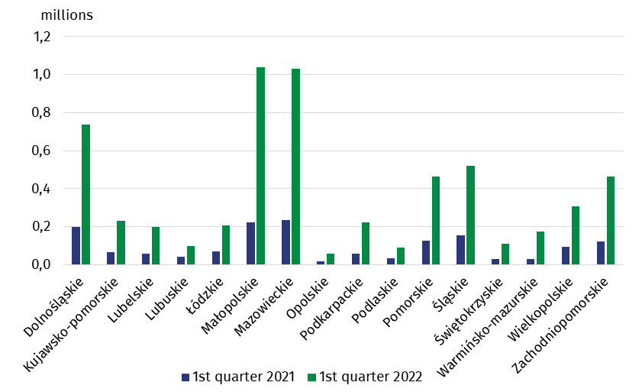
Chart 2. Tourists accommodated by voivodship
In the first quarter of 2022, 11.6 million more overnight stays were provided to tourists than in the same quarter last year
In the first quarter of 2022, tourists made 15.5 million overnight stays, i.e. almost 4 times more than in the corresponding quarter of 2021. Domestic tourists made 13.1 million overnight stays, while foreign tourists - from 2.4 million. Compared to the first quarter of 2021, there was an almost 4-fold increase in the number of overnight stays provided to domestic tourists and a 5.5-fold increase in overnight stays provided to foreign tourists. Tourists were most likely to choose hotels, where they made 9.1 million overnight stays.
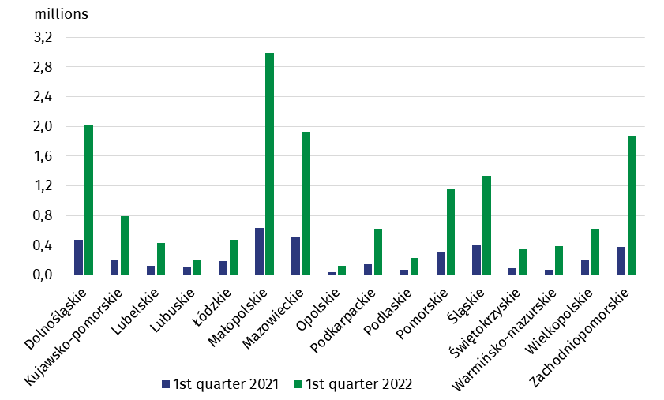
Chart 3. Overnight stays provided in tourist accommodation establishments by voivodship
The highest number of overnight stays was provided in Małopolskie Voivodship - 3.0 million (19.3% of the total), and the lowest in Opolskie Voivodship - 125.3 thousand (0.8%). The increase in the number of overnight stays, like the increase in the number of tourists, was recorded in all the voivodships, with the largest (nearly 6-fold) in Warmińsko-Mazurskie Voivodship, and the smallest (nearly 2-fold) in Lubuskie Voivodship.
In the first quarter of 2022, the occupancy rate of bed places in accommodation
establishments was 39.2%
In the first quarter of 2022, the occupancy rate was 32.2% and was 19.1 pp higher than in the first quarter of last year. The lowest occupancy rate was recorded in January - 27.0%, while in February and March this indicator was 34.9% and 35.2% respectively.
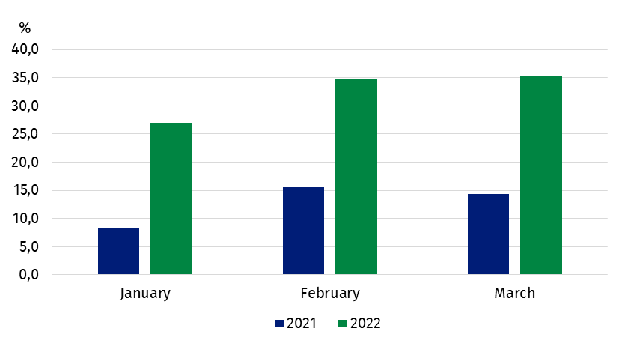
Chart 4. Occupancy rate of bed places

When quoting Statistics Poland data, please provide information: “Source of data: Statistics Poland”, and when publishing calculations made on data published by Statistics Poland, please provide information: “Own study based on Statistics Poland data”.

Prepared by:  Statistical Office in Rzeszów  Director Marek Cierpiał-Wolan  Office: tel. (+48 17) 853 52 10 | Issued by:  The Spokesperson for the President  of Statistics Poland  Karolina Banaszek  Mobile: (+48) 695 255 011
Press Office  Phone: (+48 22) 608 38 04  e-mail: obslugaprasowa@stat.gov.pl |   stat.gov.pl/en/

@ StatPoland

@GlownyUrzadStatystyczny

gus_stat

glownyurzadstatystycznygus

glownyurzadstatystyczny
Related information
Occupancy of tourist accommodation establishments in March 2022 in the face of the inflow of refugees from Ukraine and the absence of restrictions related to the COVID-19 pandemic
Occupancy of tourist accommodation establishments in 2021
Tourism in 2020
Data available in databases
Local Data Bank
Terms used in official statistics
Tourist
Tourist accommodation establishment
Bed places in tourist accommodation establishments
Foreign tourists in tourist accommodation establishments
Nights spent (overnight stays) in tourist accommodation establishments.
Duration of the stay
Occupancy rate of bed places in tourist accommodation establishments

