Tourist accommodation establishments in coastal areas in July and August 2022
(concerns tourist accommodation establishments with 10 or more bed places)
In July and August 2022, 1.8 million tourists were accommodated in tourist accommodation establishments located in coastal areas, and 8.5 million overnight stays were provided for them. Compared to the same period last year, the number of tourists was higher by 2.4%, and number of overnight stays decreased by 2.0%.
2.4%
Increase in the number of tourists in tourist accommodation establishments in coastal areas in July and August 2022 compared to the corresponding months of 2021

Coastal gminas according to Eurostat methodology
According to the Eurostat methodology, 55 gminas of the voivodships: Pomorskie (26), Zachodniopomorskie (23) and Warmińsko-Mazurskie (6) are classified as coastal areas in Poland. They are situated by the Baltic Sea or are in direct proximity to the sea. They cover 2.5% of Poland's territory (7.9 thousand square kilometres) and are inhabited by 4.2% of the country's population (1.6 million people).
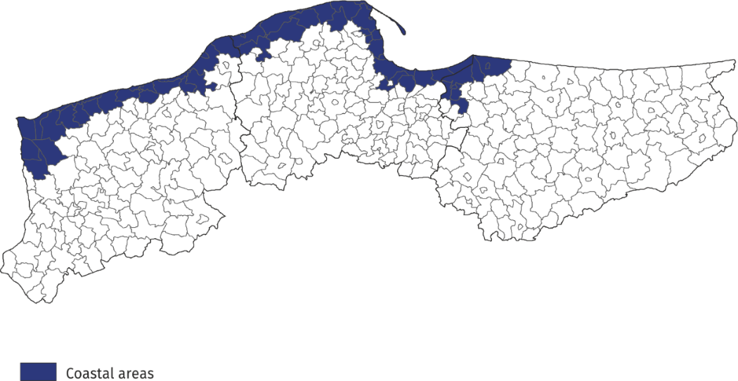
Map 1. Coastal gminas

Tourist accommodation establishments in coastal areas
As of the end of July 2022, 2283 tourist accommodation establishments operated in coastal areas, i.e. almost 1/4 of all establishments in Poland. The vast majority of them (almost 70%) operated on a seasonal basis (the percentage of seasonal establishments in Poland was less than 30%).
Almost half of the holiday centers operating in the country functioned here, as well as
43.5% of rooms for guest, 42.6% of complexes of tourist cottages, 38.7% of holiday youth centres and 28.3% of camping sites. Compared to the previous year, the number of accommodation establishments in coastal areas decreased by 59, i.e. by 2.5%.
The structure of accommodation establishments in coastal areas is fundamentally different from the structure of establishments in total in Poland. Rooms for guests prevail – at the end of July this year there were 842 of them and they accounted for 36.9% of all establishments in these areas. There were numerous holiday centres – 445 (19.5% of all establishments in coastal area) and complexes of tourist cottages – 223 (9.8%). Hotels accounted for 10.4% of tourist accommodation establishments in coastal areas (26.3% in Poland).
Chart 1. Tourist accommodation establishments in coastal areas in 2022 – as of 31 July
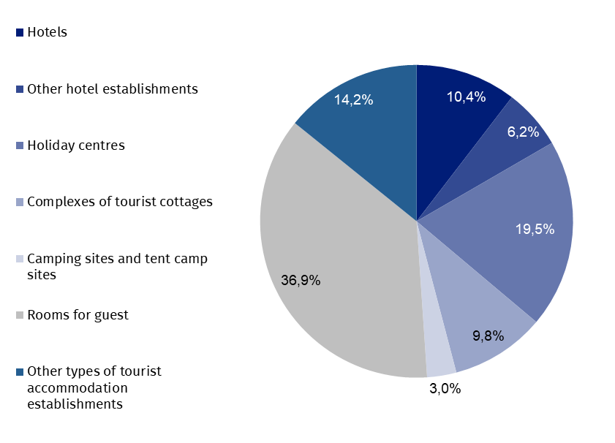
At the end of July 2022, tourist accommodation establishments located in coastal gminas had 216.0 thousand bed places, which accounted for 27.7% of the total number of bed places in accommodation establishments in Poland, and it was 1.1 thousand (0.5%) less than a year ago. However, compared to the previous year the number of bed places increased, among other things, in other hotel establishments (by 1.2 thousand), hotels (by 1.0 thousand), other types of tourist accommodation establishments (by 0,5 thousand), complexes of tourist cottages (by 0.3 thousand), training recreational centres (by 0.2 thousand), boarding houses
(by 64 places) and in agrotourism lodgins (by 29 places).

Chart 2. Bed places in coastal areas in 2022 – as of 31 July
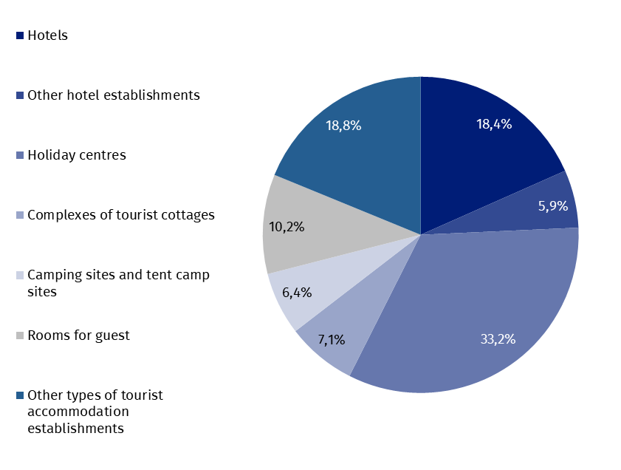
The largest number of bed places was offered by holiday centres – 71.6 thousand, i.e. 33.2% of the total number of bed places in the area. Hotels had 39.7 thousand (i.e. 18.4%) places prepared for tourists, while rooms for guest had 22.0 thousand (i.e. 10.2%). Among other types of establishments, 15.4 thousand bed places were available for tourists in complexes of tourist cottages, and 12.9 thousand in health establishments.
Establishments in coastal areas are larger than the average in Poland. One establishment functioning in coastal areas had an average of 95 places (80 places in the country).
In 2022, the density index of the accommodation establishments in coastal areas was 27.8 places per 1 square kilometre of area (in the country – 2.5).
Tourists accommodated in tourist accommodation establishments
Tourists accommodated in establishments in coastal areas during the holiday period constituted 27.1% of all tourists accommodated in the whole country during that period

During the holiday season (i.e. in July and August) of 2022, 1.8 million tourists were accommodated in accommodation establishments located in coastal gminas (898.3 thousand – in July and 880.5 thousand – in August), i.e. 21.7% of tourists accommodated in accommodation establishments throughout the country during this period (in the corresponding period of 2021 this percentage amounted to 23.3%). Compared to the corresponding period of 2021, the number of tourists using overnight stays in July and August was higher by 40.9 thousand,
i.e. by 2.4% (in July by 2.0% and in August by 2.7%).
Over 1/3 of tourists (598.1 thousand) staying in these areas were accommodated in hotels.
A large number of tourists chose to stay in holiday centres – 429.6 thousand (24.1%), and in rooms for guest – 154.0 thousand (8.7%).
Among the total number of tourists accommodated in tourist accommodation establishments 84.7% (1.5 million) were domestic tourists, and 15.3% (0.3 million) were foreign tourists. In relation to the same period of 2021, the number of domestic tourists was lower by 1.7% and the number of foreign tourists by 32.6%.

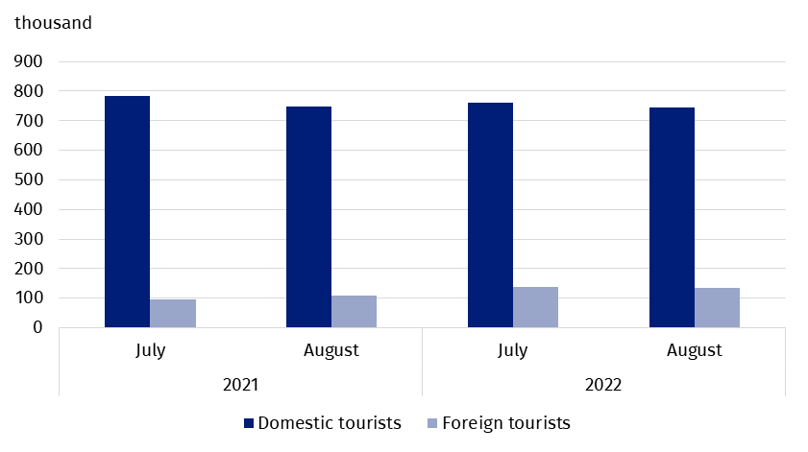
Chart 3. Tourists accommodated in coastal areas in July-August
In July and August 2022, as in previous years, the majority of foreign tourists accommodated in coastal areas were from Germany. During this period, 157.3 thousand of them arrived and compared to the same period last year there were more of them by 9.4 thousand, but their share in the total number of foreign tourists was much lower than the year before and amounted to 58.0% – in the same period of 2021 they accounted for 72.3% of the total number of foreign tourists. The share of guests from other countries did not exceed 6.0%; most of them were from Sweden (14.6 thousand), Norway (13.4 thousand) and Czechia (11.8 thousand), who constituted, respectively 5.4%, 4.9% and 4.3% of the total number of foreign tourists accommodated in coastal areas.
Overnight stays provided at tourist accommodation establishments
Overnight stays provided in July and August in coastal areas accounted for 32.9% of all overnight stays in Poland during this period

A total of 8.5 million overnight stays were provided for tourists staying in coastal areas in July and August this year, which accounted for 32.9% of all overnight stays provided at tourist accommodation establishments in Poland during that period. In the same period last year, the share was 2.0 percentage points lower.
This year a little more overnight stays were provided to tourists in August (4.3 million), than in July (4.2 million). Compared to the same period in 2021, the total number of overnight stays provided in July and August this year was lower by 2.0% (i.e. 169.8 thousand) – in July by 0.4% (15.2 thousand), and in August by 3.6% (154.5 thousand).
On average, 5 overnight stays were provided for tourists during their holiday trips, while the average length of a tourist stay in Poland during that period was just over 3 nights.
7.4 million overnight stays were provided for domestic tourists (5.3% less than in July and August last year) in the period July-August 2022, and they accounted for 87.1% of the total number of overnight stays in coastal areas and 33.2% of the total number of overnight stays provided for domestic tourists in the same period in Poland. A total of 1.1 million overnight stays were provided for foreign tourists, which was 29.0% more than in the previous year. Most overnight stays were provided to tourists from countries neighbouring Poland, i.e. Germany (745.2 thousand – 68.6% of overnight stays of foreign tourists), Czechia (47.4 thousand – 4.4%) and Ukraine (45.2 thousand – 4.2%).

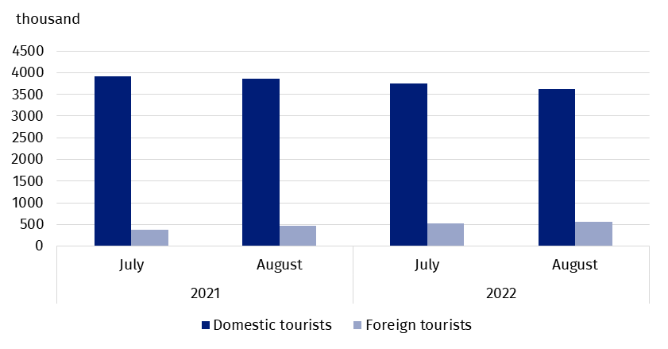
Chart 4. Overnight stays provided tourist accommodation establishments in coastal areas
in July-August
Occupancy rate of bed places in tourist accommodation establishments
During the holiday season (July, August), places in tourist accommodation establishments located in coastal gminas are usually better occupied than in other areas of the country.
The occupancy rate of bed places in coastal gminas was higher than the national average and amounted to 64.0% in July and 62.6% in August

In July, the occupancy rate of bed places amounted to 64.0%, and in August – 62.6%, while the average for the entire country amounted to 53.2% and 53.8%, respectively.
Similarly, in the corresponding months of 2021, the indicator for coastal areas was higher than for the country – in July 64.0% and 49.9%, and in August, 64.4% and 52.4%, respectively.
Chart 5. Tourism in coastal areas in comparison with the country in July-August 2022
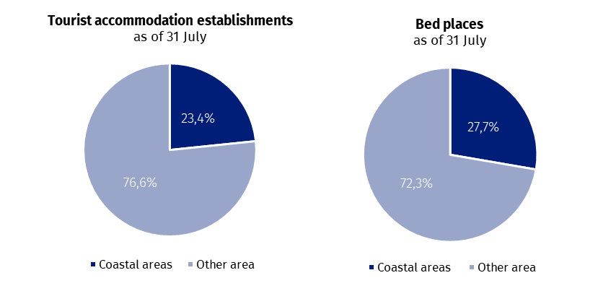

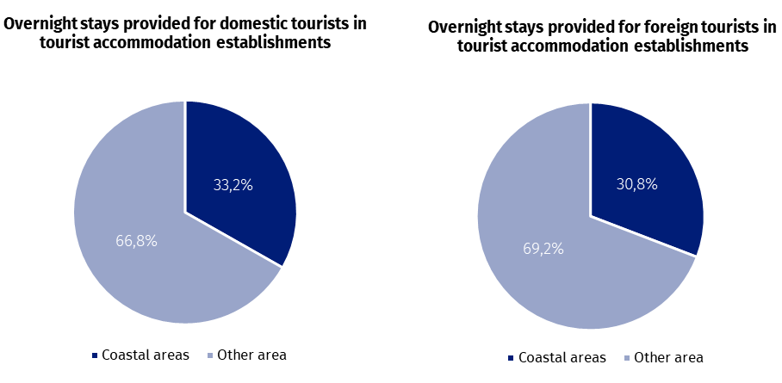
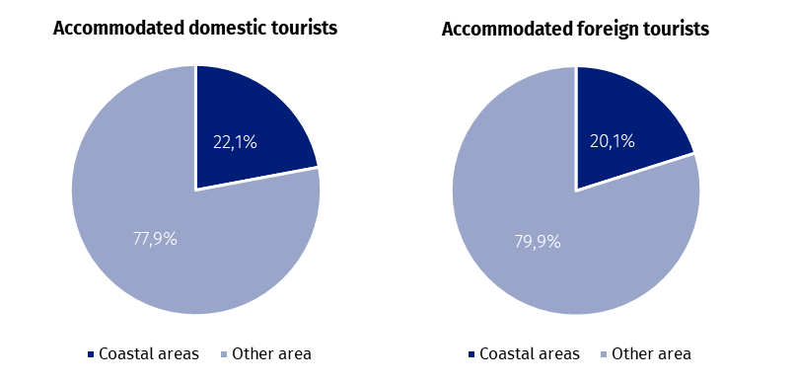
Occupancy of tourist accommodation establishments in gminas located in coastal areas in July and August 2022
In the coastal areas in July and August this year the highest number of overnight stays were provided in accommodation establishments located in Kołobrzeg urban gmina - 888.1 thousand, which constituted over 1/10 of all overnight stays provided in this area. 159.0 thousand tourists were accommodated there. This means that during the two holiday months, there were 359 tourists using the accommodation establishment and 1009 overnight stays per
100 inhabitants of the city.
In the period July-August, the largest number of overnight stays in coastal gminas was provided in urban gmina Kołobrzeg and Gdańsk

Large tourist traffic was also recorded in Gdańsk, where in July-August with almost 830.0 thousand overnight stays were provided to 290.6 thousand tourists. For 100 inhabitants of this city there were 60 tourists and 171 overnight stays.
From approximately 400 thousand up to 700 thousand overnight stays were provided in 5 gminas: Ustronie Morskie – 419.4 thousand, Świnoujście – 480.3 thousand, Władysławowo – 537.5 thousand, Rewal – 618.1 thousand and Mielno – 678.4 thousand.
After over 300 thousand overnight stays were recorded in tourist night establishments in the following gminas: Kołobrzeg rural gmina (376.3 thousand) and Łeba (316.7 thousand).

Table 1. Tourist accommodation establishments and its occupancy in the period July-August in 2022
Gmina | Overnight stays provided |  |  | Tourists accommodated
Gmina | in thousand | July-August 2021=100 | in per-centages | in thousand | July-August 2021=100
Coastal area  of which: | 8454.8 | 98.0 | 100.0 | 1778.9 | 102.4
Kołobrzeg  (urban gmina) | 888.1 | 101.3 | 10.5 | 159.0 | 103.7
Gdańsk | 830.0 | 104.6 | 9.8 | 290.6 | 111.7
Mielno | 678.4 | 102.2 | 8.0 | 116.4 | 97.8
Rewal | 618.1 | 90.1 | 7.3 | 108.6 | 92.3
Władysławowo | 537.5 | 95.5 | 6.4 | 108.5 | 103.5
Świnoujście | 480.3 | 97.5 | 5.7 | 105.3 | 93.7
Ustronie Morskie | 419.4 | 113.2 | 5.0 | 72.6 | 116.0
Kołobrzeg  (rural gmina) | 376.3 | 98.7 | 4.5 | 64.7 | 103.7
Łeba | 316.7 | 84.4 | 3.7 | 67.8 | 97.0
In total, over 60% of tourist traffic from coastal areas was concentrated in the above-mentioned 9 gminas, both in terms of the number of tourists using accommodation establishments and overnight stays.

When quoting Statistics Poland data, please provide information: “Source of data: Statistics Poland”, and when publishing calculations made on data published by Statistics Poland, please provide information: “Own study based on Statistics Poland data”.

Prepared by:  Statistical Office in Rzeszów  Director Marek Cierpiał-Wolan  Office: tel. (+48 17) 853 52 10 | Issued by:  The Spokesperson for the President  of Statistics Poland  Karolina Banaszek  Mobile: (+48) 695 255 011
Press Office  Office: tel. (+48 22) 608 38 04  e-mail: obslugaprasowa@stat.gov.pl |   stat.gov.pl/en/

@StatPoland

@GlownyUrzadStatystyczny

gus_stat

glownyurzadstatystycznygus

glownyurzadstatystyczny
Related information
Occupancy of tourist accommodation establishments in March 2022 in the face of the inflow of refugees from Ukraine and the absence of restrictions related to the COVID-19 pandemic
Occupancy of tourist accommodation establishments in 2021
Tourism in 2021
Data available in databases
Local Data Bank
Terms used in official statistics
Tourist
Tourist accommodation establishment
Bed places in tourist accommodation establishments
Foreign tourists in tourist accommodation establishments
Nights spent (overnight stays) in tourist accommodation establishments.
Duration of stay
Occupancy rate of bed places or rooms

According to the Eurostat methodology, coastal areas are classified on the basis of the distance of a given gmina from the sea: if a gmina borders on the sea, it is, as a rule, a coastal gmina; if a gmina does not border on the sea but 50% of its area is within 10 km from the sea, it is also considered a coastal gmina. In Poland, in agreement with Eurostat, the following gminas: Słupsk (rural gmina), Główczyce, Gniewino, Pruszcz Gdański (rural gmina), Cedry Wielkie, Koszalin (urban gmina) and Sianów (urban-rural gmina), are additionally considered to be coastal gminas. The list of coastal gminas is included in Annex 4 of the Methodological report "Tourist accommodation statistics" available on the website https://stat.gov.pl/obszary-tematyczne/kultura-turystyka-sport/turystyka/zeszyt-metodologiczny-statystyka-turystycznej-bazy-noclegowej,15,1.html

