Cooperation of non-profit organizations with other entities in 2021
85.8%
of organizations cooperated with other entities

In 2021, 83.0 thousand out of 96.8 thousand of active non-profit organizations cooperated with other entities, i.e. 0.6 ppt more compared to 2019. These organizations most frequently cooperated with public institutions (77.4%). In the group of cooperating organizations, 74.4% declared no barriers to cooperation.

Number of active organizations
In 2021, 96.8 thousand of associations and similar social organizations, foundations, business and professional associations were active (7.4 thousand more compared to 2019).

In Poland, 96.8 thousand of associations and similar social organizations, foundations, social faith-based charities, business and professional associations were active in 2021. Compared to 2019, the number increased by 7.4 thousand (7.6%), and until 2020 - by 1.7 thousand (1.8%).
In 2021, the most numerous group were associations and similar social organizations (67.5 thousand; 69.7% of the total), followed by foundations (16.8 thousand; 17.4%) and rural housewives clubs (8.5 thousand; 8.8%). Less numerous were the social religious entities (2.0 thousand; 2.1.%) and business and professional associations (2.0 thousand; 2.0%).
Chart 1. The number of associations and similar social organizations, foundations, social faith-based charities, business and professional associations
Rural housewives clubs were introduced by the Act of 9 November 2018 on rural housewives clubs. Data is available from 2020.

Intra-sectoral and inter-sectoral cooperation
Non-profit organizations most frequently cooperated with public institutions (77.4%).
In 2021, non-profit organizations cooperated mainly with public institutions. As many as 77.4% (74.9 thousand) of organizations cooperated with the central and local govern-ment administration or its subordinate entities. The second most frequently indicated group of entities with which the cooperation was established were other non-profit entities (50.6 thousand; 52.3%). On the other hand, established cooperation with enterprises was most rare form (26.5 thousand; 27.4%).
Figure 1. Establishment of cooperation with other entities by non-profit organizations in 2021
Non-profit organizations (NPOs) can cooperate in parallel with partners from different sectors. As few as 18.7% of non-profit organizations decided to cooperate with all groups at the same time. The cooperation with public institutions and other non-profit organiza-tions was established by 26.8% of organizations. It was the most numerous group in terms of total cooperation. Only 1.7% of entities did indicate cooperation with non-profit organ-izations and enterprises, while 13.9% of organizations did not establish any cooperation.
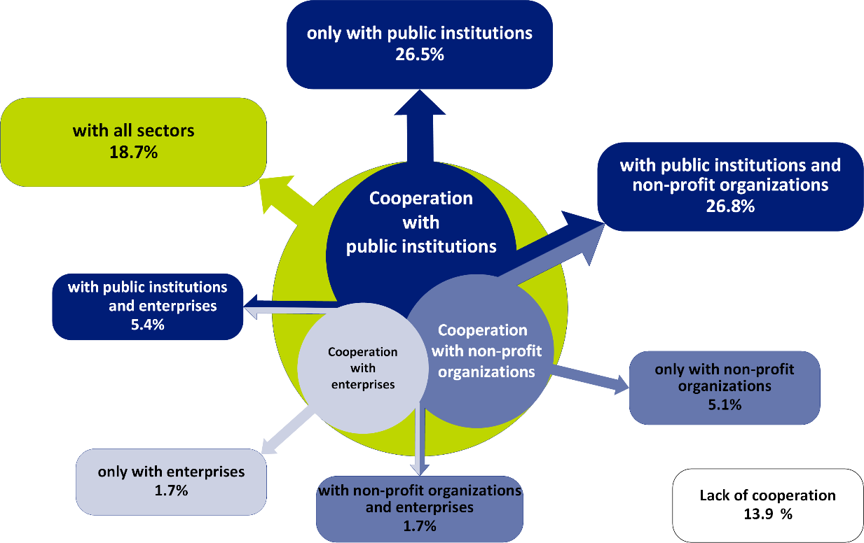
Figure 2. Cooperation of non-profit organizations in 2021 by the type of partner - in total

Compared to 2019, there was a significant decrease in cooperation with all sectors - by 5.4 percentage points (from 24.1% in 2019 to 18.7% in 2021) and lower in terms of non-cooperation – 1.7 percentage points and coopertation with public institutions and enterprises - by 1.3 percentage points. In the remaining groups, however, an increase was observed, but in none of the groups did it exceed 1.7 percentage points.

Objectives of cooperation
In 2021, for organizations cooperating with public administration, the main goal of cooperation was to raise funds (76.5%).
In 2021, the main goal of cooperation with public institutions was acquiring material resources (86.0%), of which more often financial (76.5%) than material (44.3%). A frequent reason for establishing cooperation with the sector of public institutions was access to intangible resources (48.3%). The possibility of integrating the local environment and expanding contacts motivated 33.2% of non-profit organizations to work together. On the other hand, 31.3% of the units indicated the knowledge and experience of public administration employees as the goal of cooperation.
As in cooperation with public administration, undertaking joint actions with the enterprise sector was dictated mainly by material motives (70.7%). Almost half of the non-profit organizations collaborated to obtain financial resources (48.1%), and 39.8% of units declared that the motivation to undertake joint activities with enterprises was the possibility of using material support.
Chart 2. The percentage of non-profit organizations in 2019 by the purpose of cooperation and the type of partner
Immaterial things
Material things

The values in the chart refer to organizations working with a given type of partner.
The motivation for intra-sector cooperation was different. This cooperation was primarily a source of immaterial things. Almost 60% of entities cooperating with other non-profit organizations indicated that the purpose of joint actions was to integrate the local community and expand contacts. For half of the surveyed units, the motivation to establish cooperation was the opportunity to use the knowledge and experience of employees, members or volunteers from other non-governmental organizations (49.5%). Motivations related to obtaining financial resources (30.1%) and material resources (23.0%) played a much smaller role.
Between 2019 and 2021, the greatest change in the indicated cooperation goals took place among units operating in cooperation with other non-profit organizations to integrate the local environment and expand contacts. Their percentage decreased by 5.2 percentage points. (from 65.1% in 2019 to 59.9% in 2021). Moreover, in cooperation with each type of partner, a decrease was noted in the share of organizations undertaking joint activities to achieve material benefits (from 2.9 percentage points in the case of cooperation with public institutions to 3.5 percentage points in the case of intra-sector cooperation).

Barriers to cooperation
In 2021, 74.4% of non-profit organizations reported no barriers in cooperation with other entities
Non-profit organizations relatively rarely declared barriers to cooperation with other entities. In 2021, their share was: 21.7% - in the case of organizations cooperating with the commercial sector, 21.4% - in cooperation with public institutions and 18.8% - among entities undertaking intra-sector cooperation. Compared to 2019, the percentage of organizations reporting problems in cooperation with individual types of partners decreased: in intra-sector cooperation - by 4.7 percentage points, with enterprises - by 4.2 percentage points, and in the case of cooperation with public administration by 3.6 percentage points.
Chart 3. The percentage of non-profit organizations by the types of barriers to cooperation and the type of partner in 2019
The values in the chart refer to organizations working with a given type of partner.
According to the declarations of non-profit organizations, problems in cooperation with public administration resulted primarily from bad, unclear regulations and legal procedures (10.4%). Equally often, attention was drawn to the lack of sufficient knowledge on the part of the partner about cooperation (9.4%) and the lack of partnership relations or instrumental treatment (9.1%). The lack of knowledge on the part of the partner was a major difficulty in cooperation with enterprises and other non-governmental organizations (11.5% and 9.5%, respectively). Compared to 2019, the greatest change in relation to this barrier was recorded among organizations cooperating with the enterprise sector. The share of entities declaring its occurrence decreased by 4.2 percentage points. Also in the case of other barriers, in the vast majority of cases, a reduced share of organizations indicating their presence was noted compared to 2019.

Methodological information
To develop the news releases, the preliminary results of Statistics Poland 1.04.01 were used. Associations, foundations, faith-based charities, business and professional associations for 2021 as per the SOF-5 form (Report on cooperation, management and integration activities of selected non-profit organizations).
The research was a panel survey and included the entities from the SOF-1 file (Report on the activities of foundations, associations and similar social organizations) and SOF-4s file (Report on the activities of economic and professional self-government), which, for the year 2020, submitted their reports.
The category of social economy entities presented in the study includes only those that fall within the subjective scope of the survey, i.e. associations, foundations, rural housewives clubs, faith-based charities, farmers organizations and business and professional organizations, similarly in the case of social enterprises. In addition, it should be noted that social enterprises have been identified based on the legal status in force in 2021, so they are not social enterprises that obtained such a status under the Act on Social Economy of August 5, 2022. The completed SOF-5 report was sent by a total of 21.2 thousand organizations surveyed (93.5%) and 0.8 thousand units (3.4%) declared inactivity in 2021. 2.8% of organizations refused to participate in the survsy and 0.2% of units failed to make contact.
Due to the fact that the data for the survey SOF-5 for the year 2021 was created based on the data SOF-1 and SOF-4 for the year 2020, to average the results, it was necessary to take into account the changes in the frame that occurred between the editions of the research. For this purpose, the data obtained from the Database of Statistical Units as of 31 December 2021 and from ZUS (Social Insurance Institution) were used. Weightings, which made it possible to generalize the acquired data into the whole population of active entities, were constructed for the result set.

In the case of quoting data of Statistics Poland, please provide annotation: "Source: Statistics Poland". When publishing calculations made on the data published by Statistics Poland, please include the following information: "Own elaboration based on data from Statistics Poland".
Prepared by:  Social Surveys Department  Director Piotr Łysoń, Ph.D.  Phone: (+48 22) 449 40 27  Statistical Office in Cracow  Director Agnieszka Szlubowska  Phone: (+48 12) 420 40 50 | Issued by:  The Spokesperson for the President of Statistics Poland  Karolina Banaszek  Phone: (+48) 695 255 011
Press Office  Phone: (+48 22) 608 38 04  e-mail: obslugaprasowa@stat.gov.pl |   stat.gov.pl/en/

@GUS_STAT

@GlownyUrzadStatystyczny

gus_stat

glownyurzadstatystycznygus

glownyurzadstatystyczny
Related information
Non-profit sector in 2020. Associations, foundations, faith-based charities, business and professional associations
Involvement of social economy entities in providing support due to hostilities in the territory of Ukraine (February 24th-March 31st, 2022)
Cooperation of non-profit organizations with other entities in 2019

