First aid and emergency medical services in 2021
In 2021 emergency rescue teams provided health care benefits in the occurrence place to almost 3.1 million of persons. More than 3.4 million of persons received health care benefits in hospital emergency wards or admission rooms under the outpatient treatment while almost 1.6 million of persons received health care benefits in hospital emergency wards under the inpatient treatment.
11.0%
Increase in the number of persons who received health care benefits in the occurrence place compared to 2020

Units of the State Emergency Medical Services System (denoted as PRM)
In 2021 the State Emergency Medical Services System covered: 1 587 emergency rescue teams, 21 medical air rescue teams and 241 hospital emergency wards
In 2021 the State Emergency Medical Services System covered functioning of the 1 587 of emergency rescue teams (6 more than in previous year). There were 1 250 basic emergency rescue teams and 337 specialist. On a yearly basis the number of specialist teams has been decreasing while the number of basic teams has been increasing.
The emergency medical treatment was also offered by 21 medical air rescue teams and 241 hospital emergency wards (denoted as SOR). The cooperating units role was played by 156 admission rooms, 17 trauma centers and 11 children trauma centers.

Map 1. Units of the State Emergency Medical Services System by voivodships in 2021
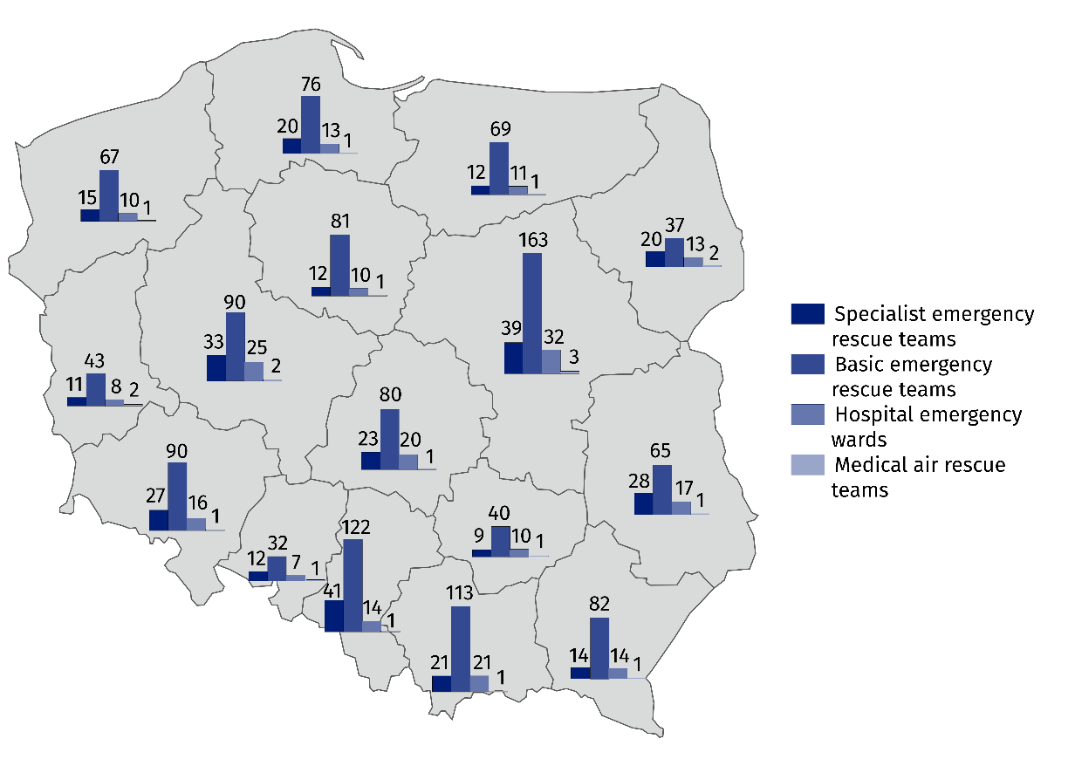
As of 31 December

Emergency rescue teams, medical air rescue teams
Almost 3.1 million of calls of the emergency rescue teams (including medical air rescue teams) to the occurrence places were recorded, of which 79.6% was at the patients’ home
The emergency rescue teams provided medical treatment for patients whose life is threatened. There were almost 3.1 million of calls of the emergency rescue teams (including medical air rescue teams) during which the emergency medical activities were provided. Compared to previous year the number of calls of the emergency rescue teams (including medical air rescue teams) to the occurrence places increased by 299.6 thousand. Among all emergency rescue teams’ call (including medical air rescue teams) 79.6% was at the patient’ home (increase by 1.7 percentage points compared to 2020).

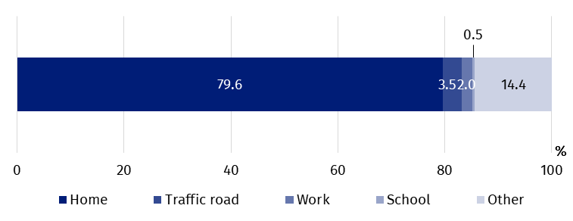
Chart 1. The structure of calls of the emergency rescue teams to the occurrence places by the type of occurrence place in 2021

The emergency rescue teams provided medical treatment to almost 3.1 million of persons (305.0 thousand more than in previous year). Among these persons 4.9% were children and youth up to age 18 and 48.4% – persons aged 65 and more (in 2020 4.5% and 48.5% respectively).

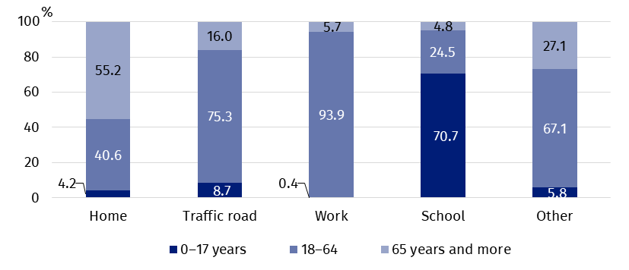
Chart 2. The structure of persons who received health care benefits in the place of occurrence by the age group and the type of occurrence place in 2021
In 2021 the emergency res-cue teams provided medical treatment to 80 persons per 1 thousand population
In Poland, per 1 thousand population there were 80 persons to whom the emergency rescue teams provided medical treatment (compared to 72 persons in 2020). The maximum value (104) was observed in Zachodniopomorskie Voivodship and the minimum value (59) in Wielkopolskie Voivodship.

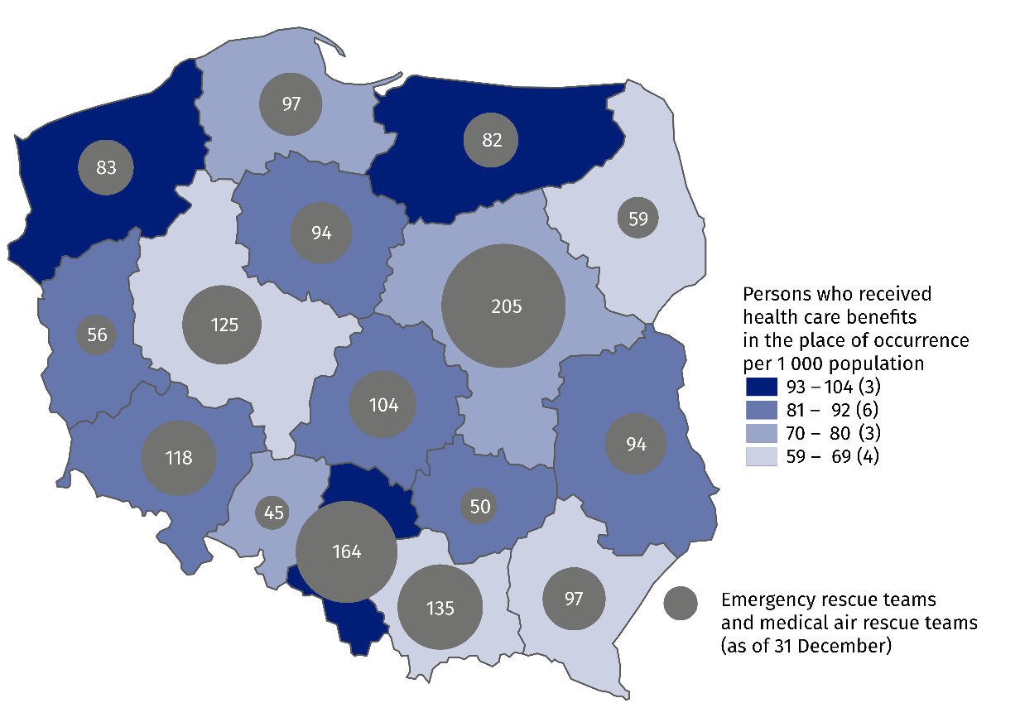
Map 2. Emergency rescue teams and persons who received health care benefits in the place of occurrence per 1 000 population by voivodships in 2021

As of 31 of December 2021, the number of medical personnel of emergency rescue teams amounted to 12.9 thousand workers. The largest group – almost 11.0 thousand – was constituted by emergency medical technicians. Moreover, there were over 1.1 thousand of nurses of emergency medical services, more than 0.4 thousand of physicians of emergency medical services and almost 0.4 thousand of other personnel. Compared to 2020, the number of medical personnel of emergency rescue teams remained at a similar level.

Chart 3. The structure of emergency rescue teams by medical personnel in 2021
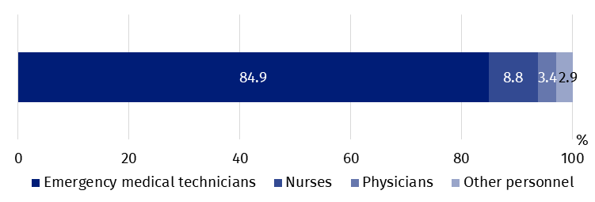
As of 31 December

Hospital emergency wards, admission rooms
In 2021 the number of persons who received health care benefits under outpatient treatment in both hospital emergency wards and admission rooms amounted to over 3.4 million

In hospital emergency wards the inpatient treatment was provided to almost 1.6 million persons
Hospital emergency wards (SOR) provide medical treatment of two distinct kind: outpatient treatment (with no subsequent hospitalization) and inpatient treatment. In both hospital emergency wards and admission rooms the largest number of services was provided under the outpatient treatment.
In 2021 the number of patients who received health care benefits in both hospital emergency wards and admission rooms under the outpatient treatment amounted to over 3.4 million persons (increase by 5.3% as compared to 2020), while in the hospital emergency wards under the inpatient treatment – almost 1.6 million (increase by 14.1% as compared to 2020). Children and youth up to age 18 stood for 17.2% of the total number of treated in hospital emergency wards or in admission rooms while persons aged 65 and more – 27.7% (in 2020 15.6% and 27.8% respectively).

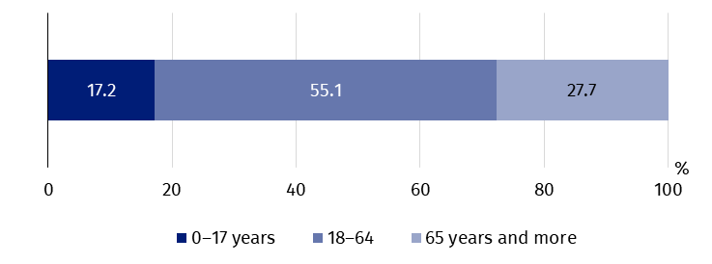
Chart 4. The structure of persons who received health care benefits in the hospital emergency wards or admission rooms by the age group in 2021

At the national level, there were 130 persons who received health care benefits in the hospital emergency wards or in admission rooms per 1 thousand population (120 persons in 2020). The maximum ratio of persons who received medical treatment in these places per 1 thousand population was observed in Pomorskie Voivodship (158) and the minimum value (90) in Śląskie Voivodship.

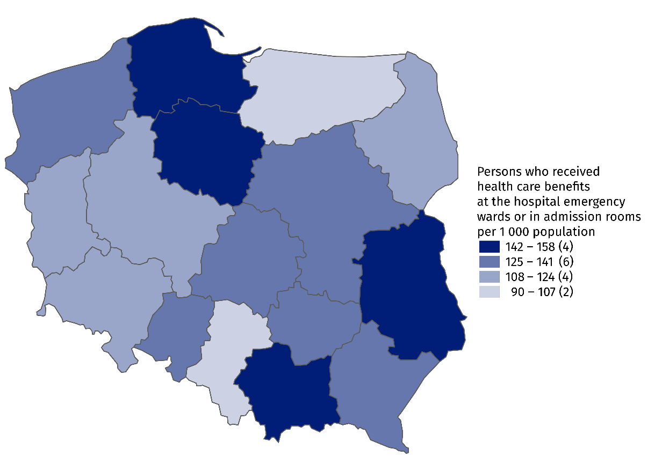
Map 3. Persons who received health care benefits in the hospital emergency wards or admission rooms per 1 000 population by voivodships in 2021
In the case of quoting data from the Statistics Poland, please provide information: "Statistics Poland data source", and in the case of publishing calculations made on data published by the Statistics Poland, please provide information: "Own study based on Statistics Poland data".

Prepared by:  Statistical Office in Kraków  Director Agnieszka Szlubowska  Phone: (+48 12) 420 40 50 | Issued by:  The Spokesperson for the President  of Statistics Poland  Karolina Banaszek  Phone: (+48) 695 255 011
Press Office  Phone: (+48 22) 608 38 04  e-mail: obslugaprasowa@stat.gov.pl |   stat.gov.pl/en/

@StatPoland

@GlownyUrzadStatystyczny

gus_stat

glownyurzadstatystycznygus

glownyurzadstatystyczny
Related information
Health and health care in 2020
Methodological report. Health and health care statistics − Statistics Poland’s reports
Data available in databases
Local Data Bank -> Health care, social welfare and benefits to the family
Analytical Platform – SWAID – Knowledge Databases -> Health and Health care
Terms used in official statistics
Emergency medical services
Units of emergency medical service
Hospital emergency ward
The place of occurrence
Trauma center
Physician of emergency medical services
Nurse of emergency medical services

Medical personnel for whom it was the main workplace, regardless of the form of employment contract.
Drivers and pilots.

