Pharmacies and pharmaceutical outlets in 2021
At the end of 2021, there were operating 11.9 thousand pharmacies (generally available and dispensaries) and 1.1 thousand pharmaceutical outlets in which 58.3 thousand pharmacists and pharmaceutical technicians were employed.
 1.6%
Decrease in the number of generally available pharmacies compared to 2020

Pharmacies and pharmaceutical outlets
At the end of 2021, there were operating 11.9 thousand generally available pharmacies (decrease of 1.6% in comparison with the previous year), 24 dispensaries (as in 2020) and 1.1 thousand pharmaceutical outlets (by 0.4% less than a year earlier).
The night duties were fulfilled permanently by 2.8% generally available pharmacies, as well as temporarily by 22.5% pharmacies. The sales of medical products by mail order using the website (via e-pharmacies) were carried out by 164 pharmacies and 4 pharmaceutical out-lets.
In Poland, there were on average 2 926 persons per 1 generally available pharmacy and pharmaceutical outlet (by 29 more than in the previous year). Like a year earlier, the highest number of inhabitants per 1 generally available pharmacy and pharmaceutical outlet was recorded in Pomorskie Voivodship (3 348), while the lowest – in Wielkopolskie Voivodship
(2 600).

Map 1. Generally available pharmacies and pharmaceutical outlets by voivodships in 2021
At the national level the number of population per
1 generally available pharmacy and pharmaceutical outlet amounted to 2 926 persons
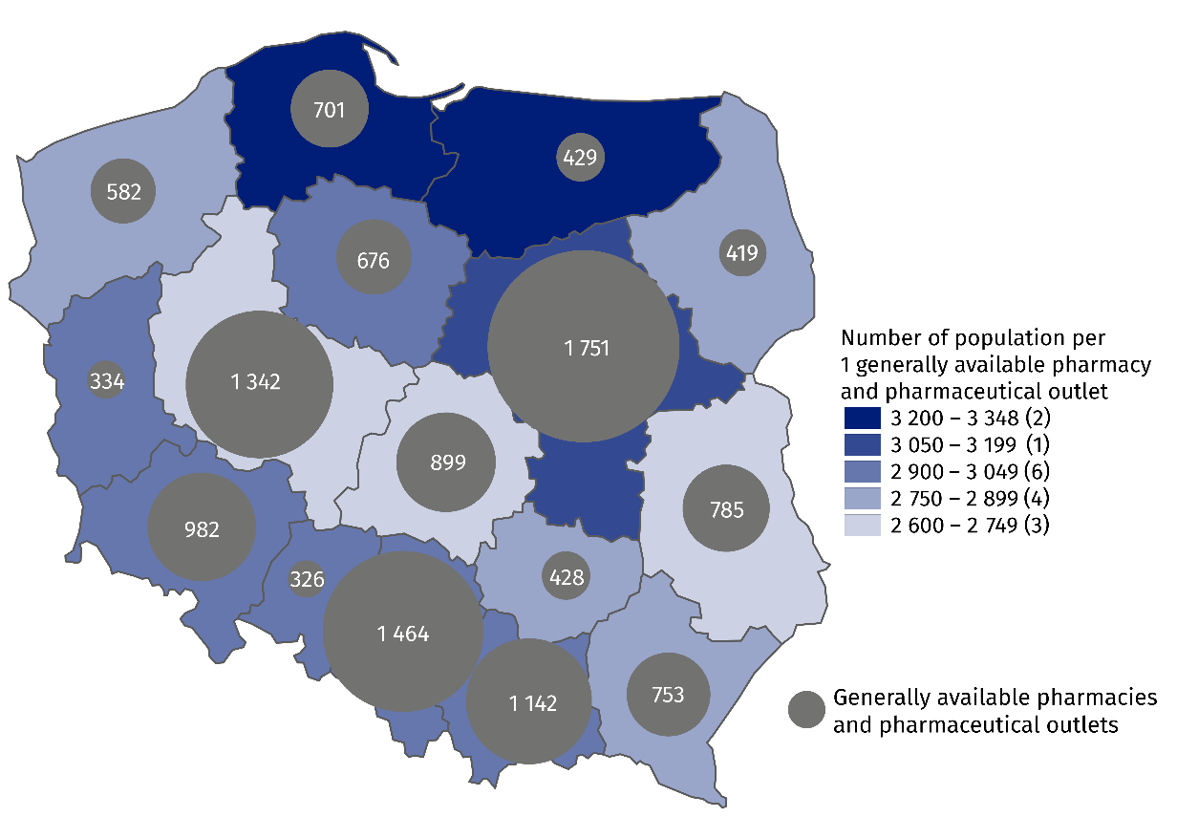
As of 31 December

Employed in pharmacies and pharmaceutical outlets
Pharmacies and pharmaceu-tical outlets employed 26.1 thousand pharmacists and 32.2 thousand pharmaceutical technicians
As of 31 December 2021, generally available pharmacies, dispensaries and pharmaceutical outlets employed 63.6 thousand employees , of which 26.1 thousand pharmacists (decrease by 0.6% compared to 2020) and 32.2 thousand pharmaceutical technicians (by 2.1% less than a year earlier). Like a year earlier, the vast majority of employees were females (83.1% of pharmacists and 94.3% of pharmaceutical technicians).

Table 1. Employed in pharmacies and pharmaceutical outlets in 2021
WYSZCZEGÓLNIENIE | Employees total | Of which
WYSZCZEGÓLNIENIE | Employees total | pharmacists | pharmaceutical  technicians
WYSZCZEGÓLNIENIE | in thousands
Generally available  pharmacies | 61.7 | 25.9 | 30.6
Dispensaries | 0.2 | 0.1 | 0.1
Pharmaceutical outlets | 1.7 | 0.1 | 1.5
Map 2. Employed in generally available pharmacies and pharmaceutical outlets by voivodships in 2021
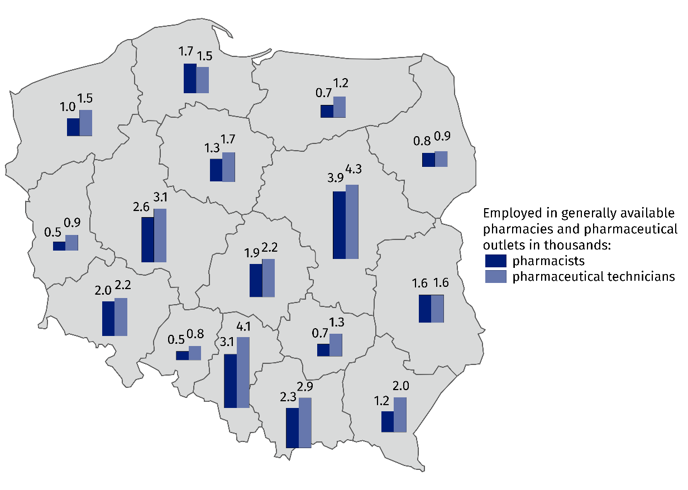
As of 31 December

In the case of quoting data from the Statistics Poland, please provide information: "Statis-tics Poland data source", and in the case of publishing calculations made on data published by the Statistics Poland, please provide information: "Own study based on Statistics Poland data".

Prepared by:  Statistical Office in Kraków  Director Agnieszka Szlubowska  Phone: (+48 12) 420 40 50 | Issued by:  The Spokesperson for the President  of Statistics Poland  Karolina Banaszek  Phone: (+48) 695 255 011
Press Office  Phone: (+48 22) 608 38 04  e-mail: obslugaprasowa@stat.gov.pl |   stat.gov.pl/en/

@StatPoland

@GlownyUrzadStatystyczny

gus_stat

glownyurzadstatystycznygus

glownyurzadstatystyczny
Related information
Health and health care in 2020
Methodological report. Health and health care statistics − Statistics Poland’s reports
Data available in databases
Local Data Bank -> Health care, social welfare and benefits to the family
Knowledge Databases -> Health and Health care
Terms used in official statistics
Generally available pharmacy
Dispensary
Pharmaceutical outlet
The main workplace

Concerns employed persons for whom this is the main workplace. Total number of employed covers all employees in an establishment, including non-medical staff (e.g. cashiers, manual workers) as well as owners and co-owners of pharmacies.

