Emergency rescue services activity in 2021
In 2021, fire brigades intervened in 579.7 thousand events. Interventions concerned 106.5 thousand fire events, 428.0 thousand local threats, and 45.2 thousand false alarms.
0.6%
Decrease in the number of interventions of fire brigades in 2021 compared to 2020
422 drowning accidents, of which 408 people died, including 40 women, were reported to the Police.
Water life rescue services carried out 1 581 rescue actions.

Fire safety
In 2021, throughout the country, fire brigades intervened in 579.7 thousand events (decrease by 0.6% in comparison with 2020). Most of the interventions of fire brigades were recorded in Mazowieckie Voivodship (84.0 thousand), the lowest number of events was recorded in Podlaskie Voivodship (14.8 thousand). Indicator of the number of events requiring intervention of fire brigades per 1 thousand persons, reached the highest level in Łódzkie Voivodship (18.3), and the lowest in Podlaskie and Podkarpackie Voivodship (12.7 each).
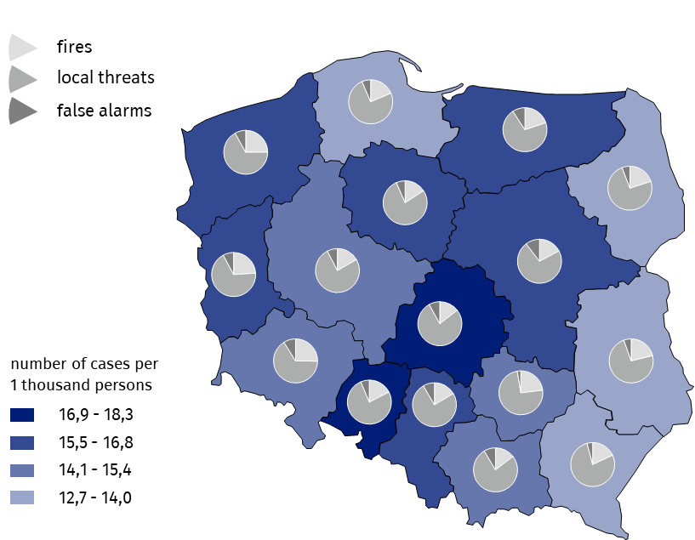
Map 1. Interventions of fire brigades in 2021
Source: National Headquarters of the State Fire Service.
Interventions concerned 428.0 thousand local threats (by 3,4% more than in 2020), 106.5 thousand fires (by 17.3% less than in 2020) and 45.2 thousand false alarms (by 11.3% more).
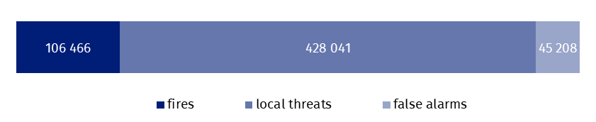
Chart 1. Number of interventions of fire brigades in 2021
In 2021, 96.1% of all fires were recognised as small fire

Source: National Headquarters of the State Fire Service.
In terms of the size of fires, the biggest share of fires was recognised as small ones – 102.3 thousand (which accounts for 96.1%), whereas 78 events were classified as very big fires.
In case of local threats per 1 thousand persons, requiring the participation of fire brigades, the highest value of the indicator was in Łódzkie Voivodship (14.2), while the lowest value was in Podlaskie Voivodship (9.4). The most common local threats requiring the intervention of fire brigades were medical incidents (93.7 thousand). Their number, in comparison with 2020, decreased by 28.2%.
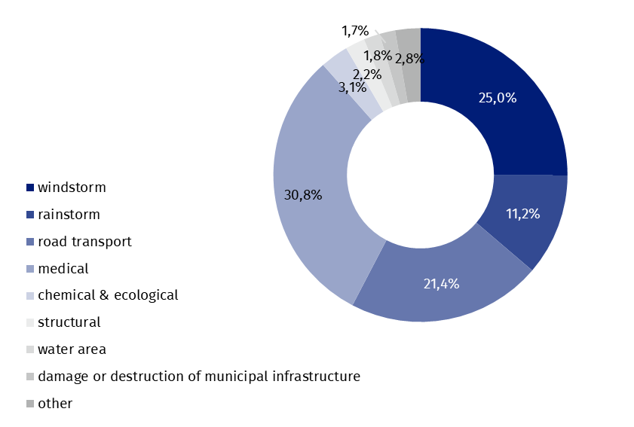
Chart 2. Structure of local threats by type in 2021
The most common local threats requiring the participation of fire brigades were medical incidents (30.8% cases)

Source: National Headquarters of the State Fire Service.
Similarly to the previous years, more than a half of false alarms (55.3%) were reported in good faith.
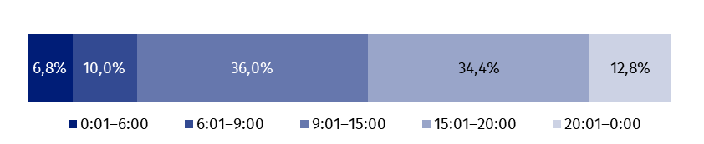
Chart 3. Structure of events requiring intervention of fire brigades by time of spotting in 2021
Source: National Headquarters of the State Fire Service.
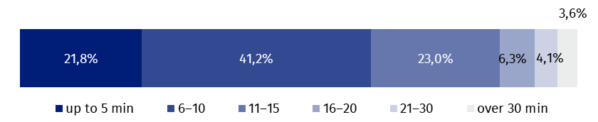
Chart 4. Structure of events requiring intervention of fire brigades by drive time in 2021
Source: National Headquarters of the State Fire Service.
Most often, the drive time of fire brigades to the scene of the incident was from 6 to 10 minutes (41.2%)

The most frequent drive time of fire brigades to the scene of the incident was from 6 to 10 minutes (41.2% of events). Drive times longer than 30 minutes accounted for 3.6% of all interventions.
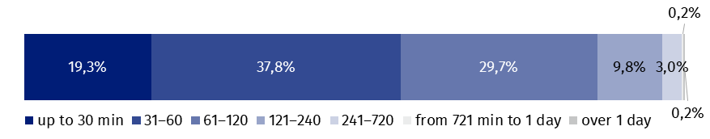
Chart 5. Structure of events requiring intervention of fire brigades by duration of intervention in 2021
Source: National Headquarters of the State Fire Service.
The most frequent duration of rescue operation by fire brigades was from 31 to
60 minutes (37.8% cases)

The most of interventions of fire brigades took from 31 to 60 minutes.
3 882.1 thousand firefighters were involved in interventions of fire brigades, including 1 907.9 thousand volunteer firefighters, 939.3 thousand vehicles were used in rescue actions, of which 746.0 thousand fire engines. As a result of fires and local threats, 7.5 thousand persons died, and 53.0 thousand were injured.
Table 1. Events involving fire brigades in 2021
Voivodships | Total | Fires | Local threats | False alarms
POLAND | 579 715 | 106 466 | 428 041 | 45 208
Dolnośląskie | 43 572 | 10 970 | 28 721 | 3 881
Kujawsko-pomorskie | 33 568 | 5 290 | 26 094 | 2 184
Lubelskie | 27 429 | 5 806 | 20 127 | 1 496
Lubuskie | 15 931 | 3 817 | 10 860 | 1 254
Łódzkie | 44 301 | 6 436 | 34 297 | 3 568
Małopolskie | 50 002 | 7 284 | 38 424 | 4 294
Mazowieckie | 83 996 | 14 511 | 60 752 | 8 733
Opolskie | 16 814 | 2 943 | 12 804 | 1 067
Podkarpackie | 26 781 | 4 822 | 20 858 | 1 101
Podlaskie | 14 799 | 2 963 | 10 985 | 851
Pomorskie | 32 731 | 6 101 | 24 539 | 2 091
Śląskie | 71 656 | 11 801 | 53 822 | 6 033
Świętokrzyskie | 17 167 | 3 968 | 12 750 | 449
Warmińsko-mazurskie | 23 311 | 4 638 | 16 516 | 2 157
Wielkopolskie | 51 432 | 8 555 | 38 952 | 3 925
Zachodniopomorskie | 26 225 | 6 561 | 17 540 | 2 124
Source: National Headquarters of the State Fire Service.

Drowning events
In 2021, 408 persons drowned, by 52 persons less than in the previous year

In 2021, 422 drowning events were reported to the police (by 12.6% less than in 2020), resulting in 408 deaths (by 11.3% less), including 40 women.
Most victims of drowning events were recorded in Warminsko-mazurskie Voivodship (44). The smallest number of victims of drowning was recorded in Podkarpackie Voivodships (10).
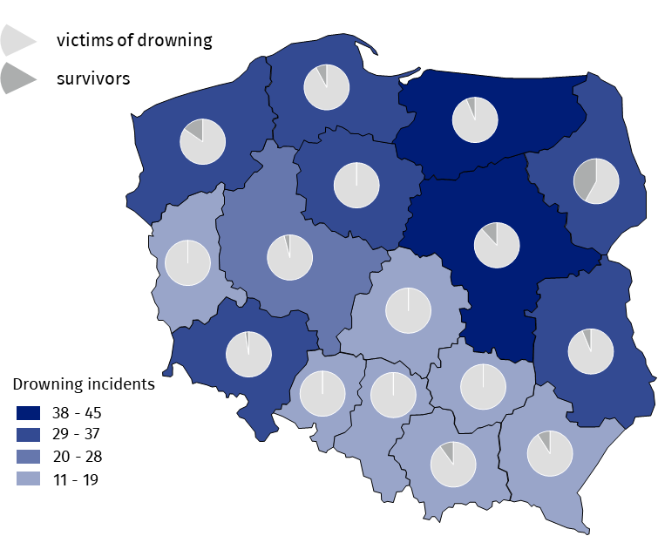
Map 2. Drowning incidents by voivodships in 2021
Source: data on the basis of data from registered proceedings by Police offices.
208 victims of drowning were over 50 years of age (51.0% of all victims)

Persons over 50 years of age were most frequent victims of drowning (208 persons), while children under 7 years and between 8 – 14 years of age were the least frequent victims (5 persons in each).
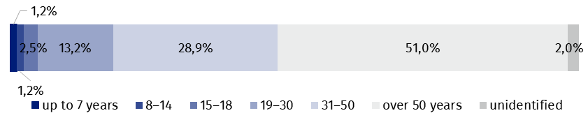
Chart 6. Structure of victims of drowning by age in 2021
Source: National Headquarters of Police.
Most of the drowning events occurred at the weekends

Weekends were most frequent days of drowning – on Saturdays (72), on Sundays (96). The lowest number of drowning was recorded on Mondays (36).
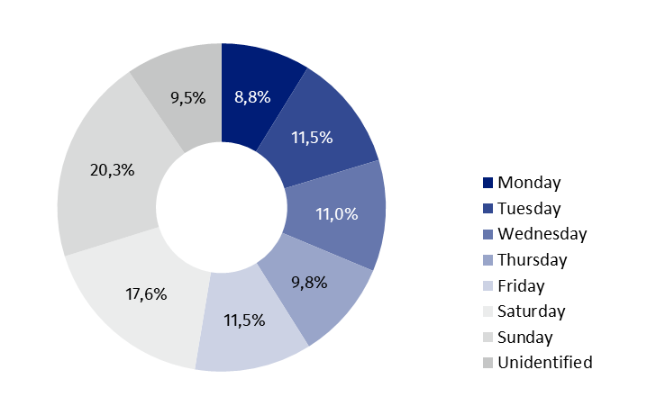
Chart 7. Structure of drowning incidents by days of the week in 2021
Source: National Headquarters of Police.
The most of victims drowned in the rivers (98 cases)

Most of victims drowned in rivers (98). The biggest number of victims of drowning in the rivers was recorded in Dolnośląskie Voivodship (15), no victim of drowning in the rivers in Śląskie Voivodship was recorded. 95 persons drowned in lakes. The biggest number of victims of drowning in the lakes was recorded in Warmińsko-mazurskie Voivodship (27), while in Łódzkie and Podkarpackie voivodships no victim of drowning was recorded. 26 persons drowned in the sea, i.e. by 1 more than in 2020, (16 victims in Pomorskie Voivodship and 10 victims in Zachodniopomorskie Voivodship).
In 312 events of drowning (76.5%) state of consciousness (i.e. sober, intoxicated or under influence of drugs) could not be determined. At the moment of the incident, 78 drowning victims were intoxicated and 17 were sober.
Table 2. Drowning incidents in 2021
42 persons were rescued from drowning incidents

Voivodships | Total | Of which
Voivodships | Total | victims of drowning | survivors
POLAND | 422 | 408 | 42
Dolnośląskie | 36 | 37 | 1
Kujawsko-pomorskie | 31 | 31 | –
Lubelskie | 32 | 30 | 2
Lubuskie | 16 | 17 | –
Łódzkie | 18 | 18 | –
Małopolskie | 17 | 18 | 2
Mazowieckie | 42 | 37 | 5
Opolskie | 17 | 17 | –
Podkarpackie | 11 | 10 | 1
Podlaskie | 33 | 25 | 18
Pomorskie | 36 | 35 | 3
Śląskie | 14 | 14 | –
Świętokrzyskie | 19 | 19 | –
Warmińsko-mazurskie | 42 | 44 | 3
Wielkopolskie | 23 | 23 | 1
Zachodniopomorskie | 35 | 33 | 6
Source: data on the basis of data from registered proceedings by Police stations.

Actions of water rescue services
In 2021, 119 entities were eligible to water rescue

As of 31 December 2021, 119 entities received permission to water rescue service and they employed 12 082 water lifeguards.
Water rescuers made 1 581 rescue operations, most of them in inland and coastal water area (968). In places occasionally used for swimming 53 rescue operations were recorded, while 319 occurred on bathing beaches.
Water lifeguards carried out 1 581 rescue operations

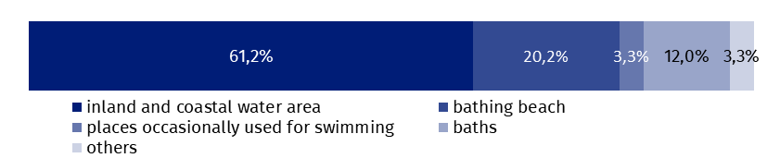
Chart 8. Structure of rescue operations to save drowning people by place of occurrence in 2021
Source: Ministry of Interior and Administration.
Water lifeguards carried out 4 560 actions requiring professional first aid. Most rescue actions occurred in the inland and coastal water area (1 464), such interventions were the least frequent in places occasionally used for swimming (56).
In the analysed period 546 actions dealt with transporting victims of the incidents or in danger of losing health or life in water area to a location where it was possible to perform medical rescue actions by the units of the State Medical Emergency³.
Water lifeguards saved lives of 1 455 drowning persons

Water lifeguards took part in 658 actions of searching for missing people. They saved 1 455 persons.
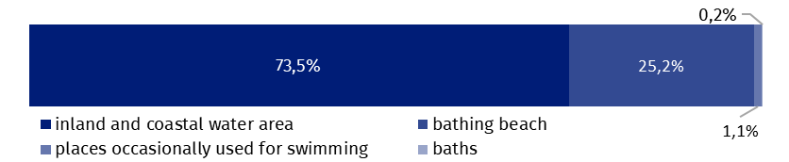
Chart 9. Structure of actions of searching for missing persons in water area by place of occurrence in 2021
Source: Ministry of Interior and Administration.
Entities, eligible to water rescue, were carrying out training activities in the area of water rescue. In 2021 they delivered 419 training courses, including 398 training courses dedicated to water lifeguards. 16 courses were delivered for instructors of water rescue and 5 courses for rescue dogs with the guide. 3 835 persons were awarded with the certificate of acquired qualifications.
In the case of quoting data from the Statistics Poland, please provide information: “Statistics Poland data source”, and in the case of publishing calculations made on data published by the Statistics Poland, please provide information: “Own study based on Statistics Poland data”.

Prepared by:  Statistical Office in Kraków  Director Agnieszka Szlubowska  Phone: (+48 12) 420 40 50 | Issued by:  The Spokesperson for the President  of Statistics Poland  Karolina Banaszek  Phone: (+48) 695 255 011
Press Office  Phone: (+48 22) 608 38 04  e-mail: obslugaprasowa@stat.gov.pl |   stat.gov.pl/en/

@StatPoland

@GlownyUrzadStatystyczny

gus_stat

glownyurzadstatystycznygus

glownyurzadstatystyczny
Related information
Emergency rescue services activity in 2020
Emergency rescue services activity in 2019
Data available in databases
Database Local Data Bank – organisation of the state and justice

Data based on events reported to the Police.
Data based on reports of services entitled to water life savings reported to the Ministry of Interior and Administration. 3 Reference to Article 32(1) Act of 8 September 2006 on Medical State Emergency.

