Stationary social welfare facilities in 2021
As of 31 December 2021, in Poland there were 2 015 stationary social welfare facilities, which had 127.3 thousand places in total in all facilities. 114.3 thousand residents stayed in stationary social welfare facilities, including 55.5 thousand women.
127.3 thousand
The number of places in stationary social welfare facilities in 2021

Facilities
Social assistance houses accounted for nearly 45% of all stationary social welfare facilities

Social assistance houses amounted to nearly 45% of all stationary social welfare facilities operating at the end of 2021, followed by establishments ensuring 24-hour care for disabled persons, chronic patients, or elderly persons within the scope of economic activity or their statutory activity (27.6%) and hostels for homeless persons (14.9%). Family-based assistance houses, community self-help centres (with round-the-clock available places), houses for mothers with children under age and pregnant women, night shelters and other centres jointly accounted for 13.0% of all facilities.

Table 1. Stationary social welfare facilities by typeª in 2021
As of 31 December
SPECIFICATION | Centres | Places | Residents
Stationary social welfare facilities | 2 015 | 127 256 | 114 293
Social assistance houses | 897 | 84 200 | 79 919
Family-based assistance houses | 26 | 204 | 195
Centres run within the scope of economic or statutory activity^{b} | 556 | 21 928 | 18 951
Community self-help centres^{c} | 7 | 143 | 135
Houses for mothers with children under age and pregnant women | 54 | 1 301 | 867
Night shelters | 85 | 2 875 | 1 882
Hostels for homeless persons | 301 | 14 796 | 11 701
Others | 89 | 1 809 | 643
a Centres excluding branches. Places and residents including branches. b Establishments ensuring 24-hour care for disabled persons, chronic patients, or elderly persons within the scope of economic activity or their statutory activity. c Including round-the-clock places
Over 87% of the facilities had buildings adjusted to meet the needs of persons with disabilities. The most frequently reported amenities were bathrooms for persons with disabilities (68.4% facilities were equipped), ramps, ascents and platforms easing the entrance (65.4%) and lifts (61.8%). Nearly 13% of facilities, predominantly night shelters and hostels for homeless persons, did not have any conveniences for persons with disabilities.

Places
About 66% of all places in stationary social welfare facilities is located in social assistance houses

At the end of 2021, the places in social assistance houses accounted for 66.2% of all places in stationary social welfare facilities, 17.2 % for establishments ensuring 24-hour care for disabled persons, chronic patients, or elderly persons within the scope of economic activity or their statutory activity and 11.6% for hostels for homeless persons. Family-based assistance houses, community self-help centres (with round-the-clock available places), houses for mothers with children under age and pregnant women, night shelters and others accounted jointly for 5.0% of all places.
The biggest number of places in stationary social welfare facilities was in Mazowieckie Voivodship and the smallest one in Lubuskie Voivodship. The biggest number of places in stationary social welfare facilities per 10 thousand persons was in Opolskie Voivodship (48.5) and the smallest one in Wielkopolskie Voivodship (27.3). The indicator for Poland amounted to 33.4.

Map 1. Places in stationary social welfare facilities per 10 thousand persons in 2021
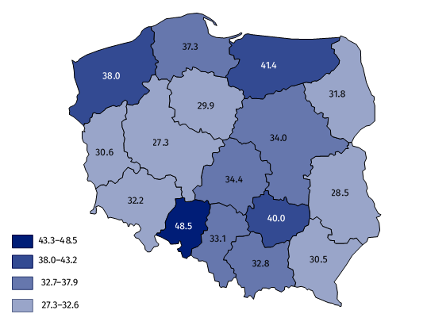
As of 31 December

Residents
Nearly 70% residents of social welfare facilities stayed in social assistance house
As of 31 December, in stationary social welfare facilities, there were 114.3 thousand residents. Men constituted the majority of residents – 58.8 thousand. Out of all residents, 69.9% stayed in social assistance houses. 16.6% of all residents stayed in establishments ensuring 24-hour care for disabled persons, chronic patients, or elderly persons within the scope of economic activity or their statutory activity and 10.2% residents were in hostels for homeless persons. The residents in community self-help centres (with round-the-clock available places) accounted only for 0.1% of all residents.
Nearly 85% of the residents in stationary social welfare facilities paid, at least partly, for their accommodation from own income, e.g. old age pension, disability pension. The cost of accommodation for 7.5% of residents was incurred completely by their families, while the accommodation for 6.1% was paid entirely by the local government. About 1% of the residents was exempted from the payment.
The persons over 65 years old were the majority of residents in stationary social welfare facilities, which amounted to over a half of all residents. Every fifth of the residents was a person at age of 40-59. The residents at age of 17 and less constituted the smallest age group (1.7 thousand).

Chart 1. Structure of residents in stationary social welfare facilities by age in 2021
As of 31 December
The most of residents stayed in facilities for elder persons (28.0% of total number of residents), less in centres for chronically mentally ill (20.5%), and in centres for chronically ill with somatic disorders and in centres for mentally retarded (18.6% each). The smallest share referred to persons addicted to alcohol (0.1%).

Chart 2. Residents in stationary social welfare facilities by groups in 2021
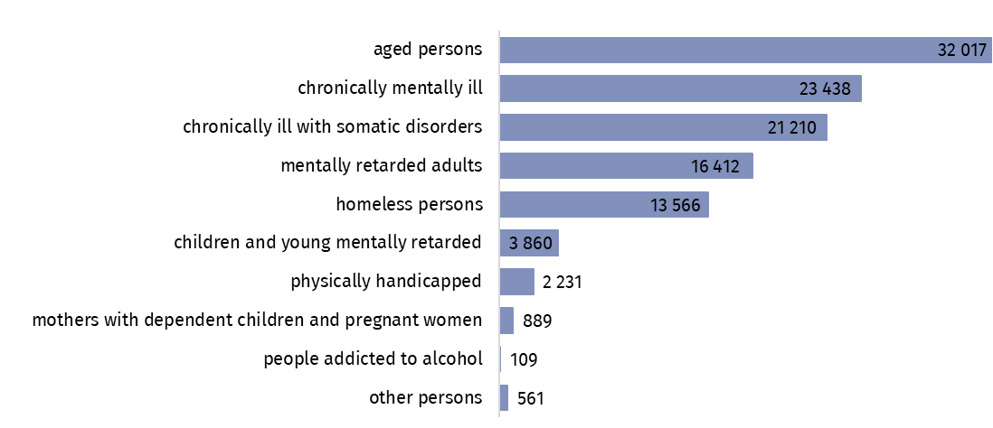
As of 31 December
Throughout 2021, 158.4 thousand persons stayed in stationary social welfare facilities, including 83.7 thousand men. Every fourteenth resident (11.4 thousand) was infected with COVID-19. The highest share of infected persons was related to community self-help centres (including round-the-clock places), where 21.9% of all residents were infected. 9.3% was infected in establishments ensuring 24-hour care for disabled persons, chronic patients, or elderly persons within the scope of economic activity or their statutory activity, 7.4% in hostels for homeless persons, 7.1% in social assistance houses and 6.0% in family assistance houses. For night shelters, houses for mothers with children under age and pregnant women and for other facilities, the share of persons diagnosed with COVID-19 accounted for less than 4.0%.

Table 2. Stationary social welfare facilities by voivodshipsª in 2021
As of 31 December
VOIVODSHIPS | Centres | Places | Residents
POLAND | 2 015 | 127 256 | 114 293
Dolnośląskie | 132 | 9 266 | 8 359
Kujawsko-pomorskie | 94 | 6 127 | 5 457
Lubelskie | 93 | 5 925 | 5 261
Lubuskie | 49 | 3 061 | 2 758
Łódzkie | 113 | 8 323 | 7 574
Małopolskie | 170 | 11 180 | 10 341
Mazowieckie | 308 | 18 448 | 16 246
Opolskie | 76 | 4 706 | 4 346
Podkarpackie | 94 | 6 432 | 5 540
Podlaskie | 62 | 3 704 | 3 326
Pomorskie | 149 | 8 757 | 7 977
Śląskie | 244 | 14 767 | 13 071
Świętokrzyskie | 79 | 4 854 | 4 500
Warmińsko-mazurskie | 100 | 5 818 | 5 170
Wielkopolskie | 160 | 9 524 | 8 686
Zachodniopomorskie | 92 | 6 364 | 5 681
a Centres excluding branches. Places and residents including branches.
In the case of quoting data from the Statistics Poland, please provide information: “Statistics Poland data source”, and in the case of publishing calculations made on data published by the Statistics Poland, please provide information: “Own study based on Statistics Poland data”.

Prepared by:  Statistical Office in Kraków  Director Agnieszka Szlubowska  Phone: (+48 12) 420 40 50 | Issued by:  The Spokesperson for the President  of Statistics Poland  Karolina Banaszek  Phone: (+48) 695 255 011
Press Office  Phone: (+48 22) 608 38 04  e-mail: obslugaprasowa@stat.gov.pl |   stat.gov.pl/en/

@StatPoland

@GlownyUrzadStatystyczny

gus_stat

glownyurzadstatystycznygus

glownyurzadstatystyczny
Related information
Social assistance, child and family services in 2020
Data available in databases
Database Local Data Bank – health care and social welfare
Terms used in official statistics
Community self-help centre
Establishment ensuring 24-hour care for disabled persons, chronic patients, or elderly persons within the scope of economic activity or their statutory activity
Family-based assistance house
Hostel for homeless persons
House for mothers with children under age and pregnant women
Night shelter
Social assistance house

