Nurseries and children’s clubs in 2021

In 2021 the number of institutional care facilities for children up to age of 3 increased by 9.6% compared to the previous year. There were 5.0 thousand nurseries, children’s clubs and nursery wards, which had 191.6 thousand places. The indicator of the number of children up to age of 3 per 1 thousand population increased from 128 in 2020 to 155 in 2021.
10.4%
Growth of the number of places in nurseries, children’s clubs and nursery wards compared to 2020

Children
In 2021 the number of children in nurseries, children’s clubs and nursery wards increased by 21.1 thousand (14.8%) compared to the previous year

At the end of the analysed period, there were 163.4 thousand children in nurseries, children’s clubs and nursery wards. Most of them stayed in nurseries (nearly 92%). The highest value of the indicator of the number of children up to age of 3 per 1 thousand population was (as in the previous year) in Dolnośląskie Voivodship (230), while the lowest value was recorded in the Warmińsko-Mazurskie Voivodship (107). The low value of that indicator was also recorded in the Świętokrzyskie Voivodship (118).

Map 1. Facilities for children up to age of 3 in 2021
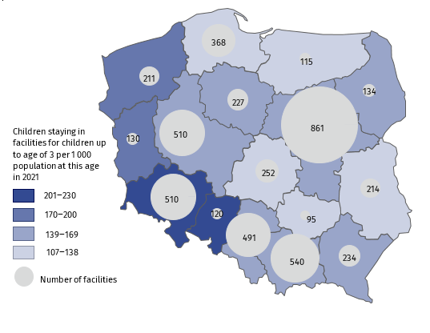
As of 31 December

Two-year olds constituted the biggest group in facilities – 52.3%. The share of one-year-old children and children under age of 1 accounted for 39.5% and 1.3% respectively. The girls accounted for 48.0% of the total number of children in facilities.
Chart 1. Children in facilities for children up to age of 3ª by sex and age in 2021
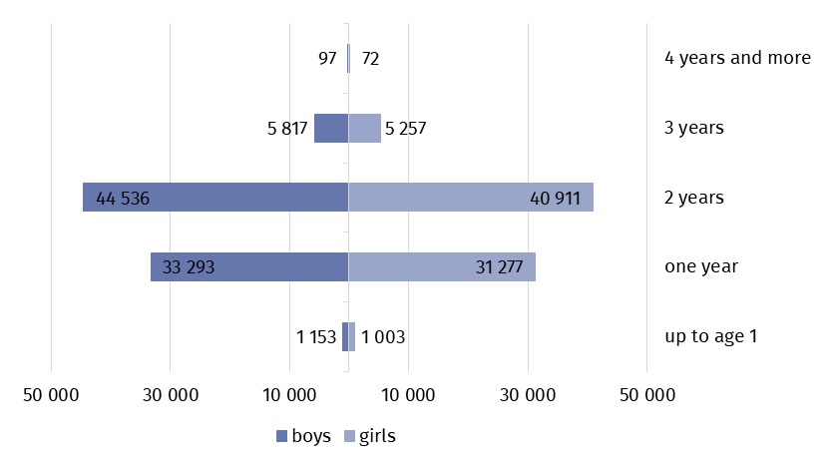
As of 31 December
a Child care may be performed up to the end of the school year when child reaches age of 3 or when it is either impossible or impeded to provide child with pre-school education – up to age of 4.

Throughout 2021, 256.4 thousand children stayed in facilities, including 1.5 thousand disabled children. Local government covered, partly or entirely, the costs of accommodation in facilities for 65.5% of children.

Facilities
Nearly 84% of all facilities for children up to age of 3 are nurseries
At the end of the analysed period, there were 5.0 thousand facilities for children up to age of 3 in Poland, including 4.2 thousand nurseries. Facilities in private sector (75.4%) accounted for three times more than facilities in public sector (24.6%). Most of nurseries and children’s clubs in private sector were run by physical person (66.9%), then by limited liability companies (11.5%) and by civil law partnership company (9.2%). Local government run the biggest number of nurseries and children's clubs in the public sector (over 97%). Every nursery ward was affiliated with kindergartens, most of them with public kindergartens (90.0%).

Chart 2. Facilities for children up to age of 3 by type of property in 2021
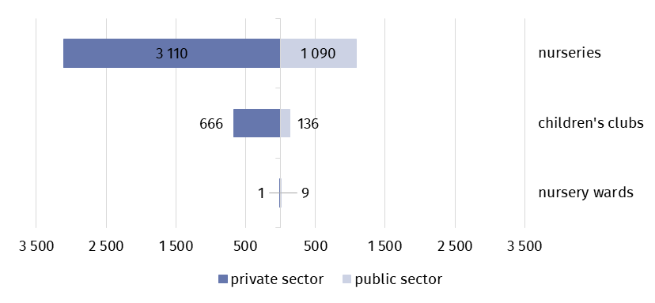
As of 31 December

65.9% of all facilities for small children were open 5 to 10 hours a day, 33.4% worked even over 10 hours a day. Only children’s clubs were open up to 5 hours a day (0.7% of total).
58.4% of facilities for small children had amenities for the disabled children. Mostly there were slipways, driveways and platforms (37.2% of total), bathrooms adapted for disabled children (26.9%) and non-slip floors (26.4%).
Places
Nearly 61% of all places in facilities for children up to age of 3 are places in private sector facilities
The number of places in all facilities for children up to age of 3 increased from 173.5 thousand in 2020 to 191.6 thousand in 2021. There were 116.4 thousand places in nurseries, children’s clubs and nursery wards in private sector and 75.2 thousand places in public sector.
In private sector, there were 33 places per one nursery on average and in public sector average value was two times higher – 66 places. In the case of nursery wards there were 15 and 38 places respectively and in children’s clubs – 19 and 21.

Staff
31.5 thousand women worked in nurseries, children’s clubs and nursery wards, which accounted for 99.2% of all employees

31.8 thousand people worked in facilities for children at age up to 3. Children’s carers prevailed among the employees in facilities – almost 72%. Teachers accounted for more than 10% of the total number of employees. The vast majority of employees were women – 99.2%. Facilities for children up to age of 3 were the main workplace for over 90% of children’s carers and teachers. In the case of midwives and nurses, the share was evidently lower and accounted for 49% and 39% respectively.

Chart 3. Structure of employees in facilities for children up to age of 3 in 2021
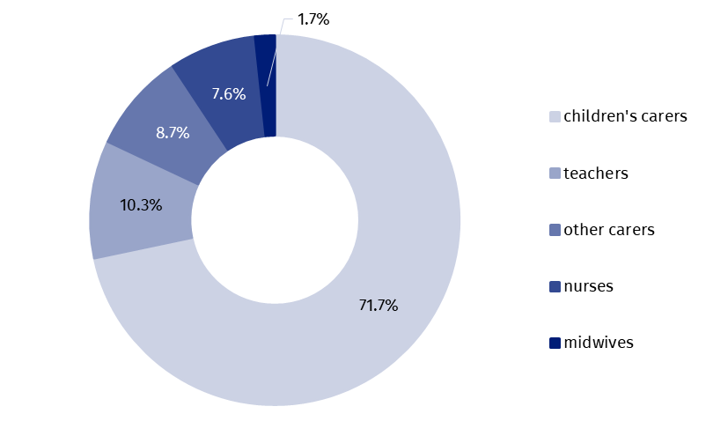
As of 31 December

Nurseries, children’s clubs and nursery wards were supported by volunteers. Throughout the year, 485 volunteers worked in those facilities. Their number increased by nearly 14% compared to the previous year.

Table 1. The institutional care facilities for children up to age of 3 by voivodships in 2021
As of 31 December
Voivodships | Facilities | Places | Children
POLAND | 5012 | 191648 | 163416
Dolnośląskie | 510 | 20496 | 17697
Kujawsko-pomorskie | 227 | 9009 | 7378
Lubelskie | 214 | 8308 | 6885
Lubuskie | 130 | 5352 | 4818
Łódzkie | 252 | 9678 | 8325
Małopolskie | 540 | 19286 | 15124
Mazowieckie | 861 | 31771 | 27984
Opolskie | 120 | 5587 | 4929
Podkarpackie | 234 | 9290 | 8361
Podlaskie | 134 | 5668 | 4953
Pomorskie | 368 | 12355 | 10092
Śląskie | 491 | 20493 | 16974
Świętokrzyskie | 95 | 3707 | 3316
Warmińsko-mazurskie | 115 | 4348 | 3765
Wielkopolskie | 510 | 17874 | 15087
Zachodniopomorskie | 211 | 8426 | 7728

In the case of quoting data from the Statistics Poland, please provide information: “Source of Statistics Poland data”, and in the case of publishing calculations made using data published by the Statistics Poland, please provide information: “Own study based on Statistics Poland data”.

Prepared by:  Statistical Office in Kraków  Director Agnieszka Szlubowska  Phone: (+48 12) 420 40 50 | Issued by:  The Spokesperson for the President  of Statistics Poland  Karolina Banaszek  Phone: (+48) 695 255 011
Press Office  Phone: (+48 22) 608 38 04  e-mail: obslugaprasowa@stat.gov.pl |   stat.gov.pl/en/

@StatPoland

@GlownyUrzadStatystyczny

gus_stat

glownyurzadstatystycznygus

glownyurzadstatystyczny
Related information
Social assistance, child and family services in 2020

Availability in databases
Database Local Data Bank – health care, social welfare and benefits to the family

