Cultural and creative industries 2020
124.1 thousand enterprises belonging to the cultural and creative industries operated in 2020. The overwhelming majority of entities (99.1%) were microenterprises, comprising 73.8% of those working in the area of cultural and creative industries. Gross monthly salary per employee amounted to PLN 6,335, i.e. PLN 123 less than in 2019; it was higher by PLN 941 in comparison with all non-financial enterprises. The foreign trade of cultural and creative goods was characterised by a positive turnover balance, while foreign trade of cultural and creative services ended up with a negative turnover balance.
2.2%
The increase in the number of enterprises belonging to the cultural and creative industries as compared with 2019

2020 was the first year of the COVID-19 pandemic in Poland. The possibility of conducting activities was limited also for the entities classified as the cultural and creative industries. Introduced restrictions affected the manner and scope of their operation.

The number and types of enterprises belonging to the cultural and creative industries
In recent years, the number of enterprises whose activities were classified as cultural and creative industries has been growing systematically. The last three years saw, however, a decline in the growth rate of the number of entities. Compared to the previous year, in 2020 there was an increase in the number of entities by 2.2%, versus 3.6% in 2019.

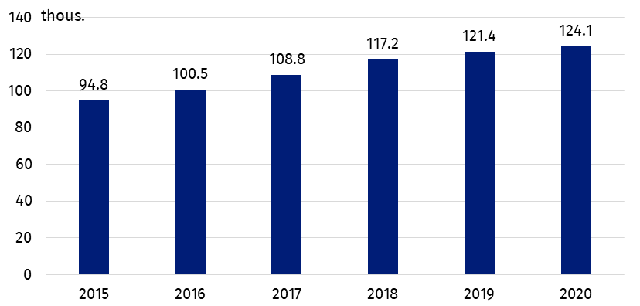
Chart 1. Number of enterprises belonging to the cultural and creative industries
The largest number of enterprises belonging to the cultural and creative industries operated in the domain of Advertising (22.2%).
Most entities operated in the field of Advertising (22.2%), followed by Visual arts (21.5%) and Audiovisual arts and multimedia (20.4%). Compared to 2019, the largest increase in the number of operating entities was recorded in the field of Audiovisual arts and multimedia (by 3.6 percentage points); while the largest decrease in the number of entities was recorded in the field of Visual arts (by 2.1 percentage points).

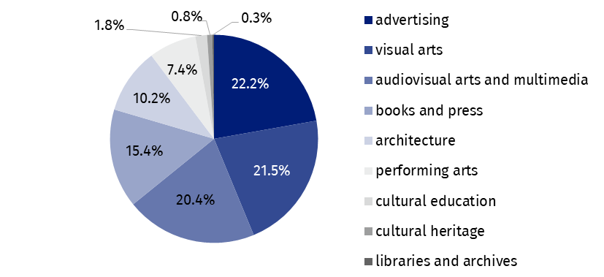
Chart 2. The structure of entities belonging to the cultural and creative industries by domain of culture in 2020
The most of the entities classified as cultural and creative industries were microenterprises. They accounted for 5.6% of all non-financial microenterprises.

The majority of entities were classified as microenterprises (99.1% of all entities belonging to the cultural and creative industries). In 2020, there was a total of 122.9 thousand of them, which constituted 5.6% of all non-financial microenterprises. In the remaining size classes of enterprises the share of the cultural and creative industries in the group of non-financial enterprises was as follows: small enterprises – 1.9%, medium – 1.3%, large – 1.2%.

Employed persons, average employment and salaries
As of December 31, 2020, 242.5 thousand people worked in enterprises classified as the cultural and creative industries, i.e. 2.0 percentage points more than in 2019. This accounted for 2.0% of the total number of people working in non-financial enterprises. Microenterprises concentrated 73.8% of those working in the area of cultural and creative industries, large enterprises – 11.7%, medium-sized enterprises – 7.1%, and small enterprises – 7.4%. The average paid employment structure was more balanced than the structure of the persons employed: the average employment in microenterprises amounted to 40.8 thousand full-time jobs (41.2% of the total number of employees), in large enterprises – 26.0 thousand (26.3%), and in both small and medium enterprises 16.1 thousand full-time jobs (16.2% each).

Table 1. Employed persons, average paid employment, gross wages, and salaries in the cultural and creative industries in 2020
Specification | Number of persons employedª | Average paid employment | Gross wages and salaries in thousands PLN | Monthly gross wages and salary per 1 paid employee in PLN
Total | 242,471 | 98,929 | 7,521,111 | 6,335
Microenterprises | 179,051 | 40,794 | 1,834,295 | 3,747
Small enterprises | 17,888 | 16,073 | 1,313,531 | 6,810
Medium enterprises | 17,157 | 16,074 | 1,554,515 | 8,059
Large enterprises | 28,375 | 25,988 | 2,818,770 | 9,039
a As of December 31.
In 2020, the gross monthly salary per 1 employee in non-financial enterprises increased by PLN 226 in relation to 2019 and amounted to PLN 5,394; while the cultural and creative industries saw an average decrease in remuneration by PLN 123, to PLN 6,335. The decline was visible in all size classes of enterprises, except for large enterprises, where the average salary increased by PLN 77. However, in enterprises belonging to the cultural and creative industries, regardless of their size class, the average gross remuneration was still higher than in the case of non-financial enterprises in general. The larger the enterprise, the greater the difference. In the case of microenterprises the difference amounted to PLN 214, in small enterprises – PLN 1,795, in medium – PLN 2,395, and in large – PLN 2,730. The share of gross wages and salaries in total costs in the case of the cultural and creative industries equaled 10.4%.

Financial results
In 2020, entities belonging to the cultural and creative industries achieved total revenues of PLN 84.5 billion (2.1 billion less than in the previous year), with their total costs amounting to PLN 72.7 billion (PLN 0.7 billion less than in in 2019). Therefore, as in previous years, a surplus of total revenues over total costs was recorded, in the amount of PLN 11.8 billion (PLN 1.4 billion less than in 2019). The cost level ratio (ratio of total costs to total revenues) for all enterprises included in the cultural and creative industries amounted to 86.0% (increased by 1.2 percentage points as compared to 2019) and compared to the ratio for all non-financial enterprises it was 7.2 percentage points lower – cultural and creative activities were, therefore, less cost-intensive. Total costs per one entity included in the cultural and creative industries amounted to PLN 585.5 thousand (versus PLN 2,166.5 thousand for all non-financial enterprises), while total revenues equaled PLN 680.6 thousand (versus PLN 2,325.2 thousand).

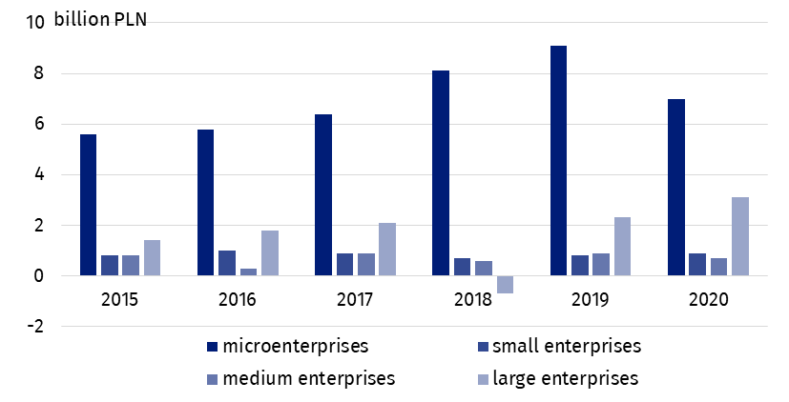
Chart 3. The surplus of total revenues over total costs in enterprises belonging to the cultural and creative industries by enterprise size class
The surplus of total revenues over total costs for cultural and creative industries amounted to PLN 11.8 billion.
The share of both total revenues and total costs generated by enterprises belonging to the cultural and creative industries in total revenues and total costs achieved by all non-financial enterprises was less than 2.0% (1.6% and 1.5% respectively).
In 2020, the cultural and creative industries generated added value of PLN 24.7 billion (PLN 2.2 billion less than the year before), which accounted for 1.9% of the added value generated by all non-financial enterprises in the analyzed year. Calculated per one enterprise, the total value added of the cultural and creative industries was 2.9 times lower than the value added per an average non-financial enterprise.

Foreign trade in cultural and creative goods and services
In 2020, cultural and creative goods worth PLN 16,980.5 million were sold abroad, i.e. PLN 1,767.5 million more compared to 2019. The import of cultural and creative goods also slightly increased (by 7.5% ) reaching the amount of PLN 10,793.5 million. As in previous years, the balance of trade in cultural and creative goods was positive and amounted to PLN 6,187.1 million. This amount confirms the growing tendency of the positive balance in the turnover of cultural and creative goods observed in the previous periods. Behind the positive balance of the entire turnover of cultural and creative goods there is, inter alia, high positive balance of turnover in the field of Books and press (PLN 4,354.1 million) and Advertising (PLN 1,023.6 million). A negative balance was recorded in the following areas: Performing arts (-PLN 123.8 million), Cultural heritage (-PLN 89.1 million) and Arts and crafts (-PLN 1.5 million). Both in terms of exports and imports of cultural and creative goods, the highest turnover was recorded in the field of Audiovisual arts and multimedia (exports: PLN 8,337.0 million, imports: PLN 7,385.2 million), followed by Books and press (exports: 7,025.5 PLN million, import: PLN 2 671.5 million).
In 2020, a positive balance of international trade in cultural and creative goods was recorded, amounting to PLN 6,187.1 million. The balance of trade in cultural and creative services was negative, at the level of -PLN 249.8 million.

Table 2. Foreign trade in cultural and creative goods and services by domain of culture in 2020
Specification | Cultural and creative goods |  | Cultural and creative services
Specification | export | import | export | import
Specification | in million PLN
Total | 16,980.5 | 10,793.5 | 11,244.4 | 11,494.3
Cultural heritage | 12.5 | 101.5 | 470.9 | 193.4
Books and press | 7,025.5 | 2,671.5 | 195.3 | 505.9
Visual arts | 188.3 | 117.4 | – | –
Architecture | 6.6 | 5.5 | 215.9 | 129.1
Performing arts | 181.7 | 305.6 | 113.6 | 330.6
Audiovisual arts and multimedia | 8,337.0 | 7,385.2 | 828.1 | 3,039.3
Advertising | 1,228.5 | 204.9 | 9,420.6 | 7,295.9
Arts and crafts | 0.4 | 1.8 | – | –
In 2020, cultural and creative services worth PLN 11,244.4 million were delivered abroad (only slightly more than in the previous year – PLN 11,136.6 million), while cultural and creative services worth PLN 11,494.3 million were purchased. For the first time in recent years, this resulted in a negative balance of turnover in cultural and creative services in the amount of -PLN 249.8 million. The areas in which the balance of international exchange of services was positive were: Advertising (PLN 2,124.8 million), Cultural heritage (PLN 277.5 million) and Architecture (PLN 86.8 million). The lowest balance of trade in services was recorded in the field of Audiovisual arts and multimedia (-PLN 2,211.2 million), where imports exceeded exports over 3.5 times. Advertising (PLN 9,420.6 million) had the largest share in the export of cultural and creative services, significantly exceeding the value of turnover in other areas: Audiovisual arts and multimedia (PLN 828.1 million) and Cultural heritage (PLN 470.9 million). Regarding imports, also Advertising (PLN 7,295.9 million) dominated there, followed by Audiovisual arts and Multimedia (PLN 3,039.3 million).
In the structure of Poland's foreign trade, trade of cultural and creative goods and services played a relatively small role and in recent years this share has fluctuated around the same values. The share of culture in the export of goods in 2020 amounted to 1.6%, in the import – 1.1%; whereas the share of trade in cultural and creative services was 4.4% (export) and 7.3% (import) respectively.
Primarily the recipients of Polish cultural and creative goods were developed countries, especially the Euro zone countries (74.4% of the value of the exports). The situation was similar in the case of the import of goods, where the main turnover was with developed countries, although to a lesser extent than in the case of exports, with the EU (42.9% of the value of imports) or the Euro zone itself (38.9%). Regarding the import of cultural and creative goods, the share of developing countries was significant (26.1% of the value of imports) - it was the only area where a negative balance of trade was recorded
(-PLN 2 618.1 million). The geographic structure of the international exchange of cultural and creative services was similar to that of trade in goods. Most services were exported and imported to and from developed countries (94.1% and 93.4% respectively), of which more than half to and from the Euro zone countries (51.4% and 58.1%).
When citing data from the Statistics Poland, please include the following information: "Source of data: the Statistics Poland", and in the case of publishing calculations made on the basis of data published by the Statistics Poland, please include the following information: "Own study based on the data of the Statistics Poland".







Powiązane opracowania
Cultural and creative industries 2014–2016
Cultural and creative industries in 2019
Culture in 2020
Terms used in the official statistics
Exports of goods and services
Imports of goods and services
Total costs
Average monthly gross wages and salaries
Average paid employment
Total revenues
Balance foreign trade commodity turnover
Balance of services
Cost level indicator
Gross earnings

Issued by:
The Spokesperson for the President of Statistics Poland

Karolina Banaszek
Mobile: (+48) 695 255 011
www.stat.gov.pl/en
@StatPoland
@GlownyUrzadStatystyczny
gus_stat
glownyurzadstatystycznygus
glownyurzadstatystyczny
Prepared by:
Statistical Office in Kraków

Director Agnieszka Szlubowska
Office: tel. (+48 22) 420 40 50
Press Office
Office: tel: +48 22 608 38 04
e-mail: obslugaprasowa@stat.gov.pl

