Market of the works of art and antiques in 2021
In 2020 the total amount of sold art and antiques amounted to PLN 591.2 million and increased by
PLN 172.8 million in comparison to 2020.
41.3%
Increase in the sales of works of art and antiques in comparison to 2020
.

The largest part of the total value of sales of works of art and antiques was obtained by entities through organisation of traditional auctions – PLN 381.9 million, an increase by 43.2% in comparison to 2020.
Out of the total number of entities (209) operating on the market of works of art and antiques, more than half (62.2%) dealt exclusively with the sale of works of art and antiques, whereas 37.8% conducted both sale of works of art and antiques and exhibition activity.
25.8% of entities selling works of arts and antiques had their headquarters in Mazowieckie Voivodship
Most of entities operating on the market of works of art and antiques had their headquarters in Mazowieckie Voivodship – 54 (25.8 % of the total number of entities) of which 46 entities conducted sale of works of art and antiques in Warsaw. There were 39 entities (18.7%) in Małopolskie Voivodship, of which 34 conducted activity in Kraków. As in the previous year the majority of entities (68.9%) involved in the sales of works of art and antiques had their headquarters in capitals of voivodships.
The total amount of sold works of art and antiques amounted to PLN 591.2 million (an increase by 41.3% in comparison to 2020). As in 2020, the highest sales value was recorded in Mazowieckie Voivodship – PLN 448.3 million, representing 78.5% of the total amount of the sales.
The highest amount of sale was obtained from sale of works of art and antiques from painting domain – PLN 468.5 million (79.3% of the total amount of sales), of which the sale of old paintings amounted to PLN 240.0 million (51.2% of amount obtained from sale of paintings) and the sale of contemporary painting works – PLN 228.5 million (48.8%). In comparison to 2020 sale of works of art and antiques from painting domain increased by 34.7%, of which the sale of contemporary painting works increased by 38.4% and old paintings by 31.2%. In Mazowieckie Voivodship the sale of paintings amounted to PLN 360.3 million, which constituted 76.9% of total amount of sale of paintings in Poland.
The largest number of works of art and antiques from painting domain were sold in Mazowieckie Voivodship (76.9%)
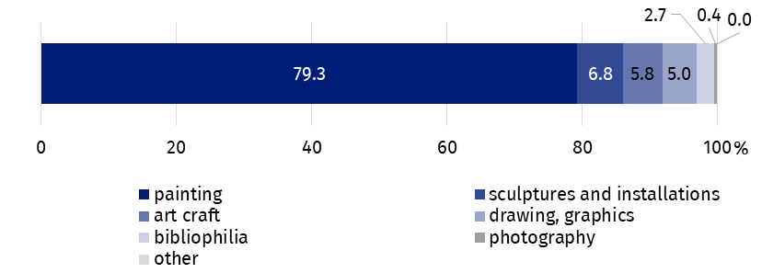
Chart 1. The structure of sale of works of art and antiques by type in 2021
In 2021 the largest part of the total value of sales of works of art and antiques was obtained by entities during traditional auctions – PLN 381.9 million, which constituted 64.6% of the total sales. In comparison to 2020 sale of works of art and antiques through traditional auctions increased by 43.2%. Sale through traditional auctions in Mazowieckie Voivodship accounted for 84,1% (PLN 321.3 million) of total amount of sale of works of art and antiques through traditional auctions in Poland.
Another significant distribution channel in terms of the total value of sales was sales through commercial facilities. Its value was PLN 141.3 million, which constituted 23.9% of total amount of sale. Sale of works of art and antiques in commercial facilities increased by 59.3% in comparison to the previous year. In Mazowieckie Voivodship sale of works of art and antiques in commercial facilities accounted for 65.1% of the total amount of sales (PLN 91.9 million) of works of art and antiques in commercial facilities in Poland.
Works of art and antiques were sold via the Internet for PLN 59.2 million (10.0% of total amount of sales), which presented an increase of 1.3% in comparison to 2020.
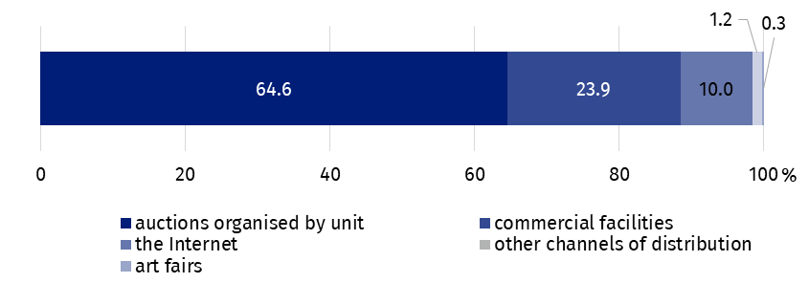
Chart 2. The structure of sale of works of art and antiques by distribution channels in 2021
More than a half (64.6%) of sale of works of art and antiques were organised through traditional auctions
In the year under review, 14.8% of entities operating on the art and antiques market participated actively in art fairs. One of the most important national, cultural events is invariably the Warsaw Art Fair, attended by 10.5% entities selling works of art and antiques.

In the case of quoting data from the Statistics Poland, please provide information: "Statistics Poland data source", and in the case of publishing calculations made on data published by the Statistics Poland, please provide information: "Own study based on Statistics Poland data".

Prepared by:  Statistical Office in Kraków  Director Agnieszka Szlubowska  Phone: (+48 12) 420 40 50 | Issued by:  The Spokesperson for the President  of Statistics Poland  Karolina Banaszek  Phone: (+48) 695 255 011
Press Office  Phone: (+48 22) 608 38 04  e-mail: obslugaprasowa@stat.gov.pl |   stat.gov.pl/en/

@StatPoland

@GlownyUrzadStatystyczny

gus_stat

glownyurzadstatystycznygus

glownyurzadstatystyczny
Related information
Culture in 2020
Market of works of art and antiques in 2020
Terms used in official statistics
Works of art
Antiques
Art gallery

