Mass events in 2021
In 2021, 3.0 thousand mass events were organised
(89.5% more than in 2020). Mass events gathered a total of 11.0 million participants, 6 million more in comparison to 2020 (an increase of 123.4%).
89.5%
Increase of the number of organised mass events in comparison to 2020
In 2021, due to the ongoing state of epidemic in Poland, number of mass events organised in Poland was significantly reduced. Mass event were held only in months when there were no restrictions caused by the coronavirus epidemic.
Comparing data to 2020 when there were very few mass events, the number of organised mass art and entertainment events increased by 136.9%, whereas mass sports events - by 74.3%. The largest number of mass events took place in Śląskie Voivodeship (494). Altogether 1.7 million participants took part in them. The most numerous mass events were organised in Mazowieckie Voivodeship. On average, 5.6 thousand people participated in 1 event in this voivodship.
3.7 thousand people on average participated in 1 mass event
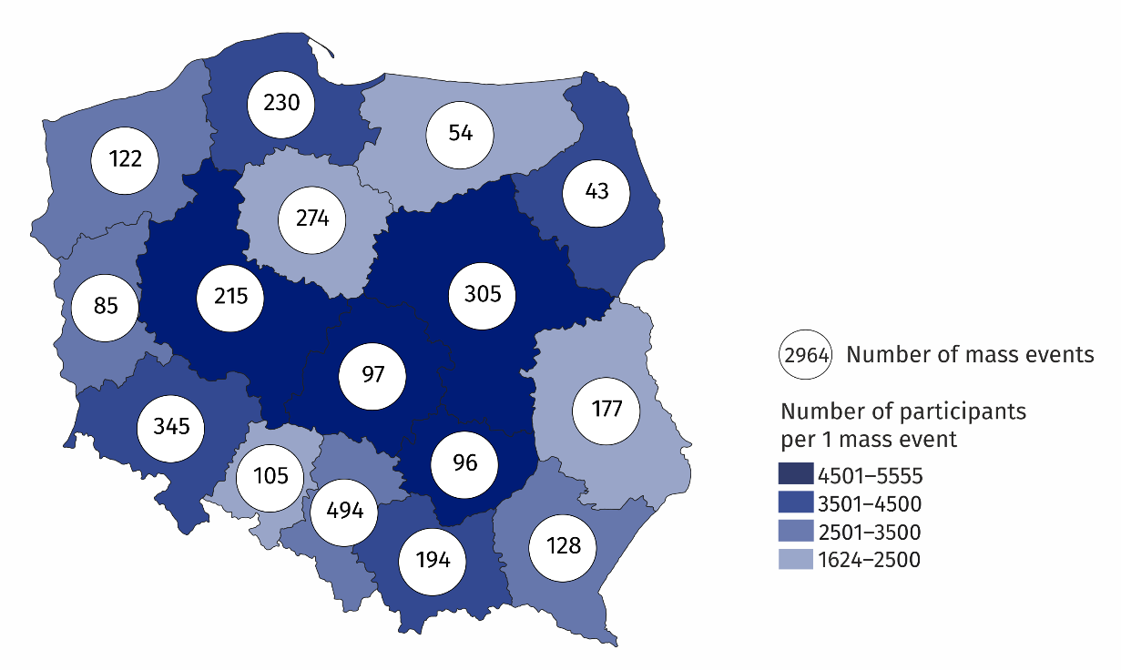
Map 1. Mass events in 2021
Mass events organised in Śląskie, Dolnośląskie and Mazowieckie Voivodships constituted 38.6% of the total number of mass events

The majority of organised events were sport events (69.7% of the total number of mass events). More than 93% participants took part in paid mass events. Compared to 2020, the number of events organised in closed facilities increased by 78.7%, and in open areas – by 124.3%.
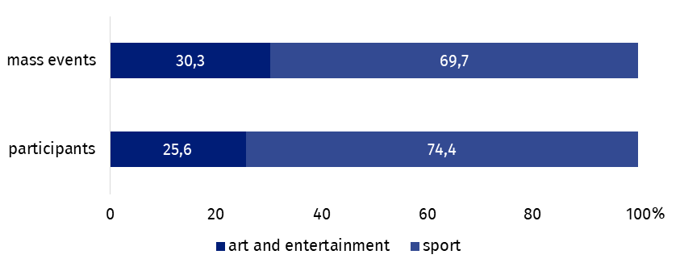
Chart 1. The structure of mass events by type in 2021
The majority of mass events were organised by legal entities (92.0% of the total number of mass events). The remaining mass events were organised by organisational units without legal personality (4.6%) and natural persons (3.4%).
In the case of quoting data from the Statistics Poland, please provide information: "Statistics Poland data source", and in the case of publishing calculations made on data published by the Statistics Poland, please provide information: "Own study based on Statistics Poland data".

Prepared by:  Statistical Office in Kraków  Director Agnieszka Szlubowska  Phone: (+48 12) 420 40 50 | Issued by:  The Spokesperson for the President  of Statistics Poland  Karolina Banaszek  Phone: (+48) 695 255 011
Press Office  Phone: (+48 22) 608 38 04  e-mail: obslugaprasowa@stat.gov.pl |   stat.gov.pl/en/

@StatPoland

@GlownyUrzadStatystyczny

gus_stat

glownyurzadstatystycznygus

glownyurzadstatystyczny
Related information
Culture in 2020
Mass events in 2020
Terms used in official statistics
Mass event
Event participant

