Activity of museums in 2021
In 2021 there were 939 museums and museum branches, visited by 25.3 million people. Museums organised 2.5 thousand regular exhibitions and 3.6 thousand temporary exhibitions in Poland (of which 33 exhibitions from abroad).
51.9%
Increase of the number of visitors in museums and museum branches in comparison to 2020
70,5% of museums and museum branches belonged to the public sector
In 2021, due to the ongoing state of epidemic in Poland, cultural entities continued to operate under the conditions of temporary constraints. The restrictions on the activity of cultural entities had different scope and forms, but were less restrictive compared to the previous year.
There were 939 museums and museum branches (932 in 2020), of which most belonged to the public sector (70.5%). Most of the units were organised by local government units (85.2%). In the private sector, most museums belonged to natural persons (54.9%).
Museums and museum branches were visited by 25.3 million people (51.9% more than in the previous year), including 10.2 million people visiting for free. Organised groups of school students accounted for 8.0% of the total number of visitors (3.7% in 2020). Museums presenting art were the most popular among visitors (63.3% of the total number of visitors). They were visited by 8.6 million people.
Museums and museum branches were visited by 25.3 million people, including 10.2 million for free
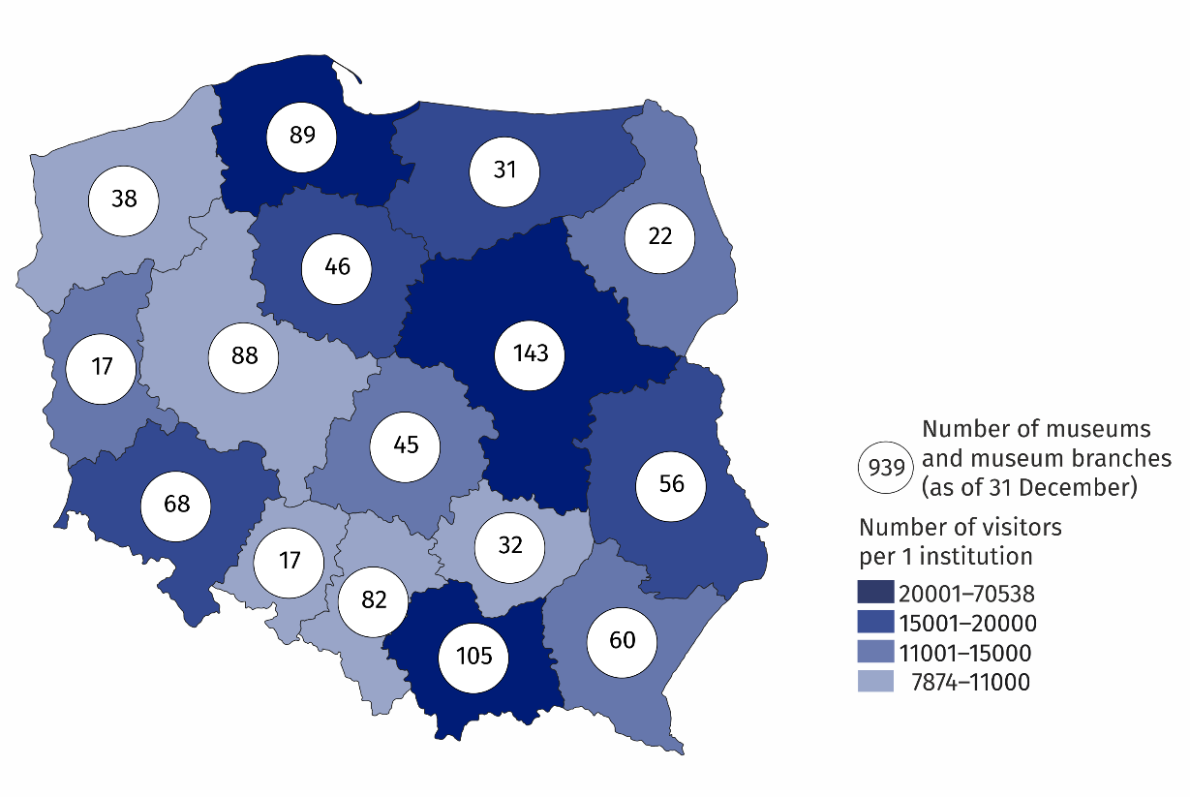
Map 1. Museums and museum branches in 2021
26.4% of the total number of museums operated in Mazowieckie and Małopolskie Voivodships
The greatest number of museums and visitors was recorded in Mazowieckie Voivodship. The number of museum visitors per 1,000 people in Mazowieckie Voivodship amounted to 1,861 people (in 2020 - 434 people).
In 2021, 38.6% of museum and museum branches limited their cultural activities due to COVID-19, i.e. did not temporarily prepare and did not make the cultural offer available to recipients. About 30% of entities introduced restrictions in the period from January to May, while in the following months of the year, over 90% of museums and museum branches conducted cultural activities without restrictions. Museums and museum branches made part of their offer available via the Internet – in on-line form cultural and educational activities were organised. 502 exhibitions were made available via websites, social networks and video channels. They were seen by 1.2 million people. Museums and museum branches organised and made available on-line 7.2 thousand events attended by 3.9 million people.
Number of cultural events increased by 54.7% compared to previous year
The vast majority of museums organised free visiting as part of the "Night of Museums". This form of visiting was used by over 160.5 thousand people (in 2020 - 18.4 thousand). The most frequently visited museums during the "Night of Museums" were historical museums, which were attended by 80.3 thousand visitors (in 2020 - 16.1 thousands).
Number of objects in museum collection amounted to 20.1 million pieces. Compared to 2020 the number of objects increased by 3.8%. The largest part of museum collection was represented by archaeological collections (25.2%), while the least numerous were objects in the field of geology and cartography (0.2% each). The greatest number of objects was gathered by interdisciplinary museums (29.9% of the total museum collections).
Number of objects in museum collection increased by 3.8% on an annual basis
Museums organised 2,529 regular exhibitions (in 2020 - 2,445) and 3,569 temporary exhibitions (in 2020 - 3,000), including 33 exhibitions from abroad. Compared to 2020, the number of temporary exhibitions increased by 19.0%, and the number of regular exhibitions - by 3.3%. History museums prepared the largest number of temporary exhibitions (1.3 thousand).
Chart 1. The structure of museum collection according to branches in 2021
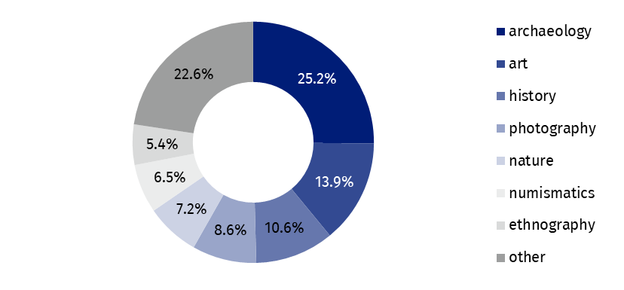
As of 31 December
In addition to the primary activity of collecting and presenting collection, museums organised 75.6 thousand events, in which 3.0 million people took part. Museum lessons were among most frequently organised (48.4 thousand), with 0.9 million attendees.
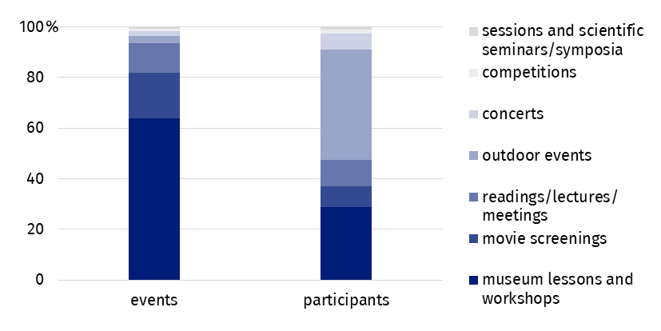
Chart 2. The structure of cultural and educational activity of museums and museum branches in 2021
In the case of quoting data from the Statistics Poland, please provide information: "Statistics Poland data source", and in the case of publishing calculations made on data published by the Statistics Poland, please provide information: "Own study based on Statistics Poland data".

Prepared by:  Statistical Office in Kraków  Director Agnieszka Szlubowska  Phone: (+48 12) 420 40 50 | Issued by:  The Spokesperson for the President  of Statistics Poland  Karolina Banaszek  Phone: (+48) 695 255 011
Press Office  Phone: (+48 22) 608 38 04  e-mail: obslugaprasowa@stat.gov.pl |   stat.gov.pl/en/

@StatPoland

@GlownyUrzadStatystyczny

gus_stat

glownyurzadstatystycznygus

glownyurzadstatystyczny
Related information
Culture in 2020
Activity of museums in 2020
Terms used in official statistics
Museum
Museum branch
Unit’s organiser
Museum lesson
Exhibits
Temporary exhibitions
Permanent exhibitions
Visitor

Starting from 2020 data on museums includes only those museums that operate on the basis of the statute or regulations agreed with the minister competent for culture and protection of national heritage, in accordance with Art. 6 of the Act of November 21, 1996 on museums (Journal of Laws of 2012, item 987, as amended).

