Activity of theatres and music institutions in 2021
In 2021 there were 185 theatres and music institutions. They presented 30.0 thousand performances/concerts with 4.7 million audience. 717 premieres took place. Theatres and music institutions had 3.8 thousand performances in their repertoire.
5.4%
Increase of the number of audience in theatres and music institutions in comparison to 2020
In 2021, due to the ongoing state of epidemic in Poland, cultural entities continued to operate under the conditions of temporary constraints. The restrictions on the activity of cultural entities had different scope and forms, but were less restrictive compared to the previous year.
In 2021, 185 theatres and music institutions with their own artistic ensemble conducted stage activity (4.6% less in comparison to 2020).
Due to COVID-19, cultural activities were limited by 45.4% entities (13.3 percentage points less than in 2020). More than 30% of the entities introduced restrictions in the period from January to May, while in the following months of the year over 90% of theatres and music institutions operated without restrictions.
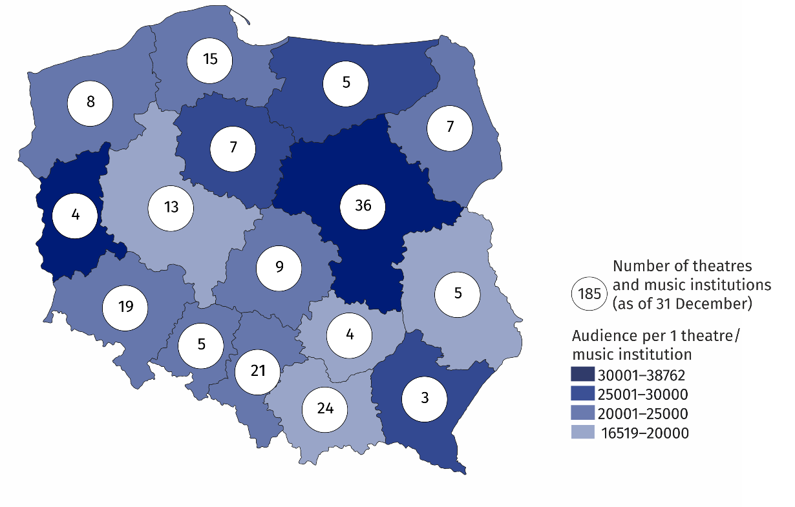
Map 1. Theatres and music institutions in 2021
32.8% of total number of audience took part in performances/concerts organised by theatres and music institutions from Mazowieckie Voivodship

The greatest number of theatres and music institutions with their own artistic ensemble operated in Mazowieckie Voivodship (36) and the least in Podkarpackie Voivodship (3). A total of 30.0 thousand performances/concerts were presented on 366 stages. Theatres and music institutions had 101.9 thousand seats for audience in fixed halls.
Of the total number of theatres and music institutions with their own artistic ensemble, 86.5% belonged to the public sector, of which 93.1% institutions were organised by local government units.
4.7 million audience took part in performances/concerts organised by theatres and music institutions in 2021 (an increase of 5.4% in comparison to 2020). On average 158 people took part in one performance/concert. One entity organised on average 162 performances/concerts (in 2020 – 126).
In addition, theatres and music institutions organised 3.0 thousand on-line performances/ concerts attended by 3.6 million participants.
Chart 1. The structure of theatres and music institutions by type in 2021
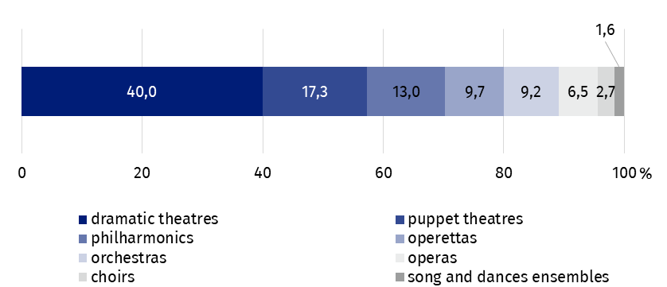
As of 31 December
19.0
39.7
In the case of quoting data from the Statistics Poland, please provide information: "Statistics Poland data source", and in the case of publishing calculations made on data published by the Statistics Poland, please provide information: "Own study based on Statistics Poland data".

Prepared by:  Statistical Office in Kraków  Director Agnieszka Szlubowska  Phone: (+48 12) 420 40 50 | Issued by:  The Spokesperson for the President  of Statistics Poland  Karolina Banaszek  Phone: (+48) 695 255 011
Press Office  Phone: (+48 22) 608 38 04  e-mail: obslugaprasowa@stat.gov.pl |   stat.gov.pl/en/

@StatPoland

@GlownyUrzadStatystyczny

gus_stat

glownyurzadstatystycznygus

glownyurzadstatystyczny
Related information
Culture in 2020
Activity of theatres and music institutions in 2020
Terms used in official statistics
Choir
Artistic activities and entertainment
Philharmonic
Music institution
Concert
Orchestra
Premiere
Performance
Scene
Theatre
Audience
Own artistic team
Song and dance ensemble

