Financial results of cultural institutions in 2021
In 2021 assets (liabilities) of the surveyed cultural institutions as of December 31, 2021 amounted to PLN 21,209.4 million. Total revenues were higher by 9.5% and total costs by 10.5% in comparison to 2020.
9.5%
Increase of the total revenues in comparison to previous year
In 2020 assets amounted to PLN 21,209.4 million. Taking into account the size of cultural institution measured by the number of employees, 49.1% of the total value of assets belonged to entities employing between 50 to 249 people (318 entities), 25.4% of total assets belonged to entities employing between 10 to 49 people (1,607 entities), 20.5% – entities employing 250 and more people (26 entities) and 5.0% – entities employing less than 10 people (2,742 entities).
Assets (liabilities) of cultural institutions at the end of 2021 were 7.3% higher than at the end of 2020
The highest value of assets was recorded in libraries, archives, museums and in entities conducting other activity in the field of culture – PLN 12,786.1 million (60.3% of the total value of assets).

Table 1. Basic data on the finances of cultural institutions
Specification | 2020 | 2021 | 2020 = 100
Specification | in PLN million |  | 2020 = 100
Assets (liabilities) | 19,757.7 | 21,209.4 | 107.3
Total revenues | 9,687.4 | 10,603.6 | 109.5
Total costs | 9,529.1 | 10,531.9 | 110.5
Gross financial result | 158.3 | 71.6 | 45.2
Net financial result | 157.1 | 70.2 | 44.7
At the end of 2021 total fixed assest of cultural institutions amounted to PLN 19,483.0 million and were 7.7% higher in comparison to the previous year. Tangible fixed assets (98.6%) had the largest share in their structure, of which fixed assets constituted 87.2% and fixed assets under construction 12.3%.

Current assets of cultural institutions were 3.4% higher in comparison to the end of 2020 and amounted to PLN 1,726.4 million. In their structure short-term investments constituted 67.3% (a decrease of 1.4 percentage point).

Chart 1. The structure of current assets

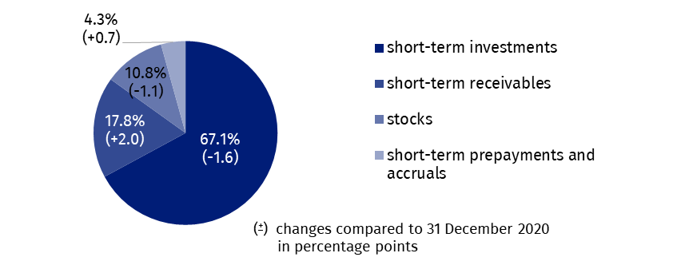
As of 31 December 2021
In the structure of liabilities 32.3% constituted equities, which increased by 8.2% in comparison to the end of 2020 and amounted to PLN 6,855.7 million, while the share of liabilities and provisions for liabilities constituted 67.7%.
Liabilities and provisions for liabilities at the end of 2021 amounted to PLN 14,353.7 million (an increase of 7.0% in comparison to the end of 2020), in which prepayments and accruals constituted 93.4%, short-term liabilities 3.7%, reserves for liabilities 2.2% and long-term liabilities 0.7%.

Chart 2. The structure of liabilities

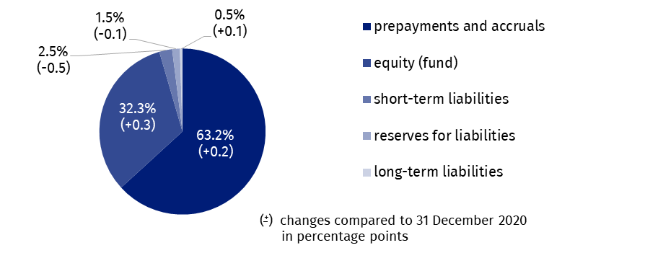
As of 31 December 2021
The total revenue generated by cultural institutions amounted to PLN 10,603.6 million and increased by 9.5% in comparison to 2020. The highest value of revenues was reported in cultural institutions employing between 50 to 249 people (39.3% of the total value of revenues). In the structure of total revenues, the largest share had subsidies to basic activity (79.1%). The remaining part constituted other operating revenues 10.7%, net revenues from sales of products (9.4%), net revenues from sales of goods and materials (0.7%) and financial revenues (0.1%).
The highest total revenues were achieved by cultural institutions in Mazowieckie Voivodship (26.9% of the total value of revenues) and then in Małopolskie Voivodship (11.9%).
In 2021, state-owned cultural institutions achieved total revenues of PLN 2,122.0 million, while total revenues of local government cultural institutions amounted to PLN 8,481.6 million.
In 2021, total costs amounted to PLN 10,531.9 million and were 10.5% higher than in previous year. The own costs of products, goods and materials sold had the largest share (98.4%) in their structure.
Total revenues in 2021 were 9.5% higher than in the previous year and total costs increased by 10.5%
In the structure of operating costs by type remuneration accounted for 49.3% (a decrease of 1.1 p.p compared to 2020), 18.5% external services (an increase of 1.9 p.p), and 9.9% social insurance and other benefits (a decrease of 0.2 p.p).
As in the case of total revenues, the highest total costs were generated by units from the Mazowieckie voivodship (26.8% of the total value of costs).
The highest value of total revenues and total costs was generated by cultural institutions conducting creative arts and entertainment activity, i.e. PLN 6,233.3 million (58.8% of the total value of revenues) and PLN 6,223.7 million (59.1% of the total cost).
The gross financial result was PLN 71.6 million (profit PLN 191.6 million, loss PLN 120,0 million).
Obligatory encumbrances on gross financial result due to income taxes increased in relation to 2020 by 17.9% and amounted to PLN 1.4 million.
The net financial result was at the level of PLN 70.2 million (compared to PLN 157.1 million in 2020), with a decrease in net profit (by 18.5%) and an increase in net loss (by 57.0%). From the total number of cultural institutions examined, 37.5% achieved a net profit and 43.2% recorded a net loss.

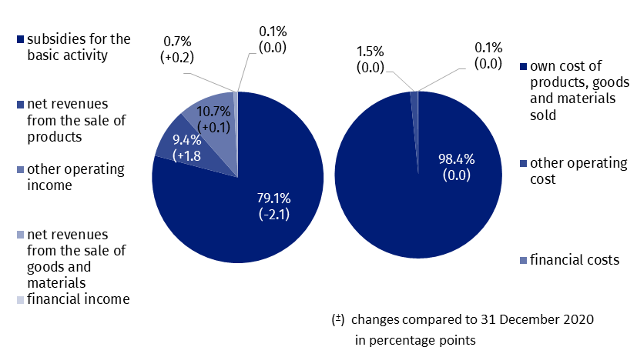
Chart 4. The structure of total revenues and total costs in 2021
As of 31 December 2021, 85.7 thousand people worked in cultural institutions, of which 11.7% in state-owned units and 88.3% in local government organisational units. Among the cultural institutions surveyed, entities employing less than 10 people predominated, constituting 58.4% of the total number of units. Similar to the previus year, most people worked in cultural institutions conducting creative arts and entertainment activities (55.1% of the total number of employees).
Table 2. Total revenues and total costs according to selected divisions and classes of PKD classification in 2021
SPECIFICATION | Total | Of which
SPECIFICATION | Total | creative, arts and entertainment activities | of which |  | libraries, archives, museums and other cultural activities | of which
SPECIFICATION | Total | creative, arts and entertainment activities | performing arts | operation of arts  facilities | libraries, archives, museums and other cultural activities | library and  archives activities | museums activities
Number of cultural institutions | 4,693 | 2,312 | 152 | 2,149 | 2,375 | 1,981 | 385
Total revenues in PLN mln | 10,603.6 | 6,233.3 | 1,907.5 | 4,174.1 | 4,185.6 | 1,861.1 | 2,199.3
of which:
net revenues from the sale of products | 995.6 | 660.9 | 227.8 | 414.6 | 273.9 | 16.1 | 251.2
subsidies for the basic activity | 8,388.2 | 4,933.0 | 1,487.6 | 3,323.0 | 3,365.4 | 1,716.6 | 1,590.2
of which:
state budget | 1,810.4 | 895.7 | 371.1 | 507.1 | 850.9 | 162.8 | 651.1
local government units | 6,447.0 | 3,984.5 | 1,109.6 | 2,770.6 | 2,459.3 | 1,528.7 | 909.1
Total costs in PLN million | 10,531.9 | 6,223.7 | 1,912.0 | 4,159.7 | 4,128.0 | 1,865.3 | 2,150.3
of which:
depreciation | 870.5 | 411.2 | 155.6 | 249.8 | 438.5 | 136.3 | 286.8
usage of materials and energy | 949.3 | 562.6 | 105.2 | 445.9 | 375.0 | 191.0 | 176.9
external services | 1,913.1 | 1,249.3 | 261.3 | 943.1 | 611.1 | 185.8 | 400.1
remuneration | 5,108.5 | 2,991.2 | 1,076.4 | 1,853.5 | 2,065.2 | 1,048.1 | 978.3
social insurance and other benefits | 1,027.5 | 582.9 | 213.6 | 358.6 | 435.2 | 221.0 | 206.0
The balance sheet and profit and loss account for 2021 were obtained from 4,693 cultural institutions with legal personality: 70 state organisational units and 4,623 self-government units of gminas, powiats and voivodships.
The data presented in this study were prepared on the basis of the form with the symbol
F-02/dk Annual report on the finances of cultural institutions.
In the case of quoting data from the Statistics Poland, please provide information: "Statistics Poland data source", and in the case of publishing calculations made on data published by the Statistics Poland, please provide information: "Own study based on Statistics Poland data".

Prepared by:  Statistical Office in Kraków  Director Agnieszka Szlubowska  Phone: (+48 12) 420 40 50 | Issued by:  The Spokesperson for the President  of Statistics Poland  Karolina Banaszek  Phone: (+48) 695 255 011
Press Office  Phone: (+48 22) 608 38 04  e-mail: obslugaprasowa@stat.gov.pl |   stat.gov.pl/en/

@StatPoland

@GlownyUrzadStatystyczny

gus_stat

glownyurzadstatystycznygus

glownyurzadstatystyczny
Related information
Financial results of cultural institutions in the period January - December 2021
Financial results of cultural institutions in 2020
Methodological report. Non-financial enterprises surveys 2019
Terms used in official statistics
Total revenues
Total costs
Gross financial result
Net financial result
Investment outlays
Outlays on intangible fixed assets
Cultural institution

