Family benefits in 2021
In 2021, PLN 11.0 billion was allocated to support families in Poland in the form of family benefits, and they were used on average by 1.5 million beneficiaries monthly. Benefits from the alimony fund were paid in the total amount of PLN 1.0 billion. As part of the government programme "Family 500 plus" PLN 39.9 billion was spent on child-raising benefits. Additionally, other activities were carried out to improve the situation of families, including the government programmes "Good Start", "Large Family Card".
2.0%
Increase in the amount of family benefits paid y/y

Family benefits
PLN 11.0 billion was transferred to the beneficiaries of family benefits to support families with children and with disabled persons
In 2021, PLN 11.0 billion was allocated to family benefits aimed at providing financial support to families with children and people with disabilities, i.e. PLN 213.7 million (2.0%) more than in 2020. These benefits were used on average by 1.5 million beneficiaries monthly, and an average of 3.5 million benefits were paid during the month. The largest amount of funds, as in 2020, was allocated to assistance for disabled people, i.e. care benefits, which accounted for 63.4% of the total amount of expenditure. On the other hand, expenses for assistance addressed to families with children, i.e. family allowances with supplements, allowances for childbirth and parental benefits accounted for 36.6% of the total amount of expenditure.

Chart 1. Structure of expenditure on family benefits in 2021
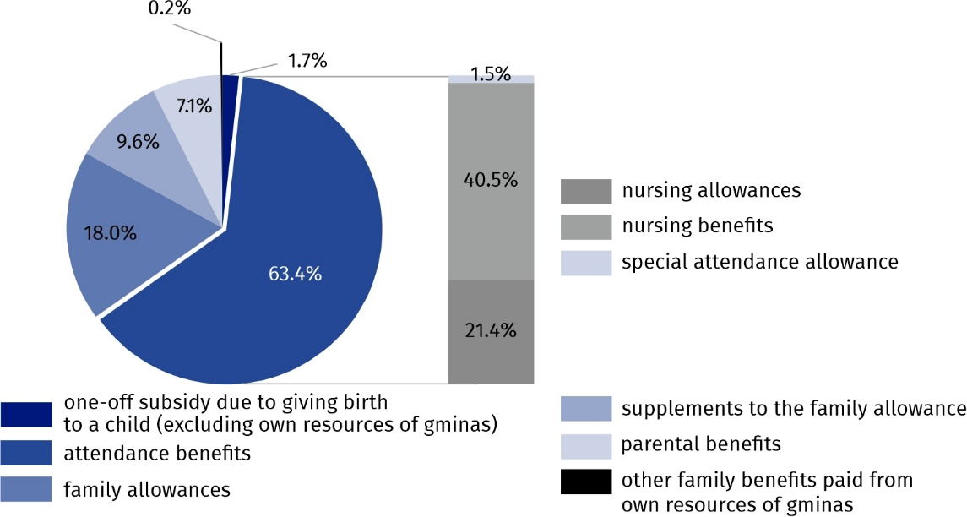
Source: National Family Benefits Monitoring System, Ministry of Family and Social Policy.

Family allowances
Family allowance was received on average by 679.0 thousand families per month
In 2021, family allowances were paid in the amount of PLN 2.0 billion, i.e. PLN 332.2 million (14.3%) less than in 2020. Family allowances were collected by an average of 679.0 thousand families, i.e. 142.9 thousand (17.4%) less than in 2020. The allowance for 1 or 2 children was received by 490.0 thousand families, which constituted 72.2% of families receiving family allowance. Families with many children receiving the allowance for at least 3 children accounted for 27.8% (189.0 thousand). Among the families receiving family allowances, full families accounted for 77.1% (523.7 thousand families), the remaining 22.9% were single-parent families (155.3 thousand families). In 2021, 97.0 thousand families with a disabled child received the family allowance, which was 14.3% of all families receiving the family allowance.
Among the families receiving family allowance, 51.4% of families (348.7 thousand families) achieved an income per person not higher than PLN 400, and 41.7% (283.1 thousand families) achieved income per capita in the range from PLN 400 to the income criterion. Income above the level of the income criterion was achieved by 6.9% of families benefiting from family benefits (47.1 thousand).

Chart 2. Structure of families receiving the family allowance in 2021

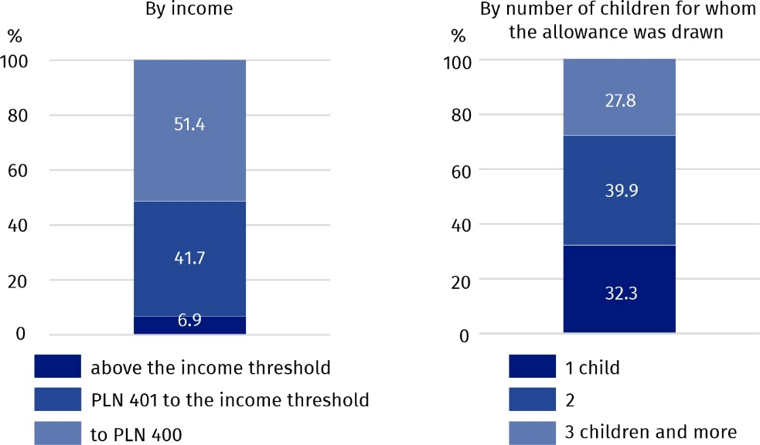
Source: National Family Benefits Monitoring System, Ministry of Family and Social Policy.
Family allowances were paid on average for 1 457.4 thousand children monthly, wherein the largest group was constituted by children aged 6–12 (568.2 thousand – 39.0%). Children under the age of 6 (428.9 thousand children) accounted for 29.4% of the total number of children for whom family allowances were paid. Children aged 13–15 accounted for 15.7%, aged 16–17 – 9.1%, and those aged 18 and more who were dependent mainly due to education – 6.8%.
Parents received family allowances for 19.6% of children under the age of 18
Share of children under the age of 18 for whom parents received family allowances in the total number of children at this age was 19.6% and was lower by 3.1 pp compared to 2020. This indicator reached the lowest value in Dolnośląskie Voivodship (14.1%) and the highest one in Lubelskie Voivodship (26.1%).

Map 1. Share of children under the age of 18 for whom parents received the family allowance in the total number of children at this age in 2021

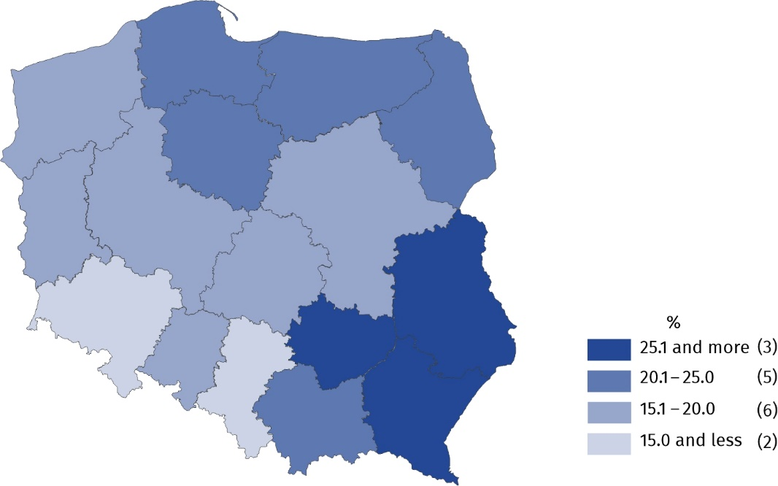
Source: National Family Benefits Monitoring System, Ministry of Family and Social Policy.

Families benefiting from supplements to family allowances
In 2021, persons receiving family allowances received supplements to allowances in the amount of PLN 1.1 billion, which constituted 9.6% of the total amount of family benefits. On average, 806.9 thousand supplements to family allowances were paid monthly, i.e. by 110.3 thousand (by 12.0%) less than in 2020. Expenditure on supplements to family allowances was financed from the state budget, and additionally, gminas from their own funds (in accordance with Article 15 of the Act on Family Benefits) spent PLN 10.2 million to increase these amounts. Among the expenses on supplements to family allowances, the largest amount – PLN 311.0 million was paid due to multi-children parenthood, and the smallest – PLN 65.7 million due to giving birth to a child.
More than 1/4 of expenses on supplements to family allowances were supplements due to multi-children parenthood

Chart 3. Structure of supplements to the family allowance in 2021
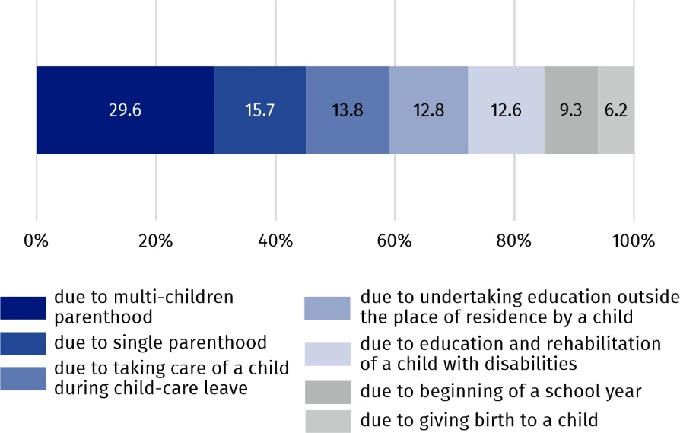
Source: National Family Benefits Monitoring System, Ministry of Family and Social Policy.

Attendance benefits
PLN 7.0 billion was allocated to attendance benefits for people with disabilities
In the total amount of family benefits paid in 2021, attendance benefits for people with disabilities constituted 63.4% (PLN 7.0 billion). Compared to 2020, the amount of these benefits increased by 13.6% (by PLN 833.8 million). More than 60% of the amount was allocated to nursing benefits (PLN 4.5 billion). The remaining part is nursing allowances (PLN 2.4 billion) and special attendance allowances (PLN 161.4 thousand). Nursing allowances were paid on average monthly for 911.6 thousand persons, towards 906.5 thousand persons in 2020. In the structure of nursing allowances, the highest share – 73.0% had benefits paid to disabled persons aged 16–74. Benefits for disabled children under the age of 16 accounted for 25.1%, however for persons aged 75 and more – 1.9%. In the discussed year, nursing allowances were paid on average monthly for 222.8 thousand children under the age of 16. The share of disabled children for whom parents received a nursing allowance in the total number of children at this age was 3.7%. In 2021, a special nursing benefit was granted on average monthly to 191.0 thousand people, and a special attendance allowance for 21.9 thousand people.

One-off subsidies due to giving birth to a child
Parents of 189.3 thousand children received subsidies due to giving birth to a child ("baby bonus")
In 2021, one-off subsidies due to giving birth to a child, the so-called "baby bonus" were directed to parents of 189.3 thousand children, and it was less by 19.0 thousand (by 9.1%) than in the previous year. Expenditure on the payment of the "baby bonus" financed from the state budget amounted to PLN 189.3 million, which accounted for 1.7% of total expenses on family benefits. Among the families receiving one-off subsidies due to giving birth to a child, families with one child constituted 62.9%, families with two children – 23.4%, and multi-children families (with three children or more) – 13.7% of the discussed population. In 2021, 8.7 thousand subsidies due to giving birth to a child were paid out additionally from own funds of gminas in the total amount of PLN 6.4 million.

Parental benefits
On average 72.6 thousand women collected parental benefits monthly
The parental benefit , introduced from 1 January 2016, is granted to women who gave birth to a child and who do not receive maternity allowance. In 2021, expenditure on parental benefits amounted to PLN 784.6 million and accounted for 7.1% of all expenditure on family benefits, and they were collected on average monthly by 72.6 thousand authorized persons. Compared to the previous year, both the amount and the average monthly number of parental benefits paid decreased by 9.1% and 8.2%, respectively.

Social and health security contributions
In 2021, PLN 851.1 million was spent on retirement and other pension contributions for people receiving nursing benefits or a special care allowance. On average, these contributions were paid for 155.1 thousand beneficiaries monthly.
Health security contributions were also paid for the persons receiving the above-mentioned benefits. PLN 176.8 million was spent on this, and they were paid on average per month for 94.7 thousand beneficiaries.

Benefits from the "Good Start" programme
As part of the "Good Start" programme, the families of pupils and students received PLN 1.3 billion
Since 2018, support for families with children has been extended by a payment once a year (in the amount of PLN 300) of benefits for a school starter kit, for each schooling child starting the school year. The benefit is paid under the "Good Start" programme and is independent of the income obtained. In 2021, nearly 4.4 million pupils and students received support under this programme and PLN 1.3 billion were allocated to families.

The Large Family Card
Almost 1.2 million families had the Large Family Card, which guaranteed a system of discounts and additional entitlements for large families
The Large Family Card is a system of discounts and additional entitlements for large families (with a minimum of three children). It is due regardless of the amount of income per capita in the family and supports budgets of large families and facilitates access to many goods and services. The Large Family Card holders can benefit, among others from discounts on rail travels, free admission to national parks, lower passport fees, as well as discounts on the purchase of food, clothes, cosmetics, books or fuel. In 2021, the Large Family Card was owned by almost 1.2 million families, while a year earlier there were over 1.0 million of them (increase by 13.1%).

Alimony fund benefits
The value of benefits paid from the alimony fund amounted to PLN 1.0 billion
The alimony fund may be used by a person entitled to receive alimony if the execution of alimony against the debtor has proved unsuccessful. In 2021, 2.5 million benefits were paid from the alimony fund, while in 2020 it was 2.6 million benefits. These benefits were paid for a total amount of PLN 1.0 billion, which was 3.4% less than in the previous year. On average, 207.0 thousand benefits were paid monthly, and their average amount was PLN 415, towards paid in 2020 on average monthly 215.7 thousand benefits in an average amount of PLN 412.

Child-raising benefits
PLN 39.9 billion was paid under the government programme "Family 500 plus"
A child-raising benefit in the amount of PLN 500 paid under the government programme "Family 500 plus" is available for every child up to the age of 18, regardless of the amount of income per capita obtained in the family. In 2021, expenditure on child-raising benefits amounted to PLN 39.9 billion, similarly to the previous year. On average, this benefit was paid out for 6.5 million children per month.

Table 1. Amounts of family benefits paid by voivodships in 2021
Specification | Amount of family benefits paid | Amount of benefits paid from the alimony fund | Amount of child-  -raising benefits paid from the “Family 500 plus” programme
Specification | million PLN
Poland | 11 009.52 | 1 030.53 | 39 892.40
Dolnośląskie | 676.14 | 86.77 | 2 827.71
Kujawsko-pomorskie | 703.99 | 72.24 | 2 094.79
Lubelskie | 661.44 | 63.96 | 2 073.06
Lubuskie | 349.24 | 32.78 | 999.54
Łódzkie | 628.17 | 60.57 | 2 402.95

Table 1. Amounts of family benefits paid by voivodships in 2021 (cont.)
Specification | Amount of family benefits paid | Amount of benefits paid from the alimony fund | Amount of child-  -raising benefits paid from the “Family 500 plus” programme
Specification | million PLN
Małopolskie | 880.68 | 61.41 | 3 789.87
Mazowieckie | 1 284.96 | 119.95 | 6 270.70
Opolskie | 216.63 | 23.75 | 869.07
Podkarpackie | 822.69 | 43.69 | 2 181.95
Podlaskie | 342.28 | 27.69 | 1 169.93
Pomorskie | 855.69 | 78.58 | 2 660.01
Śląskie | 1 079.95 | 118.71 | 4 420.86
Świętokrzyskie | 457.52 | 32.88 | 1 133.00
Warmińsko-mazurskie | 505.79 | 57.62 | 1 422.45
Wielkopolskie | 1 084.53 | 88.16 | 3 985.82
Zachodniopomorskie | 459.82 | 61.79 | 1 590.72
Source: National Family Benefits Monitoring System, Ministry of Family and Social Policy and Central Statistical Application – the area of Child-raising Benefit of the Ministry of Family and Social Policy.
In the case of quoting data from the Statistics Poland, please provide information: "Statistics Poland data source", and in the case of publishing calculations made on data published by the Statistics Poland, please provide information: "Own study based on Statistics Poland data".

Prepared by:  Statistical Office in Kraków  Director Agnieszka Szlubowska  Phone: (+48 12) 420 40 50 | Issued by:  The Spokesperson for the President  of Statistics Poland  Karolina Banaszek  Phone: (+48) 695 255 011
Press Office  Phone: (+48 22) 608 38 04  e-mail: obslugaprasowa@stat.gov.pl |   stat.gov.pl/en/

@StatPoland

@GlownyUrzadStatystyczny

gus_stat

glownyurzadstatystycznygus

glownyurzadstatystyczny
Related information
Social assistance, child and family services in 2020
Data available in databases
Database Local Data Bank – HEALTH CARE AND SOCIAL WELFARE
Terms used inn official statistics
Beneficiaries from family benefits
Alimony fund benefits
Benefits within the "Family 500+" Programme

Beneficiaries of family benefits are families receiving family benefits for dependent children and adults entitled to benefits for themselves.
The income criterion determining the payment of family benefits is PLN 674 of the average monthly family income per capita or PLN 764 for families with a disabled child.
It is granted to parents, actual guardians resigning from employment in order to care for a disabled child or for a disabled adult whose disability arose not later than up to 18 years of age or during education, but not later than up to the age of 25.
Pursuant to Art. 17c of the Act of 28 November 2003 on family benefits (Journal of Laws of 2016, item 1518, with later amendments), the parental benefit apart from the child's mother is also granted to the father, actual guardian, foster family in cases specified in the Act.

