Gross domestic product and gross value added
in regional breakdown in 2020
In 2020, more than 1/2 of the national value
of gross domestic product was generated in the
5 regions: Warszawski stołeczny, Śląskie, Wielkopolskie, Dolnośląskie and Małopolskie.
56.0%
Percentage of GDP value generated in the 5 regions in 2020

Gross domestic product
In 2020, value of the generated gross domestic product amounted to 2 338 996 million PLN. In comparison to 2019, it grew by 2.0% at current prices.
In 2020, there were 15 regions where GDP in current prices increased compared to the previous year
The increase in gross domestic product in current prices compared to 2019 was recorded
in 15 regions, the largest in Łódzkie region – by 4.5%, and the smallest in Pomorskie region – by 0.2%. The decrease in gross domestic product occurred in 2 regions – Śląskie and Podkarpackie (by 1.5% and 0.6%, respectively).
In 2020, the shares of individual regions in the generation of GDP ranged from 2.0% in Opolskie region to 17.8% in Warszawski stołeczny region. Value of GDP generated in Warszawski stołeczny region in 2020 was almost 9 times higher than in Opolskie region (similarly
as in 2019).
In the group of regions with high shares in the generation of GDP in 2020, apart from Warszawski stołeczny region, there were also the following regions: Śląskie, Wielkopolskie, Dolnośląskie and Małopolskie. Entities acting in the 5 above-mentioned regions, in which 49.8% of total employed persons in the national economy worked, jointly generated 56.0%
of the national value of GDP.
Graph 1. Share of regions in the generation of gross domestic product in 2020 (current prices)
Świętokrzyskie 2.3%
Opolskie 2.0%
Podlaskie 2.2%
Lubuskie 2.1%
Warszawski stołeczny 17.8%
Warmińsko-mazurskie 2.6%
Zachodniopomorskie 3.7%
Lubelskie 3.7%
Podkarpackie 3.8%
Kujawsko-pomorskie 4.4%
Pomorskie 5.8%
Łódzkie 6.2%
Mazowiecki regionalny 5.2%
Wielkopolskie 10.0%
Dolnośląskie 8.4%
Małopolskie 8.1%
POLAND
2 339.0 bn PLN
Śląskie 11.7%
In 2020, the following regions were in the group of regions with low shares in the GDP generation (less than 3% each): Opolskie, Lubuskie, Podlaskie, Świetokrzyskie and Warmińsko-mazurskie. Their total share in the GDP generation amounted to 11.2% and employment in these regions constituted 13.1% of the total employed persons in the national economy.
In 2020, the average level of gross domestic product per capita in Poland amounted to
60 984 PLN. In comparison with 2019, it was higher by 2.1% at current prices. The increase
in GDP per capita in current prices compared to 2019 was recorded in 14 regions – from 1.0% in Opolskie region to 5.0% in Łódzkie region. A decrease was recorded in the remaining
3 regions: Śląskie, Podkarpackie and Pomorskie.
In the regional breakdown, the level of GDP per capita in 2020 was considerably differentiated. This is reflected in indicator of dispersion of GDP per capita, calculated at the regions’ level for Poland, which in 2020 amounted to 22.8%.
Level of GDP per capita exceeding the national average was obtained in 3 regions: Warszawski stołeczny, Dolnośląskie and Wielkopolskie
The highest level of GDP per capita in 2020 was noted for Warszawski stołeczny region –
134 772 PLN, exceeding more than twice the national average (similarly as in 2019). In 2020 the level of GDP per capita above the national average was also observed in Dolnośląskie
region – by 10.8% and Wielkopolskie region – by 9.1%.
The highest level of GDP per capita, obtained in 2020 in Warszawski stołeczny region, exceeded over 3-times the value of GDP per capita of Lubelskie region, in which the lowest level of GDP per capita was recorded.
Low level of GDP per capita (less than 75% of the national average) was noted in 5 regions: Lubelskie, Podkarpackie, Warmińsko-mazurskie, Świętokrzyskie and Podlaskie
Low level of GDP per capita (less than 75% of the national average) in 2020 was observed
in the regions of Eastern Poland: Lubelskie, Podkarpackie, Warmińsko-mazurskie, Świętokrzyskie and Podlaskie. In 2020 the value of GDP per capita in these regions varied from 67.9% to 73.1% of the national average.
The lowest level of GDP per capita in 2020, noted in Lubelskie region, represented 30.7%
of the level of this indicator for the best in this regard Warszawski stołeczny region.
Map 1. Gross domestic product per capita by regions in 2020 (current prices)

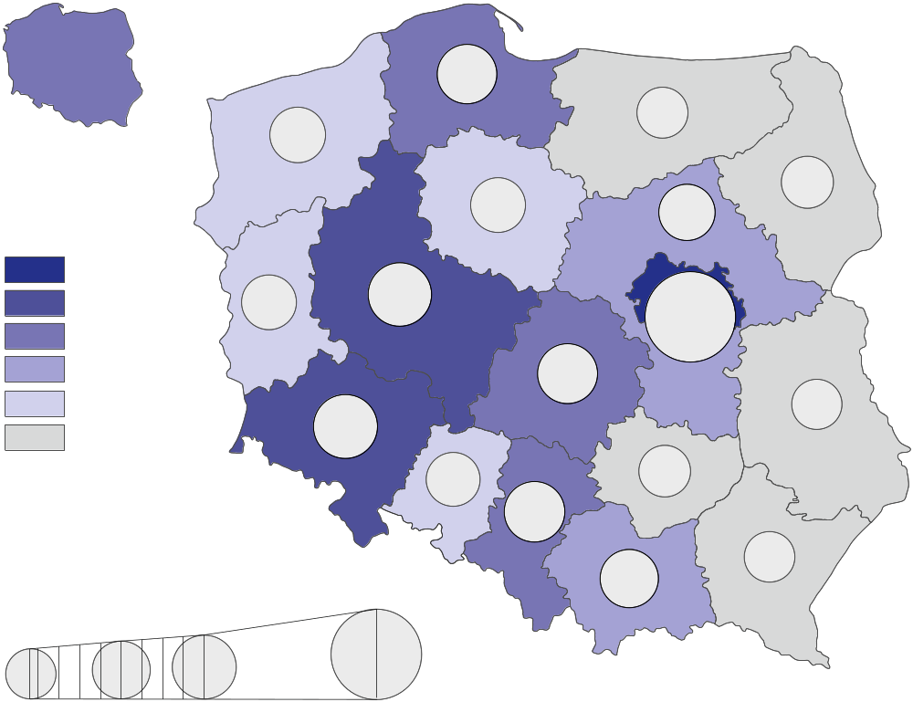
41.4-45.0
67.9%
90.0%
110.0%
81.2%
81.2%
95.2%
69.9%
83.0%
73.1%
85.2%
109.1%
221.0%
96.8%
67.9%
61.0
thousand
PLN

63.1-69.0
69.1-134.8
57.1-63.0
51.1-57.0
45.1-51.0
110.8%
71.7%
221.0%
In thousand PLN
78.3%
99.3%
68.9%
91.3%
Poland=100

Table 1. Gross domestic product by regions in 2020 (current prices)
Regions | Total |  |  | Per capita
Regions | in million PLN | in percent | previous year=100 | in PLN | Poland=100 | previous year=100
POLAND | 2 338 996 | 100.0 | 102.0 | 60 984 | 100.0 | 102.1
Dolnośląskie | 195 928 | 8.4 | 103.3 | 67 596 | 110.8 | 103.4
Kujawsko-pomorskie | 102 425 | 4.4 | 103.8 | 49 498 | 81.2 | 104.1
Lubelskie | 87 043 | 3.7 | 101.1 | 41 383 | 67.9 | 101.5
Lubuskie | 50 010 | 2.1 | 101.8 | 49 506 | 81.2 | 102.1
Łódzkie | 144 495 | 6.2 | 104.5 | 59 008 | 96.8 | 105.0
Małopolskie | 190 177 | 8.1 | 102.2 | 55 706 | 91.3 | 101.9
Mazowiecki regionalny | 121 207 | 5.2 | 100.7 | 51 956 | 85.2 | 101.1
Opolskie | 46 806 | 2.0 | 100.6 | 47 724 | 78.3 | 101.0
Podkarpackie | 89 304 | 3.8 | 99.4 | 42 007 | 68.9 | 99.5
Podlaskie | 52 484 | 2.2 | 103.2 | 44 608 | 73.1 | 103.4
Pomorskie | 136 290 | 5.8 | 100.2 | 58 077 | 95.2 | 99.8
Śląskie | 272 867 | 11.7 | 98.5 | 60 529 | 99.3 | 98.8
Świętokrzyskie | 53 771 | 2.3 | 102.0 | 43 715 | 71.7 | 102.6
Warmińsko-mazurskie | 60 540 | 2.6 | 103.8 | 42 618 | 69.9 | 104.2
Warszawski stołeczny | 417 137 | 17.8 | 103.5 | 134 772 | 221.0 | 102.6
Wielkopolskie | 232 808 | 10.0 | 102.8 | 66 510 | 109.1 | 102.7
Zachodniopomorskie | 85 703 | 3.7 | 102.0 | 50 616 | 83.0 | 102.3
Gross value added by kind of activity
In 2020, 29.3% of the national gross value added was generated by the entities engaged in activities in the area of services covering trade; repair of motor vehicles; transportation and storage; accommodation and catering; information and communication. In the individual
regions, the share of these entities in the generation of gross value added in 2020 ranged between 22.9% in Mazowiecki regionalny region and 37.2% in Warszawski stołeczny region.
In 2020, entities engaged in other services (including public administration and defence; compulsory social security) generated 25.8% of the national gross value added. In 2020, Małopolskie region was characterised by the highest share of other services – 30.0% while Mazowiecki regionalny region was marked by the smallest share – 20.2%.
In 2020, the share of industry in generating gross value added prevailed in 8 regions
In 2020, entities engaged in industry generated 25.3% of the national gross value added.
In the regions’ breakdown, in 2020 significant variation of the shares of industry was observed – from 12.9% in Warszawski stołeczny region to 33.0% in Mazowiecki regionalny region.
Entities engaged in financial and insurance activities; real estate activities in 2020 generated 9.4% of the national gross value added. In the individual regions, the share of entities acting in the field of financial and insurance activities; real estate activities in the generation of gross value added in 2020 ranged between 6.4% in Mazowiecki regionalny region and 14.5% in Warszawski stołeczny region.
In 2020, entities active in construction generated 7.4% of the national gross value added.
In the regions’ breakdown in 2020, the share of units engaged in construction in the generation of gross value added ranged from 5.8% in Łódzkie region to 8.9% in Małopolskie region.
The share of agriculture, forestry and fishing in the generation of the national gross value added in 2020 amounted to 2.8%. In the individual regions, in 2020 the shares of entities conducting activity in the range of agriculture, forestry and fishing were significantly differentiated – from 0.6% in Warszawski stołeczny region to 10.3% in Mazowiecki regionalny region.
Graph 2. Gross value added by kind of activity and regions in 2020 (current prices)
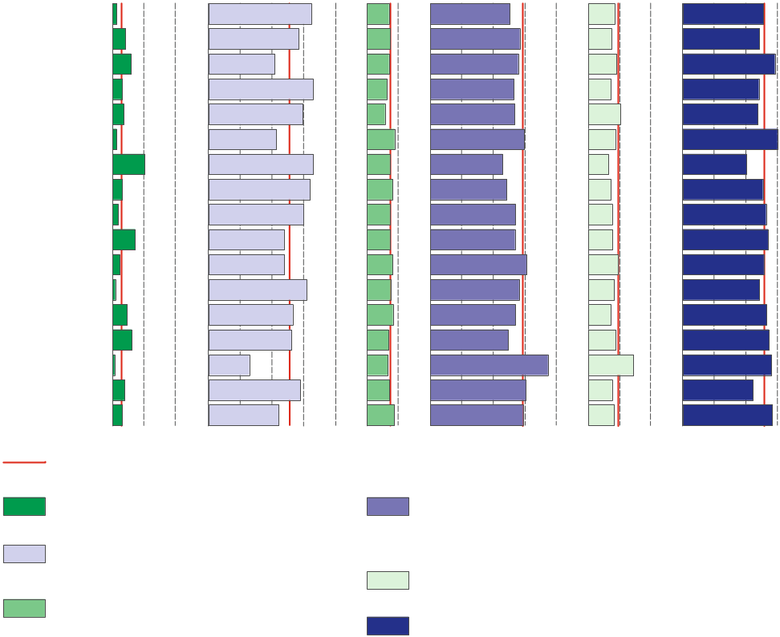
Table 2. Gross value added by kind of activity and regions in 2020 (current prices)
Dolnośląskie
Kujawsko-pomorskie
Lubelskie
Lubuskie
Łódzkie
Małopolskie
Mazowiecki regionalny
Opolskie
Podkarpackie
Podlaskie
Pomorskie
Śląskie
Świętokrzyskie
Warmińsko-mazurskie
Warszawski stołeczny
Wielkopolskie
Zachodniopomorskie
0 10 20% 0 10 20 30 40% 0 10% 0 10 20 30 40% 0 10 20% 0 10 20 30%
In % of total
0 10 20% 0 10 20 30 40% 0 10% 0 10 20 30 40% 0 10 20% 0 10 20 30%
Other services
Financial and insurance activities; real estate activities^{Δ}
Construction
Poland
Agriculture, forestry and fishing
Trade; repair of motor vehicles^{Δ};
transportation and storage; accommodation and catering^{Δ}; information and communication
Industry
REGIONS  a – in million PLN  b – in % of total  c – previous year=100 |  | Total | Agriculture, forestry  and fishing | Industry | Construction | Trade; repair of motor vehicles^{Δ};  transportation and storage;  accommodation and catering^{Δ};  information and communication | Financial and insurance activities;  real estate activities^{Δ} | Other services
POLAND | a | 2 060 380 | 57 647 | 521 596 | 152 171 | 604 322 | 192 887 | 531 756
 | b | 100.0 | 2.8 | 25.3 | 7.4 | 29.3 | 9.4 | 25.8
 | c | 102.2 | 109.7 | 102.2 | 98.2 | 100.3 | 102.7 | 104.8
Dolnośląskie | a | 172 590 | 2 253 | 55 923 | 12 175 | 43 515 | 14 552 | 44 171
 | b | 100.0 | 1.3 | 32.4 | 7.1 | 25.2 | 8.4 | 25.6
 | c | 103.5 | 109.0 | 108.4 | 96.5 | 100.1 | 99.3 | 104.5
Kujawsko-pomorskie | a | 90 224 | 3 707 | 25 581 | 6 802 | 25 535 | 6 648 | 21 952
 | b | 100.0 | 4.1 | 28.4 | 7.5 | 28.3 | 7.4 | 24.3
 | c | 104.0 | 114.3 | 105.6 | 99.3 | 102.1 | 101.0 | 105.5
Lubelskie | a | 76 675 | 4 550 | 15 994 | 5 465 | 21 316 | 6 944 | 22 405
 | b | 100.0 | 5.9 | 20.9 | 7.1 | 27.8 | 9.1 | 29.2
 | c | 101.3 | 106.8 | 99.9 | 99.4 | 98.7 | 99.0 | 105.1
Lubuskie | a | 44 052 | 1 320 | 14 479 | 2 822 | 11 630 | 3 180 | 10 622
 | b | 100.0 | 3.0 | 32.9 | 6.4 | 26.4 | 7.2 | 24.1
 | c | 102.0 | 103.5 | 101.9 | 96.8 | 101.1 | 101.7 | 104.5
Łódzkie | a | 127 283 | 4 512 | 37 850 | 7 404 | 34 031 | 13 136 | 30 349
 | b | 100.0 | 3.5 | 29.7 | 5.8 | 26.7 | 10.3 | 23.8
 | c | 104.7 | 115.5 | 109.3 | 98.7 | 99.6 | 106.0 | 104.7
Małopolskie | a | 167 524 | 2 213 | 35 900 | 14 863 | 49 794 | 14 470 | 50 285
 | b | 100.0 | 1.3 | 21.4 | 8.9 | 29.7 | 8.6 | 30.0
 | c | 102.4 | 104.3 | 103.7 | 96.8 | 99.3 | 102.7 | 106.2
Mazowiecki regionalny | a | 106 769 | 10 948 | 35 198 | 7 851 | 24 445 | 6 800 | 21 527
 | b | 100.0 | 10.3 | 33.0 | 7.4 | 22.9 | 6.4 | 20.2
 | c | 100.9 | 113.9 | 94.6 | 100.9 | 101.3 | 101.4 | 105.9
Opolskie | a | 41 231 | 1 234 | 13 185 | 3 381 | 9 969 | 2 978 | 10 484
 | b | 100.0 | 3.0 | 32.0 | 8.2 | 24.2 | 7.2 | 25.4
 | c | 100.8 | 116.5 | 103.7 | 96.9 | 99.1 | 100.3 | 98.7
Podkarpackie | a | 78 666 | 1 339 | 23 589 | 5 796 | 21 151 | 5 996 | 20 795
 | b | 100.0 | 1.7 | 30.0 | 7.4 | 26.9 | 7.6 | 26.4
 | c | 99.6 | 106.1 | 97.1 | 98.5 | 98.2 | 98.2 | 104.5
Podlaskie | a | 46 233 | 3 338 | 11 005 | 3 417 | 12 371 | 3 624 | 12 478
 | b | 100.0 | 7.2 | 23.8 | 7.4 | 26.8 | 7.8 | 27.0
 | c | 103.4 | 105.8 | 108.8 | 97.9 | 99.4 | 100.6 | 104.8
Pomorskie | a | 120 055 | 2 617 | 28 736 | 9 859 | 36 520 | 11 412 | 30 911
 | b | 100.0 | 2.2 | 23.9 | 8.2 | 30.4 | 9.5 | 25.7
 | c | 100.4 | 105.2 | 95.3 | 98.0 | 100.4 | 104.7 | 104.2

Table 2. Gross value added by kind of activity and regions in 2020 (cont.)
REGIONS  a – in million PLN  b – in % of total  c – previous year=100 |  | Total | Agriculture. forestry  and fishing | Industry | Construction | Trade; repair of motor vehicles^{Δ};  transportation and storage;  accommodation and catering^{Δ};  information and communication | Financial and insurance activities;  real estate activities^{Δ} | Other services
Śląskie | a | 240 364 | 1 894 | 74 163 | 18 366 | 67 538 | 19 906 | 58 497
 | b | 100.0 | 0.8 | 30.9 | 7.6 | 28.1 | 8.3 | 24.3
 | c | 98.7 | 100.1 | 92.6 | 96.2 | 100.2 | 104.4 | 104.5
Świętokrzyskie | a | 47 366 | 2 160 | 12 549 | 3 995 | 12 740 | 3 393 | 12 528
 | b | 100.0 | 4.6 | 26.5 | 8.4 | 26.9 | 7.2 | 26.5
 | c | 102.2 | 110.4 | 102.4 | 97.5 | 99.2 | 101.6 | 105.6
Warmińsko-mazurskie | a | 53 329 | 3 238 | 13 998 | 3 721 | 13 153 | 4 669 | 14 549
 | b | 100.0 | 6.1 | 26.2 | 7.0 | 24.7 | 8.8 | 27.3
 | c | 104.1 | 113.6 | 106.9 | 98.3 | 100.1 | 104.4 | 104.6
Warszawski stołeczny | a | 367 449 | 2 200 | 47 349 | 24 744 | 136 649 | 53 378 | 103 130
 | b | 100.0 | 0.6 | 12.9 | 6.7 | 37.2 | 14.5 | 28.1
 | c | 103.7 | 107.2 | 111.3 | 99.6 | 101.0 | 103.6 | 105.0
Wielkopolskie | a | 205 076 | 7 887 | 59 325 | 14 888 | 61 857 | 15 505 | 45 614
 | b | 100.0 | 3.8 | 28.9 | 7.3 | 30.2 | 7.6 | 22.2
 | c | 103.0 | 109.6 | 104.3 | 98.0 | 101.6 | 102.3 | 104.2
Zachodniopomorskie | a | 75 495 | 2 239 | 16 771 | 6 622 | 22 108 | 6 296 | 21 459
 | b | 100.0 | 3.0 | 22.2 | 8.8 | 29.3 | 8.3 | 28.4
 | c | 102.2 | 104.8 | 105.3 | 100.4 | 98.2 | 102.8 | 104.2

Symbol (∆) — categories of applied PKD 2007 classification (link) are presented in abbreviated form.
Data from regional accounts included in this note have been revised in relation to those published on 31 December 2021 and balanced with annual national accounts data included
in the publication “National accounts by institutional sectors and sub-sectors 2017-2020”. They will be subject to further revision, in accordance to the revision policy applied in national and regional accounts (link). Complete range of data for the year 2020 will be available in November of the current year.
In case of quoting Statistics Poland data, please provide information: “Source of data: Statistics Poland”, and in case of publishing calculations made on data published by Statistics Poland, please include the following disclaimer: “Own study based on figures from Statistics Poland”.
Prepared by:  Statistical Office in Katowice  Director Aurelia Hetmańska  Office: tel: (+48 32) 779 12 48 | Issued by:  The Spokesperson for the President  of Statistics Poland  Karolina Banaszek  Mobile: (+48) 695 255 011
Press Office  Office: tel: (+48 22) 608 38 04  e-mail: obslugaprasowa@stat.gov.pl |   stat.gov.pl/en/

@StatPoland

@GlownyUrzadStatystyczny

gus_stat

glownyurzadstatystycznygus

glownyurzadstatystyczny
Related information
Gross domestic product – regional accounts in the years 2017-2019
Gross value added decreased in all regions but four
Methodological report. Gross domestic product and its elements in the regional breakdown
National accounts by institutional sectors and sub-sectors 2017-2020
Provisional estimates of gross domestic product in regional breakdown in 2020
Data available in databases
Knowledge Database -> National Accounts
Local Data Bank -> Regional accounts
Terms used in official statistics
Gross domestic product
Regional accounts
Value added, gross

