People over 50 on the labour market in 2020
In Poland, in 2020, the economic activity of people aged 50 and over was higher than in the previous year. A higher employment rate and a higher activity rate were recorded. The number of unemployed and economically inactive people decreased.
1.7%
Increase in the number of economi-cally active people aged 50 and over compared with 2019

Demographic situation
The increasing ageing of populations is a challenge for many countries around the world,
including Poland. Demographic changes, such as a decrease in the total fertility rate and an increase in the average age of women giving birth to children, have a significant impact,
inter alia, on the structure and size of labour resources. Statistical data indicate an increase in the number and share of elderly people in the total population. At the end of 2020, there were 14.4 million people aged 50 and over. They constituted 37.6% of the total population and in comparison with the previous year this share increased by 0.2 percentage points.
The structure of the population of people aged 50 and over 50 is dominated by people aged 60-64 (18.6%).
People aged 50 and over
accounted for nearly 38%
of Poland’s population
in 2020

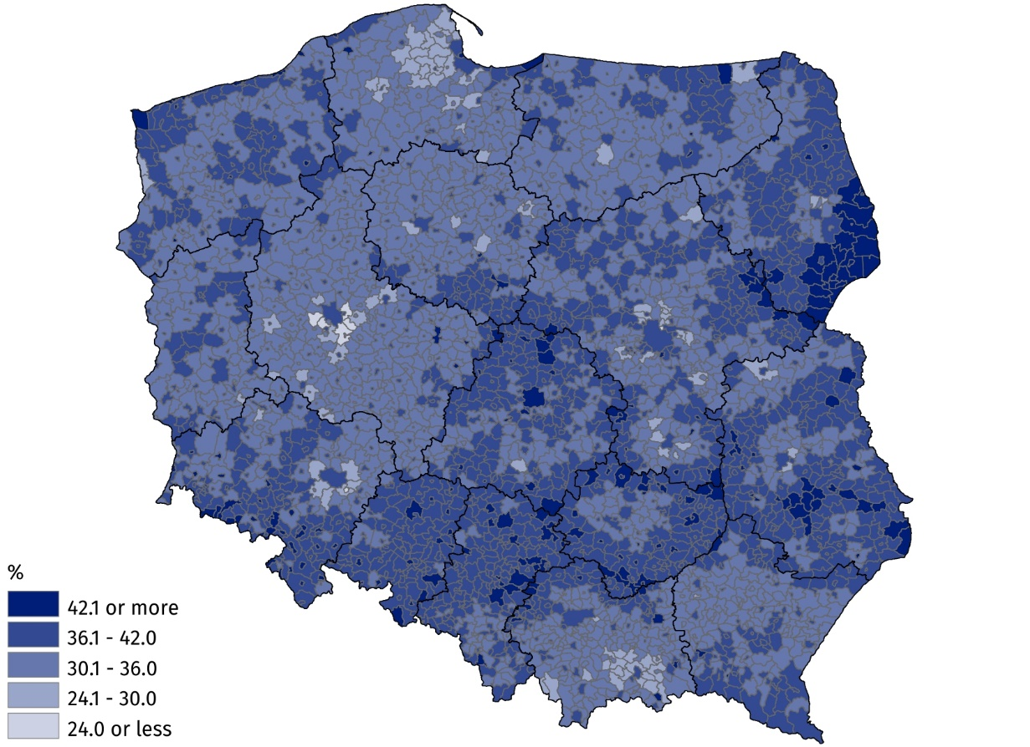
Map 1. The share of people aged 50 and over in the total population in 2020
As at 31 December

The share of people aged 50 and over varied spatially. Gminas located in the south-eastern part of the Podlaskie Voivodship were characterised by the highest share of people at this age. On the other hand, the relatively smallest share of the analysed group was recorded
in gminas around Poznań and other large cities, such as Warsaw, Wrocław, Kraków and the Tri-City.

The situation of people aged 50 and over on the labour market
The demographic changes outlined are reflected in the age structure of the labour force.
According to the Labour Force Survey (LFS), in 2020, among the total number of people aged 50 and over, economically active people (employed and unemployed) accounted for 33.7%. This share is referred to as the activity rate.
In 2020, 33.7% of people aged 50 and over were economically active
In the analysed age group, this ratio was lower by 22.4 percentage points in relation to the population and higher by 0.3 percentage points in relation to the previous year.
This was mainly due to the increase in the number of employed persons. In 2020, every fourth woman aged 50 and over was economically active (26.4%). In the case of men of the same age, the activity rate was much higher and amounted to 43.0%. According to the results obtained from the Labour Force Survey, 9 164 thousand people aged 50 and over remained outside the labour market in 2020. Compared with 2019, the number of economically inactive people decreased by 3.0 thousand. This group constituted 68.9% of the total economically inactive population aged 15 and over. The most common reasons for inactivity were:
retirement, disability and illness.

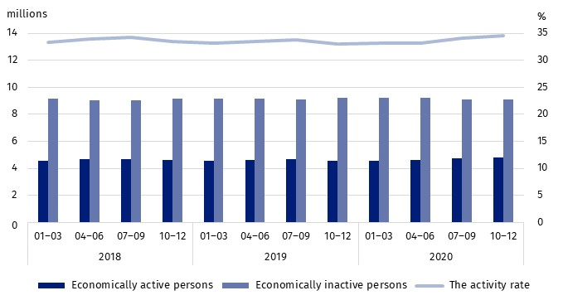
Chart 1. Economically active and inactive persons aged 50 and over (left axis)
and the activity rate (right axis) for people aged 50 and over
The employment rate among men aged 50 and over was 42.0% and was 16.0 percen-tage points higher than for women in the same age group

The one of the basic indicators of the labour market is the employment rate. This indicator, calculated on the basis of the Labour Force Survey, shows that among people aged 50 and over, men were more likely to work. In 2020, the employment rate for men of this age amounted to 42.0% and was 16.0 percentage points higher than the employment rate for women. Regardless of sex, the highest employment rate was recorded among people aged
50-54, and the lowest for people aged over 65, 79.5% and 5.7%, respectively.

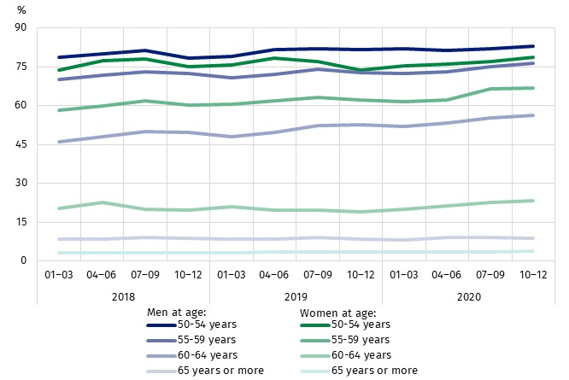
Chart 2. The employment rate for people aged 50 and over by sex and age group

The analysis of the level and variation of wages and salaries of people aged 50 and over
is an important element of the description of the situation on the labour market of this group. The basis for the analysis of the variation of wages and salaries in the analysed age group was data from the Survey on the structure of wages and salaries by occupations. These data indicate that in October 2020, the average gross wage and salary of people aged 50 and over in Poland amounted to PLN 5 705.23. The average wage and salary of men
in the analysed age group was 8.7% (by PLN 477.07) higher than the average wage and salary of women. In the analysed group of people aged 50 and over, the highest wage and salary was received by people aged 65 and over — their average wage and salary was PLN 7 687.82. People in the 55-59 age group had the lowest wage and salary (PLN 5 551.22). In almost all analysed age groups, women received lower wages and salaries than men. Only in the 60-64 age group, the average monthly wage and salary of women in October 2020 was higher than the average wage and salary of men.
The average wage and salary for men in October 2020 was higher than that for women by PLN 477.07

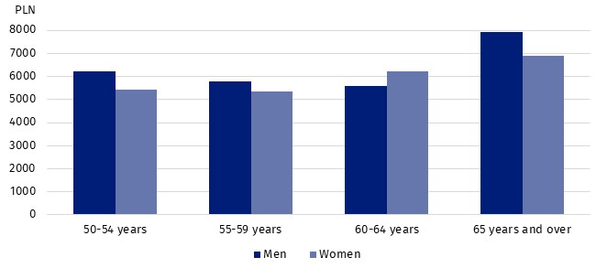
Chart 3. Average wage and salary for people aged 50 and over by age group and sex
in October 2020

In 2020, according to the LFS, among economically active people aged 50 and over there were 96.7 thousand unemployed people. The majority of them were men (61.0%). The unemployment rate for people aged 50 and over in Poland, in 2020 amounted to 2.1% and was 1.1 percentage points lower than for people aged 15 and over. Over the year, the unemployment rate for people aged 50 and over decreased by 0.2 percentage points. It was more influenced by the decrease in the number of unemployed women, which amounted to 5.1 thousand.
The highest unemployment rate in the group of people aged 50 and over occurred among people aged 55-59 (2.3%).
For all age groups, the unemployment rate decreased compared with the corresponding
period of the previous year, with the largest decrease (by 0.5 percentage points) for people aged 60-64 years.
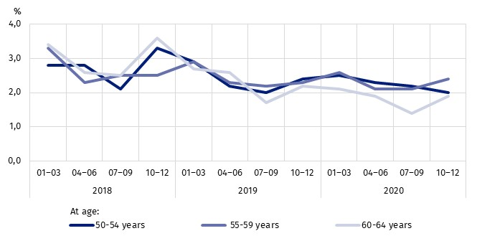
In 2020, the unemployment rate for people aged 50 and over was 2.1%
Chart 4 The unemployment rate for people aged 50 and over by age group

The source of information on unemployed people are also data from powiat labour offices, while the definition of an unemployed person and the methodology of researching unemployment based on these data are different than in the case of the LFS. Therefore, data from these two sources should not be compared. According to register data at the end of 2020, people aged 50 and over accounted for 25.7% of the total number of registered unemployed persons. The highest percentage of unemployed persons of the analysed age were recorded in the city of Dobrzany in the urban-rural gmina of Dobrzany in the Zachodniopomorskie
Voivodship (58.3%). A relatively high rate was recorded in the rural gmina of Jastarnia
in the Pomorskie Voivodship (54.5%), and also in the rural gminas of Słubice and Lubniewice in the Lubuskie Voivodship (50.0%). The rural gmina of Irządze in the Śląskie Voivodship was characterised by the lowest percentage of unemployed persons aged 50 and over (5.7%).
In 2020, 25.7% of unemployed persons registered with labour offices were people aged 50 and over

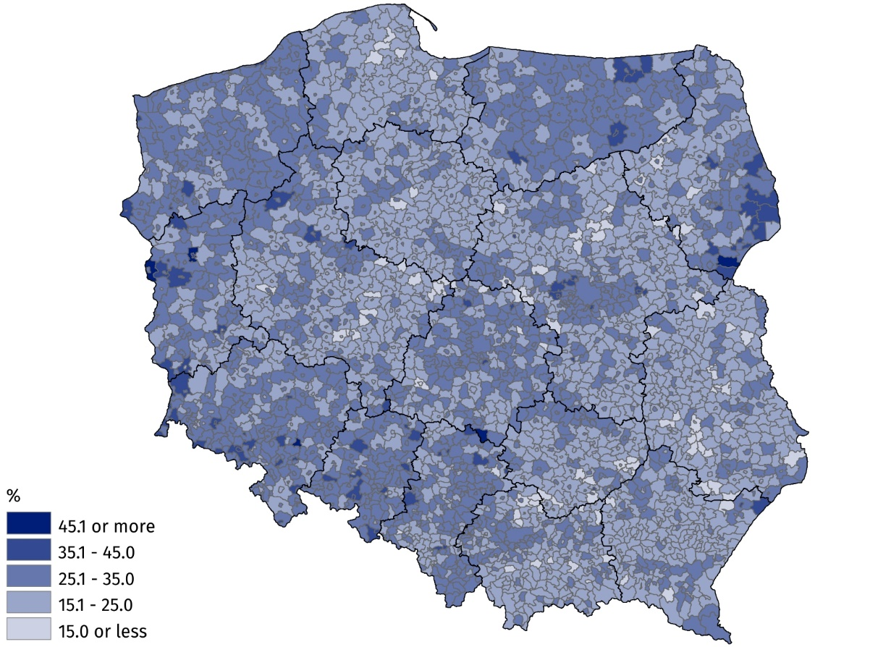
Map 2. The share of registered unemployed persons aged 50 and over in the total number
of unemployed persons in 2020
As at 31 December

Due to the growing demand for data diagnosing the situation of the analysed age group
on the labour market, attempts are made to search for new data sources. They include,
inter alia, administrative registers that allow data to be compiled at lower levels of aggregation, including by individual years. Due to the ongoing methodological work, the analyses based on them have the status of experimental statistics. According to these data, people aged 50 and over accounted for nearly 30% of all employed persons. When analysing
the graphical presentation of the distribution of employed persons by individual age group and sex, it can be seen that in the group of employed persons aged 50 and over, the number of employed persons is decreasing with each year. The predominance of the number of employed women occurs between ages 50 and 57. At later ages, there are more employed men.
In 2020, people aged 50 and over accounted for nearly 30% of the total number of employed persons

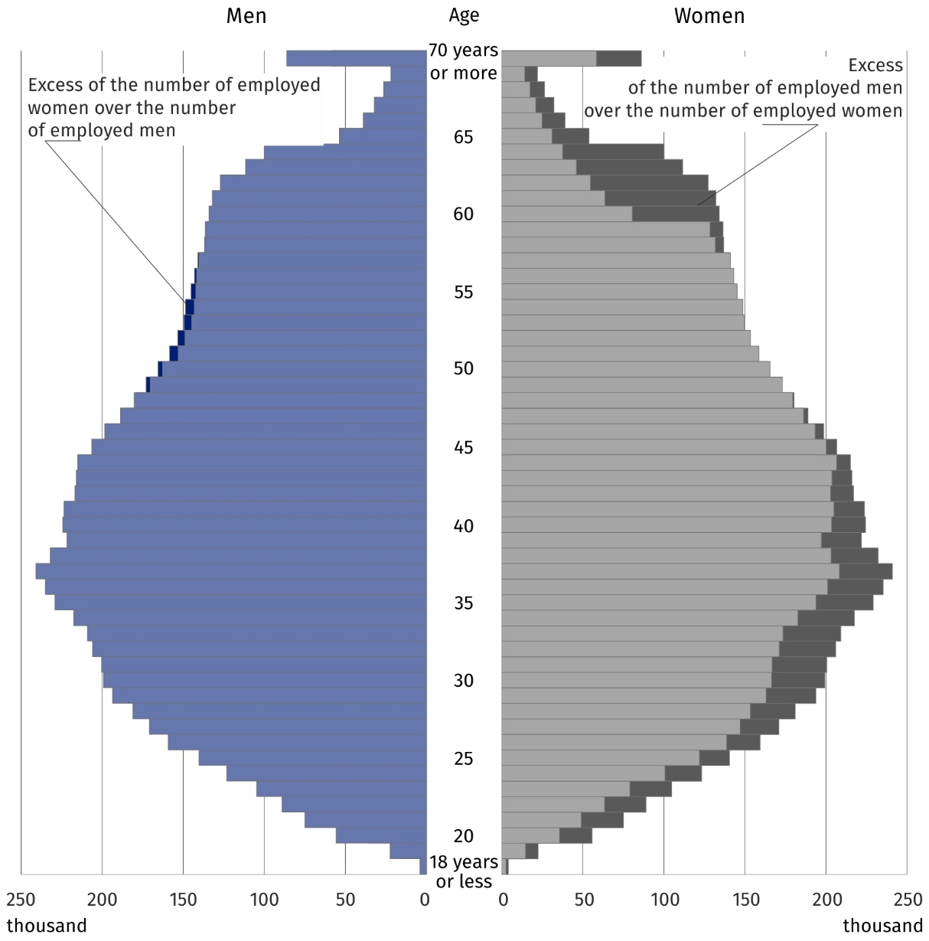
Chart 5. Age pyramid of employed persons in 2020
As at 31 December

As in the case of the share of the population aged 50 and over in the total population,
the share of employed persons aged 50 and over in the total number of employed persons varied spatially. The highest percentage of this group of employed persons was recorded
in gminas located in the south-eastern part of the Podkarpackie and Lubelskie voivodships. The lowest share of employed persons aged 50 and over in the total number of employed persons was characteristic of the capital city of Warsaw and gminas located
in the Wielkopolskie and Śląskie voivodships.

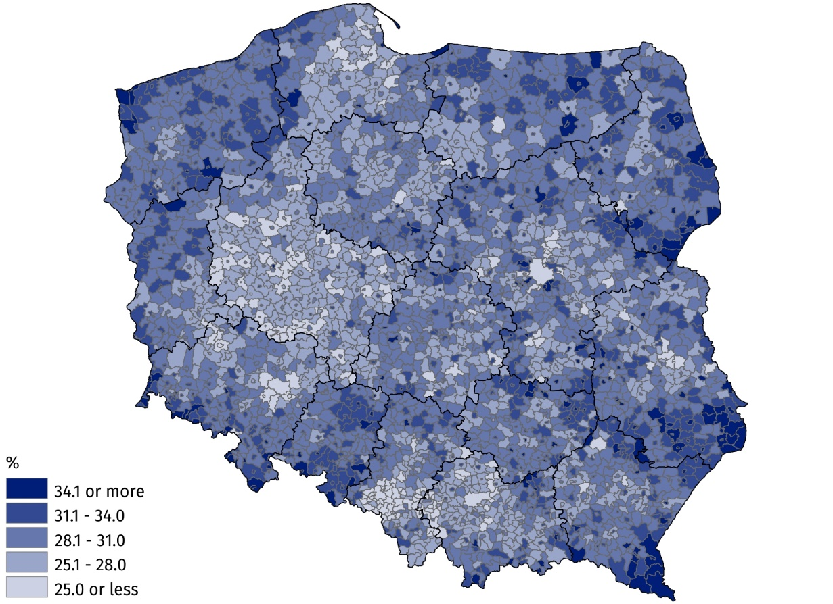
Map 3. The share of employed persons aged 50 and over in the total number of employed persons in 2020
As at 31 December

Data from administrative sources also allow for the identification of persons with a granted right to a retirement pension or other pension among the employed population aged 50
and over broken down by gmina of residence. These people accounted for 16.8% of the employed population aged 50 and over. The spatial visualisation of the share of this group
of persons in the total number of employed persons aged 50 and over by gmina indicates that the highest intensity of the discussed phenomenon occurs in large cities and the surrounding gminas. Relatively low shares of these people in the total number of employed persons were recorded in gminas located in eastern Poland, as well as in gminas
located on the border of Mazowieckie and Kujawsko-Pomorskie voivodships. The highest percentage was recorded in the city of Karpacz (32.5%) and in the city of Sopot (32.4%),
the lowest percentage was recorded in the rural gmina of Jarczów in the Lubelskie Voivodship, which was only 3.0%.
In 2020, 16.8% of employed person aged 50 and over were entitled to receiving
a retirement pension
or other pension¹

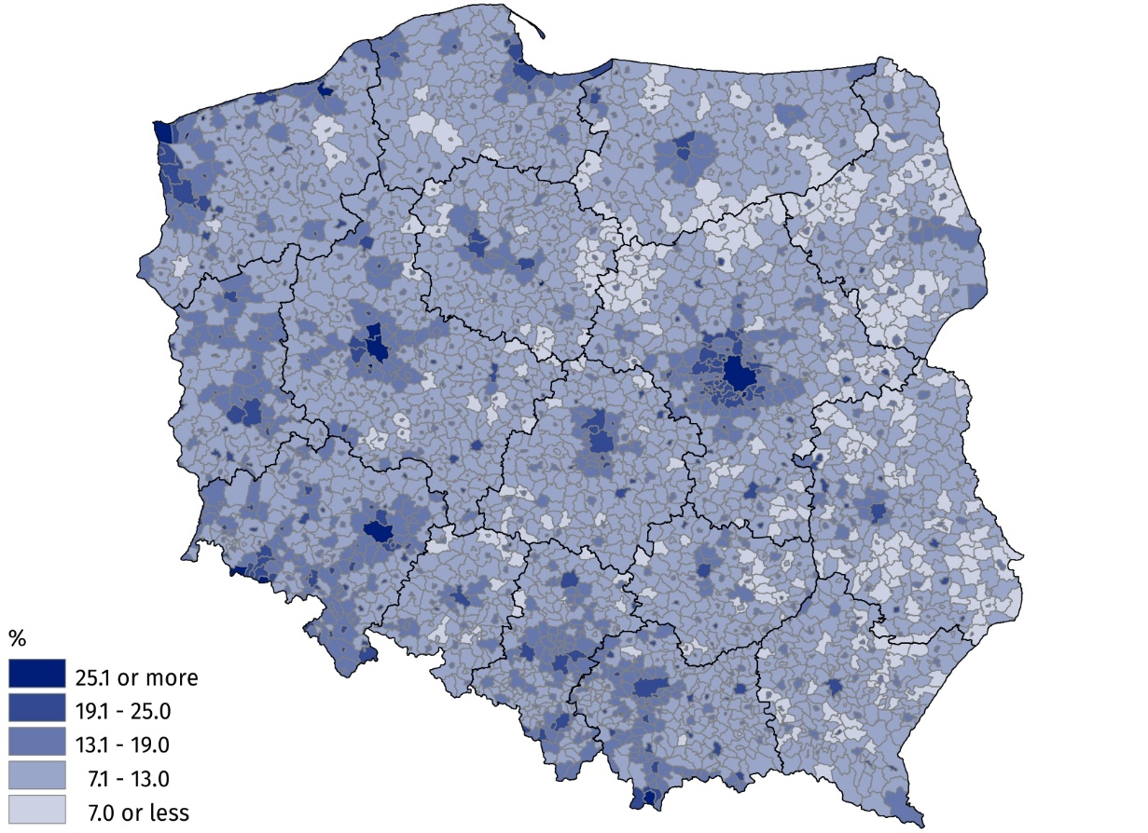
Map 4. The share of employed persons with a right to a retirement pension or other pension among employed persons aged 50 and over in 2020
As at 31 December

The process of labour force ageing varies depending on the kind of activity. The conducted analysis based on administrative data indicates that in 2020 the highest percentage
of employed persons aged 50 and over were in the electricity, gas, steam and air conditioning supply section. Employed persons of the analysed age constituted as many as 47.6%
of all employed persons in this section. A significant share of employed persons aged 50 and over in the total number of employed persons were also recorded in the following sections: real estate activities (44.4%), agriculture, forestry and fishing (42.5%), as well as human health and social work activities (40.3%). The situation was different in the information
and communication section, where, nearly every tenth employed person was aged 50 and over. In the remaining sections, the share of employed persons at the discussed age ranged from almost 20% to 40%.
In 2020, the highest percentage of people aged 50 and over were recorded in the electricity, gas, steam and air conditioning supply section

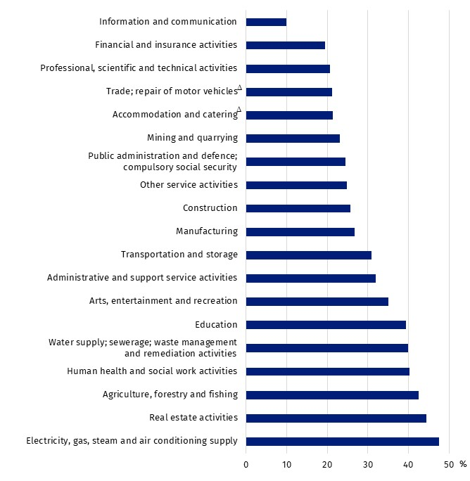
Chart 6. The share of employed persons aged 50 and over in the total number of employed persons by PKD/NACE section in 2020
As at 31 December

In the case of quoting Statistics Poland data, please provide information: ‘Source of data: Statistics Poland’, and in the case of publishing calculations made on data published by Statistics Poland, please provide information: ‘Own elaboration based on Statistics Poland data.’

Prepared by:  Statistical Office in Bydgoszcz  Director Wiesława Gierańczyk, Ph.D.  Phone: (+48 52) 366 93 90 | Issued by:  The Spokesperson of the President of  Statistics Poland  Karolina Banaszek  Mobile: (+48) 695 255 011
Press Office  Phone: (+48 22) 608 38 04  e-mail: obslugaprasowa@stat.gov.pl |   stat.gov.pl/en/

@GUS_STAT

@GlownyUrzadStatystyczny

gus_stat

glownyurzadstatystycznygus

glownyurzadstatystyczny
Related information
Methodological report Employment in the national economy according to administrative data sources
People over 50 on the labour market in 2018
People over 50 on the labour market in 2019
Data available in databases
EUROSTAT
BDL
Terms used in official statistics
Economically active population by LFS
Economically inactive population according to the LFS
Employment in national economy
Unemployed persons by LFS
Registered unemployed persons

Information on a granted right to a retirement pension or other pension concerns only employed persons working outside private farming.

