Financial results of insurance companies in 2021
The overall net financial result of insurance companies in 2021 was less favorable than a year ago and amounted to PLN 5.7 billion. This was due to a worse result obtained by life insurance companies (division I), despite a better result of non-life insurance companies (division II).
109.1
Gross written premiums growth rate in 2021

Income and costs
Total gross written premium amounted to PLN 69.2 billion
Earned premium was the dominant item in the total income structure. In 2021, the total gross written premium amounted to PLN 69 222.4 million (increase by 9.1% than in 2020),
of which PLN 22 127.5 million was the premium of life insurance companies, and
PLN 47 094.9 million non-life insurance. Claims incurred constituted the dominant position in the total cost structure. Total gross claims paid in 2021 amounted to PLN 41 302.7 million and increased by 4.2% compared to 2020, they increased to PLN 18 449.7 million in life insurance, and to PLN 22 853.0 million in non-life insurance.
Total gross claims paid amounted to PLN 41.3 billion

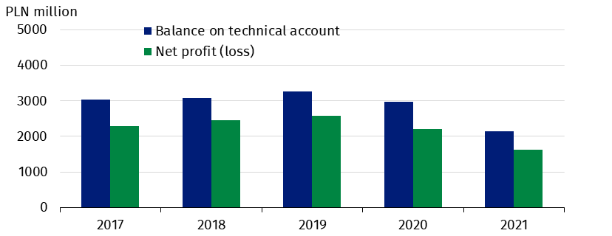
Chart 1. Life insurers financial results

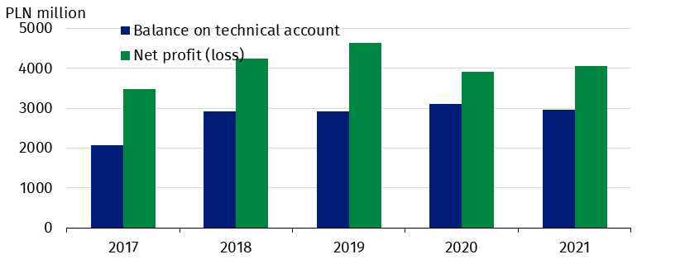
Chart 2. Non-life insurers financial results

Profit (loss) and balance on technical account
Net financial result
amounted to PLN 1.6 billion in life sector,
and PLN 4.1 billion
in non-life sector
The total net financial result of insurance companies amounted to PLN 5 690.6 million and was lower by 7.1% compared to 2020. Life insurance companies generated a result
of PLN 1 632.9 million, and non-life insurance profit amounted to PLN 4 057.7 million.
The technical result (in aggregated terms) was PLN 5 113.4 million and was 16.0% lower than in 2020. The technical result in life insurance decreased to PLN 2 143.0 million, in non-life
insurance to PLN 2 970.4 million.
The technical profit of PLN 616.1 million was achieved compared to PLN 815.8 million of profit in 2020 in the casco insurance of land vehicles. In motor vehicle liability arising out
of the possession of land vehicles, the technical profit of PLN 582.8 million was achieved compared to PLN 517.0 million of profit in the previous year.

Table 1. Income, costs and balance on technical life and non-life insurance account
Specification | Life |  |  | Non-life
Specification | 2020 | 2021 | 2020=100 | 2020 | 2021 | 2020=100
Specification | million PLN |  | 2020=100 | million PLN |  | 2020=100
Total income | 28 952.8 | 29 323.8 | 101.3 | 39 432.0 | 40 708.0 | 103.2

of which:
Earned premiums | 20 362.0 | 21 640.1 | 106.3 | 34 350.8 | 35 647.6 | 103.8
Investment income | 8 394.9 | 7 369.1 | 87.8 | 4 008.7 | 4 147.2 | 103.5
Total costs | 26 750.6 | 27 690.9 | 103.5 | 35 508.0 | 36 650.2 | 103.2
of which:
Claims incurred  including change in provisions - net of reinsurance | 17 250.6 | 18 529.6 | 107.4 | 20 670.1 | 21 246.5 | 102.8
Change in other technical provisions - net of reinsurance | –1 221.0 | –1 458.3 | x | 12.5 | 17.4 | 139.2
Net operating  expenses | 5 051.1 | 5 410.2 | 107.1 | 10 394.4 | 10 882.0 | 104.7
Investment charges | 4 410.3 | 4 271.9 | 96.9 | 1 606.4 | 1 524.1 | 94.9
Net financial account | 2 202.2 | 1 632.9 | 74.1 | 3 924.0 | 4 057.7 | 103.4
***
Balance on technical account | 2 974.5 | 2 143.0 | 72.0 | 3 115.2 | 2 970.4 | 95.4

Gross written premiums and gross claims paid in direct activities
Gross written premiums
collected from
motor insurance amounted to PLN 24.6 billion

In total direct activities, the life gross written premiums accounted for 33.6%, and the
non-life gross written premiums – 66.4%. The "life insurance" class gained a dominant
position in division I in terms of the value of gross written premiums. The next item was taken by the class “accident and sickness insurance ". The share of these two classes in life gross written premiums amounted to 41.0% and 32.1% respectively.
The gross written premiums from motor insurance were the largest item (56.3% of the value of premiums) in non-life insurance. These premiums increased by 5.1% compared to 2020 and amounted to PLN 24 624.6 million. The share of casco insurance of land vehicles in the non-life gross written premiums amounted to 22.2%, and motor vehicle liability arising out of the possession of land vehicles 34.1%.

Table 2. Gross written premiums and gross claims paid in direct activities
Specification | Gross written premiums |  |  | Gross claims paid
Specification | 2020 | 2021 | 2020= =100 | 2020 | 2021 | 2020= =100
Specification | million PLN |  | 2020= =100 | million PLN |  | 2020= =100
LIFE
Total | 20 753.5 | 22 127.5 | 106.6 | 17 415.5 | 18 449.7 | 105.9

of which:
Life insurance | 7 963.6 | 9 066.9 | 113.9 | 6 396.5 | 7 487.6 | 117.1
Life insurance linked to capital insurance fund | 5 884.5 | 5 700.5 | 96.9 | 8 341.2 | 7 996.3 | 95.9
Accident and sickness  insurance | 6 636.8 | 7 092.4 | 106.9 | 2 464.0 | 2 749.8 | 111.6
NON-LIFE
Total | 39 735.0 | 43 766.6 | 110.1 | 20 929.1 | 21 650.8 | 103.4
of which:
Accident and sickness  insurance | 2 517.8 | 3 025.1 | 120.1 | 593.9 | 620.1 | 104.4
Casco insurance of land  vehicles | 8 797.2 | 9 697.6 | 110.2 | 5 469.5 | 6 000.0 | 109.7
Insurance against fire  and natural forces | 3 934.7 | 4 414.6 | 112.2 | 1 697.7 | 2 019.9 | 119.0
Insurance against other damage and loss of property | 3 663.6 | 4 472.2 | 122.1 | 1 710.2 | 1 368.5 | 80.0
Motor vehicle liability  arising out of the possession  of land vehicles | 14 631.2 | 14 927.0 | 102.0 | 9 002.3 | 9 291.2 | 103.2
of which compulsory third-party liability insurance of owners of motor vehicle | 14 346.8 | 14 628.8 | 102.0 | 8 872.1 | 9 104.3 | 102.6
General third-party liability  insurance | 2 551.2 | 2 809.7 | 110.1 | 1 055.4 | 1 139.8 | 108.0

Assets and liabilities
The total assets decreased by 1.5% year-on-year
The total assets of insurance companies for the year ended 31 December 2021 amounted to PLN 201 632.4 million (decrease by 1.5% year-on-year), of which PLN 91 530.4 million was
allocated to life insurance companies, and PLN 110 102.0 million to non-life insurance
companies.

Table 3. Assets and liabilities of insurance companies (as of 31st December)
Specification | Life |  |  | Non-life
Specification | 2020 | 2021 | 2020=100 | 2020 | 2021 | 2020=100
Specification | million PLN |  | 2020=100 | million PLN |  | 2020=100
Total assets | 95 275.2 | 91 530.4 | 96.1 | 109 473.3 | 110 102.0 | 100.6

of which:
Investments | 41 241.0 | 39 663.9 | 96.2 | 88 927.3 | 87 155.1 | 98.0
Net assets for  life assuranceª | 48 571.7 | 46 879.0 | 96.5 | x | x | x
Total liabilities | 95 275.2 | 91 530.4 | 96.1 | 109 473.3 | 110 102.0 | 100.6

of which :
Capital and reserves | 12 813.1 | 10 358.0 | 80.8 | 34 091.9 | 29 673.5 | 87.0
Technical provisions | 78 814.5 | 77 708.9 | 98.6 | 73 988.6 | 79 321.5 | 107.2
a Where the investment risk is borne by the policyholders.

In case of quoting Statistics Poland data, please provide information: “Source of data: Statistics
Poland”, and in case of publishing calculations made on data published by Statistics Poland,
please include the following disclaimer: “Own study based on figures from Statistics Poland”.
This news releases has been prepared on data received on 9/03/2022 from
the Polish Financial Super-vision Authority.

Prepared by:  Macroeconomics Studies  and Finance Department  Director Miroslaw Blazej  Phone: (+48 22) 608 37 73 | Issued by:  The Spokesperson for the President  of Statistics Poland  Karolina Banaszek  Phone: (+48) 695 255 011
Press Office  Phone: (+48 22) 608 38 04  e-mail: obslugaprasowa@stat.gov.pl |   www.stat.gov.pl/en/

@StatPoland

@GlownyUrzadStatystyczny

gus_stat

glownyurzadstatystycznygus

glownyurzadstatystyczny
Related information
Polish insurance market 2018
Annual bulletin. Insurance market 2020

Data available in databases
Financial Results of Insurance Companies
Quarterly bulletin. Insurance market

Terms used inn official statistics
Insurance undertaking
Gross written premium

