Non-financial enterprises established in 2021
Among the non-financial enterprises declaring the start of operations in 2021, 146 947 units remained active by 2022 i.e. 52.1%. The highest survival rate after the first year of activity was recorded for entities in information and comunication section (66.8%).
52.1%
Survival rate of non-financial enterprises after the first year of activity

Persons employed
In the one-year non-financial enterprises there were employed 283.8 thousand persons
In non-financial enterprises established in 2021 and active until 2022 there were employed 283 831 persons of which 65.8% worked in enterprises that were natural persons and 34.2% legal persons.

Chart 1. Number of persons employed in enterprises established in 2021 and active until 2022
According to the predominant kind of activity, the highest number of persons employed was in enterprises that conducted activity in sections: construction (50 880 persons), trade; repair of motor vehicles (47 072 persons) and professional, scientific and technical activities (40 189 persons).
In terms of the territorial division, the highest number of persons employed in one-year enterprises was in the enterprises which had their registered offices in the Mazowieckie Voivodship (62 451 persons).

Revenues and costs
Enterprises established in 2021 and active until 2022 achieved total revenues of 66 933.3 million PLN.
One-year non-financial enterprises generated total revenues of 66 933.3 million PLN
The share of total revenues generated in the first year of activity by entities in the area of trade; repair of motor vehicles comprised 44.6% of all one-year enterprises' total revenue.
Total costs in one-year enterprises amounted to 55 688.3 million PLN of which 47.7% were incurred by entities conducting trade; repair of motor vehicles activity.

Chart 2. Total revenues and total costs of enterprises established in 2021 and active until 2022 according to the NACE sections

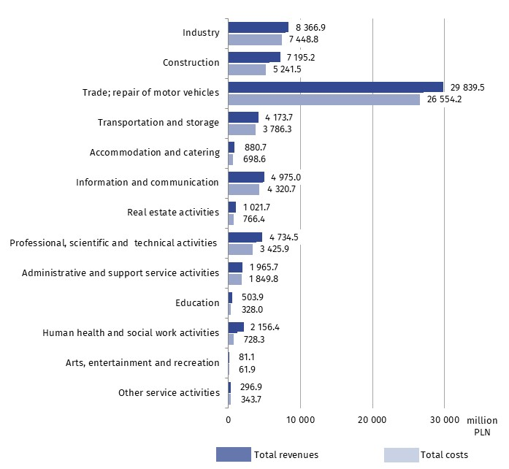

Data presented herein concern non-financial enterprises established in 2021 and active until 2022, irrespective of the number of persons employed. Data do not cover agriculture, forestry and fishing (section A of NACE Rev. 2); financial and insurance activities (section K of NACE Rev. 2); higher education; independent public health care units; cultural institutions with legal personality and trade unions, religious and political organizations.
The results of newly-born non-financial enterprises survey will be present in publication titled „Non-financial enterprises established in 2017–2021”.
Due to data rounding, in some cases sums of components may slightly differ from the amount given in the „total” item.
In the case of quoting Statistics Poland data, please provide information: „Source of data: Statistics Poland” and in the case of publishing calculations made on data published by Statistics Poland, please include the following disclaimer: „Own study based on figures from Statistics Poland”.

Prepared by:  Enterprises Department  Director Katarzyna Walkowska  Phone: (+48 22) 608 31 25 | Issued by:  The Spokesperson for the President  of Statistics Poland  Karolina Banaszek  Phone: (+48) 695 255 011
Press Office  Phone: (+48 22) 608 38 04  e-mail: obslugaprasowa@stat.gov.pl |   stat.gov.pl/en/

@StatPoland

@GlownyUrzadStatystyczny

gus_stat

glownyurzadstatystycznygus

glownyurzadstatystyczny
Related information
Methodological report. Non-financial enterprises surveys
Non-financial enterprises established in 2020
Terms used inn official statistics
Total revenues
Total costs

