Real estate sales in 2021

701,5 thousand notarial deeds relating to real estate sales were concluded in 2021, by 24.3% more than in the previous year. Compared to 2020 the highest increase in the number of notarial deeds concerned sales of land properties (by 33.3%). The smallest increase was recorded in the case of notarial deeds on sales of properties to the State Treasury or local self-government bodies (by 12.8%) as well as the sales of other properties (by 13.4%).
24.3%
increase in the number of notarial deeds related to real estate sales in comparison with 2020

Table 1. Notarial deeds related to real estate sales concluded in 2021
In 2021, the highest increase in the number of notarial deeds concerned the sales
of land properties (by 33.3%) compared to the previous year

Specification | 2021 | 2020=100
Total | 701 462 | 124.3
Sales of premises | 257 274 | 122.9
Sales of land properties | 188 334 | 133.3
Sales of agricultural land | 76 675 | 121.9
Sales of properties built-up with residential buildings | 73 064 | 121.9
Sales of cooperative ownership right to premises | 51 469 | 119.0
Sales of other properties | 26 425 | 113.4
Sales of other built-up properties | 18 959 | 116.6
Sales of perpetual usufruct right | 6 101 | 116.2
Sales of properties to the State Treasury or local self-government bodies | 2 952 | 112.8
Transfer of properties by the State Treasury or local self-government bodies for perpetual usufruct with the sale of building | 209 | 122.9
Source: data of Ministry of Justice

According to data from the Real estate Price Register (RCN) 614.3 thousand real estate transactions were concluded in 2021. The value of their transactions amounted to over
PLN 197 billion.
Table 2. Real estate sales (according to the RCN, state as of 25th April 2022)
In 2021, the largest share in the number and in value of real estate purchase/ sale transactions
concerned the sale of premises (44.0% and 47.6% respectively)
Specification | Number of transactions |  |  | Value of transactions
Specification | 2020 | 2021 |  | 2020 | 2021
Specification | units |  | 2020=100 | million PLN |  | 2020=100
Total | 504 870 | 614 260 | 121.7 | 143 099 | 197 140 | 137.8
Premises ¹ | 220 576 | 270 466 | 122.6 | 67 700 | 93 867 | 138.7
Built-up properties ² | 84 368 | 94 849 | 112.4 | 40 721 | 50 140 | 123.1
Land properties | 199 926 | 248 945 | 124.5 | 34 678 | 53 133 | 153.2
¹ Partially estimated data; there were estimated not registered real estate purchase / sale transactions
concluded in 2021 in 3 cities with powiat status, whose registration process took place in the period up to
25th April 2022.
² Properties built-up with residential buildings, built-up agricultural land, other built-up properties and buildings are included.

The largest share in the total number of real estate transactions were the premises (in the following voivodships: Pomorskie, Dolnoslaskie and Mazowieckie) as well as land properties (in the following voivodships: Lubelskie, Podkarpackie and Swietokrzyskie).
Chart 1. Shares in real estate transactions by type in voivodships in 2021
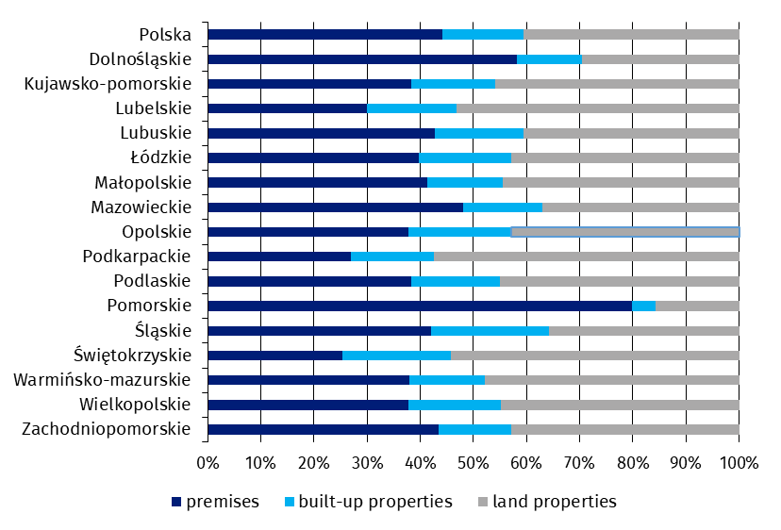
Table 3. Price indices of residential premises in 2021
Prices of residential premises in 2021 increased by 9.2% in the comparison with the previous year (of which on the primary market – by 9.1% and on the secondary market – by 9.3%)

Specification | 2021
Specification | 2020=100 | 2015=100
Total | 109.2 | 139.9
Primary market | 109.1 | 134.3
Secondary market | 109.3 | 146.7

Chart 2. Changes in prices of residential premises compared to the previous year
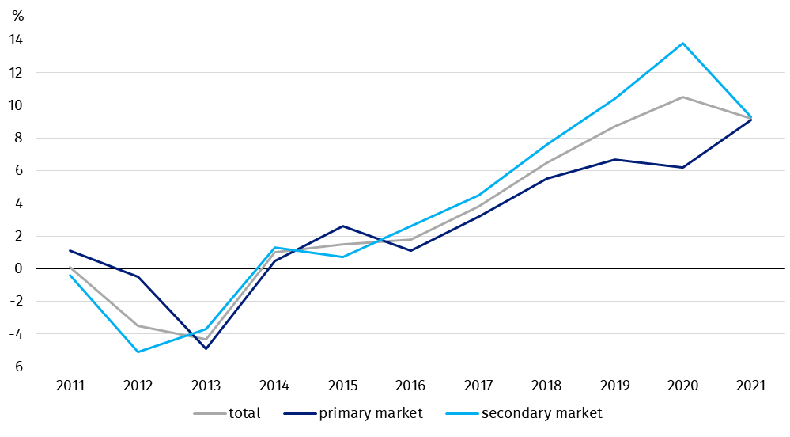
Chart 3. Changes in prices of residential premises compared to 2015
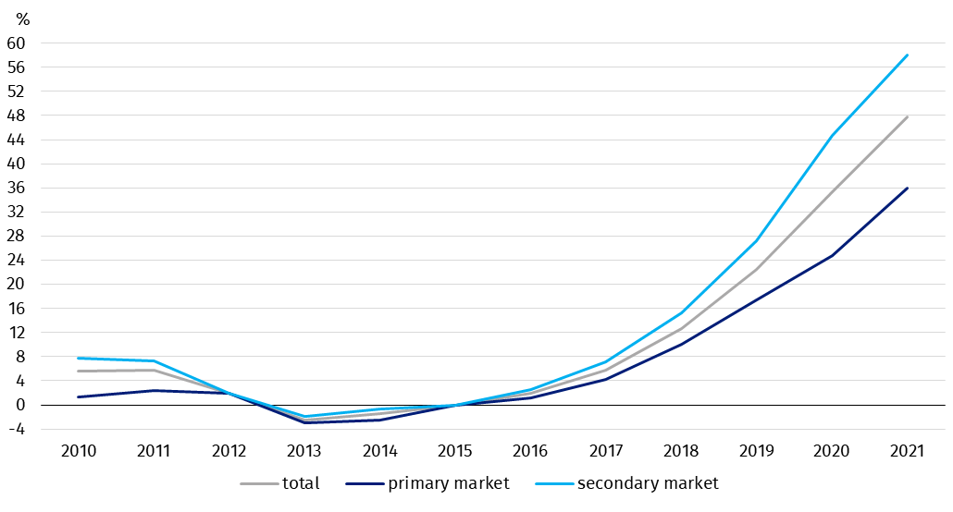
In case of quoting Statistics Poland data, please provide information: “Source of data: Statistics Poland”, and in case of publishing calculations made on data published by Statistics Poland, please include the following disclaimer: “Own study based on figures from Statistics Poland”.

Prepared by:  Trade and Services Department  Director Ewa Adach - Stankiewicz  Phone: (+48 22) 608 31 24 | Issued by:  The Spokesperson for the President  of Statistics Poland  Karolina Banaszek  Phone: (+48) 695 255 011
Press Office  Phone: (+48 22) 608 38 04  e-mail: obslugaprasowa@stat.gov.pl |   www.stat.gov.pl/en/

@StatPoland

@GlownyUrzadStatystyczny

gus_stat

glownyurzadstatystycznygus

glownyurzadstatystyczny
Related information
Price indices of residential premises by voivodships
Price of one square meter of usable floor space of a residential building
Real estate sales in 2020

Data available in databases
Knowledge Databases (DBW) Prices
Local Data Bank – Real Estate Market

Terms used in official statistics
Real estate turnover
Real estate Price Register
Premises
Price indices of residential premises
Real estate transaction

