Economic aspects of environmental protection 2021
The amount of outlays on fixed assets for environmental protection in 2021 amounted to approx. PLN 12.4 billion (compared to PLN 11.4 billion in 2020), and outlays on fixed assets for water management reached the level of approx. PLN 3.3 billion (PLN 2.7 billion in 2020). In 2021, outlays on environmental protection and water management accounted for 0.47% and 0.12% of GDP, respectively (0.49% and 0.11% in 2020, respectively).
10.9%
Outlays on fixed assets for environmental protection and water management in relation to 2020.
As in previous years, enterprises are the main investor in outlays on fixed assets for environmental protection, followed by gminas, and then budgetary units. The group of investors with the highest share of outlays in the field of water management were budgetary units, then enterprises and gminas.
In 2021, outlays on fixed assets for environmental protection amounted to approx. PLN 12.4 billion, and on water management to approx. PLN 3.3 billion
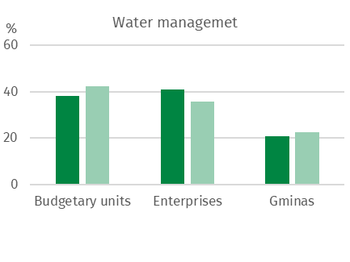
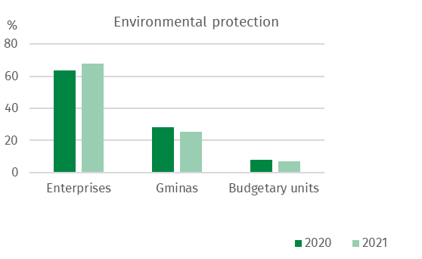
Chart 1. Structure of outlays on fixed assets for environmental protection and water management by groups of investors

The highest outlays on fixed assets for environmental protection were incurred in the following voivodships: Mazowieckie (18.9% of total outlays on fixed assets for environmental protection), Śląskie (12.8%) and Wielkopolskie (9.2%), while the lowest in Podlaskie (2.3%), Świętokrzyskie (2.9%) and Lubuskie (3.0%).
In water management, the highest outlays were incurred in the following voivodships: Dolnośląskie (20.1% of total expenditure), Mazowieckie (13.9%) as well as Małopolskie and Śląskie (8.1% each), while the lowest in Warmińsko-Mazurskie (1.9%) and Podlaskie (1.4%).

Chart 2. Outlays on fixed assets for environmental protection and water management by voivodship in 2021
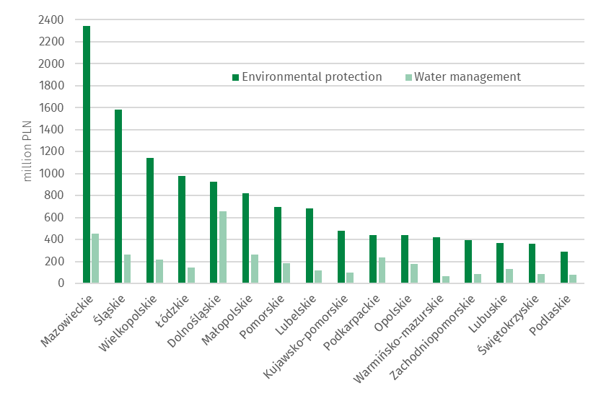

Outlays on fixed assets for environmental protection

Outlays on fixed assets for environmental protection are classified according to 9 areas of environmental protection: 1. air and climate protection; 2. wastewater management and protection of water; 3. waste management; 4. protection and restoration of the utility value of soils and protection of groundwater and surface waters; 5. noise and vibration reduction; 6. protection of biodiversity and landscape; 7. protection against ionising radiation; 8. research and development activities and 9. other environmental protection activities (mainly administration and environmental management, education, training).
The structure of outlays on fixed assets for environmental protection in Poland in 2021 was dominated by outlays on wastewater management and protection of water, as well as on air and climate protection, with a share of 46.0% and 35.6%, respectively. The remaining 18.4% of outlays are outlays on waste management (7.9%), noise and vibration reduction (1.8%), protection of biodiversity and landscape (1.1%), protection of soil and ground and surface waters (0.7%) and other environmental protection activities (6.9%), respectively.
In 2021, outlays on fixed assets for wastewater management and protection of water amounted to PLN 5.7 billion
In 2021, outlays on fixed assets for wastewater management and protection of water amounted to PLN 5.7 billion. The highest outlays for this purpose were incurred in the following voivodships: Mazowieckie (17.1%), Wielkopolskie (10.1%) and Śląskie (9.9%), the lowest in Podlaskie (2.5%), Lubuskie and Opolskie (2.6% each) and Warmińsko-Mazurskie (2.9%)

Chart 3. Outlays on fixed assets for wastewater management and protection of water by amount and voivodship in 2021
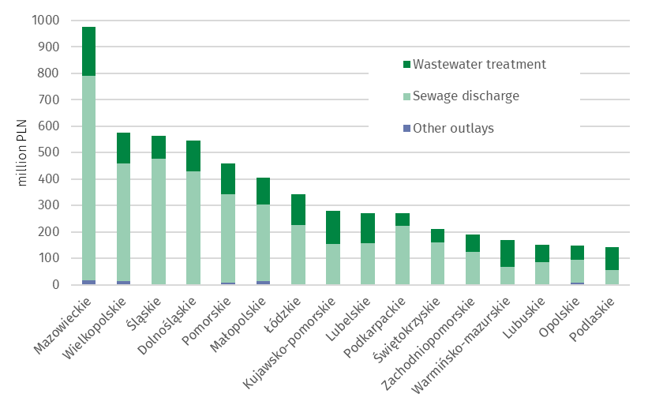

In 2021, outlays on fixed assets for air and climate protection amounted to PLN 4.4 billion
Outlays on fixed assets for the protection of air and climate amounted to PLN 4.4 billion. The highest outlays were incurred in the following voivodships: Mazowieckie (23.6%), Śląskie (13.8%) and Wielkopolskie (10.6%), the lowest in Podlaskie (1.8%), Podkarpackie (2.2%) and Kujawsko-Pomorskie (2.3%).
The largest part of outlays on air and climate protection were outlays on pollution prevention equipment (57.3% of the total expenditure), including modern fuel combustion technologies along with the modernisation of boiler and thermal energy plants (34.4%), unconventional energy sources (16.2%) and pollution reduction equipment (41.6%)
The highest outlays on pollution prevention equipment were in the following voivodships: Mazowieckie (PLN 913 million), Śląskie (PLN 215 million) and Lubelskie (PLN 214 million), the lowest in Świętokrzyskie (PLN 16 million) and Zachodniopomorskie (PLN 28 million). Moreover, the highest outlays on unconventional energy sources were in Wielkopolskie (PLN 120 million), the lowest in Lubuskie (PLN 6 million) as well as Świętokrzyskie and Opolskie (PLN 7 million each).
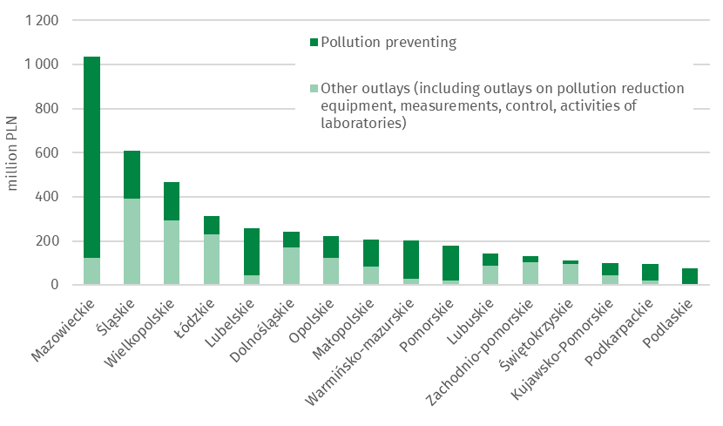
Chart 4. Outlays on fixed assets for air and climate protection by voivodship in 2021

Outlays on waste management amounted to PLN 1.0 billion, on noise and vibration reduction PLN 0.2 billion, on biodiversity and landscape protection PLN 0.1 billion, on soil, ground and surface water protection PLN 0.1 billion , and on other activities PLN 0.8 billion was spent in total.
The highest outlays on waste management were in the following voivodships: Mazowieckie (PLN 271 million) as well as Dolnośląskie and Śląskie (PLN 106 million each), the lowest in Świętokrzyskie (PLN 9 million) and Lubuskie (PLN 11 million).
In 2021 the Łódzkie voivodship was characterized amongst other voivodships by the highest outlays on noise and vibration reduction (PLN 112 million), on biodiversity and landscape protection (PLN 76 million) and on soil, ground and surface water protection (PLN 43 million). The lowest outlays on noise and vibration reduction were in the Kujawsko-Pomorskie (PLN 0.1 million), moreover in Zachodniopomorskie, Podlaskie and Pomorskie there were no outlays incurred. The lowest outlays on biodiversity and landscape protection were in Kujawsko-Pomorskie and Wielkopolskie (PLN 0.1 million summed), and on soil, ground and surface water protection in Lubuskie and Opolskie (PLN 0.5 million summed).
The highest outlays on research and development activities were in Śląskie voivodship (PLN 8 million).

Outlays on fixed assets for water management
Investments related to water management include water intakes and systems (including the main and distribution water network and construction of water quality control laboratories, including automatic water quality measurement stations), construction and modernization of water treatment plants, construction of water reservoirs (except fire and daily equalisation reservoirs), water, sailing and energy falls, as well as locks and weirs, regulation and management of rivers and mountain streams, construction of flood embankments and construction of pump stations behind embankments and in depression areas.
In 2021, the amount of outlays on water management amounted to approximately PLN 3.3 billion. The main stream of outlays were directed to the construction of drinking water infrastructure. Investments in water intakes and systems accounted for 44.1% of all outlays in water management.
Chart 5. Structure of outlays on fixed assets for water management
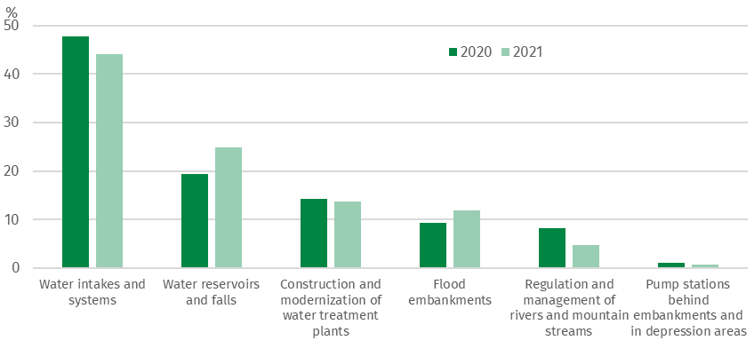

The largest outlays on water intakes and systems were incurred in Mazowieckie (PLN 263 million) and Śląskie (PLN 194 million). On the other hand, on water reservoirs and falls as well as flood embankments in Dolnośląskie (PLN 547 million) and Opolskie (PLN 141 million). For the construction and modernization of water treatment plants, the greatest amount of funds was allocated in Mazowieckie (PLN 153 million).

Chart 6. Outlays on fixed assets for water management by investment directions and voivodship in 2021
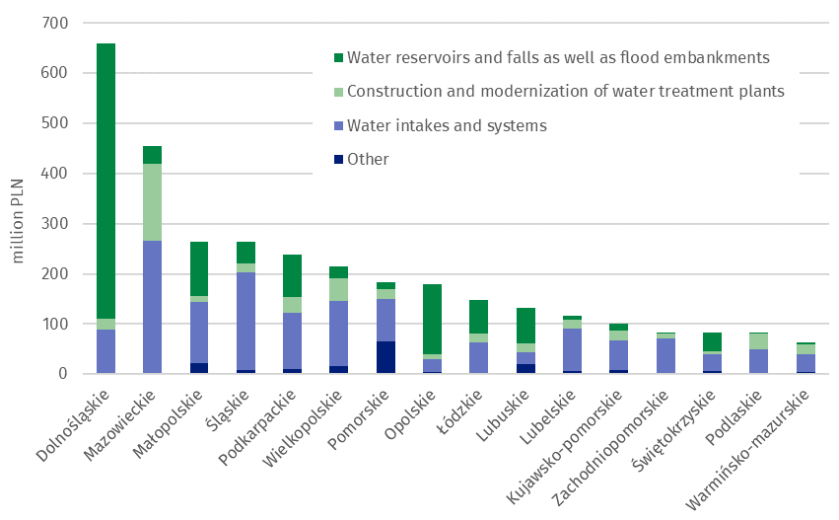
Tangible effects of investments in environmental protection and water management
In 2021, as a result of the implementation of environmental protection investments, 26 wastewater treatment plants with a total capacity of 50 thousand m³/day (including 24 municipal wastewater treatment plants with a total capacity of 49 thousand m³/day) were completed. 3.4 thousand km of sewage network discharging of wastewater and approx. 0.7 thousand km of sewage network discharging of precipitation water were completed.
In the field of air protection, devices for reducing gaseous pollutants with a capacity of approx. 56 thousand tons/year and equipment for neutralisation of particulates pollutants with a capacity of approx. 5 thousand tons/year were completed.
In 2021, waste neutralisation equipment and installations with a total capacity of approx. 95 thousand tons/year (of which approx. 77% was waste treatment by landfilling) were completed.
In 2021, in terms of the tangible effects of water management investments, water supply devices (i.e. water intakes and water treatment) with a total capacity of approx. 124 thousand m³/day were completed. The capacity of the water treatment plants amounted to approx. 61 thousand m³/day, and the capacity of newly completed water intakes approx. 63 thousand m³/day. Six water reservoirs were built with a total capacity of approx. 2.9 million m³. In addition, 3 thousand kms of the water supply network were built, 41 km of rivers and mountain streams were regulated and management, and 64 km of flood embankments were built or modernised.
When citing data from Statistics Poland (GUS), please include the information: "Source of GUS data", and when publishing calculations made on the data published by GUS, please include the following information: "Own study based on GUS data”.

Prepared by:  Spatial and Environmental Surveys  Department  Deputy Director Wiesława Domańska  Phone: (+48 22) 608 32 58 | Issued by:  The Spokesperson for the President  of Statistics Poland  Karolina Banaszek  Phone: (+48) 695 255 011
Press Office  Phone: (+48 22) 608 38 04  e-mail: obslugaprasowa@stat.gov.pl |   www.stat.gov.pl/en/

@StatPoland

@GlownyUrzadStatystyczny

gus_stat

glownyurzadstatystycznygus

glownyurzadstatystyczny

Related works
Infographic - Economic aspects of environmental protection
Economic aspects of environmental protection 2021

Subject available in databases
Local Data Bank Environmental protection

More important terms available in the dictionary
Tangible effects of environmental protection and water management investments

In accordance with the Polish Statistical Classification of Activities and Facilities Related to Environmental Protection, introduced by the Regulation of the Council of Ministers of March 2, 1999 (Journal of Laws 1999, No. 25, pos. 218).

