Index numbers of construction and assembly production in July 2022
Acording to preliminary data construction and assembly production (in constant prices) carried out carried out domestically by construction enterprises employing more than 9 persons was in July 2022 by 4.2% higher than a year before (an increase of 3.2% the year before) and by 6.3% lower compared with June 2022 (a decrease of 4.7% the year before).
104.2
Index number of construction and assembly production as compared to July of 2021

Table 1. Index numbers of construction and assembly production (constant prices)
SPECIFICATION | 07 2022 |  | 01-07 2022
SPECIFICATION | 06 2022=100 | 07 2021=100 | 01-07 2021=100
CONSTRUCTION | 93.7 | 104.2 | 110.7
Construction of buildings ^{Δ} | 95.3 | 111.7 | 121.6
Civil engineering works ^{Δ} | 89.5 | 102.2 | 104.7
Specialised construction activities | 98.5 | 98.6 | 106.5

^{Δ} Abbreviated form according PKD 2007.

Sales of construction and assembly production in July 2022, compared to the corresponding period of 2021, increased in entities dealing mainly with construction of buildings (11.7%) and in whose basic type of activity were civil engineering works (2.2%), whereas
a decrease by 1.4 % was noted in performing specialised construction activities.

Compared with June 2022, decreases in the value of works carried out were noted in entities performing specialised construction activities by 1.5%, in whose basic type of activity was construction of buildings by 4.7% and dealing mainly with civil engineering works by 10.5%.
In period of January-July 2022, sales of construction and assembly production, compared to the corresponding period of 2021, increased in all division of contruction, in entities whose basic type of activity was construction of buildings (21.6%), performing specialised construction activities (6.5%) and dealing mainly with civil engineering works (4.7%).
Sales of construction and assembly production in July 2022, compared to the corresponding period of 2021 increased for investment works by 2.0% (a decrease of 0.1% in 2021) and for restoration works by 7.6% (an increase of 8.6% in 2021).
In the period of January-July 2022, in relation to the same period of previous year, there was an increase of 5.6% in the value of investment works (a decrease of 5.8% in 2021), and of 18.6% in the value of works with a restoration character (an increase of 8.4% in 2021).
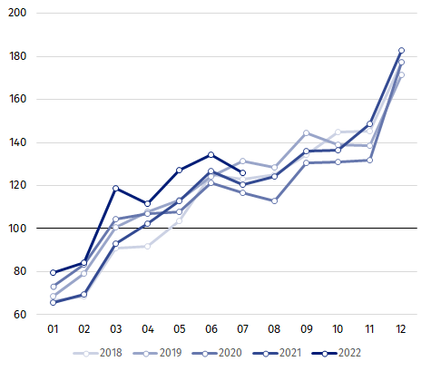
Chart 1. Index numbers of construction and assembly production (constant prices; average monthly base 2015=100)

Index number of construction and assembly production in July 2022 (in constant prices), compared to the average monthly value of 2015, was 125.7.
After eliminating the seasonal factors, construction and assembly production reached the level by 7.7% higher than in July 2021 and by 0.5% lower in comparison to June 2022.
In case of quoting Statistics Poland data, please provide information: “Source of data: Statistics Poland” and in case of publishing calculations made on data published by Statistics Poland, please include the following disclaimer: “Own study based on figures from Statistics Poland”.

Prepared by:  Statistical Office in Lublin  Director Krzysztof Markowski  Phone: (+48 81) 533 20 52 | Issued by:  The Spokesperson for the President of Statistics Poland  Karolina Banaszek  Phone: (+48) 695 255 011
Press Office  Phone: (+48 22) 608 38 04  e-mail: obslugaprasowa@stat.gov.pl |   www.stat.gov.pl/en/

@StatPoland

@GlownyUrzadStatystyczny

gus_stat

glownyurzadstatystycznygus

glownyurzadstatystyczny
Related information
Statistical Bulletin
Socio-economic situation of the country
Data available in databases
Knowledge Database - Construction
Macroeconomic Data Bank
Macroeconomic indicators
Local Data Bank
Terms used in official statistics
Sale of construction and assembly production
Seasonally unadjusted index of sale of construction and assembly production in constant prices
Seasonally adjusted index of sale of construction and assembly production
Sale of construction works with an investment character
Sale of construction works with a restoration character and other works

Reported data; comprise enterprises employing over 9 persons, whose the main type of activity is included in the section F “Construction” in accordance with the Polish Classification of Activities (PKD 2007).
² Data including final information on production and prices in June and reported data in July.
Reported data for July 2022.

