Index numbers of construction and assembly production in May 2022
Acording to preliminary data construction and assembly production (in constant prices) carried out carried out domestically by construction enterprises employing more than 9 persons was in May 2022 by 13.0% higher than a year before (an increase of 4.7% the year before) and by 14.2% higher compared with April 2022 (an increase of 10.2% the year before).
113.0
Index number of construction and assembly production as compared to May of 2021

Table 1. Index numbers of construction and assembly production (constant prices)
SPECIFICATION | 05 2022 |  | 01-05 2022
SPECIFICATION | 04 2022=100 | 05 2021=100 | 01-05 2021=100
CONSTRUCTION | 114.2 | 113.0 | 115.9
Construction of buildings ^{Δ} | 109.6 | 134.7 | 133.9
Civil engineering works ^{Δ} | 121.1 | 103.9 | 105.6
Specialised construction activities | 111.5 | 103.3 | 109.5

^{Δ} Abbreviated form according PKD 2007.

Sales of construction and assembly production in May 2022, compared to the corresponding period of 2021, increased in all division of construction, in entities dealing mainly with construction of buildings (34.7%), in entities whose basic type of activity were civil engineering works (3.9%) and performing specialised construction activities (3.3%).

Compared with April 2022, an increase in the value of works carried out were noted in entities dealing mainly with civil engineering works by 21.1%, performing specialised construction activities by 11.5% and in whose basic type of activity was construction of buildings by 9.6%.
In period of January-May 2022, the increase in the value of construction and assembly production in the corresponding period of 2021 was noted in entities whose basic type of activity was construction of buildings (33.9%), performing specialised construction activities (9.5%) and dealing mainly with civil engineering works (5.6%).
Sales of construction and assembly production in May 2022, compared to the corresponding period of 2021 increased both for investment works by 3.6% and restoration works by 28.7% (increases of 3.1% and 7.6% in the year before).
In the period January-May 2022 an increase in the value of investment works was by 10.7% higher than in the corresponding period of 2021 (a decrease of 12.1% in 2021), and works with a restoration character by 23.8% (an increase of 3.0% in 2021).
Chart 1. Index numbers of construction and assembly production (constant prices; average monthly base 2015=100)
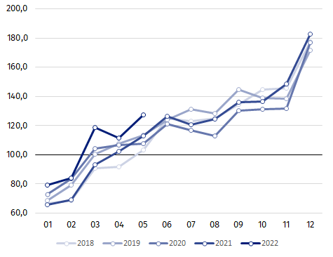

Index number of construction and assembly production in May 2022 (in constant prices), compared to the average monthly value of 2015, was 127.4.
After eliminating the seasonal factors, construction and assembly production reached the level by 9.8% higher than in May 2021 and by 2.4% higher in comparison to April 2022.
In case of quoting Statistics Poland data, please provide information: “Source of data: Statistics Poland” and in case of publishing calculations made on data published by Statistics Poland, please include the following disclaimer: “Own study based on figures from Statistics Poland”.

Prepared by:  Statistical Office in Lublin  Director Krzysztof Markowski  Phone: (+48 81) 533 20 52 | Issued by:  The Spokesperson for the President of Statistics Poland  Karolina Banaszek  Phone: (+48) 695 255 011
Press Office  Phone: (+48 22) 608 38 04  e-mail: obslugaprasowa@stat.gov.pl |   www.stat.gov.pl/en/

@StatPoland

@GlownyUrzadStatystyczny

gus_stat

glownyurzadstatystycznygus

glownyurzadstatystyczny
Related information
Statistical Bulletin
Socio-economic situation of the country
Data available in databases
Knowledge Database - Construction
Macroeconomic Data Bank
Macroeconomic indicators
Local Data Bank
Terms used in official statistics
Sale of construction and assembly production
Seasonally unadjusted index of sale of construction and assembly production in constant prices
Seasonally adjusted index of sale of construction and assembly production
Sale of construction works with an investment character
Sale of construction works with a restoration character and other works

Reported data; comprise enterprises employing over 9 persons, whose the main type of activity is included in the section F “Construction” in accordance with the Polish Classification of Activities (PKD 2007).
² Data including final information on production and prices in April and reported data in May.
Reported data for May 2022.

