Residential construction in the period of January-August 2022

In the first eight months of 2022, there were more dwellings completed than the year before. Whereas the number of dwellings for which permits have been granted or which have been registered with a construction project as well as dwellings in which construction has begun decreased.
101.8
Index number of dwellings
completed y/y

Dwellings completed
Developers and private investors completed respectively: 58.8% and 39.9% of the total number of dwellings
According to the preliminary data, 145.5 thousand dwellings were completed in the period of January-August 2022, i.e. 1.8% more than in the previous year. Developers completed 85.6 thousand dwellings – by 3.1% more than in 2021, whereas private investors completed 58.1 thousand dwellings, i.e. by 2.2% more. Within these forms of construction, 98.7% of the total number of newly completed dwellings was built. Within other forms of construction, i.e. cooperative, municipal, public building society and company construction 1 827 dwellings were completed (3 108 in the previous year).
The total useful floor area of dwellings completed amounted to 13.8 million m², i.e. by 1.4% more than a year ago and the average useful floor area of 1 dwelling was 94.5 m².

Table 1. Dwellings completed
SPECIFICATION | 08 2022 |  |  | 01-08 2022
SPECIFICATION | Number  of dwellings | 08 2021=100 | 07 2022=100 | Number  of dwellings | 01-08  2021=100
TOTAL | 18 417 | 99.1 | 104.8 | 145 532 | 101.8
Private | 6 643 | 94.1 | 101.9 | 58 056 | 102.2
For sale or rent | 11 616 | 103.3 | 105.7 | 85 649 | 103.1
of which for rent | 17 | 11.2 | almost 45-fold less | 1 483 | 96.5
Cooperative | 53 | 80.3 | . | 796 | 57.9
Municipal | 26 | 113.0 | 123.8 | 253 | 26.6
Public building society | 79 | 43.9 | 168.1 | 742 | 103.5
Company | - | . | . | 36 | 54.5

Dwellings for which permits have been granted or which have been registered with
a construction project
The number of dwellings for which permits have been granted or which have been registered with a construction project decreased in the period of 01-08 2022 by 5.7% y/y
From the beginning of January until the end of August 2022, permits and registrations have been granted for construction of 214.8 thousand dwellings, i.e. by 5.7% less than in the corresponding period of 2021. Permits for construction of the biggest number of dwellings were given to developers (146.3 thousand, an increase of 2.4% y/y) and to private investors (65.4 thousand, a decrease of 20.7%). Within these forms of construction, permits have been granted and registrations with a construction project were made for 98.6% of dwellings in total. In other forms of construction 3 097 dwellings for which permits have been granted or which have been registered with a construction project were noted (2 426 dwellings in the previous year).
Table 2. Dwellings for which permits have been granted or which have been registered with
a construction project
SPECIFICATION | 08 2022 |  |  | 01-08 2022
SPECIFICATION | Number  of dwellings | 08 2021=100 | 07 2022=100 | Number  of dwellings | 01-08  2021=100
TOTAL | 21 530 | 79,1 | 97,9 | 214 788 | 94,3
Private | 7 144 | 67,5 | 91,0 | 65 439 | 79,3
For sale or rent | 14 148 | 85,5 | 100,9 | 146 252 | 102,4
Cooperative | 31 | 31-fold more | 344,4 | 509 | 73,1
Municipal | 98 | 251,3 | 153,1 | 1 454 | 227,5
Public building society | 109 | . | 242,2 | 1 131 | 110,2
Company | - | . | . | 3 | almost 22-fold less

Dwellings in which construction has begun
From the begging of the year till the end of August 2022, the number of dwellings in which construction has begun was 148.9 thousand, i.e. by 23.4% less than a year ago. Developers have started construction of 85.1 thousand dwellings (by 27.0% less), and private investors of 61.4 thousand (by 17.4% less). Altogether the share of these forms of construction was 98.4% of the total number of dwellings. In other forms of construction the number of dwellings in which construction has begun was 2 334 (3 305 in the previous year).
Table 3. Dwellings in which construction has begun
SPECIFICATION | 08 2022 |  |  | 01-08 2022
SPECIFICATION | Number  of dwellings | 08 2021=100 | 07 2022=100 | Number  of dwellings | 01-08  2021=100
TOTAL | 12 913 | 53,9 | 79,3 | 148 897 | 76,6
Private | 7 472 | 77,3 | 98,7 | 61 443 | 82,6
For sale or rent | 5 198 | 37,0 | 62,2 | 85 120 | 73,0
of which for rent | 7 | almost 30-fold less | almost 19-fold less | 361 | 43,7
Cooperative | 16 | 16,8 | 177,8 | 584 | 40,8
Municipal | 175 | 135,7 | 221,5 | 780 | 128,9
Public building society | 24 | 45,3 | 10,2 | 887 | 80,9
Company | 28 | . | 121,7 | 83 | 48,5
It is estimated that at the end of August 2022, there were 874.7 thousand dwellings under construction, i.e. by 0.6% less than in the corresponding period of 2021.
Chart 1. Construction activity in the scope of residential construction in Poland

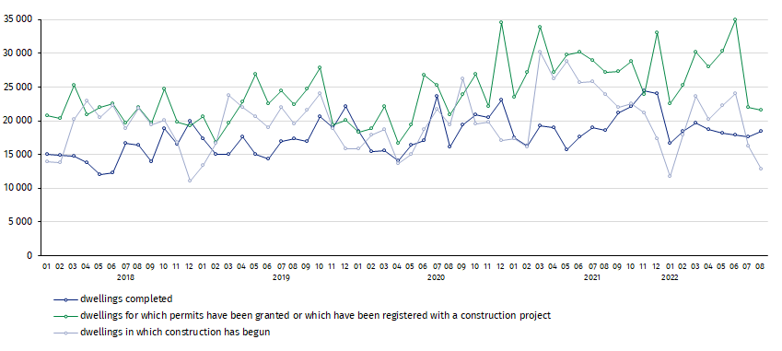
In August, compared to July 2022, the number of dwellings completed increased (by 4.8%), whereas the number of dwellings for which permits have been granted or which have been registered with a construction project decreased (by 2.1%) as well as the number of dwellings in which construction has begun (by 20.7%)
In the period of January-August 2022, the highest values of dwellings completed, as well as dwellings in which construction has begun and dwellings for which permits have been granted or which have been registered with a construction project, were recorded in Mazowieckie voivodship (respectively: 25.5 thousand, 26.1 thousand and 38.7 thousand). High values were also noted in Wielkopolskie (15.8 thousand, 13.9 thousand and 19.6 thousand) and Małopolskie (14.7 thousand,14.1 thousand and 18.4 thousand).

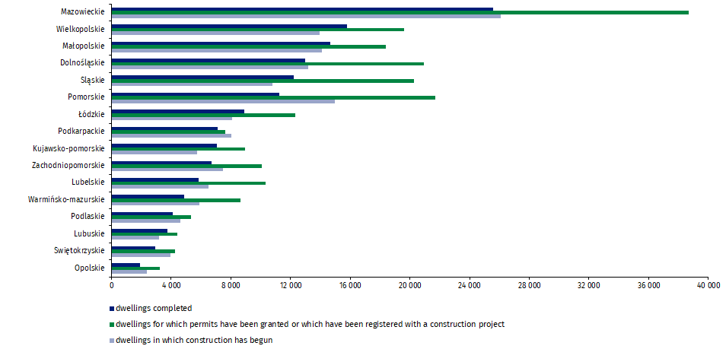
Chart 2. Construction activity in the scope of residential construction by voivodships
(January- August 2022)

In case of quoting Statistics Poland data, please provide information: “Source of data: Statistics Poland” and in case of publishing calculations made on data published by Statistics Poland, please include the following disclaimer: “Own study based on figures from Statistics Poland”.
Prepared by:  Statistical Office in Lublin  Director Krzysztof Markowski  Phone: (+48 81) 533 20 52 | Issued by:  The Spokesperson for the President  of Statistics Poland  Karolina Banaszek  Phone: (+48) 695 255 011
Press Office  Phone: (+48 22) 608 38 04  e-mail: obslugaprasowa@stat.gov.pl |   www.stat.gov.pl/en/

@StatPoland

@GlownyUrzadStatystyczny

gus_stat

glownyurzadstatystycznygus

glownyurzadstatystyczny
Related information
Statistical Bulletin
Socio-economic situation of the country
Construction results
Data available in databases
Knowledge Databases Construction
Local Data Bank
Terms used in official statistics
Dwellings for which permits have been granted or which have been registered with a construction project
Dwellings in which construction has begun
Dwellings completed

Reported data – subject to change upon developing quarterly reports.

