Residential construction in the period of January-June 2022

In the first half of 2022, there were more dwellings completed than the year before. Whereas the number of dwellings for which permits have been granted or which have been registered with a construction project as well as dwellings in which construction has begun decreased.
103.8
Index number of dwellings
completed y/y

Dwellings completed
Developers and private investors completed respectively: 57.5% and 41.0% of the total number of dwellings
According to the preliminary data, 109.4 thousand dwellings were completed in the first half of 2022, i.e. 3.8% more than in the previous year. Developers completed 62.9 thousand dwellings – by 3.7% more than in 2021, whereas private investors completed 44.9 thousand dwellings, i.e. by 6.0% more. Within these forms of construction, 98.5% of the total number of newly completed dwellings was built. Within other forms of construction, i.e. cooperative, municipal, public building society and company construction 1 598 dwellings were completed (2 459 in the previous year).
The total useful floor area of dwellings completed amounted to 10.5 million m², i.e. by 4.2% more than a year ago and the average useful floor area of 1 dwelling was 95.5 m².

Table 1. Dwellings completed
SPECIFICATION | 06 2022 |  |  | 01-06 2022
SPECIFICATION | Number  of dwellings | 06 2021=100 | 05 2022=100 | Number  of dwellings | 01-06  2021=100
TOTAL | 18 224 | 103.6 | 103.7 | 109 411 | 103.8
Private | 6 873 | 100.8 | 102.7 | 44 894 | 106.0
For sale or rent | 11 185 | 110.8 | 104.3 | 62 919 | 103.7
of which for rent | 44 | 53.0 | 46.3 | 487 | 49.7
Cooperative | 101 | 22.3 | . | 743 | 59.3
Municipal | 48 | 31.0 | . | 206 | 22.7
Public building society | 14 | 20.0 | over 12-fold less | 616 | 209.5
Company | 3 | 300.0 | . | 33 | 550.0

Dwellings for which permits have been granted or which have been registered with
a construction project
The number of dwellings for which permits have been granted or which have been registered with a construction project decreased in the period of 01-06 2022 by 0.5% y/y
In the first half of 2022, permits and registrations have been granted for construction of 170.8 thousand dwellings, i.e. by 0.5% less than in the corresponding period of 2021. Permits for construction of the biggest number of dwellings were given to developers (117.5 thousand, an increase of 7.4% y/y) and to private investors (50.6 thousand, a decrease of 16.1%). Within these forms of construction, permits have been granted and registrations with a construction project were made for 98.4% of dwellings in total. In other forms of construction 2 705 dwellings for which permits have been granted or which have been registered with a construction project were noted (2 015 dwellings in the previous year).
Table 2. Dwellings for which permits have been granted or which have been registered with
a construction project
SPECIFICATION | 06 2022 |  |  | 01-06 2022
SPECIFICATION | Number  of dwellings | 06 2021=100 | 05 2022=100 | Number  of dwellings | 01-06  2021=100
TOTAL | 34 810 | 115.4 | 115.3 | 170 803 | 99.5
Private | 8 517 | 73.0 | 94.2 | 50 593 | 83.9
For sale or rent | 25 953 | 142.3 | 124.6 | 117 505 | 107.4
Cooperative | 52 | 208.0 | . | 469 | 82.3
Municipal | 168 | 233.3 | 56.6 | 1 296 | 268.9
Public building society | 120 | 69.4 | 500.0 | 937 | 98.2
Company | - | . | . | 3 | 33.3

Dwellings in which construction has begun
From the begging of the year till the end of June 2022, the number of dwellings in which construction has begun was 119.7 thousand, i.e. by 17.2% less than a year ago. Developers have started construction of 71.6 thousand dwellings (by 18.4% less), and private investors of 46.4 thousand (by 14.5% less). Altogether the share of these forms of construction was 98.5% of the total number of dwellings. In other forms of construction the number of dwellings in which construction has begun was 1 744 (2 605 in the previous year).
Table 3. Dwellings in which construction has begun
SPECIFICATION | 06 2022 |  |  | 01-06 2022
SPECIFICATION | Number  of dwellings | 06 2021=100 | 05 2022=100 | Number  of dwellings | 01-06  2021=100
TOTAL | 24 021 | 93.3 | 108.1 | 119 707 | 82.8
Private | 8 028 | 77.5 | 92.0 | 46 400 | 85.5
For sale or rent | 15 660 | 105.2 | 119.2 | 71 563 | 81.6
of which for rent | 10 | 111.1 | 142.9 | 223 | 39.4
Cooperative | 47 | 17.0 | 24.9 | 559 | 43.3
Municipal | 208 | . | 161.2 | 526 | 305.8
Public building society | 78 | 86.7 | 162.5 | 627 | 62.0
Company | - | . | . | 32 | 24.8

It is estimated that at the end of June 2022, there were 881.6 thousand dwellings under construction, i.e. by 1.6% more than in the corresponding period of 2021.
Chart 1. Construction activity in the scope of residential construction in Poland

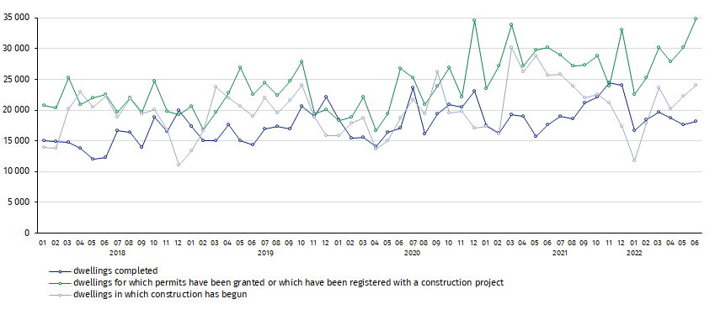
In June, compared to May 2022, the number of dwellings completed increased (by 3.7%), as well as the number of dwellings for which permits have been granted or which have been registered with a construction project (by 15.3%) and the number of dwellings in which construction has begun (by 8.1%)
In the first half of 2022, the highest values of dwellings completed, as well as dwellings in which construction has begun and dwellings for which permits have been granted or which have been registered with a construction project, were recorded in Mazowieckie voivodship (respectively: 18.8 thousand, 21.6 thousand and 31.1 thousand). High values were also noted in Wielkopolskie (12.4 thousand, 11.7 thousand and 16.5 thousand) and Małopolskie (11.1 thousand,11.1 thousand and 14.4 thousand).

Chart 2. Construction activity in the scope of residential construction by voivodships
(January- June 2022)

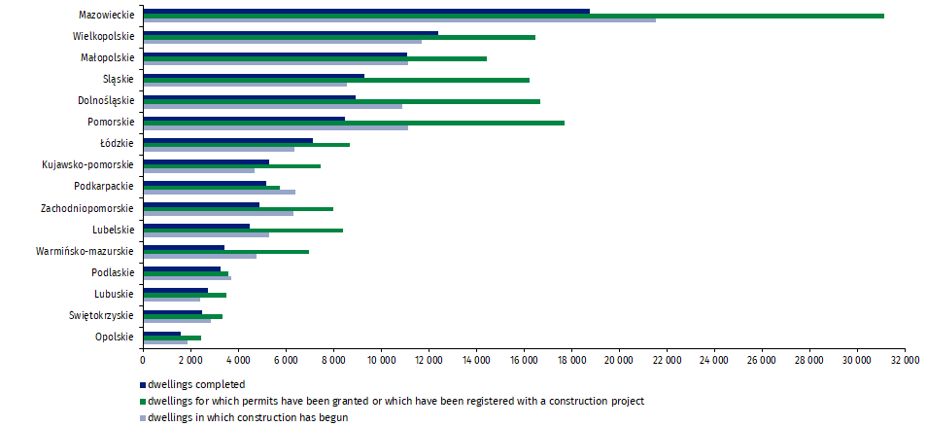

In case of quoting Statistics Poland data, please provide information: “Source of data: Statistics Poland” and in case of publishing calculations made on data published by Statistics Poland, please include the following disclaimer: “Own study based on figures from Statistics Poland”.
Prepared by:  Statistical Office in Lublin  Director Krzysztof Markowski  Phone: (+48 81) 533 20 52 | Issued by:  The Spokesperson for the President  of Statistics Poland  Karolina Banaszek  Phone: (+48) 695 255 011
Press Office  Phone: (+48 22) 608 38 04  e-mail: obslugaprasowa@stat.gov.pl |   www.stat.gov.pl/en/

@StatPoland

@GlownyUrzadStatystyczny

gus_stat

glownyurzadstatystycznygus

glownyurzadstatystyczny
Related information
Statistical Bulletin
Socio-economic situation of the country
Construction results
Data available in databases
Knowledge Databases Construction
Local Data Bank
Terms used in official statistics
Dwellings for which permits have been granted or which have been registered with a construction project
Dwellings in which construction has begun
Dwellings completed

Reported data – subject to change upon developing quarterly reports.

