Residential construction in January 2022

In January 2022, there were less dwellings completed than the year before. The number of dwellings for which permits have been granted or which have been registered with a construction project as well as dwellings in which construction has begun also decreased.
87.5
Index number of dwellings
completed y/y

Dwellings completed
Developers and private investors completed respectively 51.6% and 46.5% of the total number of dwellings
According to the preliminary data, 15.3 thousand dwellings were completed in January 2022, i.e. by 12.5% less than a year ago. Developers completed 7.9 thousand dwellings – by 23.5% less than in 2020, whereas private investors completed 7.1 thousand dwellings, i.e. by 3.2% more. Within these forms of construction, 98.1% of the total number of newly completed dwellings was built. Within other forms of construction, i.e. cooperative, municipal, public building society and company construction 286 dwellings were completed (278 in the previous year).
The total useful floor area of dwellings completed in January 2022 amounted to 1.5 million m², i.e. by 6.9% less than a year ago and the average useful floor area of 1 dwelling was 100.6 m².

Table 1. Dwellings completed
SPECIFICATION | 01 2022
SPECIFICATION | Number  of dwellings | 01 2021=100 | 12 2021=100
TOTAL | 15 315 | 87.5 | 58.1
Private | 7 124 | 103.2 | 72.9
For sale or rent | 7 905 | 76.5 | 49.0
of which for rent | 49 | 46.2 | 33.6
Cooperative | 162 | 100.0 | 87.1
Municipal | 21 | 22.8 | 60.0
Public building society | 73 | 304.2 | 38.6
Company | 30 | . | 75.0

Dwellings for which permits have been granted or which have been registered with
a construction project
The number of dwellings for which permits have been granted or which have been registered with a construction project decreased in January 2022 by 5.4% y/y
In January 2022, permits and registrations have been granted for construction of 22.2 thousand dwellings, i.e. by 5.4% less than in the corresponding month of 2021. Permits for construction of the biggest number of dwellings were given to developers (15.6 thousand, an increase of 3.1% y/y) and to private investors (6.5 thousand, a decrease of 20.9%). Within these forms of construction, permits have been granted and registrations with a construction project were made for 99.5% of dwellings in total. In other forms of construction 116 dwellings for which permits have been granted or which have been registered with a construction project were noted (120 dwellings in the previous year).
Table 2. Dwellings for which permits have been granted or which have been registered with
a construction project
SPECIFICATION | 01 2022
SPECIFICATION | Number  of dwellings | 01 2021=100 | 12 2021=100
TOTAL | 22 221 | 94.6 | 67.9
Private | 6 505 | 79.1 | 78.9
For sale or rent | 15 600 | 103.1 | 66.3
Cooperative | 50 | 66.7 | 46.3
Municipal | 65 | 232.1 | over 13 –  fold less
Public building society | - | . | .
Company | 1 | 50.0 | 25.0

Dwellings in which construction has begun
In January 2022, the number of dwellings in which construction has begun was 11.8 thousand, i.e. by 32.3% less than a year ago. Developers have started construction of 7.3 thousand dwellings (by 40.9% less), and private investors of 4.3 thousand (by 8.2% less). Altogether the share of these forms of construction was 99.1% of the total number of dwellings. In other forms of construction the number of dwellings in which construction has begun was 111 (252 in the previous year).
Table 3. Dwellings in which construction has begun
SPECIFICATION | 01 2022
SPECIFICATION | Number  of dwellings | 01 2021=100 | 12 2021=100
TOTAL | 11 800 | 67.7 | 68.0
Private | 4 349 | 91.8 | 92.7
For sale or rent | 7 340 | 59.1 | 58.3
of which for rent | 155 | 469.7 | 15.5–fold more
Cooperative | 3 | almost 39–  fold less | .
Municipal | 28 | almost 6–  fold more | 46.7
Public building society | 80 | 61.1 | 444.4
Company | - | . | .

It is estimated that at the end of January 2022, there were 867.8 thousand dwellings under construction, i.e. by 4.7% more than in the corresponding month of 2021.
Chart 1. Construction activity in the scope of residential construction in Poland

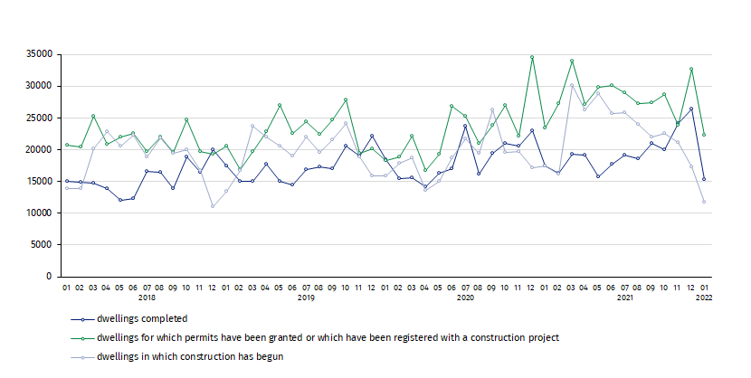

In January 2022, compared to December 2021, the number of dwellings completed decreased (by 41.9%), as well as the number of dwellings for which permits have been granted or which have been registered with a construction project (by 32.1%) and the number of dwellings in which construction has begun (by 32.0%)

In January 2022, the highest values of dwellings completed, as well as dwellings in which construction has begun and dwellings for which permits have been granted or which have been registered with a construction project, were recorded in Mazowieckie voivodship (respectively 2.9 thousand, 1.9 thousand and 3.5 thousand). High values were also noted in Wielkopolskie (2.0 thousand, 0.8 thousand and 2.9 thousand), Małopolskie (1.7 thousand, 1.0 thousand and 1.6 thousand) and Dolnośląskie (1.0 thousand, 1.3 thousand and 2.9 thousand).

Chart 2. Construction activity in the scope of residential construction by voivodships
in January 2022

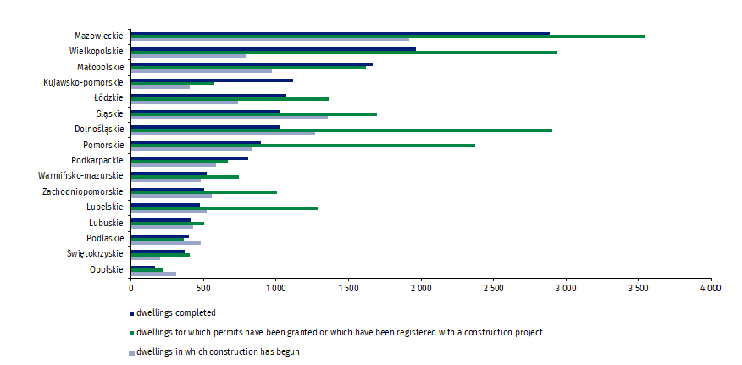

In case of quoting Statistics Poland data, please provide information: “Source of data: Statistics Poland” and in case of publishing calculations made on data published by Statistics Poland, please include the following disclaimer: “Own study based on figures from Statistics Poland”.
Prepared by:  Statistical Office in Lublin  Director Krzysztof Markowski  Phone: (+48 81) 533 20 52 | Issued by:  The Spokesperson for the President  of Statistics Poland  Karolina Banaszek  Phone: (+48) 695 255 011
Press Office  Phone: (+48 22) 608 38 04  e-mail: obslugaprasowa@stat.gov.pl |   www.stat.gov.pl/en/

@StatPoland

@GlownyUrzadStatystyczny

gus_stat

glownyurzadstatystycznygus

glownyurzadstatystyczny
Related information
Statistical Bulletin
Socio-economic situation of the country
Construction results
Data available in databases
Knowledge Databases Construction
Local Data Bank
Terms used in official statistics
Dwellings for which permits have been granted or which have been registered with a construction project
Dwellings in which construction has begun
Dwellings completed

Reported data – subject to change upon developing quarterly reports.

