The demand for labour in the third quarter of 2022
⇩ 9.2%
Decrease in the number of job vacancies compared with the end of the previous quarter
At the end of the third quarter of 2022, there were 135.5 thousand job vacancies in Poland, 11.7% fewer than in the corresponding period of the previous year. Over the year, the number of newly created jobs decreased (by 9.1%), whereas the number of jobs liquidated increased (by 24.0%). In the third quarter of 2022, there were 1.7 newly created jobs per liquidated job.
The Labour Demand Survey is conducted using the representative method on a quarterly basis, on the Z–05 reporting form. It covers national economy entities employing at least one person. At the end of the third quarter of 2022, private sector entities constituted the vast majority, whereas in terms of entity size – entities with up to 9 employed persons dominated numerically (respectively 91.0% and 68.5% of the total number of entities).
At the end of the third quarter of 2022, more than half of the national economy entities with job vacancies were entities with up to 9 employed persons; they had a quarter of the total number of job vacancies
In the third quarter of the current year, 5.9% out of 641.7 thousand national economy entities had job vacancies, 0.9 percentage points fewer than in the corresponding quarter of 2021. Among entities that had job vacancies, 81.6% were private sector entities. More than half of the entities with job vacancies (51.5%) had up to 9 employed persons.
Table 1. Basic results of the Labour Demand Survey
QUARTERS  A – corresponding quarter of the previous year  = 100  B – previous quarter = 100 | Jobs |  |  |  | Newly created jobs | Liquidated jobs
 | grand total | occupied | vacant |  | Newly created jobs | Liquidated jobs
 | grand total | occupied | total | including newly created | Newly created jobs | Liquidated jobs
 | at the end of the quarter |  |  |  | during the quarter
 | In thousands
2021
Quarter 2 | 12 332.6 | 12 189.8 | 142.8 | 35.0 | 145.8 | 58.5
Quarter 3 | 12 325.9 | 12 172.4 | 153.5 | 35.7 | 132.6 | 57.8
Quarter 4 | 12 286.8 | 12 149.4 | 137.4 | 32.3 | 112.5 | 64.9
2022
Quarter 1 | 12 684.6 | 12 525.9 | 158.7 | 30.9 | 189.7 | 81.9
Quarter 2 | 12 659.3 | 12 510.0 | 149.3 | 28.5 | 136.0 | 65.9
Quarter 3 | 12 647.7 | 12 512.2 | 135.5 | 25.6 | 120.6 | 71.7
A | 102.6 | 102.8 | 88.3 | 71.7 | 91.0 | 124.0
B | 99.9 | 100.0 | 90.8 | 89.8 | 88.7 | 108.8

Occupied jobs and job vacancies at the end of the third quarter of 2022
The met demand for labour is measured as the number of occupied jobs. In the third quarter of 2022, there were 12 512.2 thousand such jobs, which means an increase of an 2.8% on a year-over-year basis.
The majority of the occupied jobs, i.e. 59.6%, were in national economy entities with 50 or more employed persons. Out of the total number of occupied jobs, 74.3% were in private sector entities.
The analysis of changes in the number of job vacancies shows that on the last day of the third quarter of 2022 there were 9.2% fewer vacancies than at the end of the previous quarter, while at the end of the third quarter of 2021 there was an increase of 7.5%.
Most of the job vacancies, 80.6%, were in private sector entities. More than half of the job vacancies (56.8 %) were in entities with 50 or more employed persons. Employees were sought, i.a., through labour offices, to which 12.7% of the total number of job vacancies were reported.

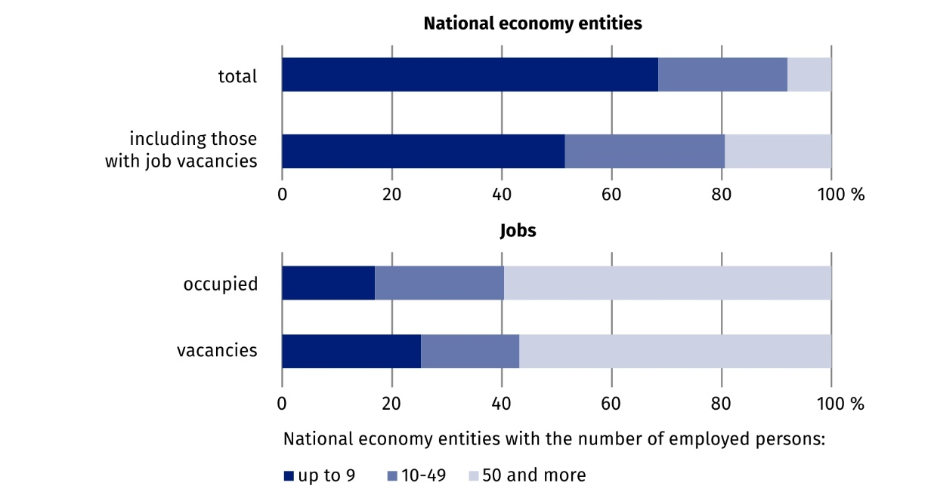
Chart 1. Structure of national economy entities and jobs by size of entities in the third quarter
of 2022
As at the end of the quarter
Compared with the corresponding period of the previous year, the number of occupied jobs at the end of the third quarter of the current year was slightly higher, while the number of job vacancies decreased

At the end of the third quarter, the largest number of job vacancies was in entities operating in Manufacturing – 27.9 thousand. A significant number of job vacancies were in the Trade; repair of motor vehicles∆ section – 21.1 thousand and in the Construction section – 15.4 thousand.

The largest increases in the number of job vacancies compared with the corresponding period of the previous year occurred in the sections: Education – by 40.2% to 7.0 thousand jobs and Electricity, gas, steam and air conditioning supply – by 29.1% to 0.7 thousand jobs.
The largest decreases in the number of job vacancies occurred in the sections: Agriculture, forestry and fishing – by 41.1% to 0.4 thousand, Accommodation and catering∆ – by 39.7% to 3.7 thousand and Construction – by 31.5% to 15.4 thousand jobs.

When analysing job vacancies by major occupational group, it can by noted that entities with job vacancies were most often looking for Professionals, for whom 38.1 thousand jobs were prepared in the third quarter. Slightly fewer offers were addressed to Craft and related trades workers – 29.2 thousand.

Chart 2. Jobs by selected major occupational groups in the third quarter of 2022
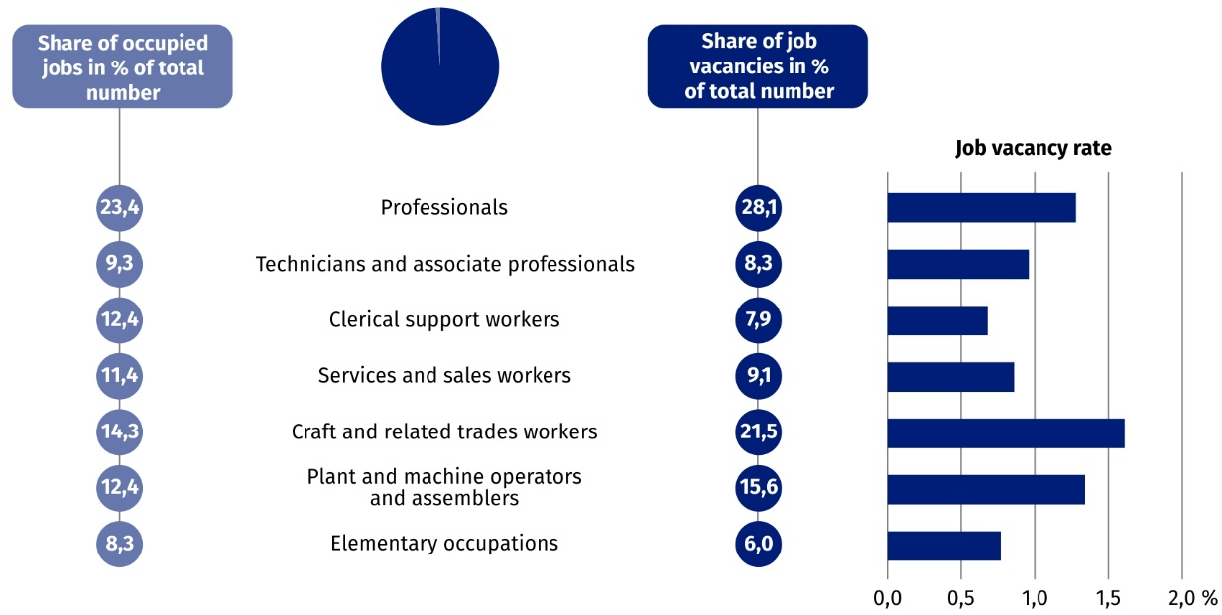
As at the end of the quarter

When analysing the number of job vacancies, it can be concluded that the largest number of vacancies for Professionals (out of the total number of job vacancies in this occupational group) existed in the following sections: Information and communication – 23.3%; Education – 15.0% and Professional, scientific and technical activities – 14.1%. Among the total number of job vacancies for Craft and related trades workers, the most job vacancies were offered by entities operating in the Manufacturing – 46.2% and Construction – 38.5% sections.

Job vacancy rate
A measure of unmet demand for labour is the job vacancy rate, which shows what proportion of all (vacant and occupied ) jobs are vacant (unoccupied) jobs.
At the end of the third quarter of 2022, the rate was 1.07%. It was lower than the rate at the end of the third quarter of 2021, as well as the rate at the end of the second quarter of the current year, by 0.18 percentage points and 0.11 percentage points, respectively.
Chart 3. Job vacancy rate
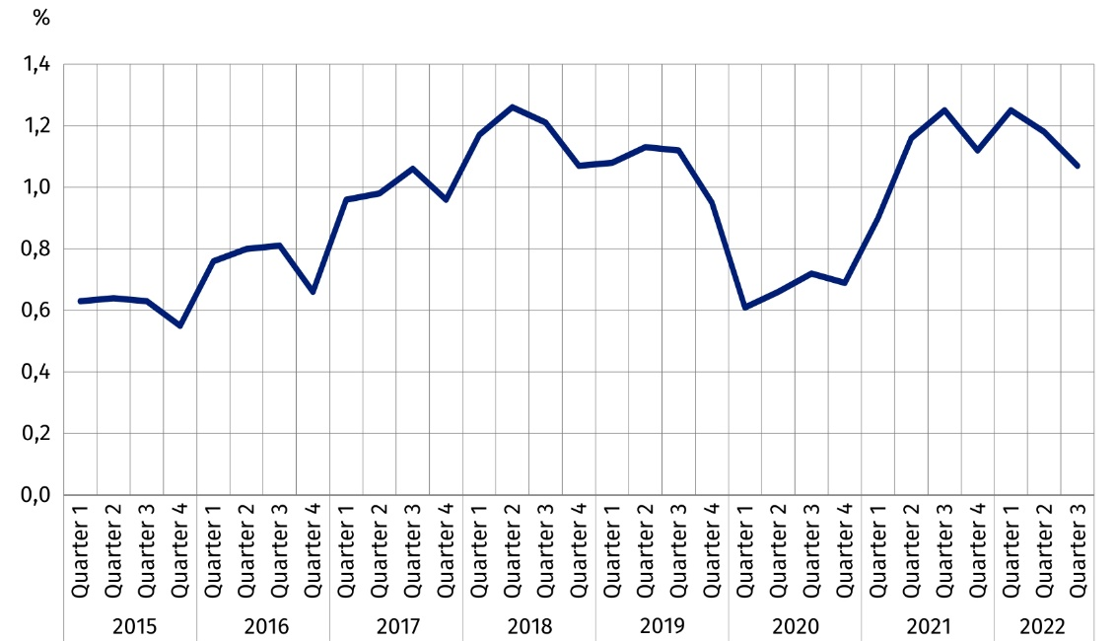
As at the end of the quarter
Looking at the job vacancy rate at the end of the third quarter of 2022 broken down by region, it can be seen that it reached its highest value in the Zachodniopomorskie region (1.72%). High values of the indicator were also found in the Dolnośląskie (1.44%) and Warszawski stołeczny (1.32%) regions. The lowest value of the job vacancy rate was recorded in the Podkarpackie region (0.54%).
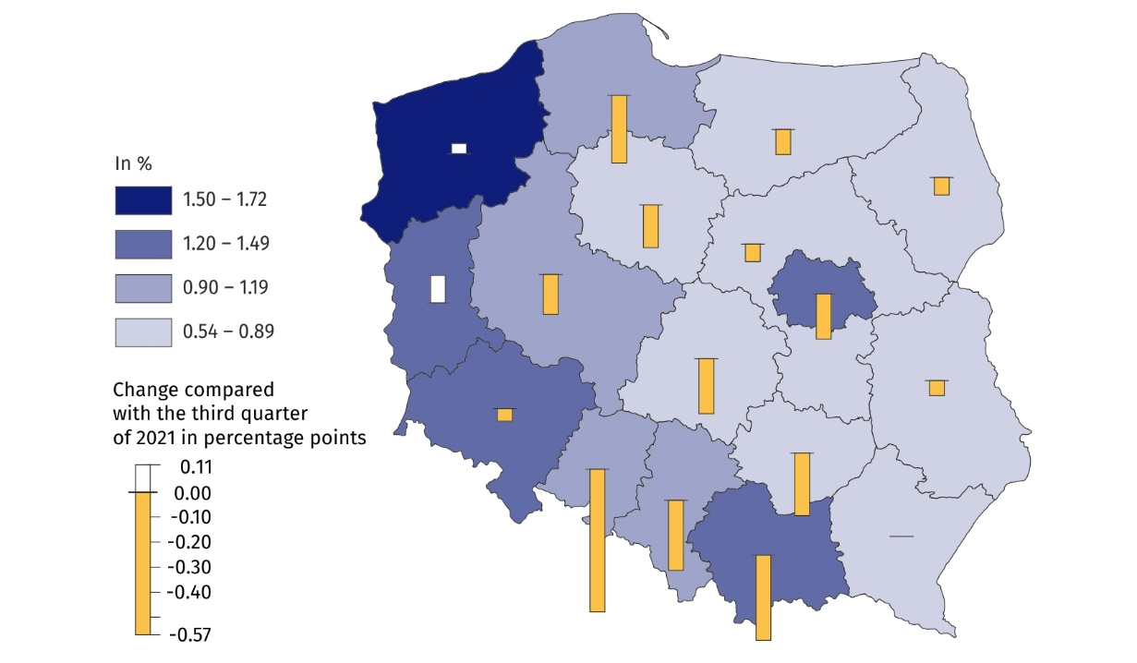
Map 1. Job vacancy rate by region (NUTS 2 level) in the third quarter of 2022
As at the end of the quarter
The highest value of the job vacancy rate was recorded in the major occupational group of Craft and related trades workers

According to another breakdown – by kind of conducted activity – the highest value of the job vacancy rate at the end of the third quarter of the current year was recorded in the Information and communication section –3,34%. This indicator was 0.55 percentage points lower than at the end of the corresponding quarter of the previous year. Sections in which the values of the rate were also high were: Construction 1.97% (where the rate in question was 0.82 percentage points lower compared with the situation a year ago) and Professional, scientific and technical activities – 1.58%. In the largest section in terms of the number of jobs, i.e. Manufacturing, the rate was 0.97%, 0.25 percentage points lower than a year ago.

Newly created and liquidated jobs in the third quarter of 2022
The Labour Demand Survey also enables to analyse the situation on the labour market in terms of newly created and liquidated jobs. During the third quarter of 2022, in Poland, 120.6 thousand new jobs were created and 71.7 thousand jobs were liquidated.
Compared with the corresponding period of the previous year, there was a decrease of 9.1% in the number of newly created jobs and an increase of 24.0% in the number of liquidated jobs.
In the third quarter of 2022, there were 1.7 newly created jobs per liquidated job (2.3 a year ago).
In the third quarter of 2022, 11.3% fewer jobs were created compared with the previous quarter of the current year and 8.8% more jobs were liquidated

During the analysed period, differences in the structure of jobs by PKD/NACE section were also visible – the most new jobs were created in national economy entities belonging to the Trade; repair of motor vehicles∆ section (22.4 thousand jobs), 2.2% more than in the third quarter of 2021. During the same period, 16.5 thousand jobs were liquidated in this section, 39.8% more on a year-over-year basis. There were 1.4 newly created jobs per liquidated job (compared with 1.9 jobs in the third quarter of 2021).
The Manufacturing section also had a significant share of jobs. Newly created jobs in the third quarter of 2022 accounted for 15.2% of their total number, while liquidated jobs accounted for 16.4% of their total number (18.3 thousand and 11.7 thousand jobs respectively). There were 1.6 newly created jobs per liquidated job.
In the third quarter of 2022, the largest number of newly created jobs per liquidated job was in the Electricity, gas, steam and air conditioning supply section (3.6 jobs).
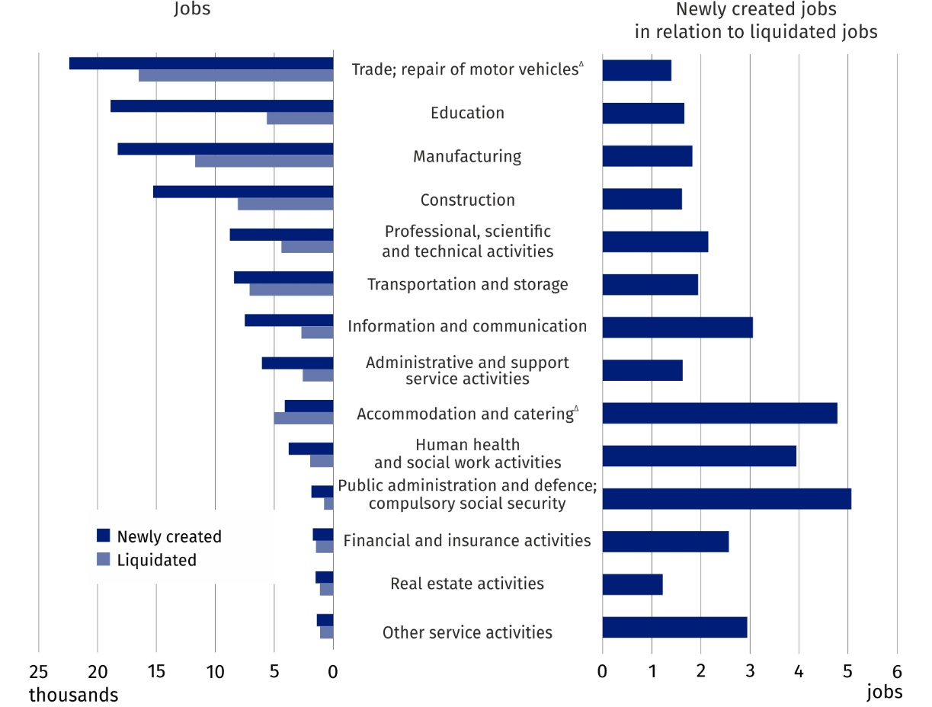
Chart 4. Newly created and liquidated jobs by selected PKD/NACE sections in the third
quarter of 2022
In this news release abbreviated names of NACE, Rev. 2 sections were used. Abbreviations are marked with a ‘Δ’ symbol. Full names are available on the Eurostat website at: https://ec.europa.eu/eurostat/data/classifications
Relative numbers (rates, percentages) were calculated on the basis of absolute data expressed with greater accuracy than given in the publication.
In the case of quoting Statistics Poland data, please provide information: ‘Source of data: Statistics Poland’, and in the case of publishing calculations made on data published by Sta-tistics Poland, please provide information: ‘Own elaboration based on Statistics Poland data.’

Prepared by:  Statistical Office in Bydgoszcz  Director Wiesława Gierańczyk, Ph.D.  Phone: (+48 52) 366 93 90 | Issued by:  The Spokesperson for the President  of Statistics Poland  Karolina Banaszek  Phone: (+48) 695 255 011
Press Office  Phone: (+48 22) 608 38 04  e-mail: obslugaprasowa@stat.gov.pl |   stat.gov.pl/en/

@StatPoland

@GlownyUrzadStatystyczny

gus_stat

glownyurzadstatystycznygus

glownyurzadstatystyczny
Related information
The demand for labour in 2021 – annual publication
The demand for labour in the second quarter of 2022 — news release
The impact of the COVID-19 epidemic on selected elements of the labour market in Poland in the second quarter of 2022 – news release
Other publications that contain the results of these surveys: stat.gov.pl → Topics → Labour market
Methodological report. The demand for labour
Data available in databases
Knowledge Databases – Labour market
Strateg → Statistics by theme → Labour market
Local Data Bank → Labour market
Statistics for the SDGs – global indicators
Terms used in official statistics
Demand for labour
Vacancies
Newly created jobs
Liquidated jobs

Classification of Occupations and Specialisations (KZiS) – introduced by the Regulation of the Minister of Labour and Social Policy of 7 August 2014 on the classification of occupations and specialisations for the needs of the labour market and the scope of its applications (Journal of Laws (Dz. U.) item 1145 as amended).

