The demand for labour in the first quarter of 2022
15.5%
Increase in the number
of job vacancies compared with the end of the fourth quarter of 2021
At the end of the first quarter of 2022, there were 158.7 thousand job vacancies in Poland, 44.0% more than
in the corresponding period of the previous year.
Over the year, the number of newly created jobs decreased slightly (by 1.0%). On the other hand,
the number of jobs liquidated during the quarter increased (by 16.6%). In the first quarter of 2022,
there were 2.3 newly created jobs per liquidated job.

The Labour Demand Survey is conducted using the representative method on a quarterly basis, on the Z–05 reporting form. It covers national economy entities employing at least one person. The results of the survey show that at the end of the first quarter of 2022, private sector entities constituted the vast majority, i.e. 91.1%, of the total number of entities.
In terms of entity size expressed by the number of employed persons, the most numerous were entities with up to 9 employed persons (69.4% of the total number of entities).
In the first quarter of 2022, 6.7% out of 662.7 thousand national economy entities had job
vacancies (1.2 percentage points more than in the corresponding period of 2021). Among
entities that had job vacancies, 87.6% were private sector entities. A little more than half
of the job vacancies — 56.7% — were in small entities (with up to 9 employed persons).
Table 1. Basic results of the Labour Demand Survey
QUARTERS  A – corresponding quarter of the previous year = 100  B – previous quarter = 100 | Jobs |  |  |  | Newly created jobs | Liquidated jobs
 | grand  total | occupied | vacant |  | Newly created jobs | Liquidated jobs
 | grand  total | occupied | total | including newly created | Newly created jobs | Liquidated jobs
 | at the end of the quarter |  |  |  | during the quarter
 | in thousands
2021
Quarter 1 | 12 297.1 | 12 186.9 | 110.2 | 24.0 | 191.7 | 70.2
Quarter 2 | 12 332.6 | 12 189.8 | 142.8 | 35.0 | 145.8 | 58.5
Quarter 3 | 12 325.9 | 12 172.4 | 153.5 | 35.7 | 132.6 | 57.8
Quarter 4 | 12 286.8 | 12 149.4 | 137.4 | 32.3 | 112.5 | 64.9
2022
Quarter 1 | 12 684.6 | 12 525.9 | 158.7 | 30.9 | 189.7 | 81.9
A | 103.2 | 102.8 | 144.0 | 128.7 | 99.0 | 116.6
B | 103.2 | 103.1 | 115.5 | 95.6 | 168.6 | 126.2
In Poland, in the first quarter of 2022, increases in the numbers of occupied jobs and job
vacancies took place on a year-over-year basis and compared with the previous quarter.
The number of job vacancies was the highest since the second quarter of 2018.
Compared with the first quarter of 2021, there was a slight decrease in the number of new jobs created during the quarter and an increase in the number of liquidated jobs (in both cases there were increases compared with the previous quarter).

Table 2. Selected indicators from the Labour Demand Survey
QUARTERS | Share of national economy entities with job vacancies | Job vacancy rate | The ratio of the number of newly created jobs to the number  of liquidated jobs (during the quarter)
QUARTERS | in % (at the end of the quarter)
2021
Quarter 1 | 5.5 | 0.90 | 2.7
Quarter 2 | 6.1 | 1.16 | 2.5
Quarter 3 | 6.7 | 1.25 | 2.3
Quarter 4 | 5.8 | 1.12 | 1.7
2022
Quarter 1 | 6.7 | 1.25 | 2.3

Occupied jobs and job vacancies at the end of the first quarter of 2022
The number of occupied jobs, measured by the number of employed persons, indicates
the so-called met demand for labour. In Poland, in the first quarter of 2022, there were
12 525.9 thousand occupied jobs, 2.8% more than a year ago and 3.1% more than in the previous quarter. The majority of occupied jobs, i.e. 59.3%, were in national economy entities with 50 or more employed persons. Almost three quarters of the total number of occupied jobs were in private sector entities.
The Labour Demand Survey enables the analysis of data on job vacancies (the so-called
unmet demand for labour), i.e. positions or jobs unoccupied due to labour turnover or newly created ones that simultaneously meet the following three conditions:
- the positions and jobs were actually unoccupied on the survey day,
- the employer made efforts to find people willing to take up the job,
- if adequate candidates were found to occupy the vacancies, the employer would readily
take them on.
At the end of the first quarter of 2022, there were 158.7 thousand job vacancies. Compared with the corresponding quarter of 2021, this number increased by 44.0%, and compared with the fourth quarter of 2021, it increased by 15.5%. The number of job vacancies was the highest since the second quarter of 2018 (then it amounted to 164.7 thousand).
The number of job vacancies at the end of the first quarter of 2022 was greater than in the corresponding period of the previous year and than in the previous quarter
Almost one fifth of job vacancies were newly created. The number of vacant newly created jobs increased on a year-over-year basis by 28.7%, and decreased by 4.4% on a quarterly basis. Employees were sought, among other things, through labour offices to which as at the end of the first quarter of 2022, 20.6 thousand job vacancies were reported.
One of the measures for assessing the situation on the labour market is the job vacancy rate, which is the share of job vacancies in the sum of the number of occupied posts
and the number of job vacancies in a given period. At the end of the first quarter of 2022, this rate amounted to 1.25%. It was 0.35 percentage points higher compared with the corresponding period of 2021 and 0.13 percentage points higher compared with the fourth quarter
of 2021.

Chart 1. Job vacancy rate
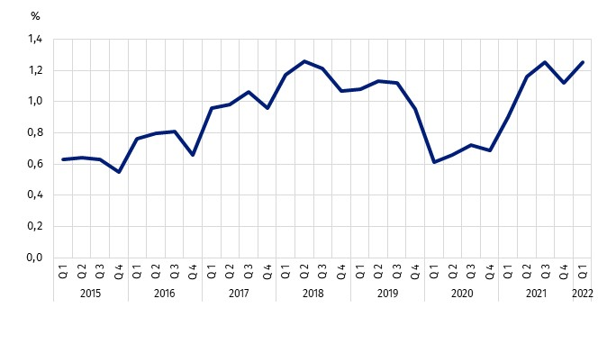
As at the end of the quarter
When looking at the job vacancy rate in the first quarter of 2022 in a territorial breakdown by region, it can be seen that its highest value was recorded in the Warszawski stołeczny
region (1.84%), where the number of job vacancies increased on a year-over-year basis
by 87.6% (to 39.8 thousand job vacancies). High values of the rate were also recorded
in the Zachodniopomorskie (1.71%) and Opolskie (1.56%) regions. The job vacancy rate was the lowest in the Podkarpackie region (0.62%), where the number of job vacancies increased to 3.4 thousand compared with the first quarter of 2021.
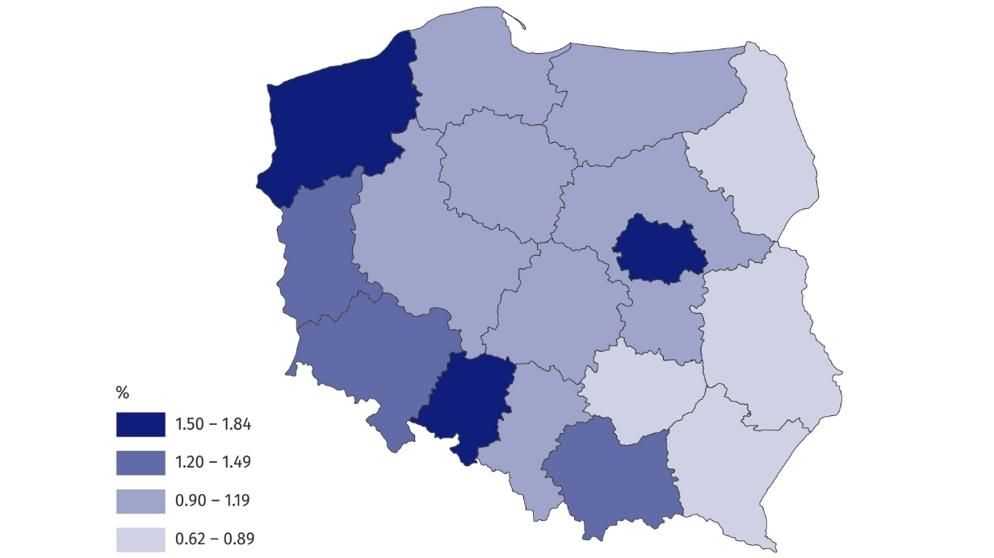
Map 1. The job vacancy rate by regions (NUTS 2 level) in the first quarter of 2022
As at the end of the quarter
The highest job vacancy rate at the end of the first quarter of 2022 was in the Warszawski stołeczny region
When analysing data by kind of conducted activity it can be noticed that at the end
of the first quarter of 2022, the most jobs (22.8% of occupied jobs and 19.4% of job
vacancies) were in entities conducting economic activities in the scope of Manufacturing: 2 854.0 thousand and 30.7 thousand, respectively. Compared with the corresponding quarter of 2021, the number of jobs increased by 3.4% in the case of occupied jobs, and by 22.5%
in the case of job vacancies. In the Manufacturing section, 5.5 thousand vacant newly created jobs were recorded.
In the first quarter of 2022, the most jobs (occupied and vacant) were recorded in the Manufacturing section
At the end of the first quarter of 2022, also the Trade; repair of motor vehicles∆ section had
a significant share in the structure of jobs. Occupied jobs in this section accounted for 17.5% (2 190.2 thousand), while job vacancies — 14.2% (22.5 thousand).
Among the remaining PKD/NACE sections, less significant in the structure of jobs, the largest annual increase (by 8.5%) in the number of occupied jobs was recorded in the Education section. At the end of the first quarter of 2022, in this section, there were 1 367.0 thousand occupied jobs, which accounted for 10.9% of the total number.
At the end of the first quarter of the current year, the highest job vacancy rate was
in the Information and communication section
On the other hand, the largest increase (2.8-fold) in the number of job vacancies compared with the first quarter of 2021 was recorded in the Professional, scientific and technical activities section (up to 10.5 thousand jobs, i.e. 6.6% of total job vacancies). The number of job
vacancies in the Accommodation and catering∆ section increased more than 2.5 times on
a year-over-year basis. However, the share of this section in the structure was insignificant (3.9%).
As at the end of the first quarter of 2021, also at the end of the first quarter of the current year, the highest job vacancy rate was recorded in the Information and communication
section (3.99%, compared with 2.81% in 2021).
Chart 2. Job vacancies and the job vacancy rate by selected PKD/NACE section in the first
quarter of 2022
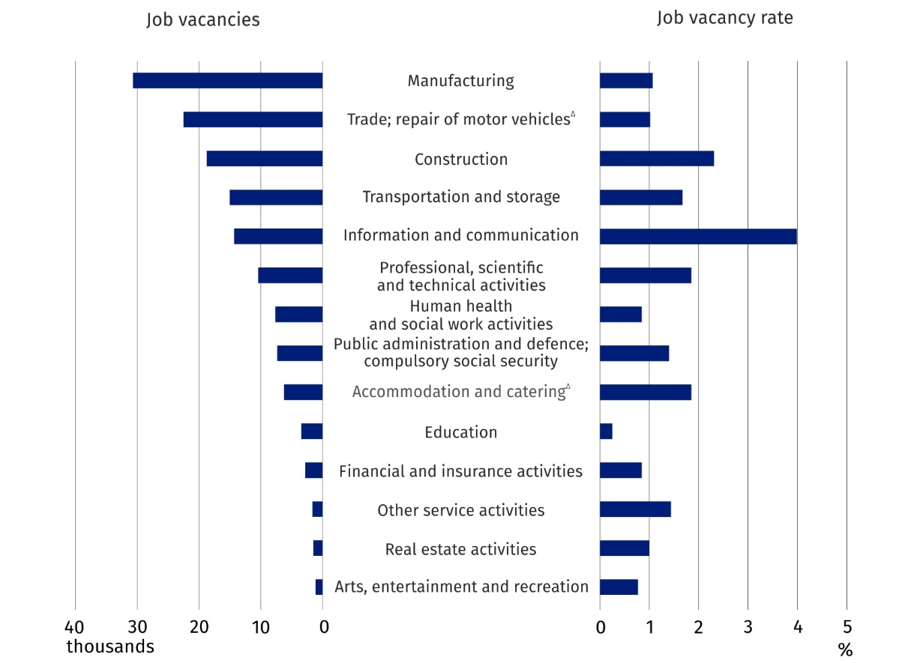
As at the end of the quarter
The analysis of the results of the Labour Demand Survey for the first quarter of 2022 broken down by major occupational group shows that the most jobs were in the major occupational group of Professionals. Professionals accounted for 23.1% of occupied jobs (2 888.3 thousand jobs). At the end of the first quarter of 2022, the number of job vacancies in this group was 39.4 thousand, i.e. 24.8% of their total number. On a year-over-year basis, the number of job vacancies in the said occupational group increased by 43.5%. The job vacancy rate in this group was 1.34%.
Significant numbers of occupied jobs (1 799.6 thousand, i.e. 14.4% of the total number)
and job vacancies (31.9 thousand, i.e. 20.1%) were in the major occupational group of Craft and related trades workers. Compared with the corresponding period of the previous year an increase in the number of jobs took place in this occupational group – by 0.7% in the case of occupied jobs and by 24.1% in the case of job vacancies. In the major occupational group of Craft and related trades workers there were 1.74 job vacancies per 100 jobs (i.e. the most among all major occupational groups).
In the first quarter of 2022, jobs (occupied and vacant)
occurred mainly in occupations belonging to major
occupational groups of Professionals and Craft and related trades workers

When compared with the first quarter of 2021, in most major occupational groups the number of jobs increased. The largest increase in the number of occupied jobs was recorded
in the major occupational group of Professionals (by 7.8%), while the number of job vacancies increased the most in the occupational group of Services and sales workers (by 129.7%).

Newly created and liquidated jobs during the first quarter of 2022
In the first quarter of 2022, despite a decrease in the number of newly created jobs and an increase in the number of liquidated jobs on
a year-over-year basis, there was still a surplus of newly created jobs over liquidated jobs
The Labour Demand Survey also enables to analyse the situation on the labour market in terms of the number of newly created jobs (resulting from organisational changes, expansion or change in the business profile and all jobs in newly created units) and liquidated jobs (lost as a result of organisational changes, limiting or changing the business profile). During the first quarter of 2022, in Poland, 189.7 thousand jobs were created and 81.9 thousand jobs were liquidated. As a result of these changes, the number of jobs increased over the quarter by 107.9 thousand.
When compared with the corresponding period of the previous year, there was recorded
a decrease in the number of newly created jobs (by 1.0%) and an increase in the number of liquidated jobs (by 16.6%). When comparing the results of the current survey to those for the fourth quarter of 2021, there were noticeable increases of jobs: newly created — by 68.6%, and liquidated — by 26.2%.
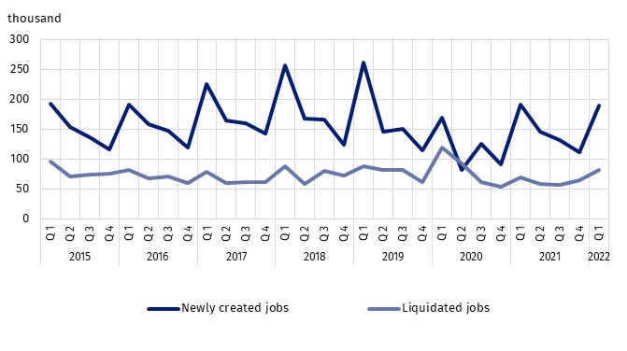
Chart 3. Newly created and liquidated jobs
One of the measures for assessing the labour market's adjustment to the labour demand is the ratio of the number of newly created jobs to the number of jobs liquidated in a given period. In the first quarter of 2022, 2.3 new jobs were created per job liquidated (2.7 jobs a year ago). In the fourth quarter of 2021, the ratio was much lower — there were 1.7 newly created jobs per liquidated job.

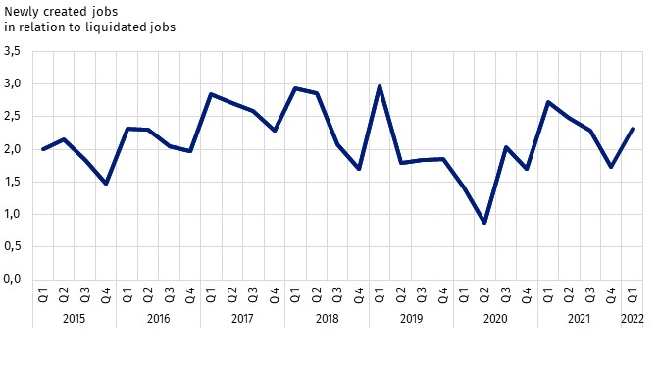
Chart 4. The ratio of the number of newly created jobs to the number of liquidated jobs
The distribution of jobs in the first quarter of 2022 in a territorial breakdown shows that the largest number of newly created jobs (3.4) per liquidated job were recorded in the Warszawski stołeczny region. In the Podlaskie and Śląskie regions, there were 2.8 newly created jobs per liquidated job. On the other hand, the lowest ratio — 1.2 newly created jobs per liquidated job — occurred in the Lubelskie region.
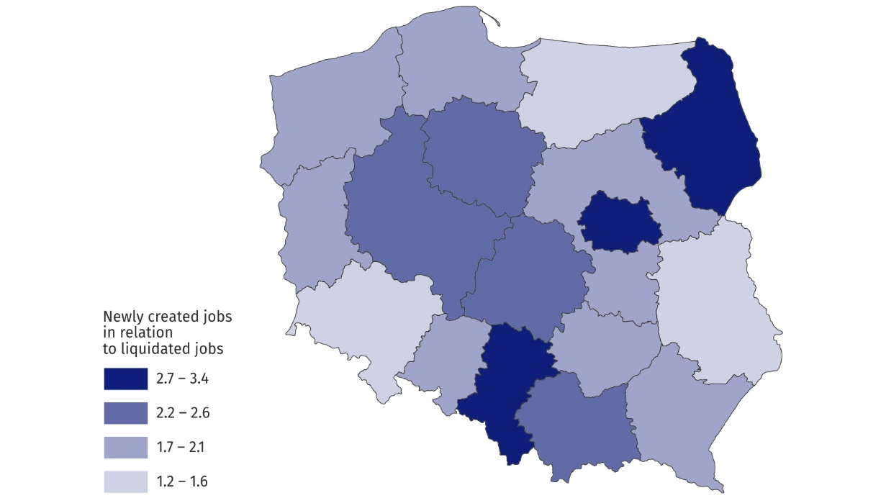
Map 2. The ratio of the number of newly created jobs to the number of liquidated jobs
by regions (NUTS 2 level) in the first quarter of 2022
In the first quarter of 2022, the largest number of newly created jobs per liquidated job were recorded in the Warszawski stołeczny region
In the analysed period, there were also visible differences in the indicator in terms
of PKD/NACE sections. In the first quarter of 2022, the largest number of new jobs were created in entities from the Trade; repair of motor vehicles∆ section (33.4 thousand, i.e. 6.3% fewer than in the first quarter of 2021). In the same period, 17.3 thousand jobs were liquidated in this section (a year-over-year increase of 28.8%). There were 1.9 newly created jobs per liquidated job in this section (compared with 2.7 jobs in the first quarter of 2021).
In the analysed quarter
of 2022, the largest number
of new jobs were created
in the Trade; repair of motor vehicles∆ section, whereas
the largest number of jobs were liquidated in the Construction section
In the analysed quarter of the current year, the largest number of jobs were liquidated
in the Construction section (17.6 thousand), in which at the same time 21.4 thousand new jobs were created. As a result of these movements, 1.2 new jobs were created per liquidated job in the first quarter of 2022 (in the corresponding quarter of 2021 there were 2.8 jobs).
The Manufacturing section had a significant share in the structure of jobs. Newly created jobs in the first quarter of 2022 accounted for 16.0% of the total number, whereas liquidated jobs — 15.9% (30.4 thousand and 13.0 thousand jobs, respectively). There were 2.3 newly created jobs per liquidated job.
In the first quarter of 2022, the largest number of newly created jobs per liquidated job was in the Information and communication section
In the first quarter of 2022, the largest number of newly created jobs (5.7) per liquidated job were recorded in the Information and communication section.
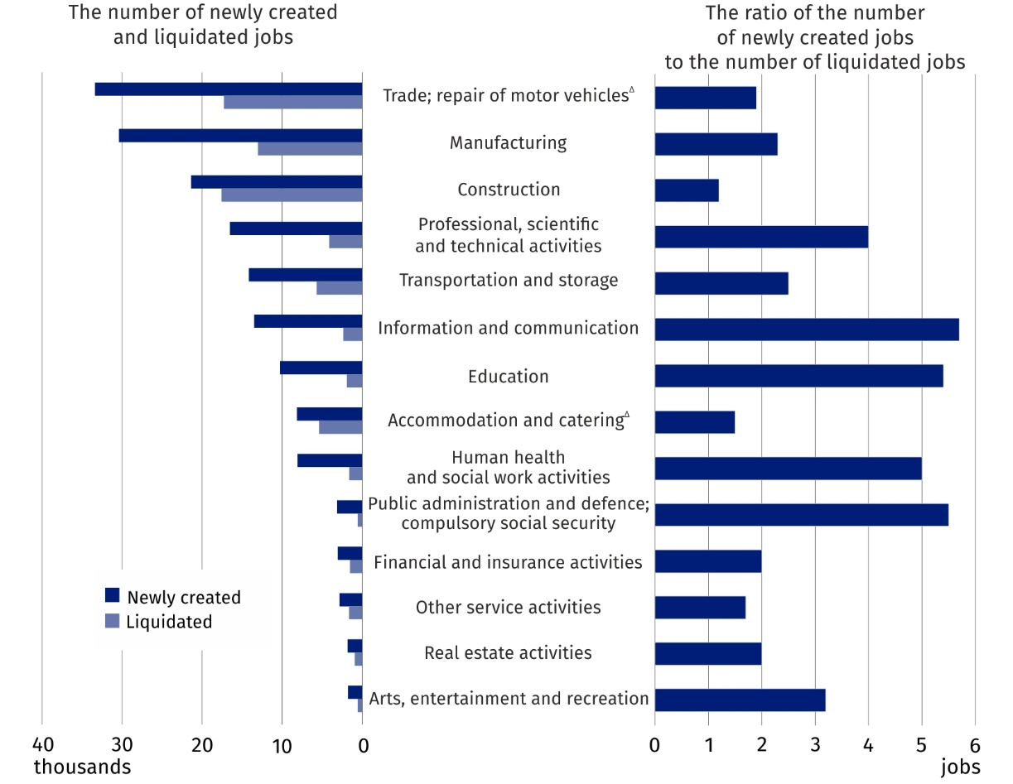
Chart 5. Newly created and liquidated jobs in selected PKD/NACE sections
in the first quarter of 2022

In this news release abbreviated names of NACE, Rev. 2 sections were used. Abbreviations are marked with a ‘Δ’ symbol. Full names are available on the Eurostat website at: https://ec.europa.eu/eurostat/data/classifications
Relative numbers (rates, percentages) were calculated on the basis of absolute data expressed with greater accuracy than given in the study.

In the case of quoting Statistics Poland data, please provide information: ‘Source of data: Statistics Poland’, and in the case of publishing calculations made on data published by Statistics Poland, please provide information: ‘Own elaboration based on Statistics Poland data.’

Prepared by:  Statistical Office in Bydgoszcz  Director Wiesława Gierańczyk, Ph.D.  Phone: (+48 22) 366 93 90 | Issued by:  The Spokesperson for the President  of Statistics Poland  Karolina Banaszek  Phone: (+48) 695 255 011
Press Office  Phone: (+48 22) 608 38 04  e-mail: obslugaprasowa@stat.gov.pl |   stat.gov.pl/en/

@StatPoland

@GlownyUrzadStatystyczny

gus_stat

glownyurzadstatystycznygus

glownyurzadstatystyczny
Related information
The demand for labour in 2020 – annual publication
The demand for labour in the fourth quarter of 2021
The impact of the COVID-19 epidemic on selected elements of the labour market in Poland in the fourth quarter of 2021
Other publications that contain the results of these surveys: stat.gov.pl → Topics → Labour market
Methodological report. The demand for labour
Data available in databases
Knowledge databases – Labour market
Strateg → Themes → Labour market
Local Data Bank → Labour market
Statistics for the SDGs – global indicators
Terms used in official statistics
Demand for labour
Vacancies
Newly created jobs
Liquidated jobs

Classification of Occupations and Specialisations (KZiS) – introduced by the Regulation of the Minister of Labour and Social Policy of 7 August 2014 on the classification of occupations and specialisations for the needs of the labour market and the scope of its applications (Journal of Laws (Dz. U.) item 1145 as amended).

