Financial results of non-financial enterprises in 2021
In 2021 financial results of the surveyed non-financial enterprises were higher than those obtained a year earlier. Also, the economic and financial indicators have significantly improved. Investment outlays were higher by 7.3% than those recorded in 2020 (when there was a decrease by 7.3%).
23.5%
Increase in total revenues y/y

Total revenues were higher by 23.5% comparing to the previous year and total costs of obtaining the revenues increased by 20.6%. The cost level indicator improved from 95.6% in the previous year to 93.3%. Net revenues from sale of products, goods and materials increased by 23.3% and the costs of obtaining them increased by 22.0%.
The financial result from the sale of products, goods and materials amounted to 221.5 bn PLN and was by 48.6% higher than in 2020. The financial result from other operating activity amounted to 32.4 bn PLN and was higher by 22.9 bn PLN over the previous year. There was an improvement observed in the result on financial activities (11.1 bn PLN compared to minus 16.0 bn PLN in 2020).
In 2021 net financial result of non-financial enterprises was 91.4% higher than the year before
Gross financial result amounted to 265.0 bn PLN compared to 142.5 bn PLN a year ago and its obligatory encumbrances amounted to 42.5 bn PLN (compared to 26.3 bn PLN a year ago). Net financial result amounted to 222.5 bn PLN and was by 91.4% higher than the year before. Net profit amounted to 247.8 bn PLN and was higher by 90.2 bn PLN than in 2020 while net loss was 25.3 bn PLN and decreased by 16.1 bn PLN over the year. Net profit was recorded by 84.4% of all enterprises (compared to 80.4% a year ago) and the revenues obtained by them constituted 91.8% of total revenues of the surveyed enterprises (compared to 80.0% the year before). In manufacturing, net profit was recorded by 85.5% of all enterprises (it was 83.3% a year ago) and the share of the total revenues generated by these enterprises in the total revenues of all enterprises in this section was 91.1% (compared to 75.9% a year ago).
Chart 1. Profitability indicators from 2002 to 2021
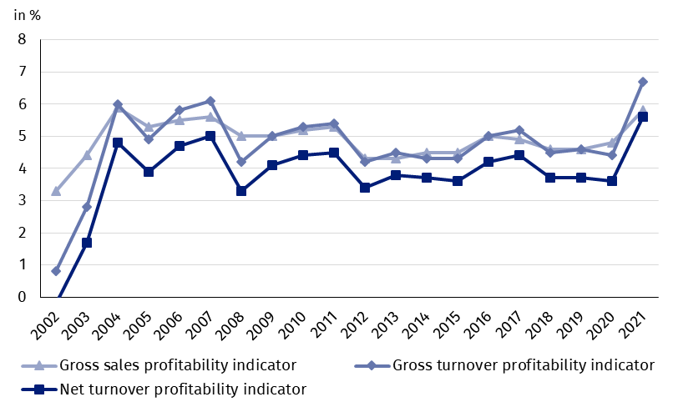

Table 1. Basic financial data of surveyed enterprises
SPECIFICATION | Jan.-Dec. 2020 | Jan.-Dec. 2021 | Jan.-Dec. 2020  = 100
SPECIFICATION | in million PLN |  | Jan.-Dec. 2020  = 100
Total revenues | 3 206 898.4 | 3 960 652.7 | 123.5
of which net revenues from sale  of products, goods and materials | 3 107 607.7 | 3 832 281.4 | 123.3
Total costs | 3 064 359.9 | 3 695 681.8 | 120.6
of which cost of products,  goods and materials sold | 2 958 560.5 | 3 610 823.8 | 122.0
Financial result from the sale of products,  goods and materials | 149 047.2 | 221 457.6 | 148.6
Financial result from other  operating activity | 9 533.6 | 32 419.3 | 340.1
Result on financial activity | -16 042.4 | 11 094.0 | x
Gross financial result | 142 538.4 | 264 970.9 | 185.9
Net financial result | 116 250.0 | 222 463.3 | 191.4
Net profit | 157 625.4 | 247 798.9 | 157.2
Net loss | 41 375.4 | 25 335.6 | 61.2
 | %
Cost level indicator | 95.6 | 93.3 | x
Gross sales profitability indicator | 4.8 | 5.8 | x
Gross turnover profitability indicator | 4.4 | 6.7 | x
Net turnover profitability indicator | 3.6 | 5.6 | x
First degree financial liquidity indicator | 43.9 | 44.1 | x
Second degree financial liquidity indicator | 103.4 | 107.6 | x
Cost level indicator for all enterprises was 93.3% (compared to 95.6% a year ago). Gross sales profitability indicator increased from 4.8% to 5.8% and gross turnover profitability indicator increased from 4.4% to 6.7% as well as net turnover profitability indicator - from 3.6% to 5.6%.
In 2021 an increase in net turnover profitability indicator was recorded in majority of sections

The most significant increase in net turnover profitability indicator was recorded i.a. in mining and quarrying (from minus 5.5% to 7.7%), accommodation and catering (from minus 7.7% to 5.3%), information and communication (from 9.1% to 15.2%), other service activities (from minus 1.3% to 4.4%), administrative and support service activities (from 3.9% to 7.7%), construction (from 4.6% to 7.8%), transportation and storage (from 1.5% to 4.1%), professional, scientific and technical activities (from 6.9% to 9.1%), water supply; sewerage, waste management and remediation activities (from 7.1% to 8.9%) as well as manufacturing (from 4.1% to 5.8%). A decrease in net turnover profitability indicator was recorded in real estate activities (from 6.2% to 5.5%).
First degree financial liquidity indicator was 44.1% (compared to 43.9% a year ago) and second degree financial liquidity indicator was 107.6% (compared to 103.4% in the previous year). First degree financial liquidity indicator at the level over 20% was achieved by 58.4% of the surveyed enterprises (compared to 62.6% a year ago). Second degree financial liquidity indicator, which ranged from 100% to 130%, was recorded by 12.5% of the surveyed enterprises (compared to 11.9% a year ago).

Chart 2. Net turnover profitability indicator
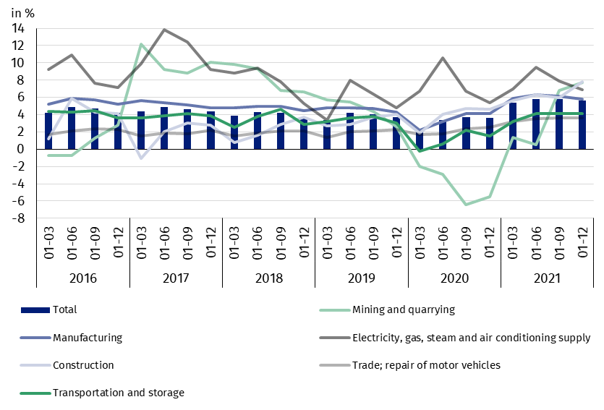

In the structure of total costs, there was an increase in the share of consumption of materials (by 3.2 pp.). There was a decrease in the share of wages and salaries (by 1.4 pp.), depreciation (by 0.8 pp.), external services (by 0.6 pp.), social insurances and other benefits (by 0.3 pp.) as well as taxes and fees (by 0.1 pp.). The share of comsumption of energy as well as other costs by kind remained unchanged.

Chart 3. Structure of costs by type in 2021

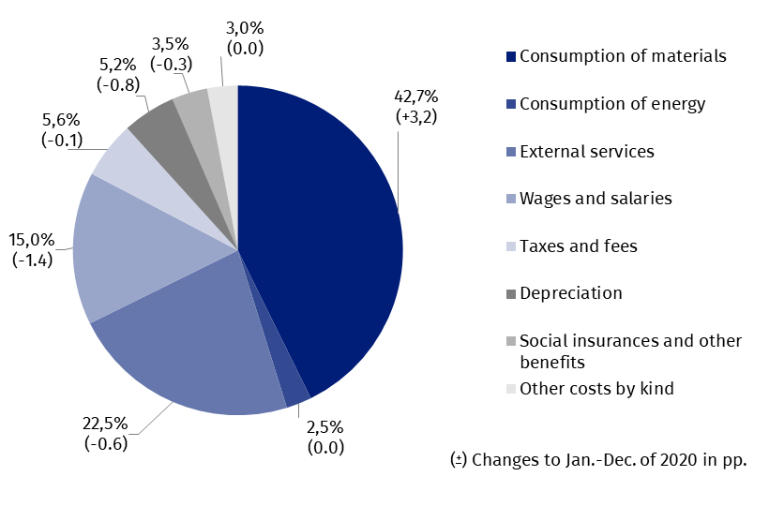

53.6% of the surveyed enterprises reported net revenues from sale of products, goods and materials for export in 2021 (compared to 54.0% in the previous year). The revenues from export sales were by 25.1% higher than a year earlier. The share of export in total sales revenues for all surveyed enterprises increased from 24.9% to 25.2%. The share of 86.9% of the exporting enterprises reported net profit (compared to 83.2% in the previous year). There was an improvement of basic economic and financial relations among the exporting enterprises and these relations were better than for total surveyed enterprises.
There was an increase in investment outlays of the surveyed enterprises by 7.3% compared to 2020
In 2021 investment outlays of the surveyed enterprises amounted to 167.0 bn PLN and were (in constant prices) by 7.3% higher than in 2020 when a decrease by 7.3% was recorded. Expenditures on buildings and structures increased by 6.2% (after a drop of 8.4% a year earlier), on purchases increased by 7.8% (in comparison to the decrease in the previous year – 6.3%). The share of purchases in investment outlays increased from 60.8% a year earlier to 61.2% this year.
The increase in investment outlays (in current prices) was recorded among others for trade; repair of motor vehicles (by 29.0% compared to the decrease by 15.9% in the previous year), transportation and storage (by 26.5% compared to the increase by 4.1% in the previous year), administrative and support service activities (by 24.7% compared to the decrease by 0.1% the year before), information and communication (by 14.3% compared to the decrease by 8.9% in the last year), water supply; sewerage, waste management and remediation activities (by 14.0% compared to the decrease by 2.8% a year earlier), construction (by 9.6% compared to the decrease by 2.4% the year before), manufacturing (by 8.4% compared to the decrease by 7.5% year earlier). The decrease in investment outlays was recorded among others for real estate activities (by 27.8% compared to the increase by 78.9% in the previous year), mining and quarrying (by 7.8% compared to the decrease of 16.0% a year earlier), electricity, gas, steam and air condition-ing supply (by 4.2% compared to the decrease of 10.9% in the previous year).
Chart 4. Dynamics of investment outlays - increase/decrease compared to the corresponding period of the previous year
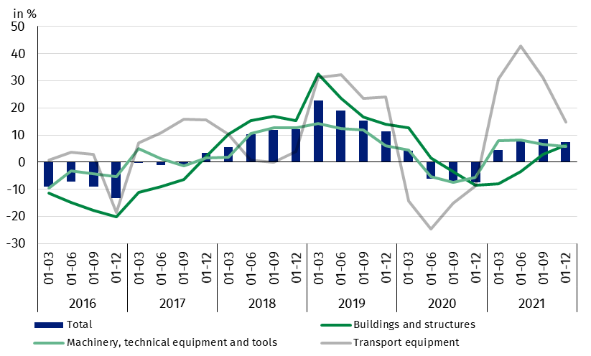

The data refer to 17 611 non-financial enterprises (legal entities) with 50 and more persons employed keeping accounting ledgers. The data do not include agriculture, forestry, hunting and fishing (section A according to NACE rev. 2); financial and insurance activities (section K according to NACE rev. 2); higher education institutions; independent public health care facilities; cultural institutions with legal personality; trade unions, religious and political organisations.
In the case of quoting Statistics Poland data, please provide information: “Source of data: Statistics Poland” and in the case of publishing calculations made on data published by Statistics Poland, please include the following disclaimer: “Own study based on figures from Statistics Poland”.

Prepared by:  Enterprise Department  Director Katarzyna Walkowska  Phone: (+48 22) 608 31 25 | Issued by:  The Spokesperson for the President  of Statistics Poland  Karolina Banaszek  Phone: (+48) 695 255 011
Press Office  Phone: (+48 22) 608 38 04  e-mail: obslugaprasowa@stat.gov.pl |   www.stat.gov.pl/en/

@StatPoland

@GlownyUrzadStatystyczny

gus_stat

glownyurzadstatystycznygus

glownyurzadstatystyczny
Related information
Statistical Bulletin
Information on the socio-economic situation of the country
News releases. Financial results of non-financial enterprises
Methodological report. Non-financial enterprises surveys
Data available in databases
Local Data Bank
Knowledge Database Non-financial Enterprises
Macroeconomic Data Bank
Terms used inn official statistics
Total revenues
Total costs
Gross financial result
Net financial result
Cost level indicator
Gross turnover profitability indicator
Net turnover profitability indicator
First degree financial liquidity indicator
Second degree financial liquidity indicator
Investment outlays

