Index numbers of sold production of industry in December 2021^{a)}

In December 2021, sold production of industry was by 16.7% higher than in December 2020, when an increase was recorded by 11.1%, whereas in comparison with November 2021, it decreased by 2.9%. In the period January-December of 2021, sold production of industry was by 14.9% higher than in the corresponding period of 2020, which saw a decrease by 1.0%.
16.7%
Increase in sold production of industry as compared to December 2020

After seasonal adjustment, an increase in sold industrial production in December 2021 amounted to 13.7% per year

After eliminating the seasonal factors, in December 2021 sold production of industry reached the level higher by 13.7% than in the corresponding month of 2020 and by 0.2% lower as compared to November 2021.
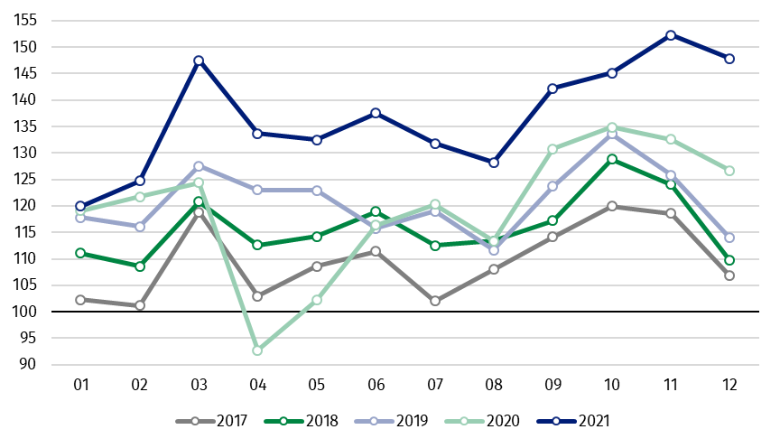
Chart 1. Sold production of industry (average monthly level in 2015=100)

In December 2021, an increase of production, as compared to previous year, was recorded in all main industrial groupings. The highest growth was observed in production of energy – by 39.4%. The lower increase was observed in production of intermediate goods – by 17.6%, capital goods – by 12.6%, non-durable consumer goods – by 7.7% and durable consumer goods – by 7.2%.

^{a)} Reported data; comprise enterprises with 10 or more persons employed.
Table 1. Index numbers of sold production of industry (constant prices)
SPECIFICATION | 12 2021 |  |  | 01-12 2021^{a)}
SPECIFICATION | 11 2021=100 | 12 2020=100 | monthly average  of 2015=100 | 01-12 2020=100
INDUSTRY | 97.1 | 116.7 | 147.8 | 114.9
Mining and quarrying | 97.9 | 99.1 | 92.6 | 102.8
Manufacturing | 94.8 | 113.9 | 145.3 | 114.2
Electricity, gas, steam and air  conditioning supply | 117.0 | 154.2 | 198.8 | 129.5
Water supply; sewerage waste  management and remediation  activities | 104.0 | 109.6 | 154.9 | 110.7

^{a)} Data including final information on production and prices in November and reported data – in December.
Share of production value of industry divisions, which saw an increase in comparison to December 2020, stood at 98.3%

According to the preliminary data, in December 2021, as compared to December 2020, an increase in sold production (in constant prices) was reported in 30 (out of 34) industry divisions, among others, in manufacture of basic metals – by 42.7%, manufacture of chemicals and chemical products – by 33.8%, manufacture of beverages – by 22.1%, in repair and installation of machinery and equipment – by 23.3%, in manufacture of paper and paper products – by 21.7%, manufacture of metal products – by 18.5%, manufacture of other non-metallic mineral products – by 17.0%.
A decrease in sold production of industry, as compared to December 2020, was recorded in 4 divisions, including manufacture of wearing apparel – by 9.7%.

Chart 2. Index numbers of sold production of industry by selected NACE divisions (constant prices;
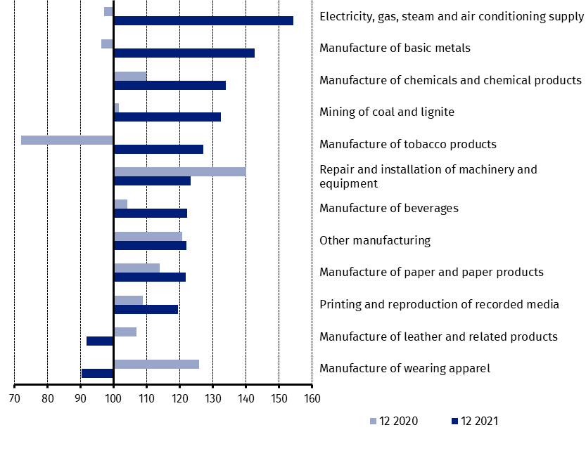
previous year =100)

As compared to November 2021, a decrease in sold production (in constant prices) in December 2021 was recorded in 20 industry divisions, among others, in manufacture of computer, electronic and optical products – by 14.5%, manufacture of products of wood, cork, straw and wicker – by 14.4%, manufacture of rubber and plastic products – by 13.9%, manufacture of motor vehicles, trailers and semi-trailers – by 13.0%, manufacture of other non-metallic mineral products – by 11.2%, manufacture of basic metals – by 10.1%, manufacture of metal products – by 8.8%.
An increase in sold production of industry, as compared to November 2021, was recorded in 13 divisions, among others, in repair and installation of machinery and equipment – by 51.3%, in mining of coal and lignite – by 19.6%, in electricity, gas, steam and air conditioning supply – by 17.0%, in manufacture of other transport equipment – by 13.5%, in manufacture of machinery and equipment – by 9.4%,

Chart 3. Index numbers of sold production of industry by selected NACE divisions (constant prices;
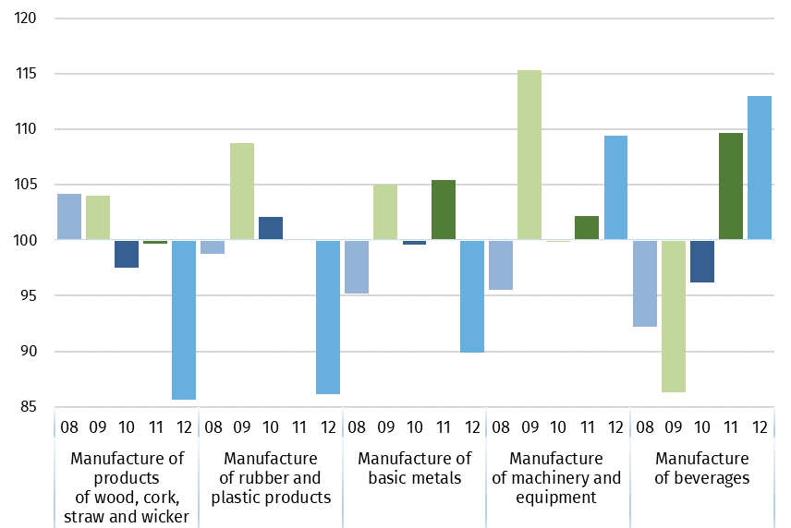
previous month =100)

In case of quoting Statistics Poland data, please provide information: “Source of data: Statistics Poland”, and in case of publishing calculations made on data published by Statistics Poland, please include the following disclaimer: “Own study based on figures from Statistics Poland”.

Prepared by:  Enterprises Department  Director Katarzyna Walkowska  Office: tel. (+48 22) 608 31 25 | Issued by:  The Spokesperson for the President of Statistics Poland  Karolina Banaszek  Mobile: (+48) 695 255 011

Press Office  Office: tel. (+48 22) 608 34 91, 608 38 04  e-mail: obslugaprasowa@stat.gov.pl |  | www.stat.gov.pl/en/
 |  | @StatPoland
 |  | @GlownyUrzadStatystyczny

Related information
Statistical Bulletin
Socio-economic situation of the country

Data available in databases
Knowledge Database - Industrial Production
Macroeconomic Data Bank
Macroeconomic indicators
Local Data Bank

Terms used in official statistics
Sold production of industry
Seasonally un-adjustedindex of sold production of industry
Seasonally adjustedindex of sold production of industry
Production of capital goods
Production of non-durable consumer goods
Production of durable consumer goods
Production of intermediate goods
Production of goods related to energy

