Prices of agricultural products in November 2022
Procurement prices of basic agricultural products increased in November 2022 in comparison with the previous month (by 1.8%) as well as while compared to the corresponding month of the previous year (by 51.7%).
51.7%
an increase in procurement prices of basic agricultural products in comparison with November 2021

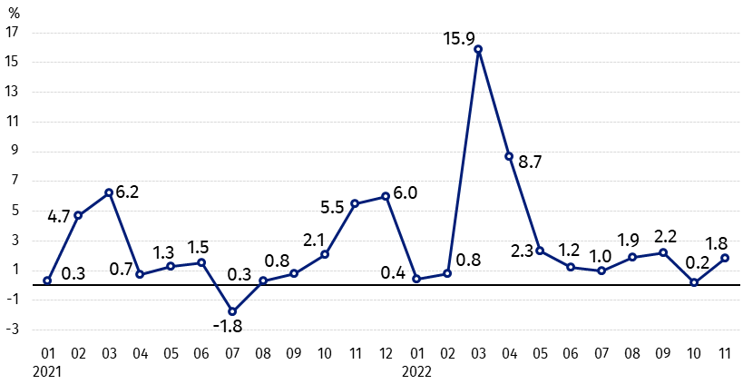
Chart 1. Changes in procurement prices of basic agricultural products in relation to the previous month
In November 2022 in comparison with October 2022 the procurement prices of poultry and cows’ milk increased

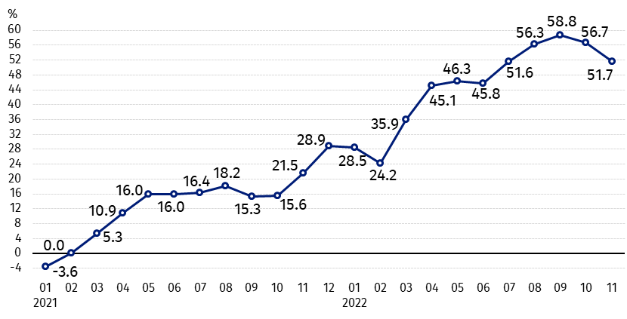
Chart 2. Changes in procurement prices of basic agricultural products in relation to the corresponding month of the previous year
Procurement prices of all basic agricultural products in November 2022 were much higher than a year ago

Procurement prices and marketplace prices received by farmers
In November 2022 compared to the previous month procurement prices of most agricultural products increased. The prices of wheat, rye, triticale and pigs for slaughter decreased. Only cattle for slaughter were sold on the marketplaces at prices lower than in October this year, which were also slightly cheaper in procurement.
Prices of all agricultural products, in procurement as well as on marketplaces, were much higher than a year ago. The prices of potatoes and pigs for slaughter in procurement and oats on both markets increased the most.

Table 1. Prices of agricultural products (excluding VAT) in November 2022
Specification | Procurement prices |  |  | Marketplaces prices
Specification | 11 2022
Specification | in zloty | 10 2022=100 | 11 2021=100 | in zloty | 10 2022=100 | 11 2021=100
Cereal grain – per 1 dt
Wheat | 153.18 | 98.8 | 127.9 | 172.16 | 100.2 | 149.3
Rye | 123.93 | 92.7 | 126.6 | 139.14 | 100.1 | 158.3
Barley | 137.51 | 101.1 | 142.4 | 158.56 | 100.8 | 156.1
Triticale | 141.04 | 99.7 | 139.5 | 152.84 | 100.3 | 157.9
Oat | 137.72 | 107.2 | 163.1 | 139.47 | 100.9 | 164.2
Maize | 108.00 | 102.2 | 136.1 | 175.78 | 101.4 | 141.6
Potatoes– per 1 dt | 62.97 | 111.4 | 184.0 | 170.32 | 101.5 | 123.9
Animals for slaughter – per kg
Cattle (excl. calves) | 10.85 | 99.8 | 116.4 | 10.12 | 92.7 | 124.8
of which young cattle | 10.95 | 100.0 | 114.7 | 10.71 | 91.7 | 126.9
Pigs ª | 7.43 | 99.9 | 173.8 | . | . | .
Poultry | 6.60 | 101 .6 | 151.7 | . | . | .
Cows’ milk – per 1 hl | 270.46 | 103.9 | 155.8 | . | . | .
a – No data.
Data on procurement prices were calculated on the basis of information on value and quantity of procurement by legal persons and independent organizational entities without legal personality (without natural persons).
Indices of procurement prices and prices received by farmers on marketplaces were calculated on the basis of absolute data expressed with more precision than In the tables.

Prices of major agricultural products in November 2022
In November 2022 procurement price of wheat (153.18 PLN per dt) decreased as related to the previous month (by 1.2%) but it was higher than year ago (by 27.9%). On marketplaces, wheat (172.16 PLN per dt) was sold more expensive compared to October this year (by 0.2%) as well as to the corresponding period of the last year (by 49.3%).
Rye was paid (123.93 PLN per dt) less than in the previous month (by 7.3%), but more in comparison with November 2021 (by 26.6.%). Rye (139.14 PLN per dt) increased slightly on marketplaces in relation to October this year (by 0.1%), and as related to the corresponding month of the last year its price was much higher (by 58.3%).
In November 2022 there was an increase in the price of potatoes in procurement (62.97 PLN per dt) compared to the previous month (by 11.4%) and on an annual basis (by 84.0%), and also on marketplaces (170.32 per dt) – in comparison with October this year (by 1.5%) as well as with the corresponding month of the previous year (by 23.9%).
The procurement price of cattle for slaughter (10.85 PLN per kg) was slightly lower than in October this year (by 0.2%), but higher (by 16.4%) than recorded a year before. On marketplaces this livestock was sold for 10.12 PLN, i.e. by 7.3% cheaper than in the previous month but by 24.8% more expensive than a year ago.
In November 2022 the procurement price of pigs for slaughter (7.43 PLN per kg) remained at a level similar to that recorded of the month ago (minimal fall – by 0.1%), but it was much higher on an annual basis (by 73.8%).
The procurement price of poultry for slaughter (6.60 PLN per kg) increased in comparison with October this year (by 1.6%), as well as compared to November 2021 (by 51.7%).
270.46 PLN was paid in procurement per hl of cows’ milk, i.e. by 3.9% more than in the previous month and by 55.8% - than a year ago.

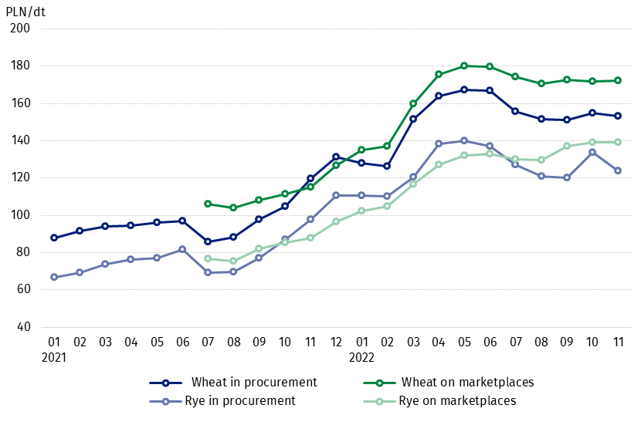
Chart 3. Procurement and marketplaces prices of wheat and rye

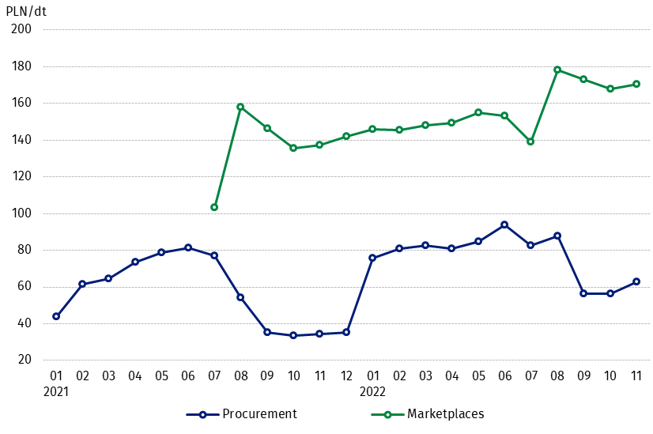
Chart 4. Procurement and marketplaces prices of potatoes

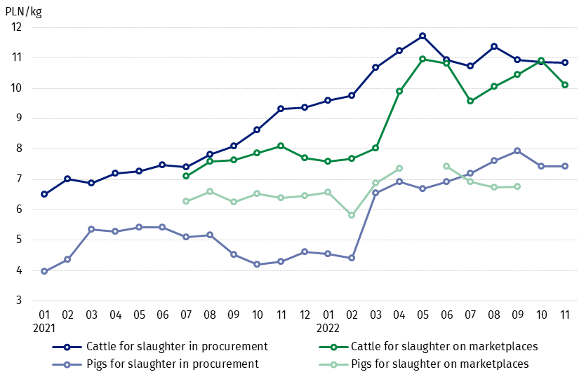
Chart 5. Procurement and marketplaces prices of cattle for slaughter and pigs for slaughter

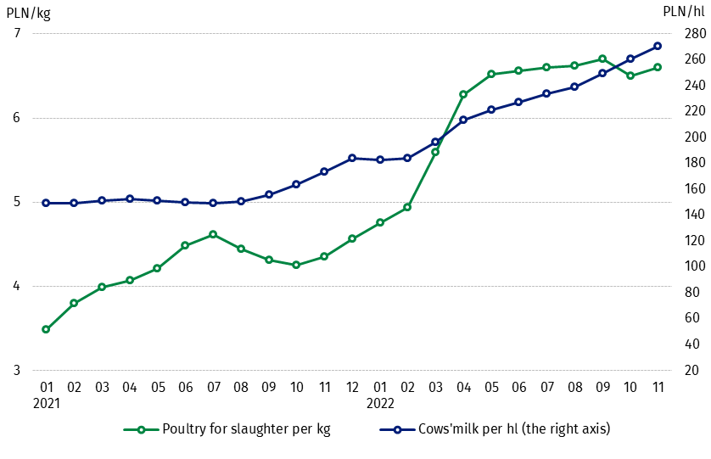
Chart 6. Procurement prices of poultry for slaughter and cows’ milk

The differentiation of the level of prices of basic agricultural products in particular voivodships is presented in Table 2 for procurement prices and in Table 3 for prices obtained by farmers on marketplaces (Excel sheet).
In case of quoting Statistics Poland data, please provide information: “Source of data: Statistics Poland”, and in case of publishing calculations made on data published by Statistics Poland, please include the following disclaimer: “Own study based on figures from Statistics Poland”.

Prepared by:  Trade and Services Departament  Director Ewa Adach-Stankiewicz  Phone: (+48 22) 608 31 24 | Issued by:  The Spokesperson for the President  of Statistics Poland  Karolina Banaszek  Phone: (+48) 695 255 011
Press Office  Phone: (+48 22) 608 38 04  e-mail: obslugaprasowa@stat.gov.pl |   www.stat.gov.pl/en/

@StatPoland

@GlownyUrzadStatystyczny

gus_stat

glownyurzadstatystycznygus

glownyurzadstatystyczny
Related information
Socio-economic situation of the country in 2022
Procurement and prices of agricultural products in 2021
Prices in the national economy in 2020

Data available in databases
BDL - Prices in agriculture (monthly and annual data)
DBW - Prices in agriculture (monthly and annual data)

Terms used in official statistics
Procurement of agricultural products
Procurement prices
Marketplace
Marketplace prices

Wheat, rye, cattle for slaughter, pigs for slaughter, poultry, cows’ milk
Procurement prices – excluding sowing seed.
Procurement prices – total (of which: edible early kinds, seeds, edible late, industrial, of which starch). Marketplaces prices – edible excluding early kinds.
Marketplaces prices – average weighted price of cattle for slaughter calculated with the adoption of the structure of procurement quantity of young cattle and cows for slaughter.

