Prices of agricultural products in October 2022
Procurement prices of basic agricultural products increased in October 2022 in comparison with the previous month (by 0.2%) as well as while compared to the corresponding month of the previous year (by 56.7%).
56.7%
an increase in procurement prices of basic agricultural products in comparison with October 2021

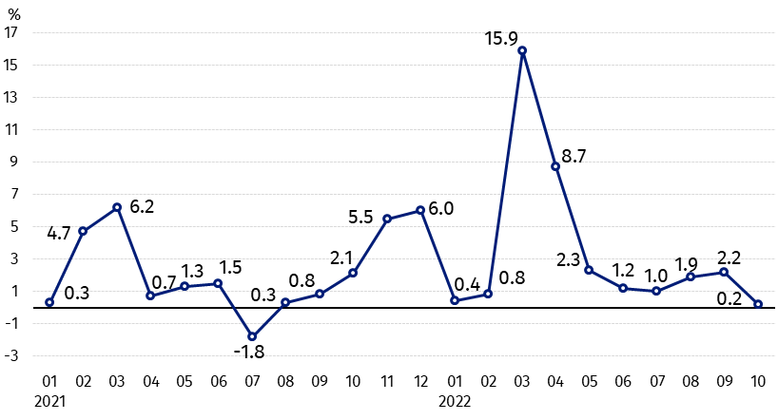
Chart 1. Changes in procurement prices of basic agricultural products in relation to the previous month
The growth in prices of basic agricultural products in October 2022 in comparison with the previous month was the lowest since August 2021. The procurement prices of wheat, rye and cows’ milk were higher than in September 2022

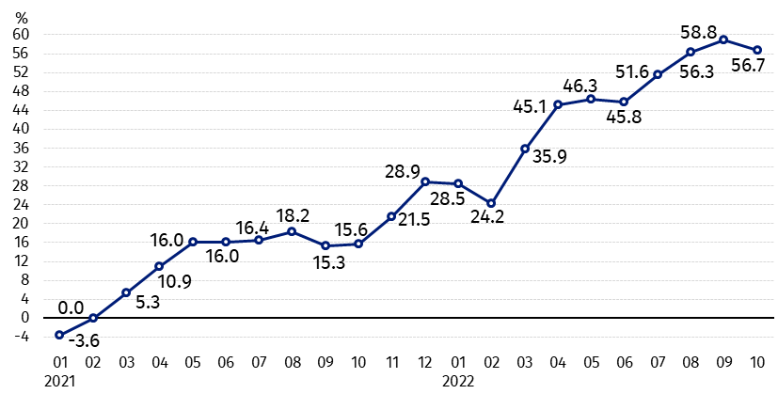
Chart 2. Changes in procurement prices of basic agricultural products in relation to the corresponding month of the previous year
Procurement prices of all basic agricultural products in October 2022 were much higher than a year ago

Procurement prices and marketplace prices received by farmers
In October 2022 cereals, except maize and cows’ milk were purchased at higher prices than in the previous month. While procurement prices of other agricultural products decreased. Wheat, maize and potatoes were sold on the marketplaces at prices lower than in September this year.
Prices of all agricultural products, in procurement as well as on marketplaces, were much higher than a year ago. On both markets oats increased the most. Prices of pigs for slaughter in procurement and rye on marketplaces increased more than prices of other agricultural products.

Table 1. Prices of agricultural products (excluding VAT) in October 2022
Specification | Procurement prices |  |  | Marketplaces prices
Specification | 10 2022
Specification | in zloty | 09 2022=100 | 10 2021=100 | in zloty ª | 09 2022=100 | 10 2021=100
Cereal grain – per 1 dt
Wheat | 155.01 | 102.7 | 148.1 | 171.83 | 99.5 | 154.5
Rye | 133.67 | 111.4 | 153.9 | 138.95 | 101.2 | 163.0
Barley | 136.03 | 101.2 | 154.6 | 157.35 | 101.1 | 160.9
Triticale | 141.46 | 100.2 | 152.2 | 152.36 | 100.9 | 162.7
Oat | 128.51 | 104.8 | 191.5 | 138.27 | 105.1 | 174.1
Maize | 105.72 | 77.8 | 153.8 | 173.28 | 99.8 | 144.2
Potatoes– per 1 dt | 56.53 | 99.9 | 169.4 | 167.74 | 96.8 | 123.6
Animals for slaughter – per kg
Cattle (excl. calves) | 10.87 | 99.3 | 125.9 | 10.92 | 104.4 | 138.9
of which young cattle | 10.95 | 98.8 | 123.9 | 11.68 | 104.8 | 141.9
Pigs | 7.43 | 93.7 | 176.8 | . | . | .
Poultry | 6.50 | 97.0 | 152.9 | . | . | .
Cows’ milk – per 1 hl | 260.35 | 104.3 | 159.0 | . | . | .
a – No data.
Data on procurement prices were calculated on the basis of information on value and quantity of procurement by legal persons and independent organizational entities without legal personality (without natural persons).
Indices of procurement prices and prices received by farmers on marketplaces were calculated on the basis of absolute data expressed with more precision than In the tables.

Prices of major agricultural products in October 2022
In October 2022 procurement price of wheat (155.01 PLN per dt) increased as related to the previous month (by 2.7%), as well as to the corresponding period of the last year (by 48.1%). On marketplaces, wheat was sold for 171.83 PLN, i.e. by 0.5% cheaper than in September this year but by 54.5% more expensive than a year ago.
133,67 PLN was paid per dt of rye in procurement, i.e. more in comparison with September this year (by 11.4%) as well as with October last year (by 53.9%). Rye (138.95 PLN per dt) increased on marketplaces in relation to the previous month (by 1.2%), as well as to the corresponding month of the previous year (by 63.0%).
The price of potatoes in procurement (56.53 PLN per dt) dropped slightly compared to September this year (by 0.1%), but it was higher by 69.4% on an annual basis. On marketplaces 167.74 PLN were paid per dt of potatoes, i.e. by 3.2% less than in the previous month while by 23.6% more than in October 2021.
The procurement price of cattle for slaughter (10.87 PLN per kg) was lower than in September this year (by 0.7%), but higher (by 25.9%) than recorded a year earlier. On marketplaces this livestock was sold for 10.92 PLN, i.e. by 4.4% more expensive than in the previous month and by 38.9% – than a year ago.
In October 2022 the procurement price of pigs for slaughter (7.43 PLN per kg) decreased by 6.3% compared to the previous month however it remained higher on an annual basis by 76.8%.
The procurement price of poultry for slaughter (6.50 PLN per kg) was lower than in September this year (by 3.0%), but it was higher in comparison with October 2021 (by 52.9%).
260.35 PLN was paid in procurement per hl of cows’ milk, i.e. by 4.3% more than in the previous month and by 59.0% - than a year ago.

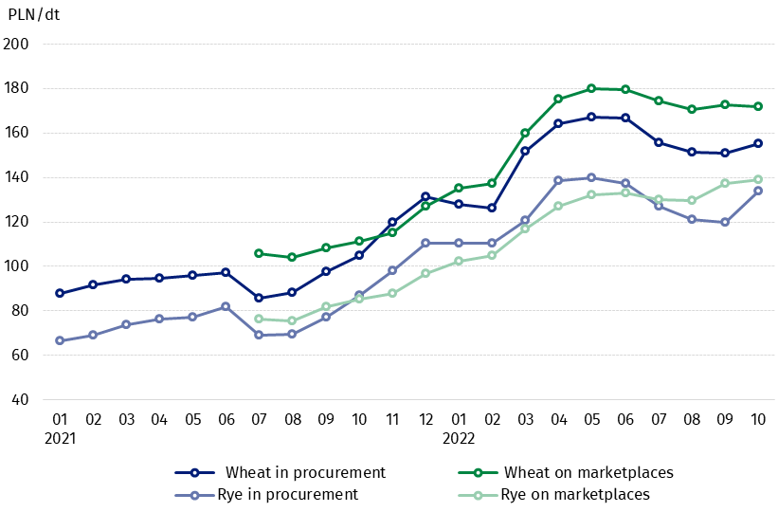
Chart 3. Procurement and marketplaces prices of wheat and rye

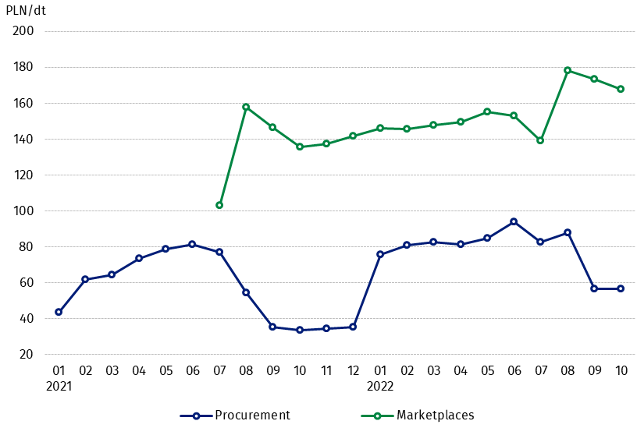
Chart 4. Procurement and marketplaces prices of potatoes

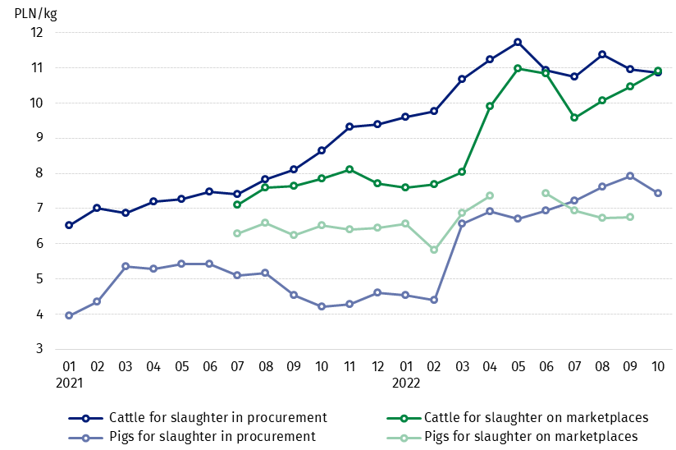
Chart 5. Procurement and marketplaces prices of cattle for slaughter and pigs for slaughter

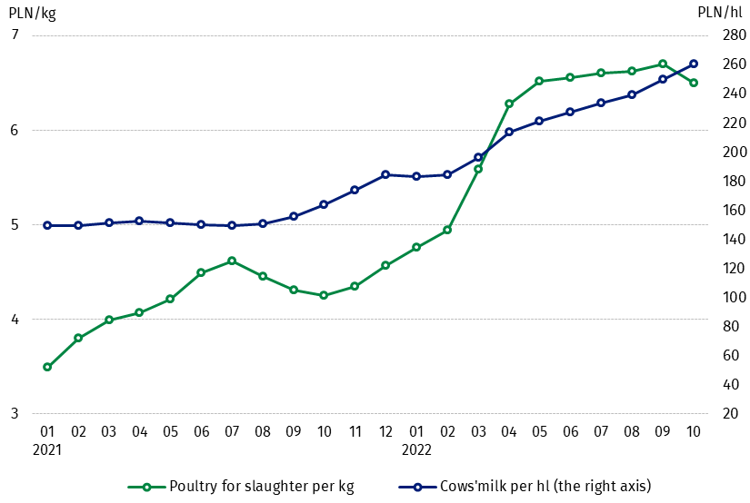
Chart 6. Procurement prices of poultry for slaughter and cows’ milk

The differentiation of the level of prices of basic agricultural products in particular voivodships is presented in Table 2 for procurement prices and in Table 3 for prices obtained by farmers on marketplaces (Excel sheet).
In case of quoting Statistics Poland data, please provide information: “Source of data: Statistics Poland”, and in case of publishing calculations made on data published by Statistics Poland, please include the following disclaimer: “Own study based on figures from Statistics Poland”.

Prepared by:  Trade and Services Departament  Director Ewa Adach-Stankiewicz  Phone: (+48 22) 608 31 24 | Issued by:  The Spokesperson for the President  of Statistics Poland  Karolina Banaszek  Phone: (+48) 695 255 011
Press Office  Phone: (+48 22) 608 38 04  e-mail: obslugaprasowa@stat.gov.pl |   www.stat.gov.pl/en/

@StatPoland

@GlownyUrzadStatystyczny

gus_stat

glownyurzadstatystycznygus

glownyurzadstatystyczny
Related information
Socio-economic situation of the country in 2022
Procurement and prices of agricultural products in 2021
Prices in the national economy in 2020

Data available in databases
BDL - Prices in agriculture (monthly and annual data)
DBW - Prices in agriculture (monthly and annual data)

Terms used in official statistics
Procurement of agricultural products
Procurement prices
Marketplace
Marketplace prices

Wheat, rye, cattle for slaughter, pigs for slaughter, poultry, cows’ milk
Procurement prices – excluding sowing seed.
Procurement prices – total (of which: edible early kinds, seeds, edible late, industrial, of which starch). Marketplaces prices – edible excluding early kinds.
Marketplaces prices – average weighted price of cattle for slaughter calculated with the adoption of the structure of procurement quantity of young cattle and cows for slaughter.

