Prices of agricultural products in June 2022
Procurement prices of basic agricultural products increased in June 2022 in comparison with the previous month (by 1.2%) as well as while compared to the corresponding month of the previous year (by 45.8%).
45.8%
an increase in procurement prices of basic agricultural products in comparison with June 2021

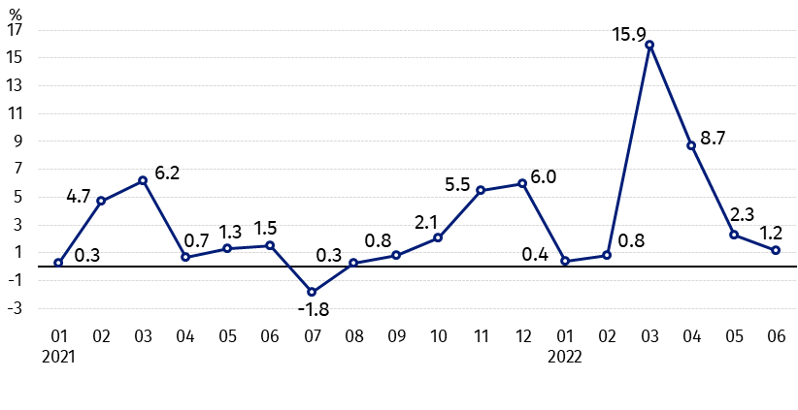
Chart 1. Changes in procurement prices of basic agricultural products in relation to the previous month
In June 2022 compared to May 2022 procurement prices of pigs for slaughter, poultry and cows’ milk increased

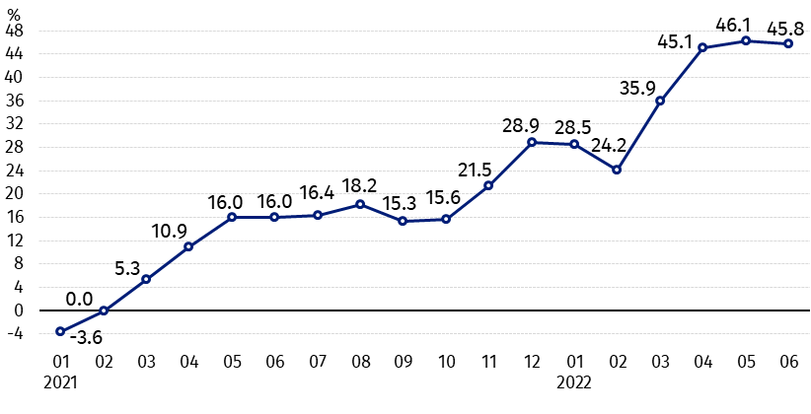
Chart 2. Changes in procurement prices of basic agricultural products in relation to the corresponding month of the previous year
Procurement prices of all basic agricultural products in June 2022 were much higher than a year ago

Procurement prices and marketplace prices received by farmers
In June 2022 in comparison with the previous month procurement prices of cereal and cattle for slaughter decreased. On marketplaces prices of most agricultural products dropped. Prices of potatoes, pigs for slaughter, poultry and cows’ milk in procurement as well as prices of rye and oat on marketplaces were higher than in May this year.
Procurement prices of all agricultural products in June 2022 were higher than a year ago. The prices of cereal and cows’ milk increased the most.

Table 1. Prices of agricultural products (excluding VAT) in June 2022
Specification | Procurement prices |  |  | Marketplaces prices
Specification | 06 2022 |  |  | 06 2022
Specification | in zloty | 05 2022=100 | 06 2021=100 | in zloty ª | 05 2022=100 | 06ª 2021=100
Cereal grain – per 1 dt
Wheat | 166.66 | 99.6 | 171.8 | 179.62 | 99.7 | .
Rye | 137.22 | 98.1 | 167.8 | 132.83 | 100.4 | .
Barley | 140.57 | 96.1 | 162.5 | 157.57 | 99.9 | .
Triticale | 150.84 | 99.8 | 168.9 | 151.33 | 99.7 | .
Oat | 116.35 | 97.6 | 191.8 | 131.17 | 101.4 | .
Maize | 137.74 | 97.9 | 140.6 | 172.86 | 99.4 | .
Potatoes– per 1 dt | 93.88 | 110.6 | 115.2 | 153.15 | 98.8 | .
Animals for slaughter – per kg
Cattle (excl. calves) | 10.94 | 93.3 | 146.2 | 10.83 | 98.7 | .
of which young cattle | 10.98 | 93.0 | 144.6 | 11.21 | 98.1 | .
Pigs | 6.93 | 103.4 | 127.8 | 7.44 | . | .
Poultry | 6.56 | 100.6 | 146.0 | . | . | .
Cows’ milk – per 1 hl | 227.18 | 102.7 | 151.2 | . | . | .
a – No data, b – No data in June 2021 due to close the marketplaces because of the state of danger of COVID-19 disease, it was not possible to obtain data on prices of agricultural products on marketplaces.
Data on procurement prices were calculated on the basis of information on value and quantity of procurement by legal persons and independent organizational entities without legal personality (without natural persons).
Indices of procurement prices and prices received by farmers on marketplaces were calculated on the basis of absolute data expressed with more precision than In the tables.

Prices of major agricultural products in June 2022
In June 2022 procurement prices of wheat (166.66 PLN per dt) decreased as related to the previous month (by 0.4%) and it was higher than a year ago (by 71.8%). On marketplaces, 179.62 PLN was paid per 1 dt of wheat, i.e. by 0.3% less than in May this year.
The price of rye in procurement amounted to 137.22 PLN per dt, and was lower than in the previous month (by 1.9%) but higher than in June 2021 (by 67.8%). In marketplace transactions, rye prices (132.83 PLN per dt) increased by 0.4% in relation to May 2022.
In June 2022 the price of potatoes in procurement (93.88 PLN per dt) was increased by 10.6% in comparison with May this year and on an annual basis - by 15.2%. On marketplaces, 153.15 PLN was paid per 1 dt of potatoes, i.e. by 1.2% less than in May 2022.

The procurement price of cattle for slaughter (10.94 PLN per kg) decreased by 6.7% as related to the previous month, but increased by 46.2% than a year ago. On marketplaces 10.83 PLN per kg was paid for cattle for slaughter, i.e. by 1.3% less than in May this year.
In June 2022 the price of pigs for slaughter in procurement amounted to 6.93 PLN per kg and was higher in comparison with the previous month as well as in relation to the corresponding period of the last year - respectively by 3.4% and by 27.8%. On marketplaces, 7.44 PLN was paid per 1 kg of this livestock.
The procurement price of poultry for slaughter (6.56 PLN per kg) increased in relation to the May 2022 (by 0.6%), as well as in comparison with June 2021 (by 46.0%).
227.11 PLN was paid in procurement per 1 hl of cows’ milk, i.e. by 2.7% more than in the previous month and by 51.2% more than a year ago.

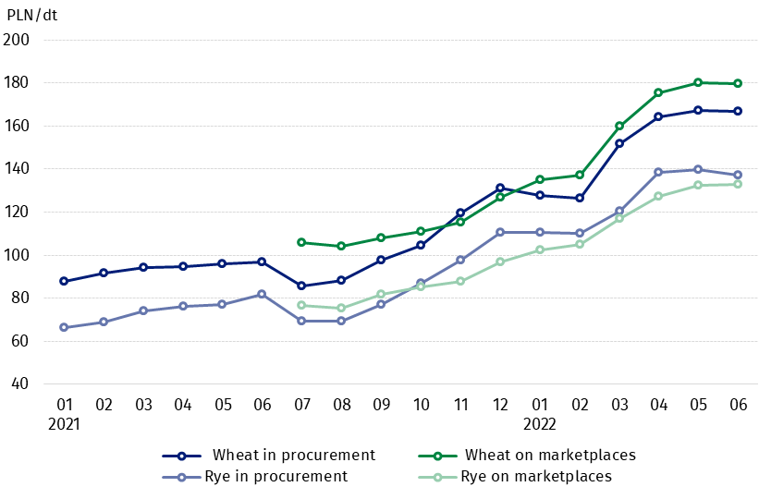
Chart 3. Procurement and marketplaces prices of wheat and rye

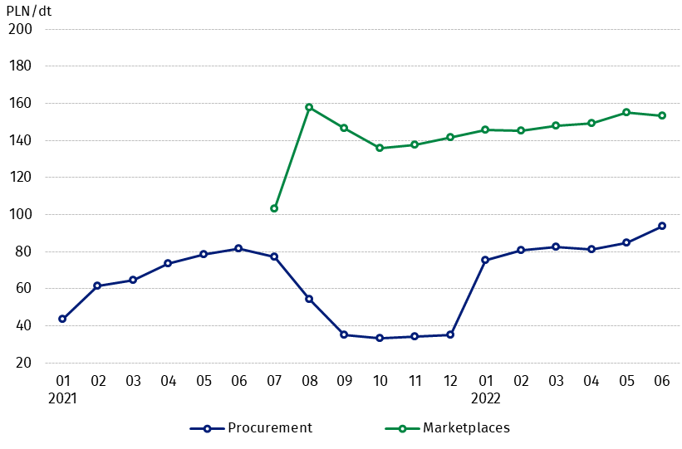
Chart 4. Procurement and marketplaces prices of potatoes

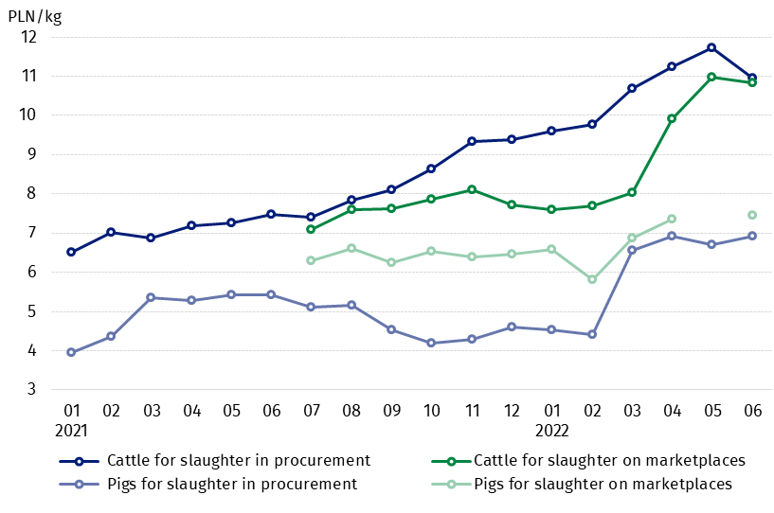
Chart 5. Procurement and marketplaces prices of cattle for slaughter and pigs for slaughter

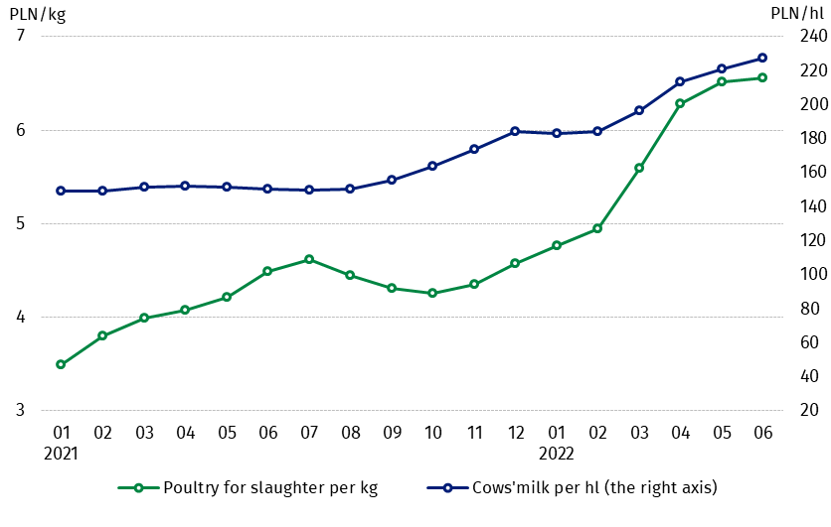
Chart 6. Procurement prices of poultry for slaughter and cows’ milk

The differentiation of the level of prices of basic agricultural products in particular voivodships is presented in Table 2 for procurement prices and in Table 3 for prices obtained by farmers on marketplaces (Excel sheet).
In case of quoting Statistics Poland data, please provide information: “Source of data: Statistics Poland”, and in case of publishing calculations made on data published by Statistics Poland, please include the following disclaimer: “Own study based on figures from Statistics Poland”.

Prepared by:  Trade and Services Departament  Director Ewa Adach-Stankiewicz  Phone: (+48 22) 608 31 24 | Issued by:  The Spokesperson for the President  of Statistics Poland  Karolina Banaszek  Phone: (+48) 695 255 011
Press Office  Phone: (+48 22) 608 38 04  e-mail: obslugaprasowa@stat.gov.pl |   www.stat.gov.pl/en/

@StatPoland

@GlownyUrzadStatystyczny

gus_stat

glownyurzadstatystycznygus

glownyurzadstatystyczny
Related information
Socio-economic situation of the country in 2022
Procurement and prices of agricultural products in 2021
Prices in the national economy in 2020

Data available in databases
BDL - Prices in agriculture (monthly and annual data)
DBW - Prices in agriculture (monthly and annual data)

Terms used in official statistics
Procurement of agricultural products
Procurement prices
Marketplace
Marketplace prices

Wheat, rye, cattle for slaughter, pigs for slaughter, poultry, cows’ milk
Procurement prices – excluding sowing seed.
Procurement prices – total (of which: edible early kinds, seeds, edible late, industrial, of which starch). Marketplaces prices – edible excluding early kinds.
Marketplaces prices – average weighted price of cattle for slaughter calculated with the adoption of the structure of procurement quantity of young cattle and cows for slaughter.

