Prices of agricultural products in March 2022
Procurement prices of basic agricultural products increased in March 2022 in comparison with the previous month (by 15.9%) as well as while compared to the corresponding period of the last year (by 35.9%).
35.9%
an increase in procurement prices of basic agricultural products in comparison with March 2021

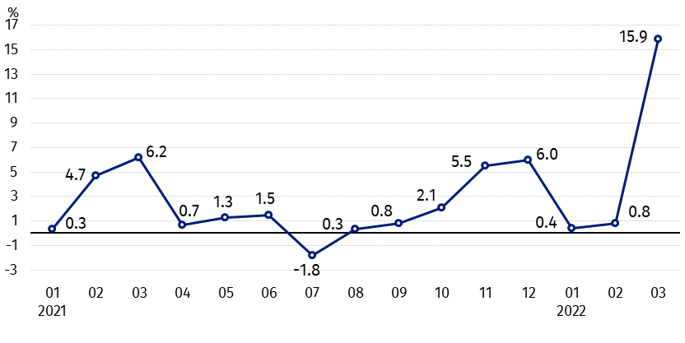
Chart 1. Changes in procurement prices of basic agricultural products in relation to the previous month
Much higher growth in procurement prices of basic agricultural products in March this year compared to February this year was mainly caused by an increase in the prices of pigs for slaughter and wheat

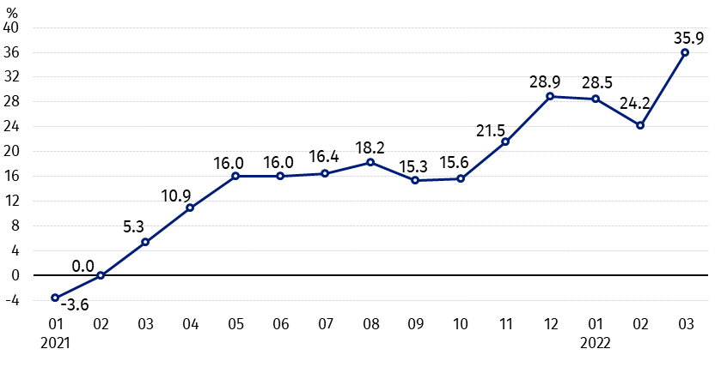
Chart 2. Changes in procurement prices of basic agricultural products in relation to the previous year
The prices of wheat, rye and cattle for slaughter increased the most on an annual basis

Procurement prices and marketplace prices received by farmers
In March 2022 in comparison with the previous month procurement prices and marketplaces prices of all agricultural products increased, of which pigs for slaughter increased the most on both markets, but potatoes the least.
Procurement prices were also much higher compared to March 2021. The prices of cereal, cattle of slaughter and poultry increased the most.

Table 1. Prices of agricultural products (excluding VAT) in March 2022

Specification | Procurement prices |  |  | Marketplaces prices
Specification | 03 2022 |  |  | 03 2022
Specification | in zloty | 02 2022=100 | 03 2021=100 | in zloty | 02 2022=100 | 03ª 2021=100
Cereal grain – per 1 dt
Wheat | 151.59 | 119.9 | 160.9 | 159.93 | 116.7 | .
Rye | 120.46 | 109.2 | 163.0 | 116.84 | 111.4 | .
Barley | 122.83 | 110.0 | 152.9 | 138.61 | 111.1 | .
Triticale | 131.84 | 116.9 | 162.9 | 134.06 | 112.2 | .
Oat | 104.88 | 108.8 | 166.8 | 117.75 | 116.1 | .
Maize | 125.63 | 114.0 | 146.6 | 153.87 | 113.0 | .
Potatoes– per 1 dt | 82.74 | 102.3 | 128.2 | 147.97 | 101.7 | .
Animals for slaughter – per kg
Cattle (excluding calves) | 10.68 | 109.4 | 155.3 | 8.03 | 104.6 | .
of which young cattle | 10.80 | 109.4 | 156.2 | 8.33 | 105.3 | .
Pigs | 6.56 | 149.2 | 122.4 | 6.88 | 118.2 | .
Poultry | 5.59 | 113.2 | 139.9 | . | . | .
Cows’ milk – per 1 hl | 196.48 | 106.7 | 129.7 | . | . | .

a – No data in March 2021 due to close the marketplaces because of the state of danger of COVID-19 disease, it was not possible to obtain data on prices of agricultural products on marketplaces.
Data on procurement prices were calculated on the basis of information on value and quantity of procurement by legal persons and independent organizational entities without legal personality (without natural persons).
Indices of procurement prices and prices received by farmers on marketplaces were calculated on the basis of absolute data expressed with more precision than In the tables.

Prices of major agricultural products in March 2022
In March 2022 procurement prices of wheat (151.59 PLN per dt) increased as related to the previous month (by 19.9%), as well as in comparison with corresponding period of the last year (by 60.9%). On marketplaces, 159.93 PLN was paid for 1 dt of wheat, i.e. by 16.7% more than in February 2022.
The price of rye in procurement amounted to 120.46 PLN per dt, and was higher by 9.2% than in February this year and by 63.0% higher than a year ago. In marketplace transactions, rye prices (116.84 PLN per dt) increased by 11.4% in relation to February 2022.
In March 2022 the price of potatoes in procurement (82.74 PLN per dt) increased by 2.3% on a monthly basis and by 28.2% - on an annual basis. On marketplaces, 147.97 PLN was paid per 1 dt of potatoes, i.e. by 1.7% more than in February 2022.

The procurement price of cattle for slaughter (10.68 PLN per kg) increased as related to the previous month, as well as in comparison with March 2021 - respectively by 9.4% and by 55.3%. On marketplaces 8.03 PLN per kg was paid for cattle for slaughter, i.e. by 4.6% more than a month ago.
In March 2022 the price of pigs for slaughter in procurement amounted 6.56 PLN per kg and was higher in comparison with the previous month by 49.2% and by 22.4% than a year ago. On marketplaces, 6.88 PLN was paid for 1 kg of this livestock, i.e. by 18.2% more than February 2022.
The procurement price of poultry for slaughter (5.59 PLN per kg) increased in relation to the February 2022 (by 13.2%), as well as in comparison with March 2021 (by 39.9%).
196.48 PLN was paid in procurement for 1 hl of cows’ milk, i.e. by 6.7% more than in the previous month and by 29.7% more than a year ago.

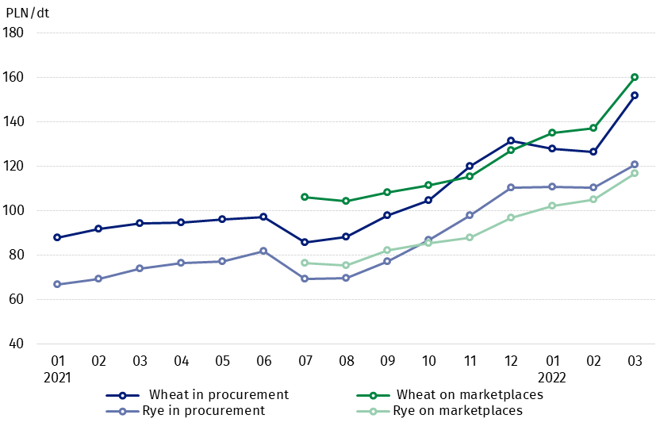
Chart 3. Procurement and marketplaces prices of wheat and rye

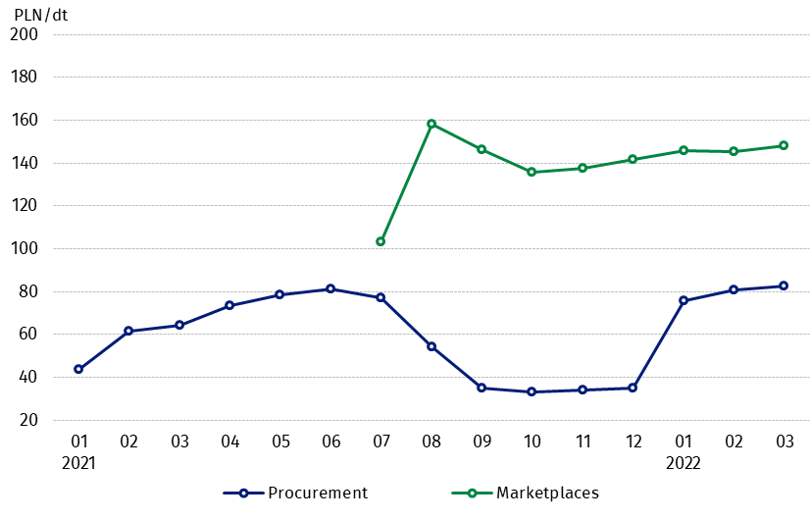
Chart 4. Procurement and marketplaces prices of potatoes

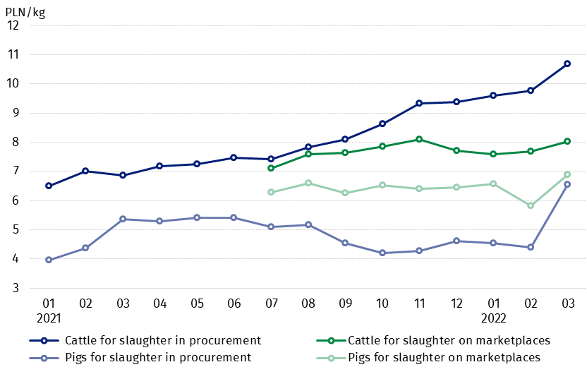
Chart 5. Procurement and marketplaces prices of cattle for slaughter and pigs for slaughter

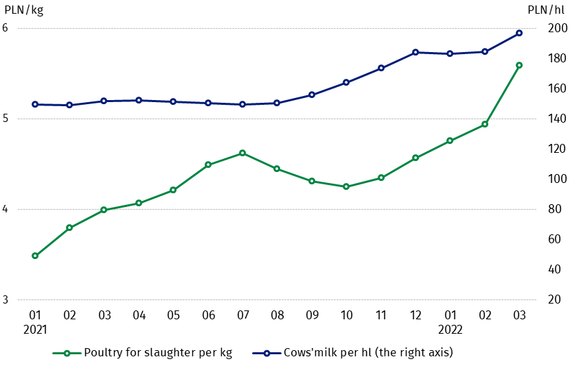
Chart 6. Procurement prices of poultry for slaughter and cows’ milk

The differentiation of the level of prices of basic agricultural products in particular voivodships is presented in Table 2 for procurement prices and in Table 3 for prices obtained by farmers on marketplaces (Excel sheet).
In case of quoting Statistics Poland data, please provide information: “Source of data: Statistics Poland”, and in case of publishing calculations made on data published by Statistics Poland, please include the following disclaimer: “Own study based on figures from Statistics Poland”.

Prepared by:  Trade and Services Department  Director Ewa Adach-Stankiewicz  Phone: (+48 22) 608 31 24 | Issued by:  The Spokesperson for the President  of Statistics Poland  Karolina Banaszek  Phone: (+48) 695 255 011
Press Office  Phone: (+48 22) 608 38 04  e-mail: obslugaprasowa@stat.gov.pl |   www.stat.gov.pl/en/

@StatPoland

@GlownyUrzadStatystyczny

gus_stat

glownyurzadstatystycznygus

glownyurzadstatystyczny
Related information
Socio-economic situation of the country in 2022
Procurement and prices of agricultural products in 2020
Prices in the national economy in 2020

Data available in databases
BDL - Prices in agriculture (monthly and annual data)
DBW - Prices in agriculture (monthly and annual data)

Terms used in official statistics
Procurement of agricultural products
Procurement prices
Marketplace
Marketplace prices

Wheat, rye, cattle for slaughter, pigs for slaughter, poultry, cows’ milk
Procurement prices – excluding sowing seed.
Procurement prices – total (of which: edible early kinds, seeds, edible late, industrial, of which starch). Marketplaces prices – edible excluding early kinds.
Marketplaces prices – average weighted price of cattle for slaughter calculated with the adoption of the structure of procurement quantity of young cattle and cows for slaughter.

