Prices of agricultural products in February 2022
Procurement prices of basic agricultural products increased in February 2022 in comparison with the previous month (by 0.8%) as well as while compared to the corresponding period of the last year (by 24.2%).
24.2%
an increase in procurement prices of basic agricultural products in comparison with February 2021

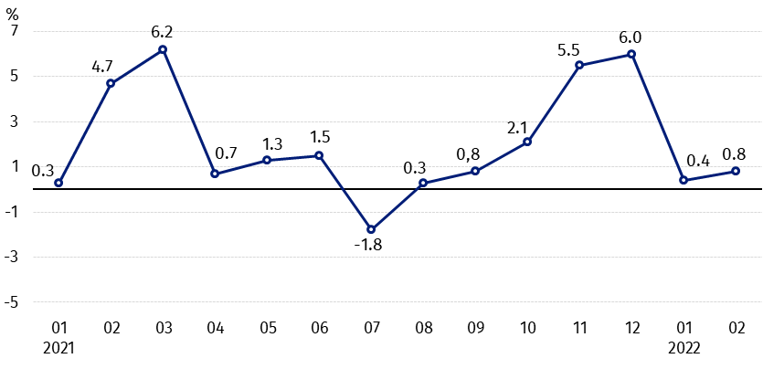
Chart 1. Changes in procurement prices of basic agricultural products in relation to the previous month
In February 2022 procurement prices of cattle for slaughter, poultry and cows’ milk were higher than a month ago

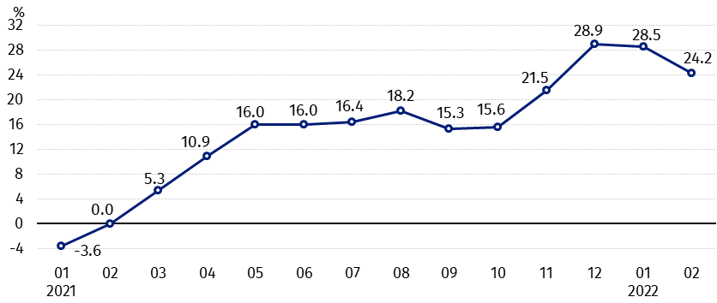
Chart 2. Changes in procurement prices of basic agricultural products in relation to the previous year
Procurement prices of basic agricultural products in February 2022 were much higher than a year ago

Procurement prices and marketplace prices received by farmers
In February 2022 in comparison with the previous month procurement prices and marketplaces prices of most agricultural products increased. The prices of wheat, rye and triticale in procurement and potatoes on marketplaces were lower. On both markets prices of pigs for slaughter decreased.
Compared to February 2021, procurement prices of all agricultural products were higher.

Table 1. Prices of agricultural products (excluding VAT) in February 2022

Specification | Procurement prices |  |  | Marketplaces prices
Specification | 02 2022 |  |  | 02 2022
Specification | in zloty | 01 2022=100 | 02 2021=100 | in zloty | 01 2022=100 | 02ª 2021=100
Cereal grain – per 1 dt
Wheat | 126.38 | 98.8 | 137.8 | 137.10 | 101.6 | .
Rye | 110.36 | 99.9 | 159.6 | 104.86 | 102.6 | .
Barley | 111.63 | 101.1 | 147.0 | 124.74 | 102.3 | .
Triticale | 112.80 | 101.1 | 147.0 | 119.43 | 102.6 | .
Oat | 96.38 | 103.8 | 150.8 | 101.43 | 101.9 | .
Maize | 110.23 | 109,9 | 136.0 | 136.16 | 100.5 | .
Potatoes– per 1 dt | 80.87 | 107,1 | 131.4 | 145.43 | 99.7 | .
Animals for slaughter – per kg
Cattle (excluding calves) | 9.76 | 101.8 | 139.0 | 7.68 | 101.2 | .
of which young cattle | 9.87 | 100.9 | 137.3 | 7.91 | 100,5 | .
Pigs | 4.40 | 96.9 | 100.9 | 5.82 | 88.6 | .
Poultry | 4.94 | 103.7 | 130.0 | . | . | .
Cows’ milk – per 1 hl | 184.21 | 100.7 | 123.5 | . | . | .

a – No data in February 2021 due to close the marketplaces because of the state of danger of COVID-19 disease, it was not possible to obtain data on prices of agricultural products on marketplaces.
Data on procurement prices were calculated on the basis of information on value and quantity of procurement by legal persons and independent organizational entities without legal personality (without natural persons).
Indices of procurement prices and prices received by farmers on marketplaces were calculated on the basis of absolute data expressed with more precision than In the tables.

Prices of major agricultural products in February 2022
In February 2022 procurement prices of wheat (126.38 PLN per dt) in relation to the previous month dropped (by 1.2%), however, they were higher than a year ago (by 37.8%). On marketplaces, 137.10 PLN was paid for 1 dt of wheat, i.e. by 1.6% more than in January 2022.
The price of rye in procurement amounted to 110.36 PLN per dt, and was lower compared to the previous month (by 0.1%), but higher to February 2021 (by 59.6%). In marketplace transactions, rye prices (104.86 PLN per dt) increased by 2.6% in relation to January 2022.
In February 2022 the price of potatoes in procurement (80.87 PLN per dt) increased by 7.1% on a monthly basis and by 31.4% - on an annual basis. On marketplaces, 145.43 PLN was paid per 1 dt of potatoes, i.e. by 0.3% less than in January 2022.

The procurement price of cattle for slaughter (9.76 PLN per kg) increased as related to the previous month, as well as in comparison with February 2021 - respectively by 1.8% and by 39.0%. On marketplaces 7.68 PLN per kg was paid for cattle for slaughter, i.e. by 1.2% more than a month ago.
In February 2022 the price of pigs for slaughter in procurement amounted 4.40 PLN per kg and was lower in comparison with the previous month – by 3.1%, but higher in an annual terms – by 0.9%. On marketplaces, 5.82 PLN was paid for 1 kg of this livestock, i.e. by 11.4% less than January 2022.
The procurement price of poultry for slaughter (4.94 PLN per kg) increased in relation to the January 2022 (by 3.7%), as well as in comparison with February 2021 (by 30.0%).
184.21 PLN was paid in procurement for 1 hl of cows’ milk, i.e. by 0.7% more than in the previous month and by 23.5% more than a year ago.

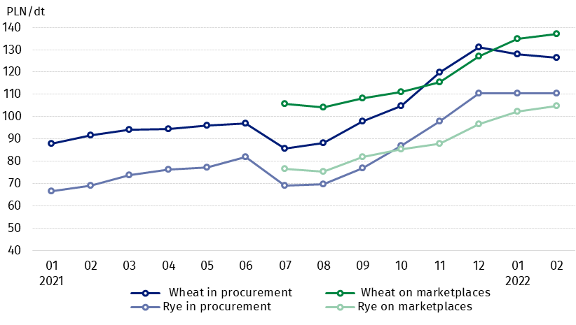
Chart 3. Procurement and marketplaces prices of wheat and rye

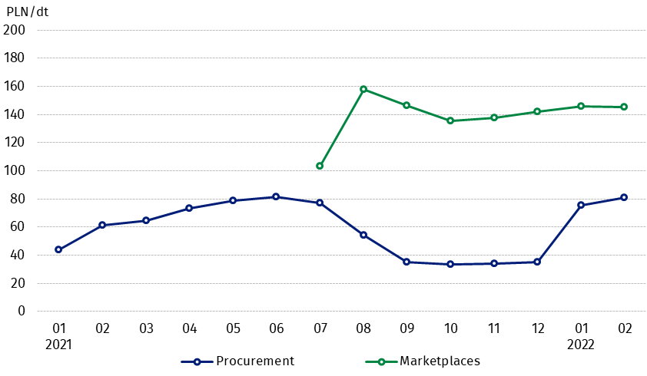
Chart 4. Procurement and marketplaces prices of potatoes

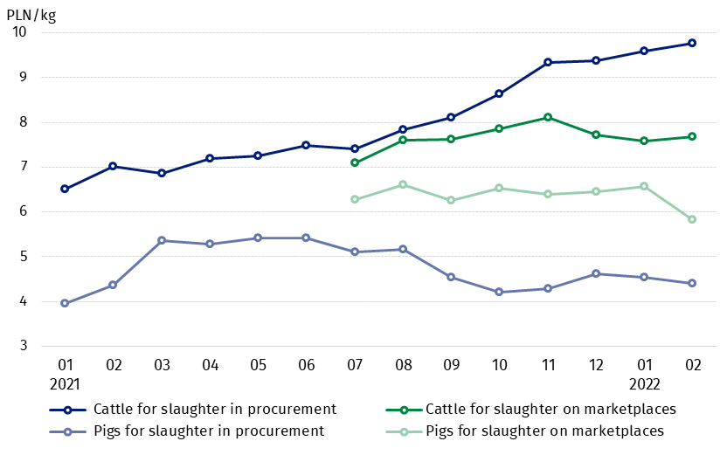
Chart 5. Procurement and marketplaces prices of cattle for slaughter and pigs for slaughter

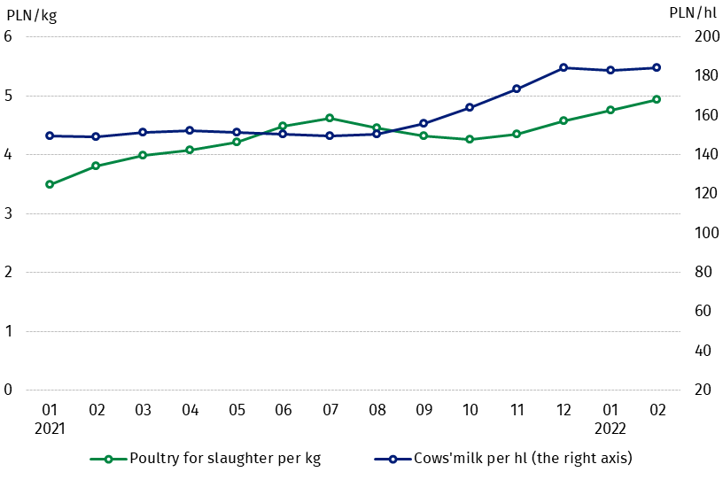
Chart 6. Procurement prices of poultry for slaughter and cows’ milk

The differentiation of the level of prices of basic agricultural products in particular voivodships is presented in Table 2 for procurement prices and in Table 3 for prices obtained by farmers on marketplaces (Excel sheet). Due to the epidemiological situation (the threat of COVID-19 disease), it was not possible to obtain data on marketplace prices of agricultural products in some months of 2020 and 2021.
In case of quoting Statistics Poland data, please provide information: “Source of data: Statistics Poland”, and in case of publishing calculations made on data published by Statistics Poland, please include the following disclaimer: “Own study based on figures from Statistics Poland”.

Prepared by:  Trade and Services Departament  Director Ewa Adach-Stankiewicz  Phone: (+48 22) 608 31 24 | Issued by:  The Spokesperson for the President  of Statistics Poland  Karolina Banaszek  Phone: (+48) 695 255 011
Press Office  Phone: (+48 22) 608 38 04  e-mail: obslugaprasowa@stat.gov.pl |   www.stat.gov.pl/en/

@StatPoland

@GlownyUrzadStatystyczny

gus_stat

glownyurzadstatystycznygus

glownyurzadstatystyczny
Related information
Socio-economic situation of the country in 2022
Procurement and prices of agricultural products in 2020
Prices in the national economy in 2020

Data available in databases
BDL - Prices in agriculture (monthly and annual data)
DBW - Prices in agriculture (monthly and annual data)

Terms used in official statistics
Procurement of agricultural products
Procurement prices
Marketplace
Marketplace prices

Wheat, rye, cattle for slaughter, pigs for slaughter, poultry, cows’ milk
Procurement prices – excluding sowing seed.
Procurement prices – total (of which: edible early kinds, seeds, edible late, industrial, of which starch). Marketplaces prices – edible excluding early kinds.
Marketplaces prices – average weighted price of cattle for slaughter calculated with the adoption of the structure of procurement quantity of young cattle and cows for slaughter.

