Price indices of construction and assembly production in December 2021

According to preliminary data, in December 2021 the prices of construction and assembly production in comparison with the corresponding month of the previous year increased by 7.6%, and in comparison with November 2021 - by 1.0%.
7.6%
the growth of producer prices in construction in comparison with December 2020

In December 2021 in comparison with November 2021 the growth of prices was recorded in construction of buildings as well as in civil engineering - by 1.0% each and in specialised construction activities - by 0.9%.

In comparison with December 2020 the increase of prices was noticed in construction of buildings by 7.8%, in civil engineering - by 7.6% as well as in specialised construction activities - by 6.5%.

Table 1. Price indices of construction and assembly production in December 2021

 | 11 2021 |  | 12 2021 |  | 01-12 2021
SPECIFICATION | 10 2021=100 | corresponding period 2020=100 |  | 11 2021=100 | 01 -12 2020=100
TOTAL | 101.1* | 106.6* | 107.6 | 101.0 | 104.2
Construction of buildings | 101.1* | 107.2* | 107.8 | 101.0 | 104.7
Civil engineering | 101.1* | 106.6* | 107.6 | 101.0 | 104.2
Specialised construction activities | 101.0* | 105.8* | 106.5 | 100.9 | 103.5

* Data revised.

In December 2021 the prices of construction and assembly production compared to the previous month increased by 1.0%
Chart 1. Prices changes of construction and assembly production in 2020-2021 in relation
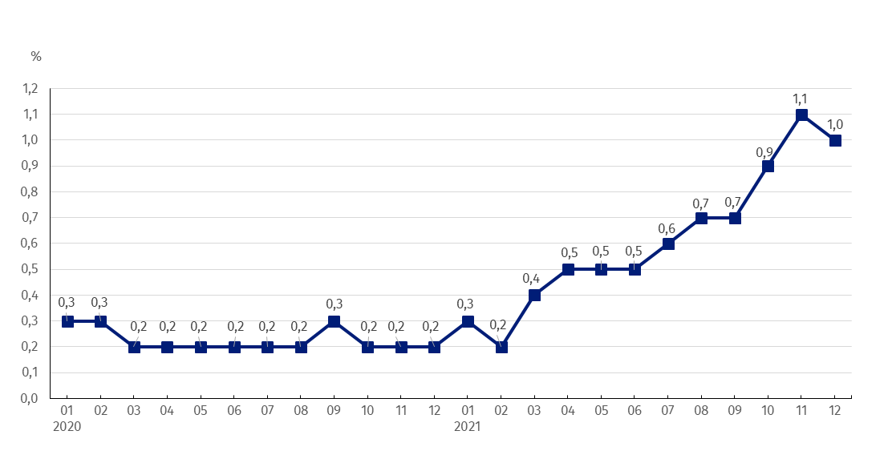
to the previous period

Chart 2. Prices changes of construction and assembly production in 2020-2021 in relation
From March 2021 a growing trend is observed in the prices dynamics of construction and assembly production in annual terms
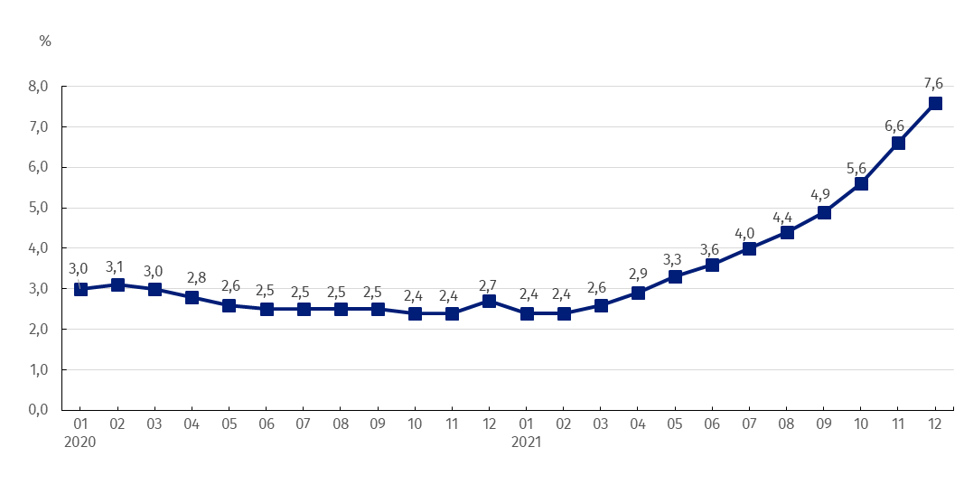
to the same period of the previous year

Chart 3. Prices changes of production and assembly construction by divisions NACE in 2020-2021
Starting from January 2020 the highest prices growth is recorded in construction of buildings
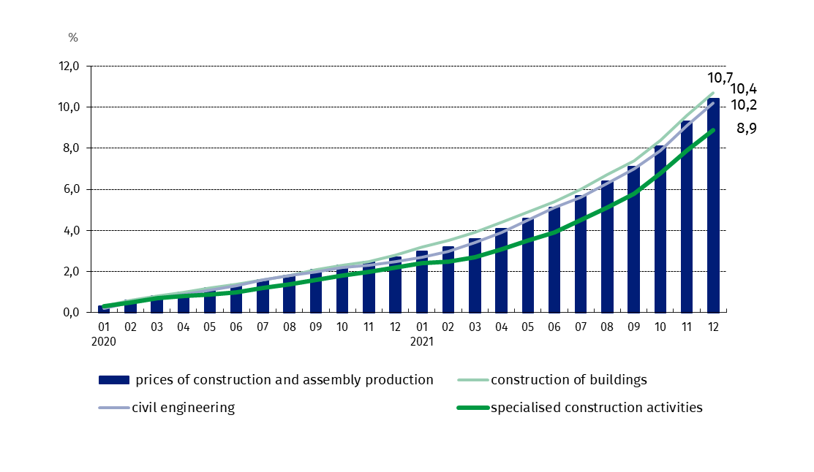
in relation to December 2019

In case of quoting Statistics Poland data, please provide information: “Source of data: Statistics Poland”, and in case of publishing calculations made on data published by Statistics Poland, please include the following disclaimer: “Own study based on figures from Statistics Poland”.

Prepared by:  The Trade and Services Department  Director Ewa Adach-Stankiewicz  Office: tel. (+48 22) 608 31 24 | Issued by:  The Spokesperson for the President  of Statistics Poland  Karolina Banaszek  Mobile: (+48) 695 255 011

Press Office  Office: tel. (+48 22) 608 34 91, 608 38 04  e-mail: obslugaprasowa@stat.gov.pl |  | www.stat.gov.pl/en/
 |  | @StatPoland
 |  | @GlownyUrzadStatystyczny

Related information
Statistical Bulletin
News Releases

Data available in databases
Analytical Platform - Knowledge Databases
Macroeconomic Data Bank
Prices indices (Topics: Prices, Trade)

Terms used in official statistics
Price index of construction and assembly production

