Consumer price indices in April 2022
Consumer prices in April 2022, compared with
the corresponding month of the previous year,
increased by 12,4% (with an increase of prices of goods – by 13,1% and services – by 10,1%).
12.4%
an increase compared with the corresponding month of the
previous year
As related to the previous month consumer prices
increased by 2,0% (of which goods – by 2,3% and services – by 1,2%).

Table 1. Consumer price indices in April 2022
SPECIFICATION | 04 2022 |  |  | 01-04 2022 | CONTRIBUTION OF CHANGES  03 2022=  =100
SPECIFICATION | 04 2021=  =100 | 12 2021=  =100 | 03 2022=  =100 | 01-04 2021=  =100 | CONTRIBUTION OF CHANGES  03 2022=  =100
TOTAL | 112,4 | 107,0 | 102,0 | 110,3 | x
Food and non-alcoholic  beverages | 112,7 | 108,2 | 104,1 | 109,7 | 1,09
Alcoholic beverages  and tobacco | 105,9 | 104,7 | 100,7 | 104,9 | 0,04
Clothing and footwear | 103,7 | 102,8 | 103,0 | 103,7 | 0,13
Housing, water, electricity, gas and other fuels | 119,5 | 110,6 | 101,9 | 116,6 | 0,38
Furnishings, household equipment and routine household maintenance | 108,6 | 104,4 | 101,7 | 107,6 | 0,09
Health | 106,5 | 103,6 | 100,6 | 105,2 | 0,03
Transport | 121,1 | 109,0 | 100,0 | 118,2 | 0,00
Communication | 102,6 | 101,8 | 100,1 | 103,8 | 0,01
Recreation and culture | 109,3 | 105,3 | 102,0 | 108,1 | 0,12
Education | 106,3 | 102,7 | 100,4 | 105,8 | 0,00
Restaurants and hotels | 114,1 | 106,7 | 101,5 | 112,2 | 0,07
Miscellaneous goods and services | 107,9 | 104,4 | 101,3 | 106,3 | 0,07

Contributions of price changes to the total consumer price index
In April of the current year, compared with the previous month, the highest contribution to the total consumer price index came from higher prices related to Food (by 4,4%), Dwelling (by 1,8%), Clothing and footwear (by 3,0%) and Recreation and culture (by 2,0%), which increased the index by 1,05 pp, 0,47 pp, 0,13 pp and 0,12 pp, respectively.
Compared with the corresponding month of the previous year, higher prices related to Dwelling (by 17,0%), Food (by 13,2%), Transport (by 21,1%), Restaurants and hotels (by 14,1%) and Recreation and culture (by 9,3%) increased the index by 4,22 pp, 3,22 pp, 1,99 pp, 0,66 pp and 0,57 pp, respectively.

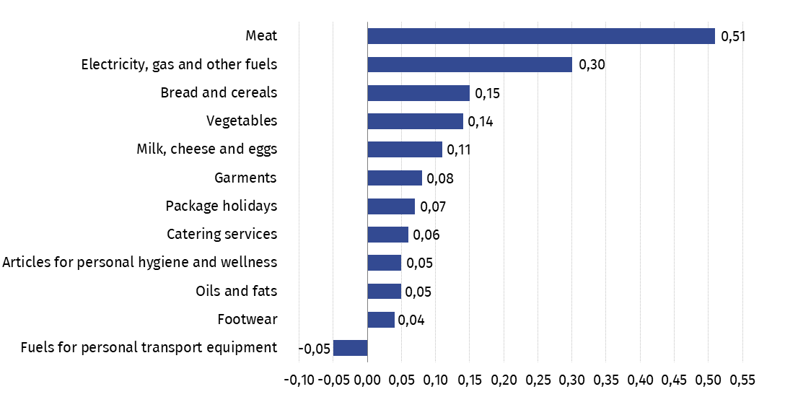
Chart 1. Contribution of price changes of selected groups of consumer goods and services
in April 2022 (change in pp compared with the previous period)

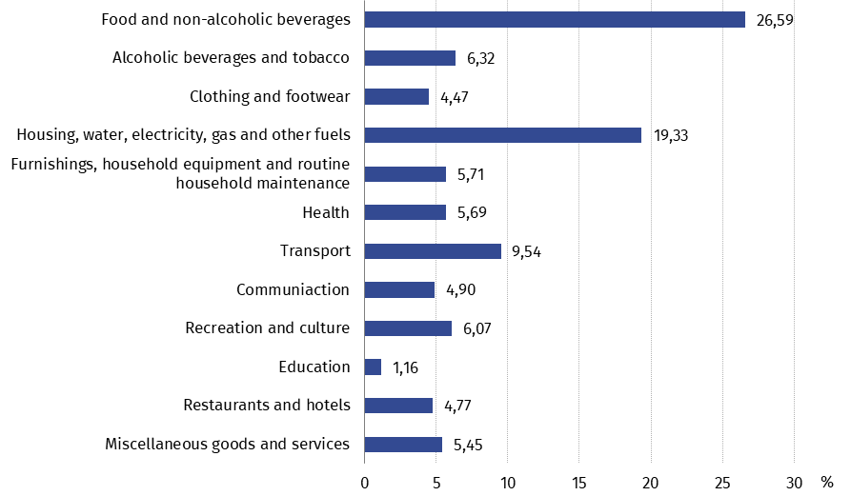
Chart 2. Weighting system used in the compilations of consumer price indices in 2022

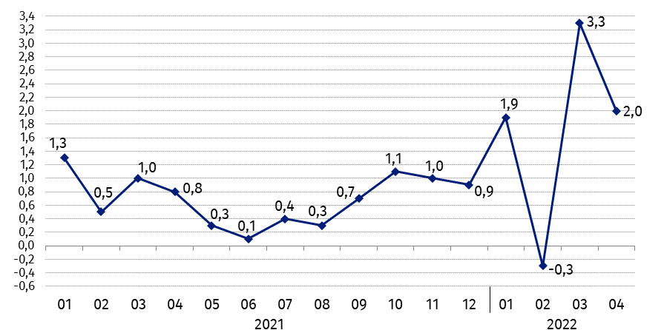
Chart 3. Changes in consumer prices as related to the previous period (in %)

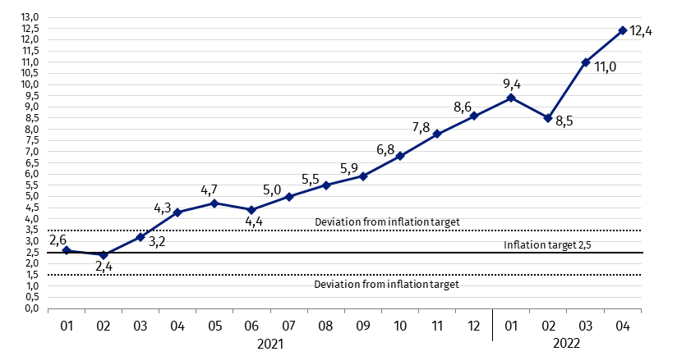
Chart 4. Changes in consumer prices as related to the corresponding period of the previous year (in %)
In April 2022 the consumer price index was above the upper band for deviations from inflation target determined by the Monetary Policy Council (2,5% +/- 1 pp)

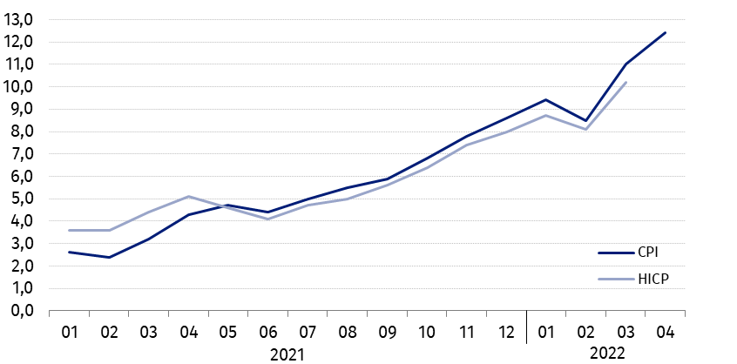
Chart 5. Changes in prices according to consumer price index (CPI) and harmonised index of consumer prices (HICP) as related to the corresponding period of the previous year (in %)
Table 2. Consumer price indices in April 2022
SPECIFICATION | 04 2022 |  |  | 01-04 2022
SPECIFICATION | 04 2021=  =100 | 12 2021=  =100 | 03 2022=  =100 | 01-04 2021=  =100
TOTAL | 112,4 | 107,0 | 102,0 | 110,3
Goods | 113,1 | 107,5 | 102,3 | 110,7
Services | 110,1 | 105,4 | 101,2 | 109,2
FOOD, NON-ALCOHOLIC BEVERAGES, ALCOHOLIC BEVERAGES AND TOBACCO | 111,3 | 107,5 | 103,5 | 108,8
FOOD AND NON-ALCOHOLIC BEVERAGES | 112,7 | 108,2 | 104,1 | 109,7
Food | 113,2 | 108,5 | 104,4 | 110,1
of which:
Rice | 113,6 | 107,0 | 104,5 | 109,6
Flour | 125,5 | 116,1 | 105,9 | 120,1
Bread | 123,7 | 112,3 | 105,7 | 118,9
Pasta products and couscous | 109,1 | 104,1 | 103,4 | 106,5
Meat | 117,6 | 113,9 | 108,5 | 110,1
of which:
Beef | 129,9 | 111,9 | 106,4 | 123,4
Veal | 113,4 | 106,9 | 104,3 | 110,2
Pork | 115,6 | 118,4 | 112,1 | 105,9
Poultry | 146,7 | 133,1 | 114,4 | 132,1
Dried, salted or smoked meat | 108,7 | 106,2 | 105,2 | 104,2
Fish and seafood | 113,3 | 104,9 | 102,2 | 111,6
Milk, cheese and eggs | 111,8 | 104,5 | 103,1 | 110,2
of which:
Milk | 112,8 | 105,6 | 104,5 | 109,8
Yoghurt, cream, milk-based desserts, milk-based beverages and other similar milk-based products | 109,2 | 103,2 | 101,8 | 108,3
Cheese and curd | 112,5 | 104,9 | 101,9 | 111,7
Eggs | 114,4 | 104,7 | 107,6 | 110,5
Oils and fats | 128,8 | 107,7 | 104,0 | 125,3
Vegetable fats | 133,0 | 110,3 | 103,9 | 129,8
Animal fats | 125,8 | 105,8 | 104,0 | 122,3
of which butter | 125,8 | 105,2 | 103,6 | 122,6
Fruit | 106,6 | 108,4 | 101,1 | 106,4
Vegetables | 112,0 | 111,4 | 104,5 | 110,6
Sugar | 135,0 | 112,0 | 108,8 | 125,7
Non-alcoholic beverages | 106,8 | 104,7 | 101,5 | 105,9
of which:
Coffee | 111,2 | 109,3 | 101,6 | 107,8
Tea | 105,9 | 104,6 | 101,5 | 104,3
Cocoa and powdered chocolate | 105,6 | 104,8 | 100,5 | 104,7
Mineral or spring waters | 105,5 | 103,9 | 102,1 | 105,2
Fruit and vegetable juices | 101,3 | 99,3 | 100,2 | 101,9
ALCOHOLIC BEVERAGES AND  TOBACCO | 105,9 | 104,7 | 100,7 | 104,9
Alcoholic beverages | 107,1 | 105,6 | 100,8 | 106,0
Tobacco | 102,5 | 102,2 | 100,5 | 101,8
CLOTHING AND FOOTWEAR | 103,7 | 102,8 | 103,0 | 103,7
of which:
Garments | 103,2 | 102,5 | 102,6 | 103,2
Footwear | 105,0 | 103,8 | 104,4 | 104,3
DWELLING | 117,0 | 109,2 | 101,8 | 114,5
HOUSING, WATER, ELECTRICITY, GAS AND OTHER FUELS | 119,5 | 110,6 | 101,9 | 116,6
of which:
Actual rentals for housing | 111,7 | 107,2 | 102,3 | 109,3
Water supply | 104,2 | 101,0 | 100,1 | 104,2
Refuse collection | 108,7 | 105,5 | 100,6 | 110,9
Sewage collection | 108,6 | 104,4 | 100,5 | 108,0
Electricity, gas and other fuels | 127,3 | 114,5 | 102,4 | 122,6
Electricity | 105,0 | 105,0 | 100,0 | 104,6
Gas | 149,2 | 126,8 | 100,2 | 147,4
Liquid and solid fuels | 176,5 | 126,6 | 109,2 | 155,1
Heat energy | 110,8 | 106,4 | 101,5 | 108,8
FURNISHINGS, HOUSEHOLD EQUIPMENT AND ROUTINE HOUSEHOLD MAINTENANCE | 108,6 | 104,4 | 101,7 | 107,6
of which:
Furniture and furnishings | 111,2 | 103,8 | 101,9 | 111,6
Household appliances | 103,7 | 102,6 | 100,4 | 103,4
Cleaning and maintenance products | 107,0 | 104,8 | 102,7 | 104,7
Domestic services and household services | 115,6 | 107,9 | 100,8 | 114,2
HEALTH | 106,5 | 103,6 | 100,6 | 105,2
of which:
Pharmaceutical products | 102,6 | 100,9 | 100,4 | 101,4
Therapeutic appliances and equipment | 106,4 | 102,9 | 100,6 | 105,5
Medical services | 113,6 | 108,6 | 101,4 | 111,7
Dental services | 113,9 | 108,8 | 100,9 | 112,3
Hospital services | 112,5 | 109,5 | 101,4 | 111,1
TRANSPORT | 121,1 | 109,0 | 100,0 | 118,2
of which:
Purchase of vehicles | 108,0 | 104,0 | 101,1 | 107,3
of which motor cars | 107,7 | 103,7 | 101,0 | 107,0
Fuels for personal transport equipment | 127,8 | 111,7 | 99,2 | 124,3
Diesel | 136,0 | 119,3 | 99,3 | 128,5
Petrol | 121,5 | 108,1 | 98,0 | 120,8
Liquid petroleum gas and other fuels for personal transport equipment | 143,4 | 110,0 | 107,5 | 134,5
Transport services | 113,5 | 104,2 | 105,8 | 108,2
COMMUNICATION | 102,6 | 101,8 | 100,1 | 103,8
of which:
Telephone and telefax equipment | 89,6 | 94,2 | 99,0 | 92,5
Telephone and telefax services | 103,2 | 102,0 | 100,2 | 104,2
RECREATION AND CULTURE | 109,3 | 105,3 | 102,0 | 108,1
of which:
Audio-visual, photographic and information processing equipment | 98,8 | 99,1 | 100,1 | 99,6
Recreational and cultural services | 106,7 | 104,1 | 100,4 | 106,2
of which:
Recreational and sporting services | 114,4 | 107,3 | 100,8 | 112,8
Cultural services | 103,7 | 102,7 | 100,2 | 103,6
of which television and radio licence fees, subscriptions | 97,2 | 101,9 | 99,9 | 97,6
Books | 106,9 | 102,4 | 100,5 | 104,2
Newspapers and periodicals | 105,1 | 101,3 | 102,0 | 102,9
Stationery and drawing materials | 113,5 | 108,3 | 102,6 | 110,4
Package holidays | 119,3 | 113,7 | 107,2 | 116,0
Package domestic holidays | 113,7 | 108,3 | 103,6 | 112,4
Package international holidays | 124,3 | 118,5 | 110,2 | 119,2
EDUCATION | 106,3 | 102,7 | 100,4 | 105,8
RESTAURANTS AND HOTELS | 114,1 | 106,7 | 101,5 | 112,2
MISCELLANEOUS GOODS AND SERVICES | 107,9 | 104,4 | 101,3 | 106,3
of which:
Personal care | 106,6 | 105,4 | 101,9 | 105,4
of which:
Hairdressing salons and personal grooming establishments | 114,3 | 108,3 | 100,8 | 112,7
Articles for personal hygiene and wellness, esoteric products and beauty products | 104,7 | 104,9 | 102,2 | 103,7
Social protection | 113,0 | 108,9 | 101,2 | 111,1
Insurance | 114,9 | 101,9 | 99,5 | 110,9
Charges by banks and post offices | 102,5 | 101,9 | 100,4 | 101,1

The guidelines in the context of the COVID-19 pandemic crisis recommended by Eurostat concerning consumer price indices and weighting system are presented under the link https://stat.gov.pl/obszary-tematyczne/ceny-handel/wskazniki-cen/wytyczne-dotyczace-opracowania-hicp-w-kontekscie-kryzysu-zwiazanego-z-covid-19,19,1.html

In case of quoting Statistics Poland data, please provide information: “Source of data: Statistics Poland”, and in case of publishing calculations made on data published by Statistics Poland, please include the following disclaimer: “Own study based on figures from Statistics Poland”.
Prepared by:  Trade and Services Department  Director Ewa Adach-Stankiewicz  Phone: (+48 22) 608 31 24 | Issued by:  The Spokesperson for the President  of Statistics Poland  Karolina Banaszek  Phone: (+48) 695 255 011
Press Office  Phone: (+48 22) 608 38 04  e-mail: obslugaprasowa@stat.gov.pl |   www.stat.gov.pl/en/

@StatPoland

@GlownyUrzadStatystyczny

gus_stat

glownyurzadstatystycznygus

glownyurzadstatystyczny
Related information
Communications and Announcements
News releases
Data available in databases
Knowledge Database Prices
Macroeconomic Data Bank
Local Data Bank
Price indices (Topics: Prices, Trade)
Prices (Topics: Prices, Trade)
Terms used in official statistics
Price index of consumer goods and services
Retail price

