Higher education in the 2020/2021 academic year (preliminary data)

As of 31 December 2020, 1,215.3 thousand people were enrolled in higher education institutions in Poland, by 11.3 thousand more than in the previous year. In the 2019/20 academic year, 293.4 thousand graduates received diplomas, by 20.4 thousand fewer than in the 2018/19 academic year.
 0.9%
increase in the number of students compared to the 2019/20 academic year

349 higher education institutions were operating in the 2020/21 academic year, including
130 public and 219 non-public HEIs (including 10 run by religious organisations).
In recent years, the number of students has been systematically decreasing (from
1,841.3 thousand in the 2010/11 academic year to 1,204.0 thousand in 2019/20), while there was a slight increase to 1,215.3 thousand people in the 2020/21 academic year, including 69.8% in public higher education institutions. A steady decline was also recorded in the number of graduates, from 497.5 thousand in the 2010/11 academic year to 293.4 thousand people in 2019/20 (a slight increase was recorded only in the 2016/17 academic year).
Compared to the 2010/11 academic year, the number of students decreased by 34.0% and the number of graduates fell by 41.0%

Chart 1. Students and graduates (including foreigners)
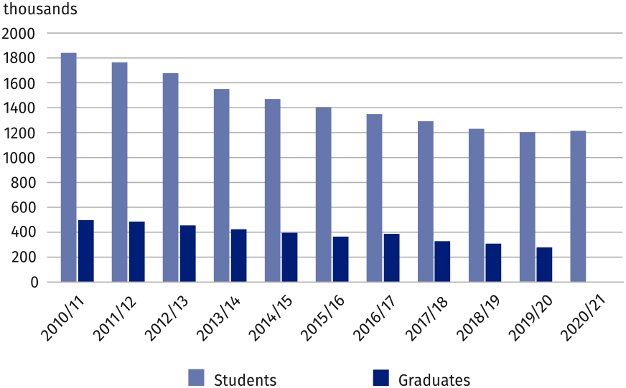

Students
65.6% of students were enrolled in full-time programmes
Women accounted for 58.0% of students in the 2020/21 academic year. 796.7 thousand people were enrolled in full-time programmes (65.6% of students), while 418.6 thousand people studied part-time. First-cycle studies were chosen by 62.7% of all students
(761.6 thousand people), second-cycle programmes by 22.9% and long-cycle programmes by 14.1% of students. The most (253.4 thousand) people studied in Mazowieckie Voivodship, while the fewest (11.9 thousand) in Lubuskie Voivodship.
Business, administration and law with 22.3% of all students was the most frequently chosen broad field, followed by Technology, manufacturing and construction (14.8% respectively), Social sciences, journalism and information, and Health and welfare (11.9% each).
Higher education institutions in Mazowieckie Voivoship were the most popular with foreign students
84.7 thousand foreigners, including 42.7 thousand women planned to study in Poland for at least one academic year, by 3.0% more than in the previous academic year. Most of the foreigners came from European countries, primarily from Ukraine (38.5 thousand, 45.4% of all foreigners), Belarus (9.7 thousand – 11.5%) and India (2.6 thousand – 3.0%). Full-time studies were undertaken by 73.2 thousand foreigners (86.5%). Higher education institutions in Mazowieckie Voivodship concentrated nearly one third of all foreigners (24.5 thousand).

Table 1. Students by voivodships in the 2020/21 academic year
SPECIFICATION | Total | Of which females | In |  | Of total number  – foreigners
SPECIFICATION | Total | Of which females | full-time programmes | part-time programmes | Of total number  – foreigners
POLAND | 1215307 | 704946 | 796701 | 418606 | 84672
Dolnośląskie | 117139 | 65487 | 75282 | 41857 | 8126
Kujawsko-pomorskie | 54827 | 33633 | 32026 | 22801 | 2168
Lubelskie | 67537 | 40506 | 51786 | 15751 | 7898
Lubuskie | 11872 | 6482 | 7416 | 4456 | 153
Łódzkie | 76897 | 46579 | 45878 | 31019 | 8246
Małopolskie | 144302 | 84460 | 107644 | 36658 | 7896
Mazowieckie | 253407 | 142020 | 151515 | 101892 | 24498
Opolskie | 18398 | 10467 | 13923 | 4475 | 1863
Podkarpackie | 44599 | 25265 | 31924 | 12675 | 2487
Podlaskie | 28575 | 16987 | 20668 | 7907 | 1596
Pomorskie | 83641 | 49164 | 51673 | 31968 | 4123
Śląskie | 106411 | 61766 | 71239 | 35172 | 5560
Świętokrzyskie | 22082 | 13908 | 13997 | 8085 | 987
Warmińsko-mazurskie | 23705 | 13632 | 18012 | 5693 | 457
Wielkopolskie | 127771 | 75391 | 77679 | 50092 | 6888
Zachodniopomorskie | 34144 | 19199 | 26039 | 8105 | 1726

Graduates
293.4 thousand graduates completed full-time programmes (65.5%), while 101.3 thousand – part-time programmes
In the 2019/20 academic year, 293.4 thousand people obtained higher education diplomas, including 185.6 thousand (63.2%) women. Most of the graduates (180.0 thousand) completed long-cycle and first-cycle programmes, while 38.6% were graduates of second-cycle studies.
Graduates most often completed their studies in the following broad fields:
Business, administration and law (23.6%), Technology, manufacturing and construction (16.5%), Health and welfare (11.2%) and Social sciences, journalism and information (10.6%).
As in the case of students, the most of 14.8 thousand foreign graduates came from Ukraine (51.7%), Belarus (8.7%) and India (6.9%). More than half of the foreign graduates were women (55.3%). 65.5% of foreigners completed full-time studies, mostly Business, administration and law (34.3% of the total number of foreign graduates).

Table 2. Graduates by broad fields of education in the 2019/20 academic year
SPECIFICATION | Total | Of which females
Total | 293436 | 185571
Education | 24875 | 21291
Arts and humanities | 25090 | 18465
Social sciences, journalism and information | 31241 | 21707
Business, administration and law | 69108 | 45999
Natural sciences, mathematics and statistics | 11811 | 8416
Information and Communication Technologies (ICTs) | 12068 | 1911
Technology, manufacturing and construction | 48275 | 19621
Agriculture, forestry, fisheries and veterinary | 5476 | 3213
Health and welfare | 32842 | 26748
Services | 25329 | 14388
Individual interfield studies | 7321 | 3812

When citing data from the Statistics Poland please provide the following information: "Statistics Poland's data". When publishing calculations made on data published by the Statistics Poland, provide the following information: "Own study based on the Statistics Poland's data".

Prepared by:  Statistical Office in Gdańsk  Director Jerzy Auksztol  Office: phone (+48 58) 76 83 130 | Issued by :  The Spokesperson for the President  of Statistics Poland  Karolina Banaszek  Mobile: (+48) 695 255 011

Press Office  Office: phone (+48 22) 608 34 91. 608 38 04  e-mail: obslugaprasowa@stat.gov.pl |  | www.stat.gov.pl/en/
 |  | @StatPoland
 |  | @GlownyUrzadStatystyczny

Related information
Higher education and its finances in 2019

Data available in databases
Local Data Bank - Higher education

Terms used in official statistics
Student
Degree programmes
Part-time programmes

