Tourist accommodation establishments in coastal areas in July and August 2021
(concerns tourist accommodation establishments with 10 or more bed places)
In July and August 2021, 1.7 million tourists were accommodated in tourist accommodation establishments located in coastal areas, and 8.6 million overnight stays were provided for them. Compared to the same period last year, the number of tourists as well as number of overnight stays was higher by 13.5% and 18.3%, respectively.
 18.3%
Increase in the number of overnight stays provided in tourist accommodation establishments in July and August 2021 compared to the same months of the previous year

Coastal gminas according to Eurostat methodology
According to the Eurostat methodology, 55 gminas of the voivodships: Pomorskie (26), Warmińsko-Mazurskie (6) and Zachodniopomorskie (23), are classified as coastal areas in Poland. They are situated by the Baltic Sea or are in direct proximity to the sea. They cover 2.5% of Poland's territory (7.9 thousand square kilometres) and are inhabited by 4.1% of the country's population (1.6 million people).
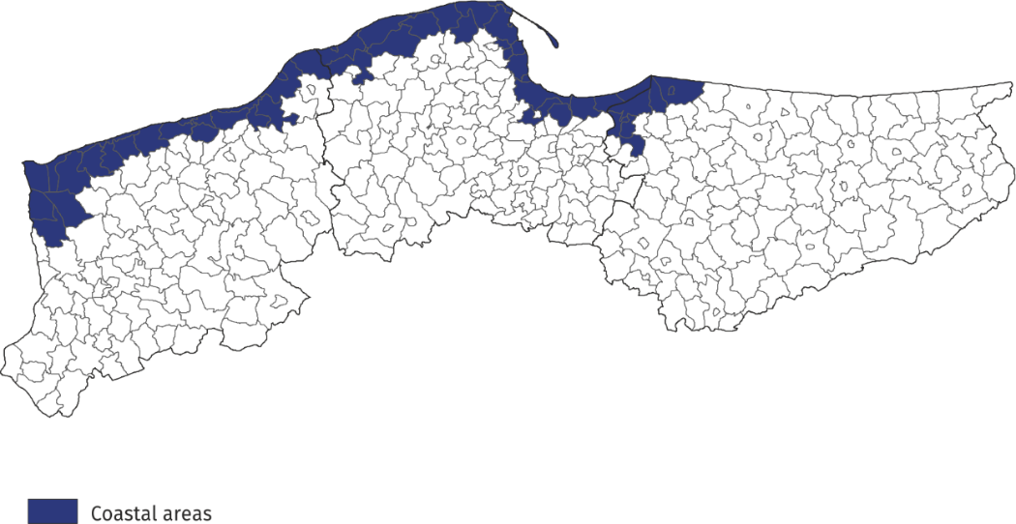
Map 1. Coastal gminas

Tourist accommodation establishments in coastal areas
As of the end of July 2021, 2 342 tourist accommodation establishments operated in coastal areas, i.e. almost 1/4 of all establishments in Poland. The vast majority of them (almost 70%) operated on a seasonal basis (the percentage of seasonal establishments in Poland was less than 30%).
Almost half of the holiday centers operating in the country functioned here, as well as 44% of rooms for guest, 42% of complexes of tourist cottages, 37% of holiday youth centres and 31% of camping sites.
Compared to the previous year, the number of accommodation establishments in coastal areas decreased by 160, i.e. by 6.4%. Decreases were recorded in most types of establishments, except for hotels, motels, school youth hostels, hostels and health establishments, where slight increases were observed.
The structure of accommodation establishments in coastal areas is fundamentally different from the structure of establishments in total in Poland. Rooms for guests prevail – at the end of July this year there were 876 of them and they accounted for 37.4% of all establishments in these areas. There were numerous holiday centres – 456 (19.5%) and complexes of tourist cottages – 221 (9.4%). Hotels accounted for 10.1% of tourist accommodation establishments in coastal areas (25.4% in Poland).
Chart 1. Tourist accommodation establishments in coastal areas in 2021 – as of 31 July
At the end of July 2021, tourist accommodation establishments located in coastal gminas had 217.1 thousand bed places, which accounted for 27.7% of the total number of bed places in accommodation establishments in Poland, and it was 1.3 thousand (0.6%) less than a year ago. However, not all types of accommodation establishments recorded a decrease in the number of bed places – their number increased, among other things, in hotels (by 3.4 thousand), health establishments (by 0.9 thousand) and complexes of tourist cottages (by 0.6 thousand).
Chart 2. Bed places in coastal areas in 2021 – as of 31 July

The largest number of bed places was offered by holiday centres – 72.3 thousand, i.e. 33.3% of the total number of bed places in the area. Hotels had 38.7 thousand (i.e. 17.8%) places prepared for tourists, while rooms for guest had 22.8 thousand (10.5%). Among other types of establishments, 15.1 thousand bed places were available for tourists in complexes of tourist cottages, and 13.2 thousand in health establishments.
Establishments in coastal areas are larger than the average in Poland. One establishment functioning in coastal areas had an average of 93 places (79 places in the country).
In 2021, the density index of the accommodation establishments in coastal areas was 27 places per 1 square kilometre of area (in the country – less than 3).

Turyści korzystający z turystycznych obiektów noclegowych
Tourists accommodated in establishments in coastal areas during the holiday period constituted 23.3% of all tourists accommodated in the whole country during that period

During the holiday season (i.e. in July and August) of 2021, 1.7 million tourists were accommodated in accommodation establishments located in coastal gminas (880.4 thousand – in July and 857.6 thousand – in August), i.e. 23.3% of tourists accommodated in accommodation establishments throughout the country during this period (in the corresponding period of 2020 this percentage amounted to 25.9%). Compared to the corresponding period of 2020, the number of tourists using overnight stays in July and August was higher by 206 thousand, i.e. by 13.5% (in July by 26.0% and in August by 2.9%).
Nearly 1/3 of tourists (544.0 thousand) staying in these areas were accommodated in hotels. A large number of tourists chose to stay in holiday centres – 418.4 thousand (24.1%), and in rooms for guest – 165.3 thousand (9.5%).
Among the total number of tourists accommodated in tourist accommodation establishments 88.2% (1.5 million) were domestic tourists, and 11.8% (0.2 million) were foreign tourists. In relation to the same period of 2020, the number of domestic tourists was higher by 15.0% and the number of foreign tourists by 2.9%.
Chart 3. Tourists accommodated in coastal areas in July-August

In July and August 2021, as in previous years, the majority of foreign tourists accommodated in coastal areas were from Germany. During this period, 147.9 thousand of them arrived and compared to the same period last year there were less of them by 11.0 thousand. Likewise, their share in the total number of foreign tourists was much lower than the year before and amounted to 72.3% – in the same period of 2020 they accounted for 79.9% of the total number of foreign tourists. The share of guests from other countries did not exceed 5%; most of them were from Czechia (8.5 thousand), Sweden (6.1 thousand) and Norway (5.2 thousand), who constituted, respectively, 4.2%, 3.0% and 2.5% of the total number of foreign tourists accommodated in coastal areas.
Overnight stays provided at tourist accommodation establishments
Overnight stays provided in July and August in coastal areas accounted for 34.9% of all overnight stays in Poland during this period

A total of 8.6 million overnight stays were provided for tourists staying in coastal areas in July and August this year, which accounted for 34.9% of all overnight stays provided at tourist accommodation establishments in Poland during that period. In the same period last year, the share was 2.0 percentage points higher.
This year a little more overnight stays were provided to tourists in August (4 million 332 thousand), than in July (4 million 292 thousand). Compared to the same period in 2020, the total number of overnight stays provided in July and August this year was higher by 18.3% (i.e. 1.3 million) – in July by 28.5% (1.0 million), and in August by 9.6% (0.4 million).
On average, 5 overnight stays were provided for tourists during their holiday trips, while the average length of a tourist stay in Poland during that period was just over 3 nights.
In the period July-August 2021, 7.8 million overnight stays were provided for domestic tourists (20.4% more than in July and August last year) and they accounted for 90.2% of the total number of overnight stays in coastal areas and 34.6% of the total number of overnight stays provided for domestic tourists in the same period in Poland. A total of 842.3 thousand overnight stays were provided for foreign tourists, which was 1.3% more than in the previous year. Most overnight stays were provided to tourists from countries neighbouring Poland, i.e. Germany (666.1 thousand – 79.1% of overnight stays of foreign tourists), Czechia (29.5 thousand – 3.5%) and Ukraine (18.4 thousand – 2.2%).
Chart 4. Overnight stays provided tourist accommodation establishments in coastal areas in July-August

Occupancy rate of bed places in tourist accommodation establishments
During the holiday season (July, August), places in tourist accommodation establishments located in coastal gminas are usually better occupied than in other areas of the country.
The occupancy rate of bed places in coastal gminas was higher than the national average and amounted to 64.0% in July and 64.4% in August

In July, the occupancy rate of bed places amounted to 64.0%, and in August – 64.4%, while the average for the entire country amounted to 49.9% and 52.4%, respectively.
Similarly, in the corresponding months of 2020, the indicator for coastal areas was higher than for the country – in July 49.6% and 38.3%, and in August, 58.5% and 44.5%, respectively.

Chart 5. Tourism in coastal areas in comparison with the country in July-August 2021

Occupancy of tourist accommodation establishments in gminas located in coastal areas in July and August 2021
In the coastal areas in July and August this year the highest number of overnight stays were provided in accommodation establishments located in Kołobrzeg – 876.7 thousand, which constituted 1/10 of all overnight stays provided in this area. Over 153 thousand tourists were accommodated there. This means that during the two holiday months, there were 334 tourists using the accommodation establishment and 1 909 overnight stays per 100 inhabitants of the city.
In the period July-August, the largest number of overnight stays in coastal gminas was provided in Kołobrzeg and Gdańsk

Large tourist traffic was also recorded in Gdańsk, where in July-August with almost 794 thousand overnight stays were provided to 260 thousand tourists. For 100 inhabitants of this city there were 55 tourists and 169 overnight stays.
From approximately 400 thousand up to 700 thousand overnight stays were provided in 4 gminas: Rewal – 686.3 thousand, Mielno – 664.1 thousand, Władysławowo – 562.8 thousand and Świnoujście – 492.7 thousand.
After over 300 thousand overnight stays were recorded in tourist night establishments in the following gminas: Kołobrzeg (381.1 thousand), Łeba (375.0 thousand), Ustronie Morskie (370.4 thousand) and Dziwnów (354.8 thousand).
Table 1. Tourist accommodation establishments and its occupancy in the period July-August in 2021

Gmina | Overnight stays provided |  |  | Tourists accommodated
Gmina | in thousand | July-August 2020=100 | in per-centages | in thousand | July-August 2020=100
Coastal area  of which: | 8 624.6 | 118.3 | 100.0 | 1 738.0 | 113.5
Kołobrzeg  (urban gmina) | 876.7 | 120.1 | 10.2 | 153.3 | 119.6
Gdańsk | 793.8 | 123.1 | 9.2 | 260.1 | 117.9
Rewal | 686.3 | 124.9 | 8.0 | 117.7 | 121.3
Mielno | 664.1 | 115.8 | 7.7 | 119.0 | 120.6
Władysławowo | 562.8 | 115.1 | 6.5 | 104.9 | 107.0
Świnoujście | 492.7 | 105.9 | 5.7 | 112.4 | 95.9
Kołobrzeg  (rural gmina) | 381.1 | 154.4 | 4.4 | 62.4 | 138.0
Łeba | 375.0 | 120.2 | 4.3 | 69.9 | 116.1
Ustronie Morskie | 370.4 | 126.9 | 4.3 | 62.6 | 120.2
Dziwnów | 354.8 | 120.3 | 4.1 | 56.9 | 113.0

In total, over 60% of tourist traffic from coastal areas was concentrated in the above-mentioned 10 gminas, both in terms of the number of tourists using accommodation establishments and overnight stays.

When quoting Statistics Poland data, please provide information: “Source of data: Statistics Poland”, and when publishing calculations made on data published by Statistics Poland, please provide information: “Own study based on Statistics Poland data”.

Prepared by:  Statistical Office in Rzeszów  Director Marek Cierpiał-Wolan  Office: tel. (+48 17) 853 52 10 | Issued by:  The Spokesperson for the President  of Statistics Poland  Karolina Banaszek  Mobile: (+48) 695 255 011

Press Office  Office: tel. (+48 22) 608 34 91, 608 38 04  e-mail: obslugaprasowa@stat.gov.pl |  | www.stat.gov.pl/en/
 |  | @StatPoland
 |  | @GlownyUrzadStatystyczny
Related information
Occupancy of tourist accommodation establishments in Poland in June and July 2021
Accommodation establishments as of 31 July 2021 and their occupancy in the first half of 2021
Occupancy of tourist accommodation establishments in the first quarter of 2021
Occupancy of tourist accommodation establishments in Poland in April and May 2021
Occupancy of tourist accommodation establishments in Poland in February and March 2021
Occupancy of tourist accommodation establishments in Poland in January and February 2021
Tourism in 2020

Data available in databases
Local data bank

Terms used in official statistics
Tourist
Tourist accommodation establishment
Bed places in tourist accommodation establishments
Foreign tourists in tourist accommodation establishments
Nights spent (overnight stays) in tourist accommodation establishments
Duration of the stay
Occupancy rate of bed places in tourist accommodation establishments

According to the Eurostat methodology, coastal areas are classified on the basis of the distance of a given gmina from the sea: if a gmina borders on the sea, it is, as a rule, a coastal gmina; if a gmina does not border on the sea but 50% of its area is within 10 km from the sea, it is also considered a coastal gmina. In Poland, in agreement with Eurostat, the following gminas: Słupsk (rural gmina), Główczyce, Gniewino, Pruszcz Gdański (rural gmina), Cedry Wielkie, Koszalin (urban gmina) and Sianów (urban-rural gmina), are additionally considered to be coastal gminas. The list of coastal gminas is included in Annex 4 of the Methodological report "Tourist accommodation statistics" available on the website https://stat.gov.pl/obszary-tematyczne/kultura-turystyka-sport/turystyka/zeszyt-metodologiczny-statystyka-turystycznej-bazy-noclegowej,15,1.html

